***OUR LADY OF AFRICA JUNIOR SCHOOL-BUKASA***

***PRIMARY SIX***

***MATHEMATICS***

***LESSON NOTES***

***TEACHER’S NAME: …………………………………………………………..***

***CLASS: ………………………………………………………………………….***

***STREAM: …………………………………… YEAR: ……………………….***

***TABLE OF CONTENT.***

|  |  |  |
| --- | --- | --- |
| ***NO*** | ***TOPIC/ THEME*** | ***PAGE*** |
| ***TERM ONE*** | | |
| ***1*** | ***SETS*** | ***3-36*** |
| ***2*** | ***NUMERATION SYTEM AND PLACE VALUES*** | ***37-51*** |
| ***3*** | ***ROUNDING OFF*** | ***52-54*** |
| ***4*** | ***STANDARD FORM/ SCIENTIFIC NOTATION*** | ***55-57*** |
| ***5*** | ***ROMAN NUMERALS*** | ***58-63*** |
| ***6*** | ***BASES*** | ***64-78*** |
| ***7*** | ***DIVISIBILITY TEST*** | ***79-87*** |
| ***8*** | ***TYPES OF NUMBERS*** | ***88-98*** |
| ***9*** | ***PRIME FACTORS, PRIME FACTORISATION, LCM AND GCF*** | ***99-112*** |
| ***10*** | ***SQUARE AND SQUARE ROOT*** | ***113-121*** |
| ***11*** | ***INDICES*** | ***122-126*** |
| ***TERM TWO*** | | |
| ***1*** | ***FRACTIONS*** | ***127-157*** |
| ***2*** | ***INTEGERS*** | ***158-171*** |
| ***3*** | ***RATIOS, PROPORTIONS AND EXCHANGE RATES*** | ***172-200*** |
| ***4*** | ***PERCENTAGES*** | ***201-232*** |
| ***5*** | ***SIMPLE INTEREST*** | ***233-236*** |
| ***6*** | ***DATA HANDLING*** | ***237-262*** |
| ***7*** | ***PIE CHARTS*** | ***263-275*** |
| ***TERM THREE*** | | |
| ***1*** | ***TIME, DISTANCE AND SPEED*** | ***276-305*** |
| ***2*** | ***TRAVEL GRAPH*** | ***306-313*** |
| ***3*** | ***COORDINATE GRAPH*** | ***314-319*** |
| ***4*** | ***GEOMETRY*** | ***320-383*** |
| ***5*** | ***PYTHAGORAS THEOREM, AREA AND PERIMTER*** | ***384-421*** |
| ***6*** | ***CONVERSION OF LENGTH*** | ***422-423*** |
| ***7*** | ***CIRCLES*** | ***424-432*** |
| ***8*** | ***VOLUME, CAPACITY AND TOTAL SURFACE AREA*** | ***433-455*** |
| ***9*** | ***ALGEBRA AND INEQUALITY*** | ***456-494*** |
| ***10*** | ***CORRECTIONS AND FINDINGS.*** | ***495*** |

**SETS**

A set is a collection of well-defined elements

**Review**

Equal sets

Equivalent sets

Intersection sets

Union sets

Difference of sets

**SUBSETS**

A subset is a set that can be obtained /formed from any given set.

A symbol for subset is ⊆ (is a subset of)

**Venn diagrams about subsets**

**Examples**

Draw a Venn diagram to show that all hens(H) are birds (B)

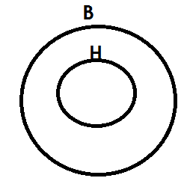 Solution

Draw a Venn diagram to show that set A=A n B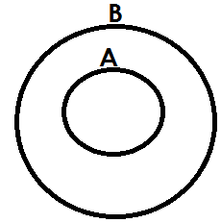

With the help of a venin diagram show that n (P) =n (P u Q)

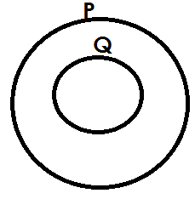 Solution

**Activity**

1. Draw a Venn diagram to show that all cows(C) are animals(A)

2. With the help of a Venn diagram show that all girls (G) are female (F).

3. Draw a Venn diagram to show that set K=P n K

4. With the help of a Venn diagram, show that n (P) =n (X u P)

5. If n (A) =n(An), show the illustration using a Venn diagram.

**Listing subsets**

**Note:**

An empty set is a subset of every set.

Any given set is a subset of itself.

Equal sets are not subsets of a given set. e.g. {a, b} and {b, a} since they are taken to be the same.

**Example1**

Set A= {2}. List all subsets in set A

**Solution**

{ }, {2}

**Example 2**

If set T= {a, b}, list all subsets in set T.

**Solution**

{ }, {a}, {b}, {a, b}

**Example3**

Given that set M= {m, a, n}. List all subsets in set M.

{ }, {m},{a},{n}, {m, a}, {m, n}, {a, n}, {m, a, n}

**Example 4**

List all subsets inset k= (1,2,3,4)

{}, {1}, {2}, {3}, {4}, {1,2}, {1,3}, {1,4}, {2,3}, {2,4}, {3,4}, {1,2,3}, {1,3,4}, {2,3,4}, {2,1,4}, {1,2,3,4}

**Activity**

1. List all subsets in set A if A=

2. Given that set T= {4} list all subsets in set T

3. If set y= {1, 2}. List all subsets in set y

4. Given that set P= . List all subsets of set P

5. If set A= {c, o, w}. List all subsets in set A.

6. Set P= {Annette, James, Ben}. List all subsets in set P.

7. Set T= {a, b, c, d}. List all subsets in set T

8. Given that set M= {7, 8, 9, 3}. List all subsets that can be formed from set M.

**FINDING NUMBER OF SUBSETS**

**Number of subsets = 2n**

Where: - **n** is number of elements is a given set

2 indicates that, number of subsets are in powers of 2.

**Example1**

Given that set P= { }, find number of subsets in set P.

**Solution**

No. of subsets = 2n

= 20

= 1 subset.

**Example2**

If set T= {5}. Find number of subsets in set T

**Solution**

No. of subsets = 2n

= 21

= 2 subsets

**Example 3**

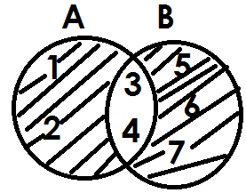Below is set A and B

Find number of subsets in set (A n B) **I**

No. of subsets = 2n

= 25

= 2x2x2x2x2

= 32 subsets

**Examples 4**

If set m= {1, 2, 3, 4, 5, 6, 7, 8} and set

P= {all factors of 12}. Find number of subsets in M n P

M= {1, 2, 3, 4, 5, 6, 7, 8}

P= {1, 2, 3, 4, 6, 12}

M n p= {1, 2, 3, 4, 6}

No. of subsets = 2n

= 25

= 2x2x2x2x2

= 32

**ACTIVITY**

1. Find number of subsets in set P with 4 elements.

2. Given that set y= {all vowel letters}. Find number of subsets in set y.

3. If set K= {a, b, c, d, e, f}, find number of subsets in set K.

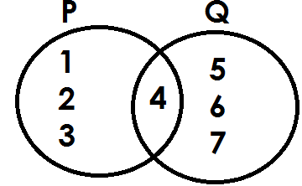4. Below is set P and Q

Find number of subsets in P U Q

6. If set A= {All even numbers less than 10} and set B= {all factors of 12}. Find number of subsets in A n B.

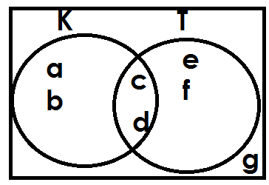7. **Use the Venn diagram below to answer question**

Find number of subsets in K**I**

**FINDING NUMBER OF ELEMENTS GIVEN NUMBER OF SUBSETS**

**Formula:**

2n = No. of subsets

**Examples**

1. Set K has 1 subset. How many elements are in set K?

**Solution**

2n = no of subsets

2n = 1 but 1 = 2**0**

2n = 20

n = 0

No element

2. Set M has 64 subsets. How many elements are in set M?

**Solution**

2n = No. of subsets

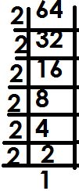 2n = 64

2n =

2n = 2x2x2x2x2x2

2n = 26

n = 6

**Example 3**

3. Set K has 128 subsets. How many elements are in set K?

**Solution**

2n = No. of subsets

2n = 128

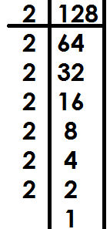 2n =

2n = 27

n = 7

**Example 4**

Set M has 256 subsets. How many elements are in set M?

2n = No. of subsets

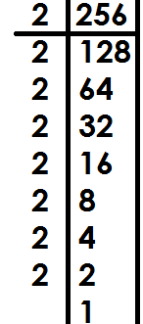 2n = 356

2n =

2n = 28

n = 8

**ACTIVITY.**

1. Set A has 8 subsets. Find the number of elements in set A.

2. There are 4 subsets in a set. How many elements are in that set.

3. Find the number of members in a set with the following number of subsets.

(a) 32 subsets

(b) 64 subsets

(c) 16 subsets

**FINDING PROPER SUBSETS**

(a) **By listing.**

1. If P= {a, b, c}, how many proper subsets has set P?

**Solution**

P= {a, b, c}

{ }, {a}, {b}, {c}, {a, b}, {a, c}, {b, c}

7 proper subsets.

2. Given that M= {p, q, r, s,}. List the number of proper subsets in set M.

**Solution**

M= {p, q, r, s}

{ }, {p}, {q}, {r}, {s}, {p,q},{p, r}, {p,s} {q,r},{q,s}, {r,s},{p,q,r},{p,q,s}, {p,r,s},

{q,r,s}

15 proper subsets

**ACTIVITY**

List the proper subsets for each of the following sets

1. B= {a,b}

2. C= {x, y, z}

3. D= {t}

4. p= {a, b, c, d}

5. q= { }

6. Z= {1, 2, 3}

(b) **By using the formula.**

**Formula:**

No. of proper subsets = 2n – 1

Where n is number of elements in a given set and 1 is the mother being

subtracted from the formula.

**Examples**

1. If x= {1, 2, 3}. Find the number of proper subsets in set X.

**Solution**

Set X has 3 elements, how many proper subsets are in set X?

Proper subsets = 2n-1

= 23-1

= {2x2x2}-1

= 8-1

= 7 proper subsets.

2. Set M = {1}, how many proper subsets are in set M?

Set M has 1 element

No. of proper subsets = 2n-1

= 21-1

= 2-1

= 1 proper subset.

3. How many proper subsets are in a set with 5 elements?

**Solution**

No. of proper subsets = 2n - 1

= 25 - 1

= {2x2x2x2x2} -1

= 32 - 1

= 31 proper subsets.

**Activity**

1. If B= {1, 2}, how many proper subsets are in set B?

2. Given that R= {a, b, c, d, e, f}. Find the number of proper subsets in set R.

3. Find the number of proper subsets of a set which has;

(a) 4 elements

(b) 3 elements

(c) 7 elements

(d) 9 elements

**FINDING NUMBER OF ELEMENTS GIVEN NUMBER OF PROPER SUBSETS**

**Formula;**

2n - 1 = No. of proper subsets

**Examples**

1. Set M has 15 proper subsets. How many elements are in set M?

**Solution**

2n – 1 = No of proper subsets

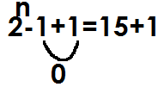 2n - 1 = 15

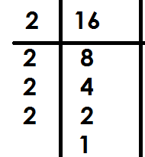 2n = 16

2n =

2n = 24

n =4

2. Set K has 255 proper subsets. How many elements are in set k?

**Solution**

2n-1=no of proper subsets

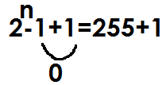 2n - 1 = 255

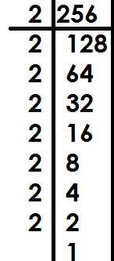 2n = 256

2n =

2n = 2x2x2x2x2x2x2x2

2n = 28

n = 8

3. Set R has 63 proper subsets. Find the number of elements in set R

2n - 1 = No of proper subsets

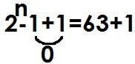2n- 1 = 63

2n = 64

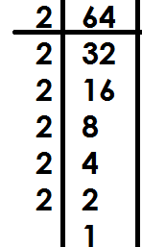2n =

2n = 26

n = 6

**Activity**

1. Set H has 3 proper subsets. How many elements are in set H?

2. There are 15 proper subsets in set D. How many elements are in set D?

3. Find the number of members in a set with;

(a) 31 proper subsets

(b) 7 proper subsets

(c) 511 proper subsets

(d) 1023 proper subsets

**UNIVERSAL SET ( )**

A universal set is a set which contains all elements from which other sets are formed.

 Example 1

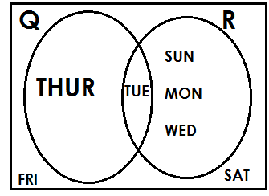

The universal set ( ) = {Thur., Tue., Sun., Mon., Wed., Fri., Sat.}

**Example2**

****Study the Venn diagram and list the members of T U M and n ( )

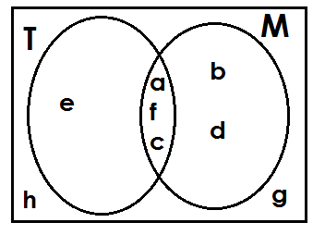

****(i)TUM = {a, e, f, c, b, d}

(ii) n ( )

= {e, a, f, c, b, d, h, g}

n = 8

**COMPLEMENT OF SETS**

It is a set of elements outside the mentioned set.

**Example**: Complement of P means members in set P are not wanted.

**Example2**

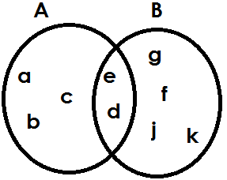Given set A= {a, b, c, d, e} and B= {e, d, g, f, j, k}

a) Find A I = {g, f, j, k}

b) List members of (A n B) I = {a, b, c, g, f, j, k}

c) The complement of B = {a, b, c}

d) List the members of (A-B) I

**Solution**

(A-B) I = {e, d, g, f, j, k}

**Study the Venn diagram below and answer questions**

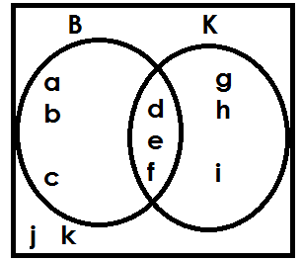

a) Find the complement of set B

B **I** = {g, h, I, j, k}

b) Find

(i) (B n K) **I**

**Solution**

(B n K) **I** = {a, b, c, g, h, I, j, k}

(ii) (B u K) **I**

**Solution**

(B u K) **I** = {J, K}

(iii) (K-B) **I**

**Solution**

(K-B) **I** = {a, b, c, d, e, f, j, k}

c) Find the number of elements in set K complement

**Solution**

n(K) **I**

K **I** = {a, b, c, j, k}

n(K) **I** = 5

**Activity**

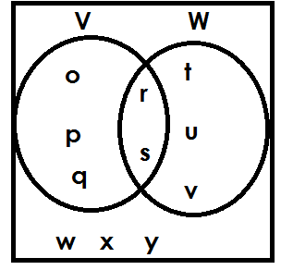 **Study the Venn diagram and answer questions**

(a) Find

(i) V **I**

(ii) (V u W) **I**

(iii) (V n W) **I**

(iv) (V - W) **I**

Find

(v) n(W) **I**

(vi) n (V u W) **I**

b. Find number of elements in the universal set.

****2. Study the given sets and answer the questions

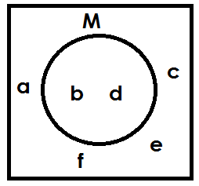

(a) Find (M) **I**

(b) List all the elements of M

(c) List all the elements in the universal set.

****3. Given the Venn diagram below

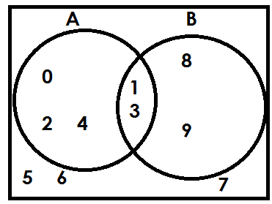

(a) List all elements in A’

(b) Find (A u B) **I**

(c) Find n (A n B) **I**

(d) List all members of the universal set

(e) Find B

****(f) List elements of set A

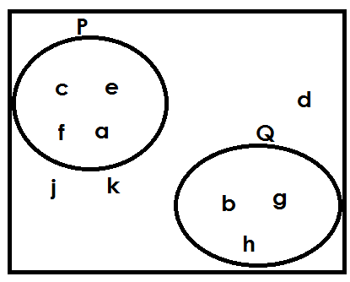4.

(a) List all elements in P

(b) List all elements in Q

(c) Find P complement?

(d) Find Q complement?

(e) Find PUQ complement?

(f) List all members in the universal set.

**Describing shaded and unshaded regions of a Venn diagram**

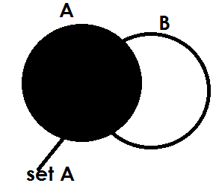 **Examples**

1.

Or set (B-A)’

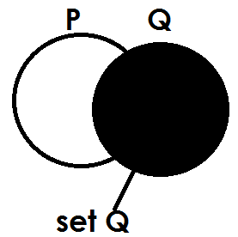

2.

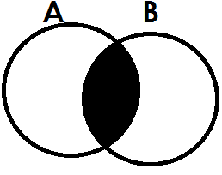

3.

A n B

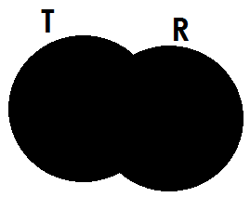 Set A intersection set B

4.

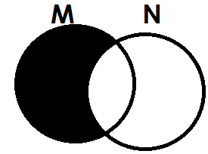 TUR or (Set T union set B)

5.

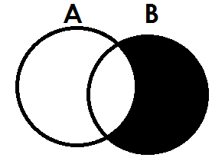 M - N or M only or N **I**

6.

B-A or B only or A’

****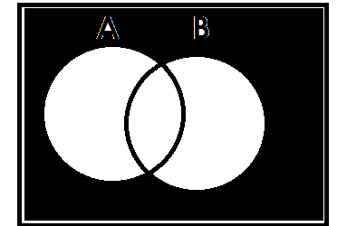7.



(A u B) **I** or - A u B

****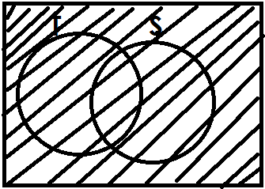8.

Universal set

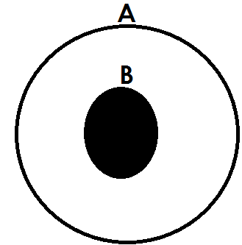9.

A n B or BCA or set B

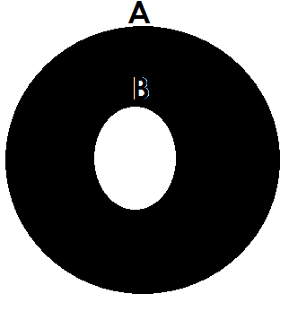10.

A only/ (A n B) **I** /B **I** / A - B

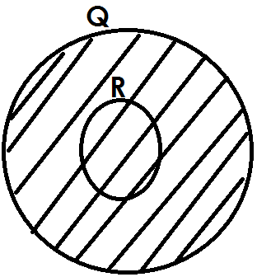11.

 QUR

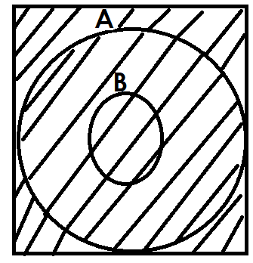12.



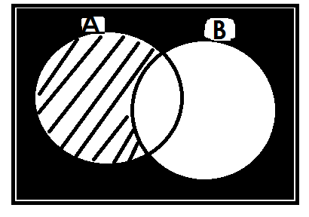13.

B **I**

****14.

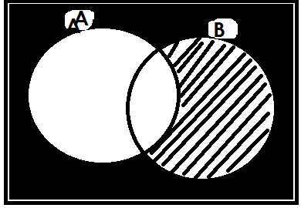

A **I**

**Activity**

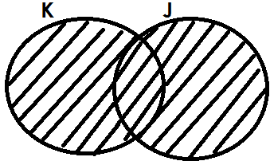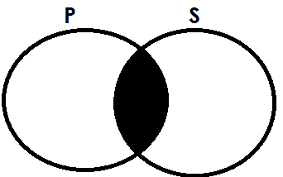 Describe each of the shaded regions in the Venn diagrams below.

1. 2.

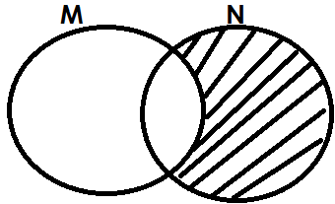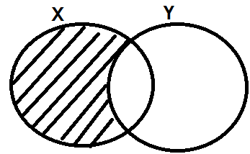

3. 4.

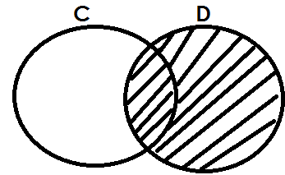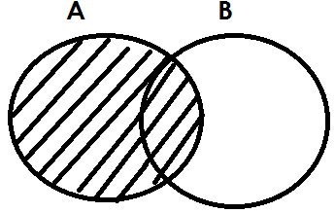5. 6.

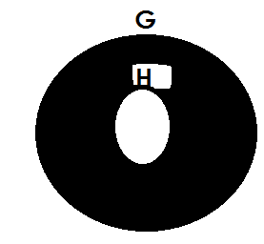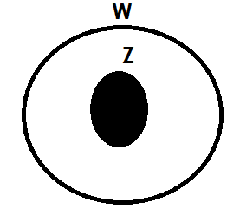

7. 8.

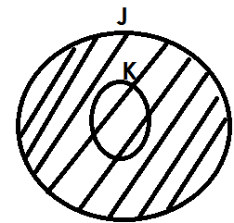****

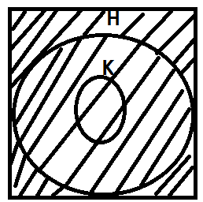9. 9.

****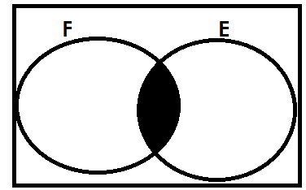

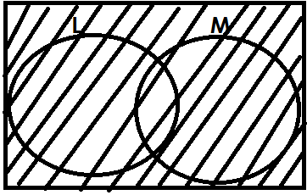11. 12.



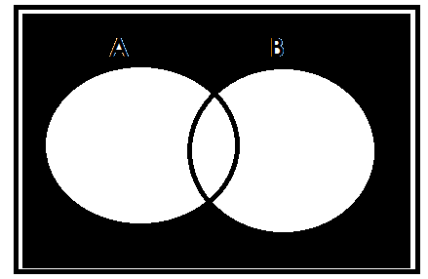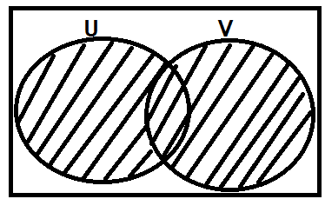13.

14.

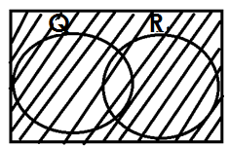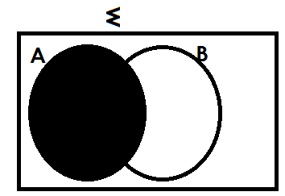15. 16.

**REPRESENTING AND FINDING NUMBER OF ELEMENTS ON A VENN DIAGRAM GIVEN GROUPED DATA**

**Examples**

1. Given that n(A-B) =9, n(B-A) =7, n(A n B)=4 and n(A u B) **I** = 2

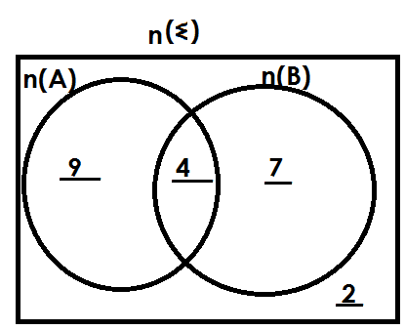(a) Represent both sets on a Venn diagram below

(b) Find

(i) n(A)

n(A)=9+4

=13

(ii) n(B)

n(B)=7+4

=11

(iii) n (A u B) = 9+4+7

= 20

(iv) n (A u B) **I**

n (A u B) **I** = 2

(v) n(A) **I**

n(A) **I** = 7+2

=9

2. If n(X) =15, n(Y) =20, n (X n Y) =8 and n (Xu Y) **I** = 5

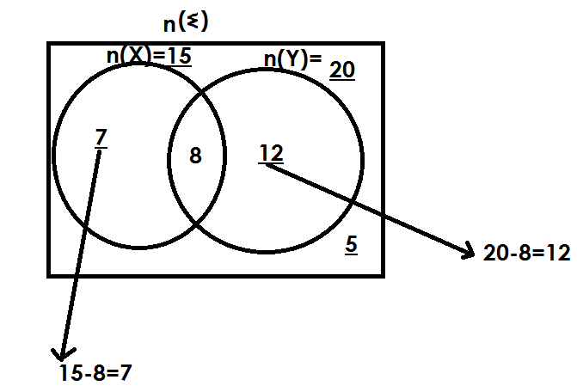(a) **Use the above information to complete the Venn diagram below.**

(b) Find (iii) n (X n Y) **I**

(ii) n(X-Y) soln.

soln. 7+8+12

 7 =24

(ii) n(Y-X) (iv) (v) n

Soln. 7+8+12+5

N(Y-X) =12 =32

3. In a class, 20pupils cat meat (M), 16 eat Fish (F) and 5 eat both while 3 pupils do not eat any of the mentioned.

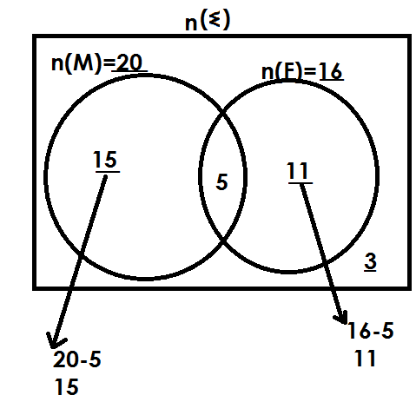(a) Represent the above information on a Venn diagram

(b) How many pupils eat only one dish?

**Solution**

Only one = n(F) only + N(M)only

=15+11

=26 pupils

(c) How many pupils are in the whole class?

** Solution**

=15+5+11+3

=34 pupils

(d) Find the probability of picking a pupil who likes meat only from the class.

**Soln.**

Probability = n (D.C)

n (T.C)

n (D.C) = 20

n (T.C) = 34

Probability = $\frac{20}{34}$

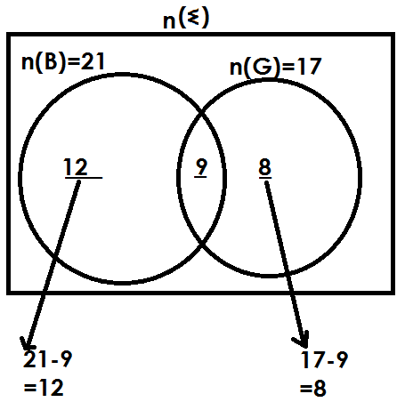4. It is given that; 21 farmers grow beans (B) and 17 farmers grow groundnuts (G). If 9 farmers grow both beans and ground nuts, draw a Venn diagram to show the above information.

(b) how many farmers grow only one type of crop?

Only one = n(B)only + n(G) only

= 12+8

= 20

c. Find the probability of selecting a farmer at random who grows both crops

soln.

Probability = $\frac{n(Q.C)}{n(T.C)}$

n (Q.C) = 9

n (T.C) = 12+9+8

= 29

Probability = $\frac{9}{29}$

**Activity**

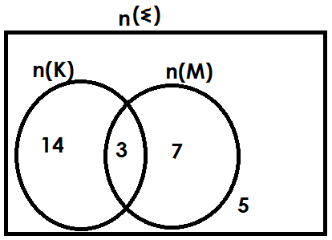1. Use the Venn diagram below to answer questions that follow.

9. Find

(i) n (K) (ii) n(M) (iii) n(K n M)

(iv) n (K u M) (v)

2. Given that n(M)=18, n(N)=25, n (M n N) =10 and n(MUN) **I** =4

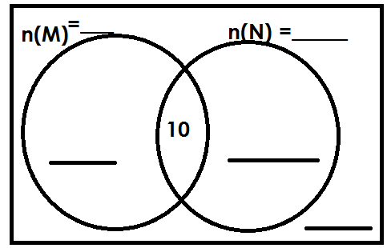(a) Complete the Venn diagram below

(b) Find n(M-N)

(c) Find

3. In a class, pupils made choices of food stuff they prefer. Given rice(R) and Matooke (M). The findings were as follows.

n (R) = 20, n (M) = 28, n (R n M) = 8 and n (R u M) **I** = 2

(a) Draw a Venn diagram representing the above information.

(b) How many pupils chose rice only?

(c) Find the number of pupils who chose matooke only.

(d) How many pupils chose only one type of food?

(e) How many pupils are in that class?

(f) Find the probability of picking a pupil at random who likes rice.

4. In a class, 18 pupils eat posho (P) and 15 pupils eat beans (B). If 8 pupils eat posho and beans. Draw a Venn diagram to show the given information.

(b) How many pupils eat only one type of food?

(c) Find the probability of picking a pupil at random who likes posho only.

5. In a market there are 24 traders who sell rice and 19 who sell beans (B), 11

sell both items.

(a) Draw a Venn diagram to show the above information.

(b) Find the probability of picking a trader who sells only one item.

**SOLVING PROBLEMS USING A VENN DIAGRAM**

(a) **GIVEN INTERSECTION AS THE UNKNOWN**

**Example**

In a village of 40 farmers, 26 grow beans (B) 24 grow maize (M) and x farmers grow both crops.

(a) Complete the Venn diagram

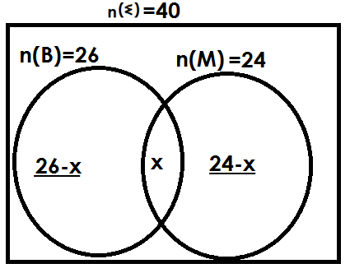

(b) Find the value of x.

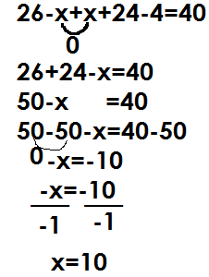 Solution

(c) How many farmers grow only one crop?

Solution

Only one = n (B) only+ n (M) only

= 26 - x + 24 - x

= 26-10+24-10

= 16 + 14

= 30 farmers

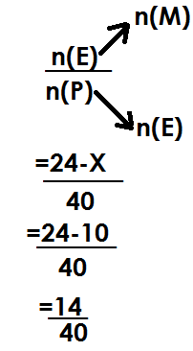(d) Find the probability of picking a farmer who grows maize only from the village

Prob=

**Example2**

In a bus of 50 passengers, 30 bought water (W), 26 bought soda(S) and M passengers bought both drinks while 8 passengers did not buy any of the mentioned.

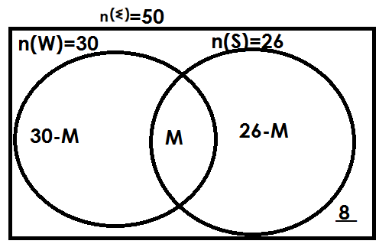(a) **Complete the Venn diagram**

(b) How many passengers bought both drinks?

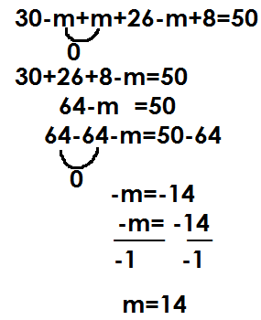 **Soln.**

passengers

(c) How many passengers did not buy water?

**Soln.**

n(W) **I** = 26-m+8

= 26-14+8

= 12+8

= 20

(d) Find the probability of picking a passenger who bought only one drink.

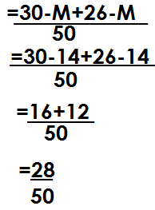 Prob= $\frac{n(E)}{n(P)}$

**Activity**

1. In a class of 60 pupils, 40 like Math (M), 30 like English (E) and K pupils like both subjects

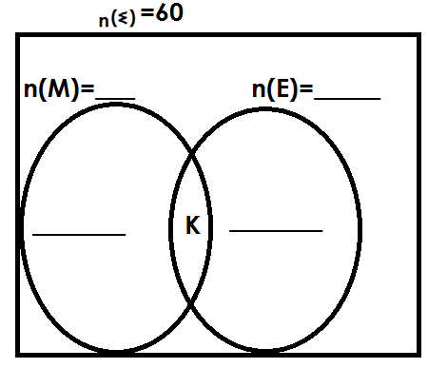a) Complete the Venn diagram

(b) Find the value of K.

(c) How many pupils like only one subject?

(d) Find the probability of picking a pupil who likes Maths only to lead a prayer.

2. In a group of 30 people, 20 eat meat (M), 15 eat fish (F) and y people eat both dishes.

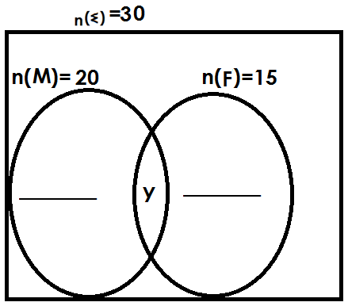(a) Complete the Venn diagram below using the above information.

(b) How many people like both dishes?

(c) How many people eat only one dish?

(d) Find the probability of picking a person who eats fish only from the group at random.

3. In a village of 40 farmers, 30 grow beans (B) 20 grow maize (M) and y farmers grow both crops while 6 farmers do not grow any of the mentioned crops.

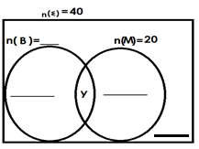(a) Complete the Venn diagram.

(b) Find the value of y.

(c) How many pupils do not grow maize?

(d) Find the probability of picking a farmer who grows only one crop.

4. At a party attended by 60 people, 35 ate chicken(C), 30 ate meat (M) and K people ate both dishes while 5 people ate neither of the two.

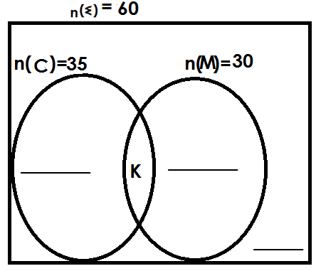(a) Complete the Venn diagram using the above information.

(b) How many people ate both dishes?

(c) Find number of people who ate only one dish.

(d) Find the probability of picking a person who did not eat chicken at the party.

5. In a school of 200 pupils,150 play football (F) 100 play volley ball(V)X pupils play both and 40 pupils play neither of the two.

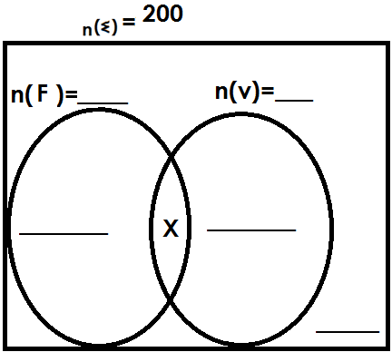(a) Complete the Venn diagram.

(b) Find the value of X

(c) How many pupils play only one game?

(d) Find the probability of picking a pupil who does not play football from the school at random.

**SOLVING PROBLEMS USING A VENN DIAGRAM**

(B) **GIVEN ONE OF THE SETS AS THE UNKNOWN**

**Example 1**

In a class of 30 pupils K pupils like math (M), 18 like English (E) and 5 pupils like both subjects while 3 pupils like neither of the two.

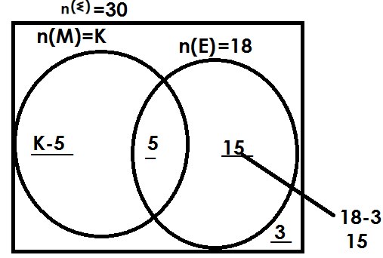(a) Complete the Venn diagram

(b) Find the value of K

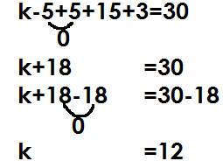 Soln.

(c) How many pupils like only one subjects

**Soln.**

Only one = n (M) only+ n (E) only

= k-5+15

= 12-5+15

= 7+15

= 22 pupils

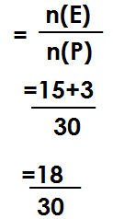(d) Find the probability of picking a pupil who does not like Maths (M) from the class.

Prob

**Example 2**

In a village of 50 farmers, 20 grow maize (M), 2P farmers grow beans (B) and 10 farmers grow both crops while 4 farmers do not grow any of the mentioned.

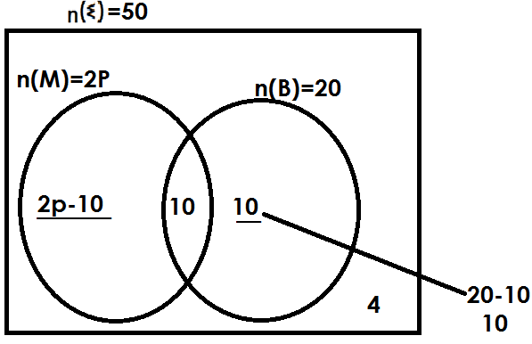(a) Complete the Venn diagram

(b) Find the value of P

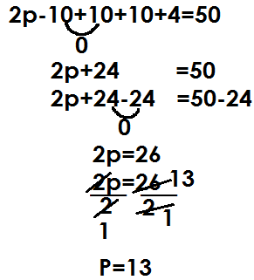 **Solution**

(c) How many farmers grow only one crop?

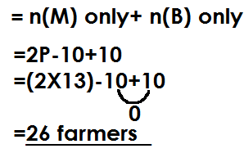 **Solution**

Only one

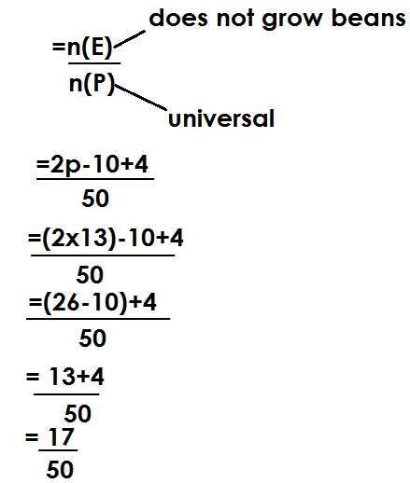(d) Find the probability of picking a farmer who does not grow beans

prob

**ACTIVITY**

1. In a group of 40 people, K people took water (W), 15 people took soda(S) and 5 people took both drinks while 8 people did not take any of the mentioned drinks.

(a) Complete the Venn diagram.

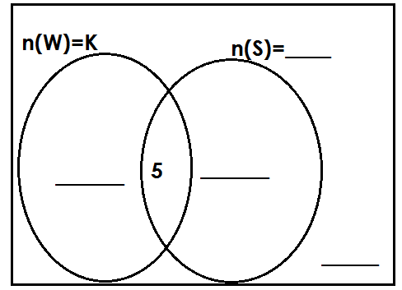

(b) Find the value of k.

(c) How many people took only one drink?

(d) Find the probability of picking a person who did not take water from the group.

2. In a class of 56 pupils, 26pupils like English (E), X pupils like Math(M) 10 pupils like both subjects and 6 pupils like none of the mentioned.

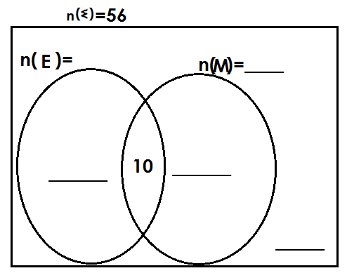(a) Complete the Venn diagram.

(b) How many pupils like Math (M)?

(c) How many pupils like only one subject?

(d) Find the probability of picking a person who does not like English.

3. At a birthday party attended by 70 people, 2m people ate meat (M),30 people ate fish(F) and 8 people ate both dishes, while 2 people did not eat any of the mentioned.

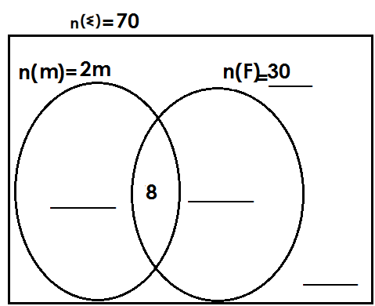(a) Complete the Venn diagram

(b) Find the value of m.

(c) How many pupils eat only one dish?

(d) How many pupils do not eat fish?

4. In a market of 40 traders, y traders sell shirts (S, 15 traders sell dresses(s) and 6 traders sell both types while 4 traders do not sell any of the mentioned.

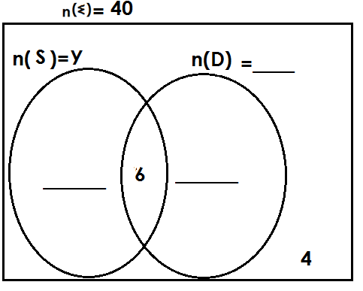(a) Complete the Venn diagram

(b) Find the value of y

(c) How many traders sell only one type of clothes?

(d) Find the probability of picking a trader who sells shirts only.

**SOLVING PROBLEMS USING A VENN DIAGRAM**

**(C) GIVEN DIFFERENCE OF SETS AS THE UNKNOWN**

**Example1**

In a village of 46 farmers, K farmers grow rice only (R), 24 farmers grow maize (m) and 7 farmers grow both crops while 3 farmers do not grow any of the mentioned.

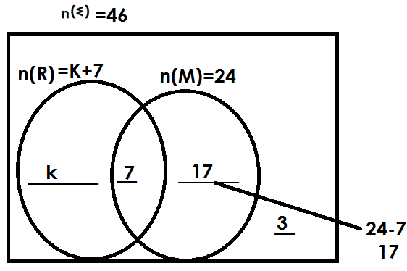(a) Complete the Venn diagram.

(b) Find the value of k

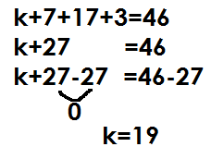 **Solution**

(c) How many farmers grow only one crop?

**Solution**

Only one = n (m) only+ n (R only)

= k+17

= 19+17

= 36 farmers

(d) How many farmers grow rice?

**Solution**

n(R) = k+7

= 19+7

= 26

**Example2**

In a class of 64 pupils, 2y pupils like math only (M), 24 pupils like English only (E) 10 pupils like both subjects and 4 pupils do not like any of the mentioned.

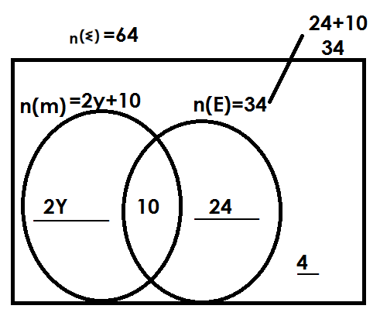(a) Complete the Venn diagram

(b) Find the value of y.

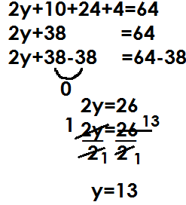 **Solution**

(c) How many pupils like math?

**Solution**

n(m) = 2y+10

= (2x13) +10

= 26+10

= 36

(d) Find the probability of picking a pupil who likes only one subject.

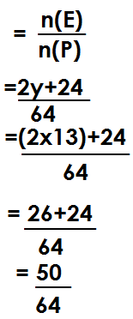 **Solution**

Prob

**ACTIVITY**

1. In a village of 42 farmers, 20 farmers grow maize (M), y farmers grow beans (B) only and 6 farmers grow both while 2 farmers do not grow any.

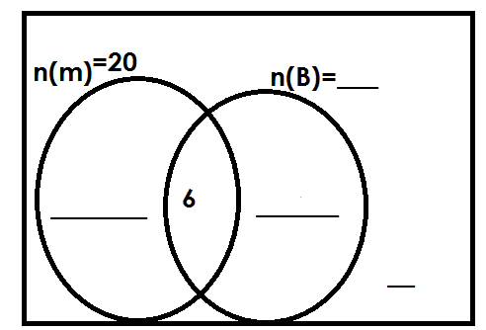(a) Complete the Venn diagram.

(b) Find the value of y.

(c) How many farmers grow only one crop?

(d) Find the probability of picking a farmer who grows beans from the village.

2. In a class of 48 pupils, 18 like Matooke(M) only. K like Posho (P) only, 12 like both Matoke and Posho while 3 pupils do not like any of the two.

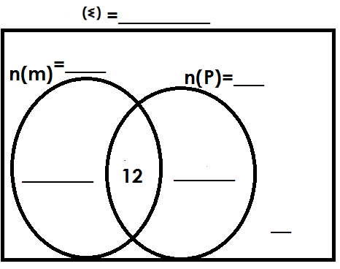(a) Complete the Venn diagram below.

(b) Find the value of K

(c) How many pupils like only one type of food?

(d) Find the probability of selecting a pupil at random who likes both matooke and posho to be the class captain.

3. In a village of 54 people, 2p grow crops(C) only, 40 people rear animals (A), 10people grow crops and rear animals, while 4 people do not do either.

(a) Complete the Venn diagram below

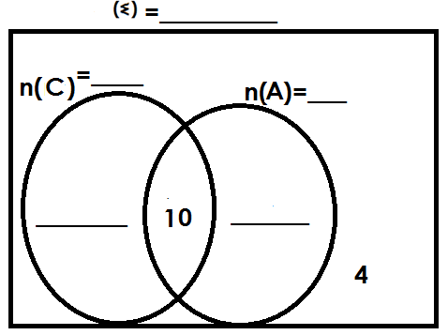

(b) Find the value of P

(c) If a person is picked at random, what is he chance that a person picked grows?

(i) Both crops

(ii) One crop only.

4. The Venn diagram below represents a class of 56 pupils. Given that 26 pupils like SST (S), (2m+4) pupils like RE (R) only, 8 pupils like both subjects and 4 pupils do not like either.

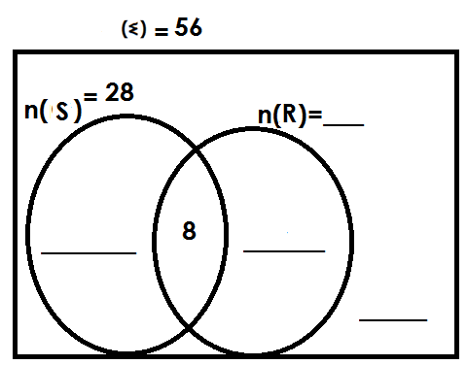(a) Complete the Venn diagram

(b) Find the value of m.

(c) How many pupils like one subject only?

**NUMERATION SYSTEMS AND PLACE VALUES**

**PLACE VALUES AND VALUES OF WHOLE NUMBERS**

**PLACE VALUE**

Place value is the position of a given digit in a given numeral.

Place values of whole digits end in letter “s”

Find the place value of each digit in the following

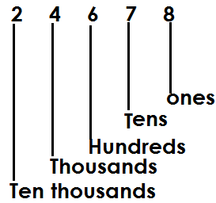a)

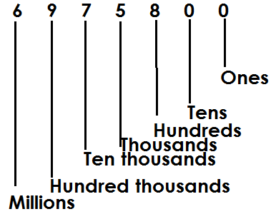b). 6975800

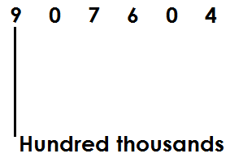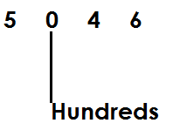Finding the value of the underlined digits in the above numerals

(a) (b)

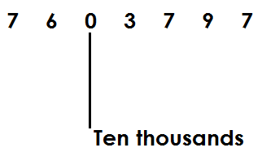

(c)

**Activity**

1. Find the place value of each digit in the following

(a) 3467 (b) 907076 (c) 30464 (d) 9076036

2. Find the place value of the underlined digits.

(a) 904 (b) 6706 (c) 30467

(d) 907,632 (c) 1,036,011

**FINDING VALUES OF WHOLE NUMBERS IN GIVEN NUMERAL**

A value is how manyness of a given digit in a given numeral.

Value is got by multiplying a digit by is place value.

Value = digit x place value.

1. Find the value of each digit in the following.

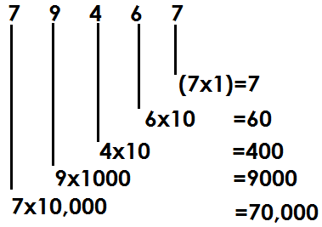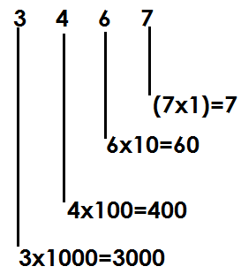a) b)

3. Find the value of digit 5 in the number

23568

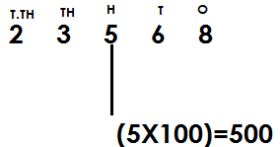**Solution**

**ACTIVITY**

1. Find the value of each digit in the following numbers

(a) 423 (b) 6834

(c) 20168 (d) 24019

2. Find the value of underlined digits in the following numbers.

(a) 463 (b) 2018 (c) 13249

3. Find the value of digit 4in 3456.

**FINDING SUM, DIFFERENCE, PRODUCT AND QUOTIENT OF DIGITS IN A GIVEN NUMBER.**

**Sum**- the answer got after adding the given numbers.

**Difference**- the answer obtained after subtracting

**Product**- the result of multiplication

**Quotient**- the result of division.

**Examples**

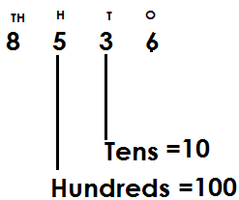1. Given the number 8536. Find the sum of the place value of 3 and place value of 5

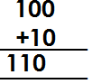 **Sum =**

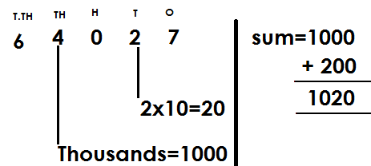2. What is the sum of the place value of 4 and the value of 2 in 64027?

3. Find the difference between the place value of 8 and the value of 6 in 8067.

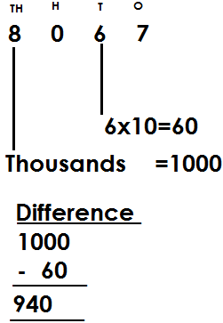 **Solution**

4. Find the product of the place value of 5 and the value of 2 in the number 4563.

**Solution**

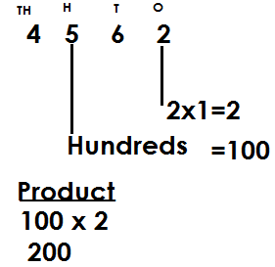

5. Find the quotient of the place value of 5 and the value of 2 in 75820.

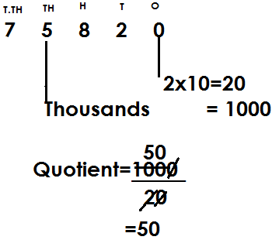 **Solution**

**ACTIVITY**

1. Given 4635. Find the sum of a place value of 4 and place of 3.

2. Find the sum of the value of 6 and value of 4 in 93461.

3. Find the difference between the place value of 8 and the value of 5 in 8057.

4. What is the difference between the value of 3 and the place value of 4 in 7324?

5. Find the product of the place value of 2 and the value of 3 in 42673?

6. Given the number 97265, find the quotient of the value of 7 and 5.

7. Given the number 8536, find the product of a place value of 3 and place value of

**EXPANDING WHOLE NUMBERS**

Whole numbers are expanded in three ways.

1. Using place values

2. Using value

3. Using powers/indices/exponents

**Examples**

1. Expand 208 using place values

**Solution**

= (2x100) + (0x10) + (8x1)

2. Expand 439 using values

 **Solution**

= (4x100) + (3x10) + (9x1)

= 400 + 30 + 9

3. Expand 650 using exponents

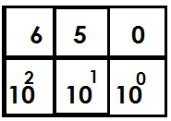 **Solution**

= (6x102) + (5x101) + (0x100)

**Activity**

1. Expand the following numbers using place values

(a) 432 (b) 1068 (c) 4674

2. Expand the following numbers using values

(a) 68 (b) 468 (c) 2074

3. Expand the following numbers using exponents

(a) 146 (b) 4023 (c) 1742

**DECIMAL NUMBERS**

These are numbers with a decimal point and decimal places.

**Note**

Decimals are also fractions whose denominators are multiples of ten.

Examples of decimals

2.356 , 0.04, 0.4, 346.9

**Illustration**

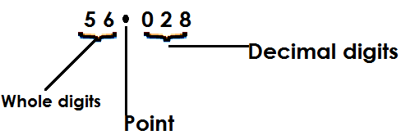 Given 56.028

* To the left of a decimal point, there are whole numbers and to the right, there are decimal numbers (fractions)
* Decimal places are the number of digits after a decimal point.

**Place values of decimal digits**

These include;

(i) Tenths

(ii) Hundredths

(iii) Thousandths

(iv) Ten thousandths

(v) Hundred thousandths

**Note**

(i) Decimal place values end in letters “ths.”

(ii) Decimal place values are given and written from left to right.

**Example**

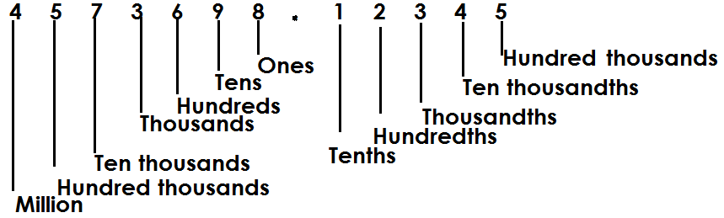1. Identify the place value of each digit in the umber 4573698.12345

2. Find the place value of 2 in 87.629

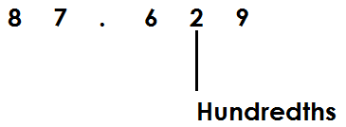 **Solution**

3. What is the place value of the underlined digit in 45.168

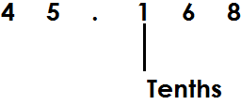 **Solution**

**Activity**

1. What is the place value of 0 in 4.506?

2. Name the place value of 6 in 962.8

3. What is the place value of the underlined digits in the following?

(a) 0.375 (b) 45.168 (c) 8.9753 (d) 0.0009 (e) 0.1235

**VALUES OF DECIMAL DIGITS**

**Note:**

A value is a product of a digit and its place value

i.e.

**GUIDING TABLE**

|  |  |
| --- | --- |
| **Words** | **Figures** |
| Tenths | $$1/{10}$$ |
| Hundredths | $$1/{100}$$ |
| Thousandths | $$1/{1000}$$ |
| Ten thousandths | $$1/{10000}$$ |
| Hundred thousandths | $$1/{100000}$$ |

**Examples**

1. Find the value of 4 in 0.341

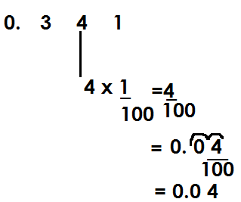 **Solution**

2. Find the value of the underlined digit in the number 0. 0 4 7

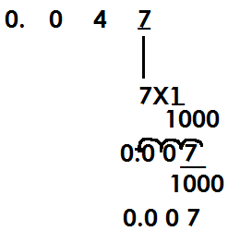 **Solution**

**Activity**

1. Find the value of 2 in 0.234

2. Find the value of the underlined digits in the following:

(a) 12.64 (b) 6.02

(c) 123.681 (d) 43.56

(e) 124.586 (f) 0.0086

(g) 6842.3579 (h) 14.6

**FINDING SUM, DIFFERENCE, PRODUCT AND QUOTIENT OF DIGITS IN GIVEN NUMBERS.**

**Examples**

1. Find the sum of the values of 2 and 3 in 0.342

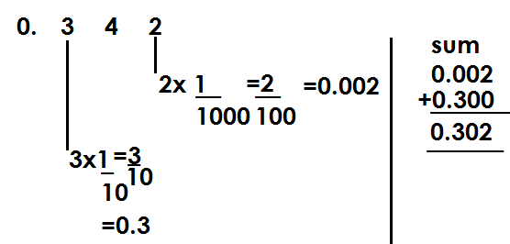 **Solution**

2. Find the difference between the values of 4 and 7 in 24.067

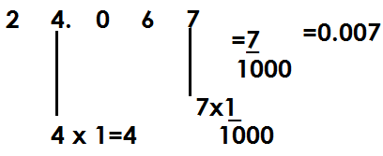 **Solution**

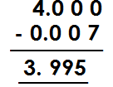**Difference**

3. Find the quotient of the values of 2 and 4 in the number 12.4

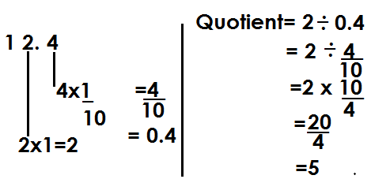 **Solution**

**Activity**

1. Find the sum of the values of 4 and 3 in 0.463

2. Find the sum of the values of 3 and 6 in 73.26

3. Find the difference of the values of 4 and 7 in 24.067.

4. Find the difference of the values of 5 and 4 in 75.649

5. Find the product of the values of 2 and 4 in 12.4.

6. Find the quotient for the values of 4 and 2 in 14.2

7. Find the sum of the values of 3 and 6 in 73.26.

**EXPANDING DECIMAL NUMBERS**

Decimal numbers are expanded using:

(a) Place values

(b) Values

(c) powers/exponents/indices

**Expanding decimal numbers using place values**

**Examples**

Using place values, expand the following

(a) 0.739

**Solution**

(0x1) + (7 x $\frac{1}{10}$) + (3 x $\frac{1}{100}$) + (9 x $\frac{1}{1000}$)

(b) 0.08

**Solution**

(0x1) + (0 x $\frac{1}{10}$) + (8 x $\frac{1}{100}$)

(c) 123.456

**Solution**

(1x100) +2x10+ (3x1) +4x $\frac{1}{10}$) + (5X $\frac{1}{100}$) + (6x $\frac{1}{1000}$)

(d) 208.763

**Solution**

(2x100) + (0x10) + (8x1) + (7x $\frac{1}{10}$) + (6x $\frac{1}{100}$) + (3x $\frac{1}{1000}$)

(e) 9.457

**Solution**

(9x1) + (4x $\frac{1}{10}$) + (5x $\frac{1}{100}$) + (7x $\frac{1}{1000}$)

**Activity**

1. Expand 2.43 using place values.

2. Express 69.241 in expanded form using place values.

3. Expand the following using place values

(a) 0.034 (b) 342.52 (c) 97.304 (d) 402.347

**Expanding decimal numbers using values.**

**Examples**

1. Expand 34.6 using values

34.6

**Solution**

= (3x10) + (4x1) + (6x $\frac{1}{10}$)

= 30 + 4 +

= 30 + 4 + 0.6

2. 69.23

**Solution**

69.23

= (6x10) + (9x1) + (2x $\frac{1}{10}$) + (3x $\frac{1}{100}$)

= 60+9+0.2+0.03

3. 7.864

**Solution**

= 7. 864

= 7 x 1 + + +

= 7 + 0.8 + 0.06 + 0.04

4. 0.063

**Solution**

0.063

= (0x1) + $\frac{0}{10}$ + $\frac{6}{100}$ + $\frac{3}{1000}$

= 0 + 0 + 0.06 + 0.003

**ACTIVITY**

**Expand the following decimal numbers using values.**

1. 4038.12

2. 0.32

3. 39.764

4. 2.3

5. 0.009

6. 72.63

**Expanding numbers using exponents/powers**

**Examples**

1. Expand 49.35 using powers.

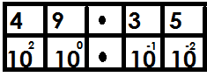 49.35

= (4x102) + (9x100) + (3x10-1) + (5x10-2)

2. 184.009

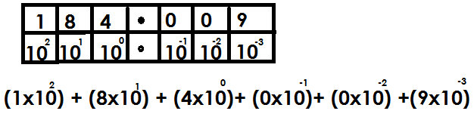

**Activity**

Express the following decimal numbers in expanded form using exponents.

1. 0.576

2. 159.38

3. 0.0008

4. 400.002

5. 2018.2019

6. 44.0782

7. 67.07

**WRITING EXPANDED DECIMALS AS SINGLE NUMBERS**

**Note:**

A given expanded decimal number is again expanded up to value form and later values obtained are added to get a single expanded number

**Examples**

1. Which numbers were expanded to give the following?

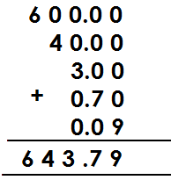(a) 660+40+3+0.7+0.09

b) 700+5+0.08

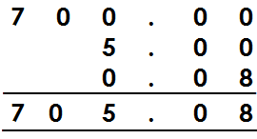 **Solution**

c) (4x10) + (3x1) + (8x $\frac{1}{10}$) + (5x $\frac{1}{100}$)

= 40 + 3 + $\frac{8}{10}$ + $\frac{1}{100}$

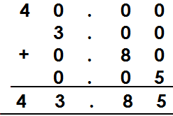= 40+3+0.8+0.05

d) (3x100) + (7x1) + (2x $\frac{1}{10}$) + (9x $\frac{1}{100}$)

**Solution**

= 300+7+ $\frac{2}{10}$ + $\frac{9}{100}$

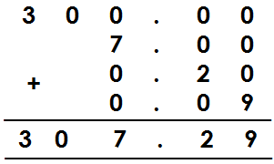= 300+7+0.2+0.09

e) (4x10) + (8x $\frac{1}{10}$) + (0x $\frac{1}{100}$) + (9x $\frac{1}{1000}$)

Solution

= 40+ $\frac{8}{10}$ + $\frac{0}{100}$ + $\frac{9}{1000}$

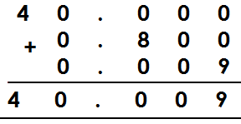= 40+0.8+0+0.009

**Activity**

Which numbers have been expanded to give?

1. 70+1+0.3+0.01

2. 900+30+8+0.5+0.06+0.007

3. 80+0.08+0.003

4. (1x100) + (4x10) + (3x1) + (6x) + (7x)

5. (4x1000) + (0x100) + (8x1) + (1x) + (2x) + (6x)

6. (0x1) + (0x) + (0x) + (9x)

7. (3x100) + (9x10) + (4x $\frac{1}{100}$) + (7x $\frac{1}{1000}$)

**MORE ABOUT WRITING EXPANDED DECIMALS AS A SINGLE NUMBER**

**Examples**

1. Which number was expanded to give the following?

(a)

Solution

(3x10x10) + (5x10) + (4x1) + (8x $\frac{1}{10}$)

300+50+4+ $\frac{8}{10}$

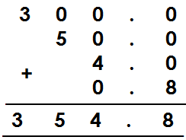 300+50+4+0.8

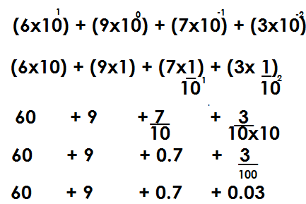(b)

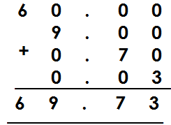

**Activity**

 Which number was expanded to give the following?

1.

2.

3.

4.



5.

**ROUNDING OFF OF WHOLE NUMBERS**

**Note:**

Rounding off is a way of approximating numbers to the required place values.

**ROUNDING OFF WHOLE NUMBERS**

* In rounding off, base on the digit on the right of the figure in the required place value to either roundup or round down.
* Round down in case the digit on the right of the figure in the required place value is either,0,1,2,3, or 4 by adding 0 to the digit in the required place value.
* Roundup in case the digit on the right of the figure in the required place value is either 5, 6, 7, 8, or 9 by adding the value of the digit in the required place value.
* All digits coming on the right of the digit in the required place value will turn into zero (0) when rounding off of whole numbers.

**Examples**

1. Round off 24643 to the nearest hundreds.

Tth Th H T O

2 4 6 44 3

0

2 4 6 0 0

 24643 24600

2. Round off 4867 to the nearest thousands

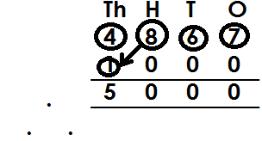 **Solution**

4867 5000

3. Round off 75 the nearest hundreds

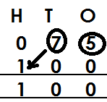 **Solution**

75

75 $≈$ 100

**Activity**

1. Round off to the nearest tens

(a) 24 (b) 337 (c) 4689 (d) 214

2. Round off to the nearest hundreds

(a) 263 (b) 586 (c) 1721 (d) 9296

3. Round off to the nearest thousands

(a) 8634 (b) 1945 (c) 57389 (d) 8634

**ROUNDING OFF DECIMAL NUMBERS**

**Note: -**

While rounding off decimals, all digits coming after the figure in the required place value are crossed out. I.e. the last digit must be in the mentioned place value.

Rounding off to the nearest whole numbers means to round off to the place value of ones.

Rounding off to one decimal place means to the place value of tenths.

Rounding off to two decimal places means to the place value of hundredths.

Rounding off to three decimal places means to the place value of thousandths.

**Examples**

Round off 39.45 to the nearest tenths

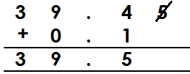

 39.45 $≈$ 39.5

Correct 97.656 to 1 decimal place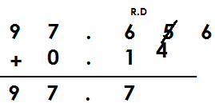

97.656 $≈$ 97.7

Round off 89.996 to the nearest hundredths

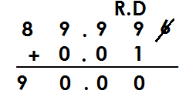



89.99 $≈$ 90.00

Round off 99.8907 to two decimal places

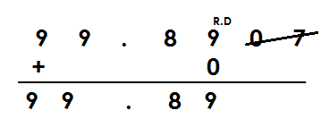**Solution**

99.8907 $≈$ 99.89

**Example 4**

Round off 99.46 to the nearest whole number

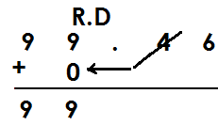 **Solution**

99.46 $≈$ 99

Round off 599.657 to the nearest whole number

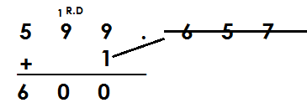 **Solution**



599.657 $≈$ 600

**Activity**

1. Round off the following to one decimal place

(a) 54.67 (b) 503.906 (c) 576.96 (d) 709.63

2. Round off the following to the nearest tenths

(a) 907.63 (b) 123.99 (c) 54.076

3. Round off the following to the nearest hundredths

(a) 40.986 (b) 49.586 (c) 50.764

4. Round off 69.465 to 2 decimal places

5. Round off 909.3976 to the nearest thousandths.

**WRITING NUMBERS IN STANDARD FORM/SCIENTIFIC NOTATION**

Standard form is a way of expressing numbers as a product of powers of ten leaving one counting digit in the places of whole.

The number of steps moved by a decimal point will determine the size of powers.

If a decimal point moves taking a left direction, a positive power is obtained.

If a decimal point moves taking the right direction, a negative power is obtained.

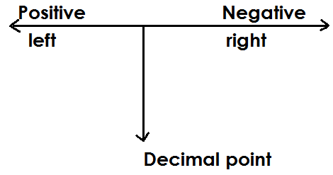 **Illustration**

**Example 1**

Write 843 in scientific notation

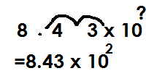 **Solution**

843=

**Example2**

Write 96.3 in standard form

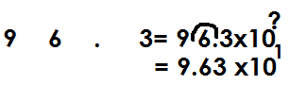 **Solution**

96.3=

**Example 3**

Write 4676.16 in scientific form

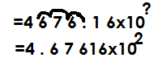 **Solution**

4676.16=

**Example 4**

Express 0.246 in standard form.

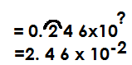 **Solution**

0.246=

Express 0.00478 in scientific notation

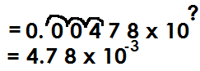 **Solution**

0.00478=

Express 420000 in scientific notation

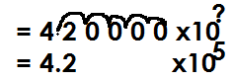**Solution**

420000=

Express 4.9 in standard form

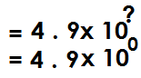**Solution**

4.9

**Activity**

1. Express following in standard form

(a) 423 (b) 3967 (c) 497.3

(d) 97.04 (e) 9.6 (f) 560000

2. Write the following in standard form

(a) 0.96 (b) 0.09 (c) 0.00789

(d) 0.0499 (e) 0.008637

**FINDING ORIGINAL NUMBERS THAT WERE WRITTEN IN STANDARD FORM**

**Example 1**

Find the number that was written in standard form to give 8.73x102?

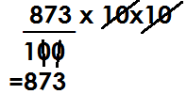 **Solution**

8.73x102 =

**Example 2**

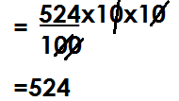Which number was written in standard form to give 5.24x102?

5.24x102

Find the number that was written in standard form to give 9.6x10-2

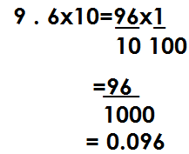**Solution**

Find the original number that was written inn scientific form to give 6x106?

**Solution**

6x106 = 6 x10x10x10x10x10x10

= 6x1000000

= 6000000

**Example 4**

Which number was written in standard form to give 6.234x10-5

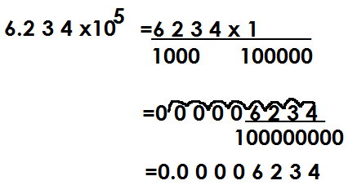**Solution**

**Activity**

1. Find the number that was written in standard for to give

(a) 4.7x102 (b) 5.4 x103 (c) 5.678 x105

(d) 6.04x103 (e) 7.1x104

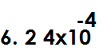2. Which numbers were written in scientific form to given the following?

(a) (b) (c) (d)



(e) (f)

**TYPES OF NUMERALS**

1. Hindu Arabic numerals

2. Roman numerals

**Hindu Arabic numerals**

These are numerals that are used in most parts of the world.

**Major Hindu Arabic numerals**

0,1,2,3,4,5,6,7,8,9

**ROMAN NUMERALS**

1. **Basic Roman numerals**

|  |  |  |  |  |  |  |  |
| --- | --- | --- | --- | --- | --- | --- | --- |
| Hindu Arabic | 1 | 5 | 10 | 50 | 100 | 500 | 1000 |
| Roman numerals | I | V | X | L | C | D | M |

**NOTE:**

* All roman numerals should be written in capital letters.
* All types of Roman numerals are derived from basic Roman numerals.

**2.** **Repeated roman numerals**

They are got by repeating some basic Roman numerals like I, X, C and M

Repeated roman numerals act on digits 2 and 3 in place values of ones, tens, hundreds and thousands.

**(a)** **In the place value of ones**

2 - II

3 - III

**(b) In the place value of tens**

20 - XX

30 - XXX

**(c) In the place value of hundreds**

200 - CC

300 - CCC

**(d) In the place value of thousands**

2000-MM

3000-MMM

**3. Addition Roman numerals**

Addition Roman numerals use digits 6, 7 and 8 in the place values of ones, tens, hundreds.

**(a) In the place value of ones**

6 = 5+1

= VI

7 = 5 + 2

= VII

8 = 5+3

= VIII

**(b) In the place value of tens**

60 = 50 +10

= LX

70 = 50 + 20

= LXX

80 = 50 + 30

= LXXX

**(c) In the place value of hundreds**

600 = 500 +100

= DC

700 = 500 +100

= DCC

800 = 500 + 300

= DCCC

4. **SUBTRACTION ROMAN NUMERALS**

These uses digits 4 and 9 in the place values of ones, tens and hundreds.

(**a) In the place value of ones**

4 = 5 -1

= IV

9 = 10 - 1

= IX

**(b) In the place value of tens**

40 = 50 - 10

= XL

90 = 100 - 10

= XC

**(c) In the place values of hundreds**

400 = 500 - 100

= CD

900 = 1000 -100

= CM

**WRITING NUMBERS IN ROMAN NUMERALS**

1.Write 149 in roman numerals

|  |  |  |
| --- | --- | --- |
| 100 | 40 | 9 |
| C | XL | IX |

149 = CXLIX

2. Write the following in roman numerals

a) 38

|  |  |
| --- | --- |
| 30 | 8 |
| XXX | VIII |

38 = XXXVIII

b) 89

|  |  |
| --- | --- |
| 80 | 9 |
| LXXX | IX |

89 = LXXXIV

c) 499

|  |  |  |
| --- | --- | --- |
| 400 | 90 | 9 |
| CD | XC | IX |

499 = CDXCIX

d) 649

|  |  |  |
| --- | --- | --- |
| 600 | 4 | 9 |
| DC | XL | IX |

649 = DCXLIX

e) 782

|  |  |  |
| --- | --- | --- |
| 700 | 80 | 2 |
| DCC | LXXX | II |

782 = DCCLXXXII

**Activity**

Write the following in Roman numerals

(a) 49 (b) 36

(c) 29 (d) 69

(e) 326 (f) 99

(g) 436 (h) 223

(i) 648 (j) 562

(k) 888 (l) 1999

**Changing from Roman numerals to Hindu Arabic numerals**

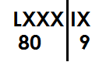1. Write LXXXIX in Hindu Arabic numerals

LXXXIX=

= 89

2. Write the following in Hindu Arabic numerals

|  |  |
| --- | --- |
| X | VIII |
| 10 | 8 |

(a) XVIII

XVIII = 18

b) DCVII

|  |  |
| --- | --- |
| DC | VII |
| 600 | 7 |

DCVII = 607

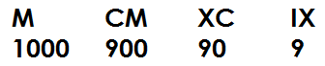(c) MCMXCIX=

1999

**Activity**

(a) XXXVI

(b) XCIV

(c) LVI

(d) CXXXVIII

(e) CDXCVIII

(f) CMXLIX

(g) MMCXI

(h) DCCCLXXXVIII

(j) MMMDCCCLXXXVIII

**WORD PROBLEMS INVOLVING HINDU ARABIC AND ROMAN NUMERALS**

**Examples**

1. Musa was born in 1996. Express his year of birth in roman numerals

|  |  |  |  |
| --- | --- | --- | --- |
| 10000 | 900 | 90 | 6 |
| M | CM | XC | VI |

1996 = MCMXCVI

2. Our teacher is 79 years old. Write his age in Roman numerals

|  |  |
| --- | --- |
| 70 | 9 |
| LXX | IX |

79 = LXXIX

3. Mugisha has CCXLIX animals on his farm. Write his number of animals in Hindu Arabic numerals

|  |  |  |
| --- | --- | --- |
| CC | XL | IX |
| 200 | 40 | 9 |

CCXLIX = 249 animals

4. Mukasa’s great grandfather died in MDCCCLXXXVIII. Write his year of death in Hindu Arabic numerals

|  |  |  |  |
| --- | --- | --- | --- |
| M | DCCC | LXXX | VIII |
| 1000 | 800 | 80 | 8 |

MDCCCLXXXVIII = 1888

**Activity**

1. 2. It is 206km from Town A to town B. Write that distance in roman numerals.
2. Alex was born in 2007. Write his year of birth in roman numerals.
3. There are 108 English books and 73 science books in the library. Write the total number of books in the library.
4. A bag contains XXXIX oranges. Write the number of oranges in Hindu Arabic number.
5. A trader sold CMLXIII bags of cotton. Write the number of bags of cotton in Hindu Arabic numeral.
6. A shop keeper sold XXIV kg of sugar on Monday and LIII kg on Tuesday. Find the total number of kg sold in Hindu Arabic numerals.

**BASES**

A base is a counting system where a particular natural/counting number is taken to be the limit of its counting system.

**Base names**

|  |  |  |
| --- | --- | --- |
| **Base** | **Name** | **Digits used** |
| 2 | binary | 0,1 |
| 3 | Trinary/ternary | 0,1,2 |
| 4 | quaternary | 0,1,2,3 |
| 5 | quinary | 0,1,2,3,4 |
| 6 | senary | 0,1,2,3,4,5 |
| 7 | Septenary/ heptanol | 0,1,2,3,4,5,6 |
| 8 | octal | 0,1,2,3,4,5,6,7 |
| 9 | nonary | 0,1,2,3,4,5,6,7,8 |
| 10 | Decimal/Standard/Normal/Denary | 0,1,2,3,4,5,6,7,8,9 |

**PLACE VALUES OF BASE NUMBERS**

**N.B**: The starting place value of base numbers is ones.

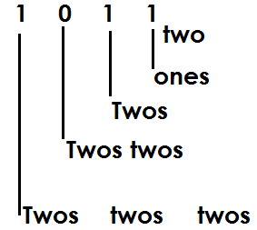1. Write the place value of each digit

a

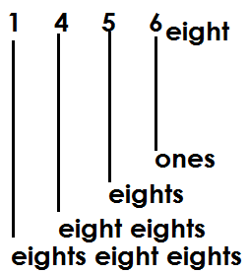b

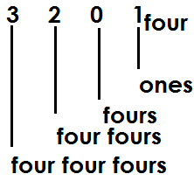c

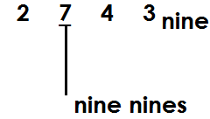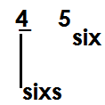Find the place value of the underlined digits.

(a) (b)

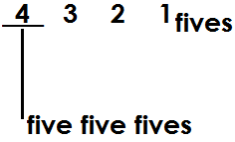(c)

**Activity**

1. Find the place value of each digit

(a) 101two (b) 231 four (c) 4031fives (d) 567 eight (e) 678 nine

2. Find the place value of the underlined digits.

(a) 203four (b) 4031five (c) 367 eight (d) 405 six

**Values of digits in base numbers**

A value is a product of a digit and its place value

Value of a digit = digit x place value

Find the value of 1 in 1000 two

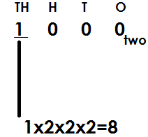 **Solution**

**Example 2**

Find the value of 1 in 100 two

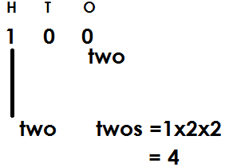 **Solution**

**Example3**

Find the value of 2 in 234 five

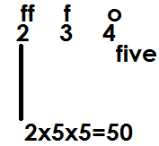 **Solution**

**Example 4**

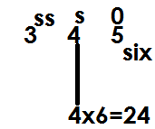Find the value of 4 in 345 six

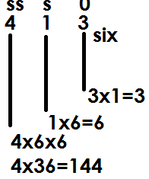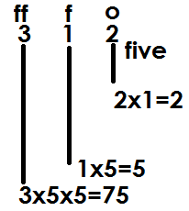Find the value of each digit

(a) (b)

**Activity**

1. Find the value of each digit

(a) 101two (b) 203three

(c) 402five (d) 121three

2. Find the value of the underlined

(a) 102three (b)101two

(c) 7203nine  1101two

**WRITING BASE NUMBERS IN WORDS**

**Note:** Base number digits are read and written independently (one by one) while the base is written last.

**Write the following in words**

1. 1010two

One zero one zero base two

2. 10001

One zero zero zero base two

3. 4302five

Four three zero two base five

4. 6254seven

Six two five four base seven

**Activity**

Write the following base numbers in words

(a) 1000two (b)11111two (c) 2022three (d)7654eight (e) 5454six

**EXPANDING BASE NUMBERS**

**Base numbers are expanded in three ways**

(i) Place values

(ii) Values

(iii) powers/exponents/indices

**Expanding base numbers using place values**

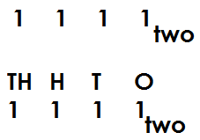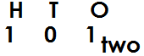Expand the following using place values

(a) (b)

(1x2x2) + (0x2) + (1x1)

(1x2x2x2) + (1x2x2) + (1x2) + (1x1)

(d) 567eight

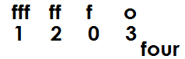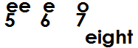(c)

(1x4x4x4) + (2x4x4) + (0x4) + (3x1) (5x8x8) + (6x8) + (7x1)

**Activity**

**Expand the following using place values**

(a) 234five (b) 101two (c) 4201five

(d) 465six (e) 17ten (f) 3102four

**Expanding base numbers using values**

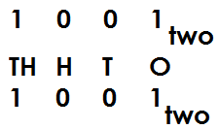Expand the following using values

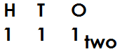(a) (b) 111two

(1x2x2) + (1x2) + (1x1)

(1x2x2x2) + (0x2x2) + (0x2) + (1x1) 4+2+1

8+0+0+1

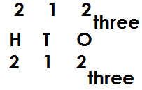 (d)

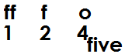(c) 124 five

= (2x3x3) + (1x3) + (2x1)

(1x5x5) + (2x5) + (4x1) 18+3+2

25+ 10+ 4

**Activity**

1. Expand the following base numbers using values

(a) 1010 two (b) 1011two

(c) 10001two (d) 203 four

(e) 103 four (f) 120three

(g) 134five (h) 2231five

(i) 1003five  (j) 435six

**EXPANDING BASE NUMBERS USING POWERS/INDICES/EXPONENTS**

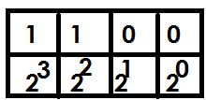1. Expand 1100two using powers.

(1x23) + (1x22) + (0x21) + (0x20)

2. **Expand the following using powers**

(a) 214 five

(b) 102 three

|  |  |  |
| --- | --- | --- |
| 2 | 1 | 4 |
| 55 | 51 | 50 |

|  |  |  |
| --- | --- | --- |
| 1 | 0 | 2 |
| 33 | 31 | 30 |

= (2x52) + (1x51) + (4x50) = (1x32) + (0x31) + (2x30)

|  |  |  |
| --- | --- | --- |
| 1 | 7 | 5 |
| 102 | 101 | 100 |

(c) 175 ten (d) 46 eight

|  |  |
| --- | --- |
| 4 | 6 |
| 81 | 80 |

= (1x102) + (7x101) + (5x100) = (4x81) + (6x80)

**Activity**

1. Expand the following base numbers using powers

(a) 1111two (b) 1001two (c) 1000two

(d) 3012four (e) 212three (f) 5312seven

(g) 43 six (h) 6735nine (i) 257ten

(j) 1010ten

**CONVERSION OF BASE NUMBERS**

**Note:**

Base numbers are converted from;

(a) Base ten/decimal base to other bases/non-decimal bases

(b) Other bases/non-decimal bases to base ten/decimal bases.

(c) Other bases/non-decimal bases t other bases/non-decimal bases.

1. Change 29ten to binary base

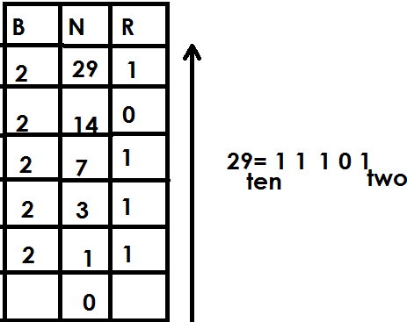

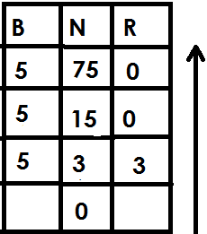2. Change 75ten to quinary base

75ten=300five

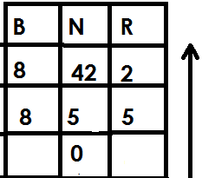3. Babirye scored 42 in a test. Express her marks in octal base

42ten=52 eight

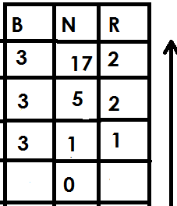4. Mukasa is 17 years old. Write his age in trinary base

17ten=122three

**Activity**

1. Change the following base numbers to the required base

(a) 23ten to binary base

(b) 49ten to binary base

(c) 29ten to base three

(d) 45ten to quinary base

(e) 9ten to ternary base.

(f) 31ten to base four

2. Alex is 19yeaers old. Write his age in binary base.

3. A girl scored 63 marks in a test. Express her mark in nonary base.

4. The teacher is 28years. Write his age in base four.

5. Makanga was born in 2000. Write his year of birth to quinary base system.

**Changing non-decimal base numbers to decimal base**

**Note**

Here we expand a non-decimal base number using powers of the given non-decimal base number

1. Change 1001two to decimal base

|  |  |  |  |
| --- | --- | --- | --- |
| 1 | 0 | 0 | 1 |
| 23 | 22 | 21 | 20 |

= (1x23) + (0x22) + (0x21) + (1x20)

= (1x2x2x2) + (0x2x2) + (0x2) + (1x1)

= 8+0+0+1

= 9ten

2. Change 132five to base ten

|  |  |  |
| --- | --- | --- |
| 1 | 3 | 25 |
| 52 | 51 | 50 |

= (1x52) + (3x51) + (2x50)

= (1x5x5) + (3x5) + (2x1)

= 25+15+2

= 42ten

3. Express 1122three as a decimal base number

|  |  |  |  |
| --- | --- | --- | --- |
| 1 | 1 | 2 | 2 |
| 33 | 32 | 31 | 33 |

= (1x33) + (1x32) + (2x31) + (2x30)

= (1x3x3x3) + (1x3x3) + (2x3) + (2x1)

= 27+9+6+2

= 44ten

**Activity**

1. Change the following non-decimal base numbers to decimal base.

(a) 1111two (b) 1010two (c) 1011two (d) 1100two (e) 1000two

(f) 202 three (g) 123 four (h) 210six (i) 143five (j) 1012five

**CHANGING NON-DECIMAL BASE NUMBERS TO NON-DECIMAL BASE NUMBERS**

**Note:**

First change a non-decimal base number to base ten by expanding then after to the required base by dividing

**Examples**

1. Change 110two to base three

|  |  |  |
| --- | --- | --- |
| 1 | 1 | 0 |
| 22 | 21 | 20 |

= (1X22) + (1X21) + (0X20)

= (1X2X2) + (1X2) + (0X1)

= 4+2+0

= 6ten

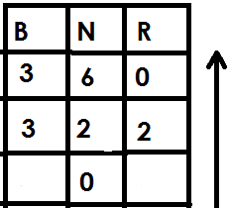

110two = 20three

2. Change 1111two to quinary base.

(1x23) + (1x22) + (1x21) + (1x20)

(1x2x2x2) +1x2x2) + (1x2) + (1x1)

8+4+2+1

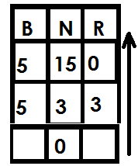15ten

1111two=30five

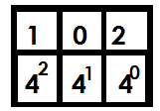3. Change 102four to binary base

(1x42) + (0x41) + (0x40)

(1x4x4) + (0x4) + (0x1)

16+0+1

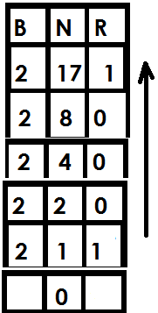17ten

102four=10001two

**Activity**

1. Change the following to the required bases

(a) 1001two to base four

(b) 1000two to base three

(c) 1010two to quinary base

(d) 122three to binary base

(e) 102four to base three

(f) 300four to base five

**FINDING UNKNOWN BASE**

**Examples**

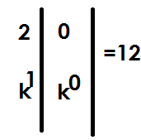1. Find the unknown base in 20k=12ten

(2xk1) + (0xk0) =12

(2xk) + (0x1) =12

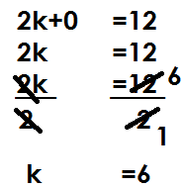

The unknown base is senary.

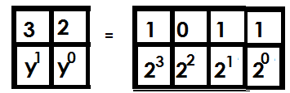2. Find the unknown base if 32y=1011two

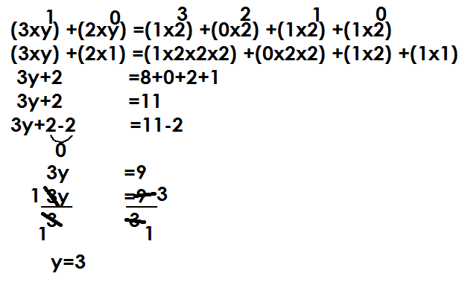

The unknown base is Trinary.

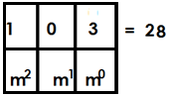3. Find the unknown base if 103m=28

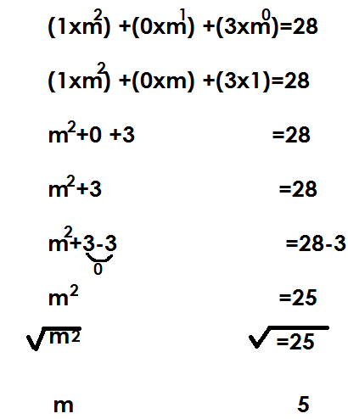

The unknown base is Quinary.

4. If 203k =1222three, find the unknown base

|  |  |  |
| --- | --- | --- |
| 2 | 0 | 3 |
| K2 | K1 | K0 |

|  |  |  |  |
| --- | --- | --- | --- |
| 1 | 2 | 2 | 2 |
| 33 | 32 | 31 | 30 |

=

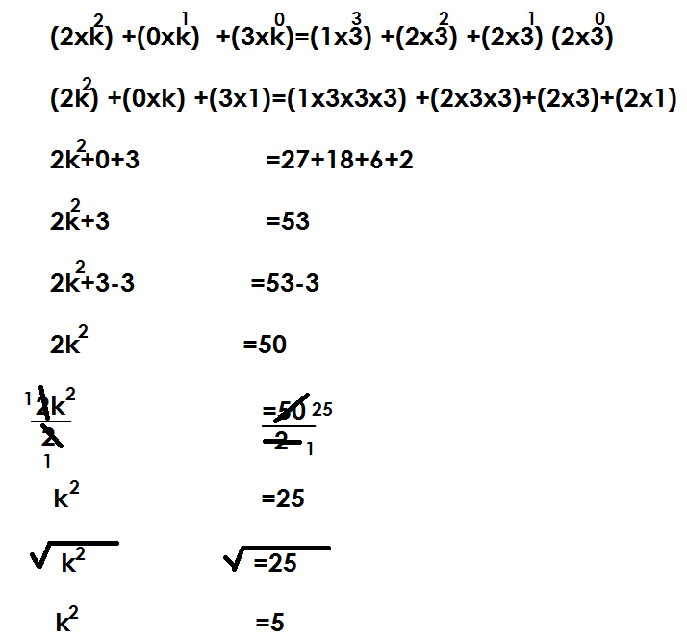

The unknown base is Quinary.

**Activity**

1. Find the unknown bases in the following given that;

(a) 23m=11 (b) 34y=25

(c) 46n=18ten (d) 20k=20three

(e) 50p=30five (f) 102k=1000three

(g) 103x=213four (h) 202k=110100two

(i) 203p=2210three

**ADDITION OF BASE NUMBERS**

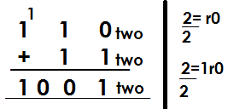1. Add: 110two+11two

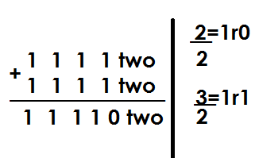2. Add: 1111two+1111two

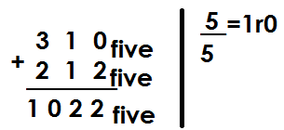3. Workout: 310five+212five

**Activity**

1. Add the following

(a) 1000two + 101two (b) 1100two+ 111two

(c) 1111two +1011two (d) 222three +122three

(e) 413five+321five  (f) 1332four+233four

**SUBTRACTION OF BASES**

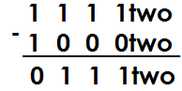1. Subtract: 1111two-1000two

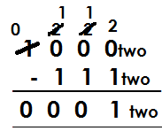2. Workout: 1000two-111two

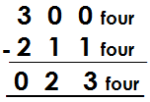3. Workout: 300four-211four

**Activity**

1. Workout the following: -

(a) 1011two-110two (b) 1010two-101two

(c) 202three-21three (d) 321four-132three

(e) 403five-344three (f) 342five-123five

(g) 1000two-111two

**MULTIPLICATION OF BASES**

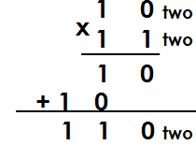1. Multiply: 10twox11two

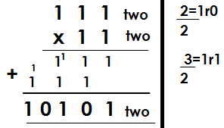2. Workout: 111two x 1 1two

3. Workout: 202three x 12three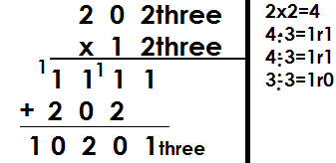

5. Workout: 312four x 32 four

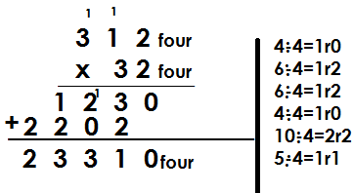4. Multiply: 142five x 43five **solution**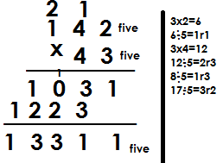

**Activity**

1. Workout the following

(a) 1101two x 11 two (b) 202three x12 three (c) 142five x 32 five

(d) 43 six x 23 six (e) 214 six x 23 six

**DIVISION OF BASES**

**Note:**

* Change the non-decimal bases to decimal bases
* Divide numbers in base ten
* Change the quotient in the given base.

1. Workout the following

(a) 103nine $÷$ 15 nine

|  |  |  |
| --- | --- | --- |
| 1 | 0 | 3 |
| 92 | 91 | 90 |

|  |  |
| --- | --- |
| 1 | 5 |
| 91 | 90 |

÷

(1x92) + (0x91) + (3x90) ÷ (1x91) + (5x90)

(1x9x9)+ (0x9) + (3x1) ÷ (1x9) + (5x1)

81+0+3 ÷ 9+5

84 ÷ 14

6ten

Therefore 103nine ÷ 15nine= 6 nine

(b) Workout: 220eight ÷ 14 eight

|  |  |  |
| --- | --- | --- |
| 2 | 2 | 0 |
| 82 | 81 | 80 |

|  |  |
| --- | --- |
| 1 | 4 |
| 81 | 80 |

÷

(2x82) + (2x81) + (0x80) ÷ (1x81) + (4x80)

(2x8x8) + (2x8) + (0x1) ÷ (1x8) + (4x1)

2x64+16+0 ÷ 8+4

128+16+0 ÷ 12

144 ÷ 12

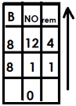 12ten

220 eight ÷ 14 eight=14 eight

Workout: 144five $÷$ 12 five

|  |  |
| --- | --- |
| 1 | 2 |
| 51 | 50 |

|  |  |  |
| --- | --- | --- |
| 1 | 4 | 4 |
| 52 | 51 | 50 |

÷

= (1x52) + (4x51) + (4x5) ÷ (1x51) + (2x50)

= (1x5x5) + (4x5) + (4x1) ÷ (1x5) + (2x1)

= 25+20+4 ÷ 5+2

= 49 ÷ 7

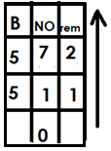= 7ten

Therefore 144 five ÷ 12 five=12 five

Workout: 124six ÷ 21 six

|  |  |  |
| --- | --- | --- |
| 1 | 2 | 4 |
| 62 | 61 | 60 |

|  |  |
| --- | --- |
| 2 | 1 |
| 62 | 61 |

÷

= (1x62) + (2x61) + (4x60) ÷ (2x61) + (1x60)

= (1x6x6) + (2x6) + (4x1) ÷ (2x6) +1x1)

= 36+12+4 ÷ 12+1

= 52 ÷ 13

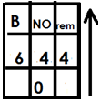= 4ten

4six

**Activity**

1. Workout: 204six ÷ 11five

2. Workout: 330four ÷ 30five

3. Workout: 44five ÷ 111 five

4. Divide 231six ÷ 21six

**NUMBER PATTERNS AND SEQUENCE**

**DIVISIBILITY TEST FOR TWO**

A number is divisible by two if its last digit is even i.e. 0, 2, 4, 6 or 8

**Example1**

Given 321, 2225,661 and 312. Identify a number that is divisible by 2

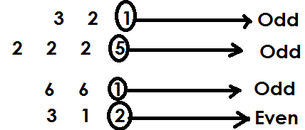 **Solution**

Therefore 312 is divisible by 2 since its last digit is even.

**DIVISIBILITY FOR 3**

A number is divisible by 3 if the sum of its digits is a multiple of 3.

**Example 1**

Given the following numbers, identify a number that is divisible by 3 in

125, 241 and 426

125 sum

1+2+5

8

141 sum

2+4+1

7

426 sum

4+2+6

12

426 is divisible by 3 since the sum of its digit is a multiple of 3.

State whether 111 is divisible by 3

**Solution**

111 sum

= 1+1+1

= 3

Therefore 111 is divisible by 3 since the sum of its digits is a multiple of 3

State whether 241 is divisible by 3

**Solution**

241 sum

= 2+4+1

= 7

Therefore 241 is not divisible by 3 since the sum of its digits is not a multiple of 3.

**Activity.**

1. By showing the working, identify numbers divisible by 3

(a) 236 (b) 245 (c) 462 (d) 4659

2. Given 101, 100, 111 and 110. Without dividing, identify a number which is exactly divisible by 3

**DIVISIBILITY TEST FOR 4**

A number is divisible by 4 if it is even and the number formed by its last two digits is a multiple of 4 or last two digits are (00)

State whether 236 is divisible by 4

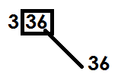 **Solution**

Therefore 336 is divisible by 4 since the number formed by its last two digits is a multiple of 4.

State whether 111112 is divisible by 4

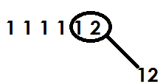 **Solution**

Therefore 111112 is divisible by 4 since the number formed by its last two digits is a multiple of 4

**Example3**

State whether 234 is a multiple by 4

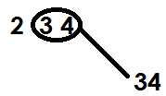 **Solution**

Therefore 234 is not divisible by 4 since the number formed by tits last two digits is a not a multiple of 4.

**Activity.**

State whether the following are divisible by 4

(a) 144 (b) 512 (c) 9444 (d) 568

Without dividing, identify the numbers that are exactly divisible by 4 from:

62748, 10018, 232332 and 97658

**DIVISIBILITY TEST FOR 5**

A number is divisible by 5 if its last digit is 5 or 0

Given the following numbers, 556,104 and 205. Which number is divisible by 5?

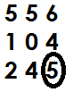 **Solution**

Therefore 245 is divisible by 5 since its last digit is 5

Which of the numbers below is exactly divisible by 5

503, 155,200 and 107

155 and 200 ends in either 0 or 5 and are divisible by 5.

**Activity**

Without dividing, identify numbers that are exactly divisible by 5 by the following.

(a) 15,27,30,38 and 45

(b) 1115, 5504 and 1053

**DIVISIBILITY TEST FOR 6**

A number is divisible by 6 if it is even and also divisible by 3

1. State whether 426 is divisible by 6.

**Solution**

4+2+6=12

Therefore 426 is divisible by 6 since it is divisible by 2 and 3

2. State whether 576 is divisible by 6

**Solution**

576----5+7+6

18

576 is divisible by 6 since it is divisible by 2 and 3.

3. State whether 646 is divisible by6

646

**Solution**

646 = 6+4+6

= 16

16 is not a multiple or 3.

Therefore 646 is not divisible by 6 since it’s not divisible by 3.

**Activity**

State whether the following numbers are divisible by 6

(a) 936 (b) 463 (c) 12462 (d) 963 (e) 612 (f) 113

**DIVISIBILITY TESTS FOR 7**

A number is divisible by 7 when the last digit of a number is doubled and the result is subtracted from the number formed by the remaining digits and the outcome is divisible by 7.

1. State whether 861 is divisible by 7

**Solution**

861

1+1=2

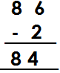

4+4=8

8-8=0

0 is divisible by 7 hence 861 is divisible by 7

2. Find whether 1792 is divisible by7

1792

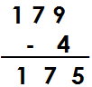 2+2=4

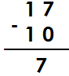 175 ----------5+5=10

7 is divisible by 7 hence 1792 is exactly divisible by 7.

3. State whether 246 is divisible by 7

246

6+6=12

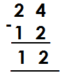

12 is not divisible by 7 hence 246 is not divisible by 7.

4. Find whether 7962 is exactly divisible by 7

7962 792

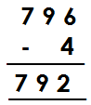 2+2=4 2+2=4

75 is not divisible by 7 hence 7962 is not divisible by 7 exactly.

**Activity**

State whether the following numbers are exactly divisible by 7

(a)105 (b) 133 (c) 686 (d) 8792

(e) 227955 (f) 18648 (g) 2864

(h) 18649 (i) 182

**DIVISIBILITY TEST FOR 8**

A number is divisible by 8 if the number formed by the last three digits is divisible by 8

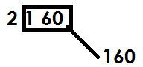1. State whether 2160 is divisible by8

160 is divisible by 8 hence 2160 is exactly divisible by8.

2. Find out whether 2080 is exactly divisible by 8

080 is divisible by 8 hence 2080 is divisible by 8 exactly.

3. Identify if 45094 is divisible by 8

094 is not divisible by 8 hence 45094 is not divisible by 8.

**Activity**

1. State whether the following numbers are divisible by 8

(a) 7960 (b) 18016 (c) 7320 (d) 65200 (e) 19098 (f) 8888

**DIVISIBILITY TEST FOR 9**

A number is divisible by 9 if the sum of its digits is divisible by 9.

1. State whether 198 is divisible by 9.

Sum=1+9+8

=18

18 is divisible by 9 hence 198 is divisible by 9 exactly.

2. Find whether 207 is divisible by 9.

Sum=2+0+7

=9

9 is divisible by 9 hence 207 is divisible by 9 exactly.

3. Find out if 21034 is exactly divisible by 9

Sum=2+1+0+3+4

=10

10 is not divisible by 9 hence 21034 is not divisible by 9 exactly.

**Activity.**

1. State whether the following numbers are exactly divisible by 9.

(a) 342 (b) 783 (c) 660

(d) 8757 (e) 4827 (f) 70308

(g) 54696 (h) 11034 (i) 10008

**DIVISIBILITY TEST FOR 10**

A number is divisible by 10 if it ends with 0.

1. State whether 120 is divisible by 10.

 **Solution**

120 ends with 0 hence divisible by 10

2. State whether 255 is divisible by 10.

 **Solution**

255 doesn’t end with 0 hence 255 isn’t divisible by 10 exactly.

**Activity**

State whether the following numbers are exactly divisible by 10.

(a)4050 (b)1980

(c)2020 (d)108

(e) 9110 (f) 1009

(h) 2345

**DIVISIBILITY TEST FOR 11**

A number is divisible by 11 if the difference between the sum of the digits in even places and the sum of the digits in the odd places is zero or divisible by 11.

Example

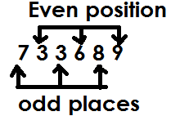Identify whether 733689 is exactly divisible by 11.

Sum of the digits in odd positions =7+3+8=18

Sum of the digits in even positions =3+6+9=18

Difference=18-18

=0

Therefore 733689 id divisible by 11.

**Example 2**

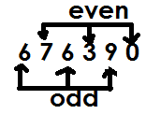Show whether 676390 exactly divisible by 11?

Sum of odd=6+6+9

=21

Sum of even=7+0+3

=10

Difference=21-10

=11

Since difference is divisible by 11 the number is divisible by 11.

**Activity**

Which of the following numbers is exactly divisible by 11?

(a) 2367 (b) 814 (c) 6425

(d) 7282 (e) 901938

**TYPES OF NUMBERS**

**1. Whole numbers**

It is where all other numbers are derived.

Whole numbers consist of 1 or more units and are not fractions

**Examples**

0, 1, 2, 3, 4, 5, 6, …

**2. Counting/ natural numbers**

These are numbers which show concrete quantity of something

**For example**

1, 2, 3, 4, 5, 6, …

**N.B** All whole numbers are counting numbers apart from zero (0)

**3.** **Even numbers**

These are numbers that are exactly divisible by 2

Even numbers have a pattern of +2 in ascending order and -2 in descending order.

**Examples.**

0, 2, 4, 6, 8, …

**N.B**

Even numbers end in an even digit.

Below is a set of the first 6 even numbers.

{0, 2, 4, 6, 8}

Find the sum of the first 4 even numbers

Solution

0,2,4,6

Sum = 0+2+4+6

= 12

**ODD NUMBERS**

These are numbers which when divided by 2, gives a remainder of 1. The first odd number is 1.

Below is a set the first 6 odd numbers.

{1, 3, 5, 7, 9}

All odd numbers end in an odd digit.

Odd numbers have a pattern of +2 in ascending order and -2 in descending order.

Find the product of the 4th and 6th odd numbers.

**Solution**

1, 3, 5, 74th, 9, 116th, 13

Product = 7x11

= 77

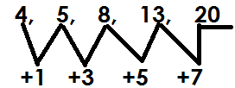Find the next number in the sequence

**PRIME NUMBERS**

A prime number is a number with only 2 factors; 1 and 2 itself.

Below is a set of prime numbers

{2,3,5,7,11,13,17,19,23………}

Find the sum of prime numbers between 6 and 15

**Solution**

7, 11, 13

Sum = 7+11+13

= 31

Find the sum of prime numbers between 20 and 30

23, 29

Sum = 23+29

= 52

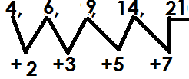Find the next number in the sequence

**COMPOSITE NUMBERS**

These are numbers with more than 2 factors.

The first composite number is 4. The rest include;

4, 6, 8, 9, 10, 12, 14, 15……

**TRIANGULAR NUMBERS**

These are numbers got by adding consecutive counting numbers.

The first triangular number is 1

1.

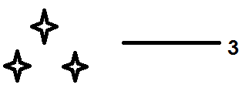

2.

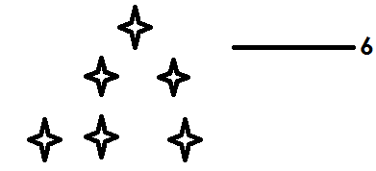

3.

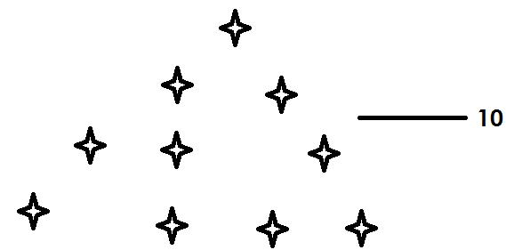

4.

**Finding triangular numbers**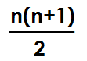

Formula=

**Examples**

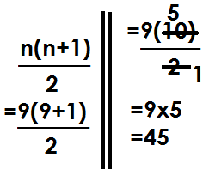1. Find the 9th triangular number

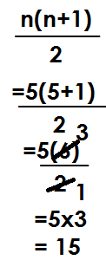2. Find the 5th triangular number

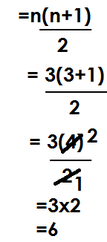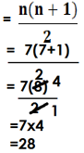3. Find the sum of the 7th and 3rd triangular number

7th 3rd=

Sum=28+6

=34

**Activity**

1. Find the 11th triangular number

2. Find the 17th triangular numbers

3. Find triangular numbers in these positions

(a) 8th (b) 21st

(c) 32nd (d) 4th

4. Find the sum of the 2oth and 15th triangular numbers.

5. What is the difference between the 10th and 6th triangular numbers?

6. Find the product of the 9th and 10th triangular numbers.

**CONSECUTIVE NUMBERS**

**Finding consecutive counting numbers**

**N.B**

Counting numbers have a pattern of +1 and -1 in ascending and descending orders respectively.

**Examples**

1. The sum of 3 consecutive counting numbers is 27. Find the numbers.

|  |  |  |  |
| --- | --- | --- | --- |
| 1st | 2nd | 3rd | sum |
| k | K+1 | K+2 | 27 |

Let the first number be k

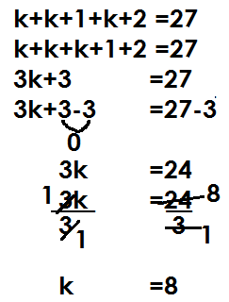

K + k + 1 + k + 2 = 27

K + k + k + 1 + 2 = 27

3k + 3 = 27

3k + 3 – 3 = 27 – 3

3k = 24

$\frac{3k}{3}$ = $\frac{24}{3}$

K = 8

|  |  |  |
| --- | --- | --- |
| 1st | 2nd | 3rd |
| k | K+1 | K+2 |
| =8 | 8+1 | =8+2 |
|  | 9 | 10 |

(b) Find their range

Range = H - L

= 10 - 8

= 2

2. Find the sum of 3 consecutive counting numbers is 39. If the 2nd number is P. find the numbers.

|  |  |  |  |
| --- | --- | --- | --- |
| 1st | 2nd | 3rd | sum |
| P-1 | P | P+1 | 39 |

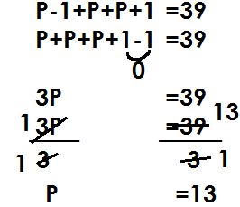

|  |  |  |
| --- | --- | --- |
| 1st | 2nd | 3rd |
| P-1 | P | P+1 |
| 13-1 | =13 | 13+1 |
| 12 |  | 14 |

(b) Find the range of numbers

Range=H-L

=14-12

=2

(c) Find the mean of the numbers

Mean = sum of items

 No.of items

=

=13

3. The sum of 3 consecutive counting numbers is 45 if the third number is k.

(a) Find the numbers

|  |  |  |  |
| --- | --- | --- | --- |
| 1st | 2nd | 3rd | sum |
| k-2 | k-1 | k | 45 |

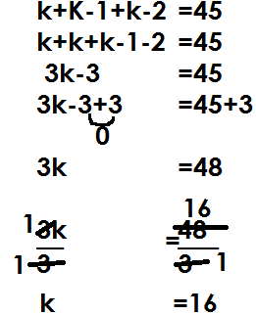

|  |  |  |
| --- | --- | --- |
| 1st | 2nd | 3rd |
| k-2 | k-1 | k |
| 16-2 | 16-1 | =16 |
| 14 | 15 |  |

(b) Find their range

Range=H-L

=16-14

=2

4. The average of 3 consecutive counting numbers is 8. Find the numbers

Let the first number be k

|  |  |  |  |
| --- | --- | --- | --- |
| 1st | 2nd | 3rd | average |
| k | K+1 | K +2 | 8 |

Sum of items = Average

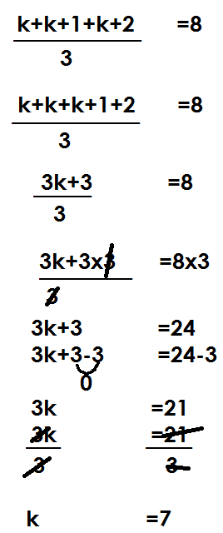No. of items

|  |  |  |
| --- | --- | --- |
| 1st | 2nd | 3rd |
| k | K+1 | K+2 |
| 7 | 7+1 | 7+2 |
| 14 | 8 | 9 |

**ACTIVITY**

1. The sum of 3 consecutive counting numbers is 42.

(a) Find the numbers

(b) Find the range of numbers

2. The sum of 3 consecutive counting numbers is 66. If the middle number is k,

(a) Find the numbers

(b) Find the range of the numbers

3. Given that the sum of consecutive counting numbers is 54. If the 4th number is P.

(a) Find the numbers

(b) Calculate the range of the numbers.

4. If the average of 3 consecutive counting numbers is 12.

(a) Find the numbers

(b) Find the range of numbers

5. The mean of 3 consecutive counting numbers is 15.

(a) Find the numbers

(b) Find the product of the numbers.

**FINDING CONSECUTIVE EVEN NUMBERS**

**N.B**

Even numbers have a pattern of +2 and -2 in ascending and descending orders respectively.

**Examples**

1. The sum of 3 consecutive even numbers is 42.

(a) Find the numbers

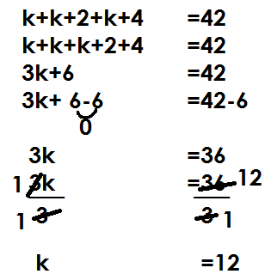 Let the 1st number be k

|  |  |  |
| --- | --- | --- |
| 1st | 2nd | 3rd |
| k | K+2 | K+4 |
| 12 | 12+2 | 12+4 |
|  | 14 | 16 |

(b) Find their range

Range =H-L

=16-12

=4

2. The sum of 4 consecutive even numbers is 44. If the last number is p.

(a) Find the numbers

|  |  |  |  |  |
| --- | --- | --- | --- | --- |
| 1st | 2nd | 3rd | 4th | Sum |
| p-6 | p-4 | p-2 | p | 44 |

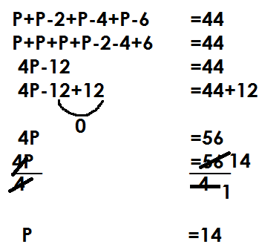

P+p-2+p-4+p-6 = 44

P+p+p+p-2-4-6 = 44

4p – 12 = 44

4p – 12 + 12 = 44 – 12

4p = 32

$\frac{4p}{4}$ = $\frac{32}{4}$

P = 8

|  |  |  |  |
| --- | --- | --- | --- |
| 1st | 2nd | 3rd | 4th |
| P-6 | P-4 | P-2 | P |
| 14-6 | 14-4 | 14-2 | =14 |
| 8 | 10 | 12 |  |

(b) Find their range

Range=H-L

=14-8

=6

3. The average of 3 consecutive even numbers is 8

(a) Find the numbers

|  |  |  |  |
| --- | --- | --- | --- |
| 1st | 2nd | 3rd | 4th |
| k | K+2 | K+4 | 8 |

Let the first number be k

Sum of items= average

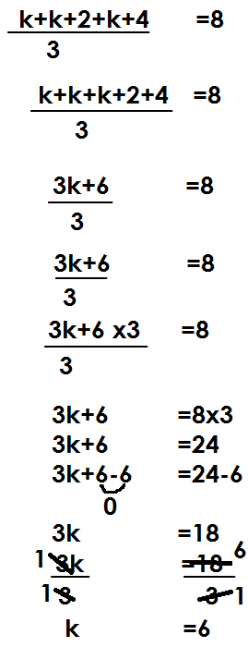No. of items

|  |  |  |
| --- | --- | --- |
| 1st | 2nd | 3rd |
| k | K+2 | K+4 |
| =6 | 6+2 | 6+4 |
|  | 8 | 10 |

**Activity**

1. The sum of 3 consecutive even numbers is 66.

(a) Find the numbers

(b) Find their range

2. The sum of 4 consecutive even numbers is 52.

(a) Find the numbers

(b) Find their range

3. The sum of 3 consecutive even numbers is 96. If the middle number is y.

(a) Find the numbers

(b) Find their range

4. Four consecutive even numbers add up to 28. If the 4th number is k

(a) Find the numbers

(b) Find their range

5. The average of 3 consecutive even numbers is 22

(a) Find the numbers

(b) Find the product of the numbers

**PRIME FACTORIZATION**

Prime factorization is a way of dividing numbers using its prime factors

Prime factors of numbers are written in two ways;

* Subscript form/ Set notation form
* Power form/ Multiplication form

**Example 1**

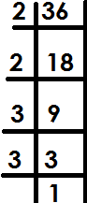Prime factorize 36 giving your answer in subscript form



**Example 2**

Prime factorize 50 and give your answer in power form

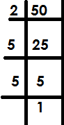**Solution**

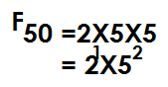

**Example 3**

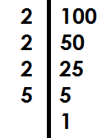Express 100 as a product of its prime factors.



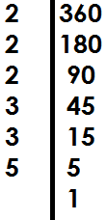Prime factorize 360 in power form

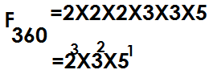

**Activity**

1. Prime factories the following and give your answer in subscript form

(a) 18 (b) 72 (c) 144

2. Prime factorize the following and give your answer in power form.

(a) 120 (b) 150 (c) 240

(d) Express each number as a product of its prime factors.

(a) 64 (b) 210 (c) 60

**Finding umbers that were prime factorized**

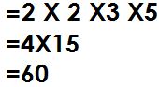1. Given that FQ = {21, 22,31, 51} Find Q

Q

2. If k = 23x51. Find k

K= (2x2) x (2x5)

= 4x10

= 40

3. Find the prime factorized number in the following

Fy = {21, 31, 32, 51}

Y = 21x31x32x51

= (2x3) x (3x5)

= 6x15

= 90

4. FK = 24x31

= (2x2) x (2x2) x3

= 4x4x3

= 16x3

=48

**Activity**

1. What number was prime factorized to give?



2. Given k = 24 x 51. Find the value of k.

3. Find the value of Z if, FZ = 21 x 32 x51

4. Find the prime factorized numbers in the following

FM = {21, 22, 23, 32, 51}

K = 2x2x3x3x5

M = 32x52

 **Finding missing factors**

1. If . Find y.

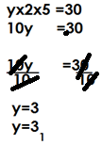 **Solution**

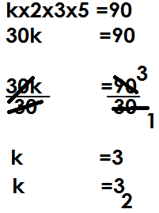2. Given that 21, 31, k and 51 are prime factors of 90. Find the value of k.

3. If 12= (21, m, 31). Find m

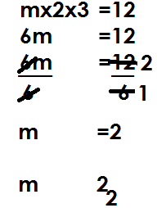

**Activity**

1. If 21, 31, 51 and y are prime factors of 150. Find y

2. Given that {21 ,22, 23, n, 51} are prime factors of 120. Find the value of n

3. If {21, 22, k, 32, 51} are prime factors of 180. Find the value of k.

4. Given that 36= {21, 22, 31, x}. Find the value of x.

5. If 100 = {21, p, 51, 52}. Find the value of p.

6. The prime factors of 360 are 21, 22, 23, m, 32 and 51. Find the value of m.

**Representing prime factors on a Venn diagram**

1. Prime factorize 12 and 18 and represent the prime factors on a Venn diagram.

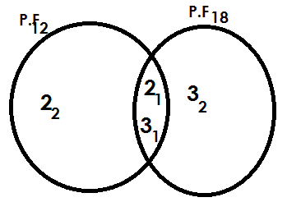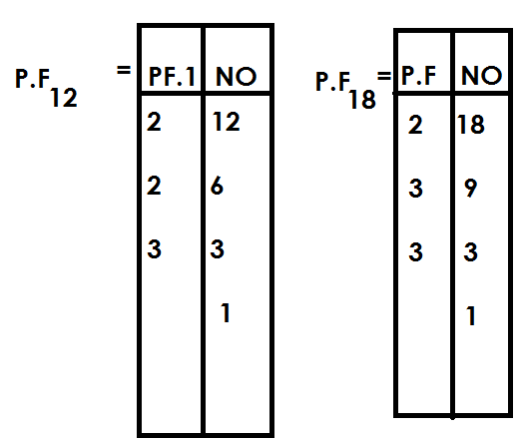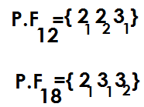

(b) Find the G.C.F of 12 and 18

GCF = intersection product

= 2x3

= 6

(c) Find LCM of 12 and 18

LCM = union product

= (2X2) X (3X3)

= 4X9

= 36

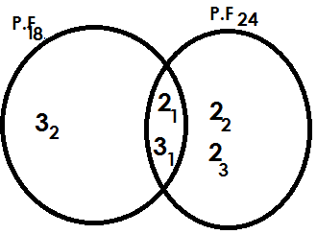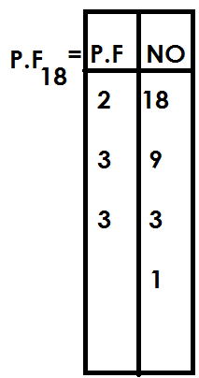2. Prime factorize 18 and 24 and represent the prime factors on a Venn diagram.

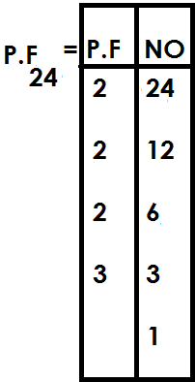



(b) Use the Venn diagram to find;

(i) GCF of 18 and 24

GCF=2X3

=6

(ii) LCM of 18 and 24

LCM=union product

= (3x2) x (3x2) x2

= (6x6) x2

=36x2

=72

**Activity**

1. Prime factorize 24 and 36 and represent the prime factors on a Venn diagram.

(b) Use the Venn diagram to find

(i) GCF of 24 and 36.

2. Show the prime factors of 36 and 48 on a Venn diagram.

(b) Use the Venn diagram to find.

(i) G.C.F of 36 and 48

(ii) L.C.M of 36 and 48

3. Prime factorize 45 and 60 and represent the prime factors on a Venn diagram.

(b) Use the Venn diagram to find;

(i) GCF of 45 and 60

(ii) LCM of 45 and 60

4. Show the prime factors of 30 and 36 on a Venn diagram

(b) Using the Venn diagram; find

(i) HCF of 30 and 36

(ii) LCM of 30 and 36

5. Show the prime factors of 120 and 180 on a Venn diagram

(b) Use the Venn diagram to find,

(i) GCF of 120 and 180

(ii) LCM of 120 and 180

**Finding unknown values on a Venn diagram**

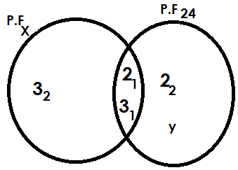1. Use the Venn diagram below to answer questions that follow.

(a) Find the value of

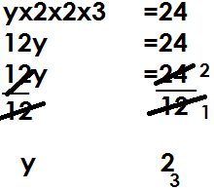(i) y

(ii) x

X = (3x2) x3

X = 6x3

X = 18

(b) Find GCF of x and 24

GCF=2x3

=6

(c) Find LCM of x and 24

LCM= (3x2) x (3x2) x y

= (3x2) x (3x2) x2

= (6x6) x2

=36x2

72

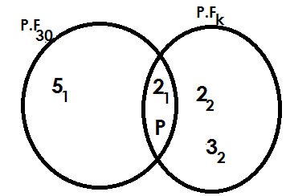2. Use the Venn diagram below to answer questions that follow.

(a) Find the value of

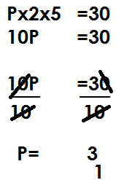(i) P

(ii) K

K = 2XPX2X3

K = (2X3) X (2X3)

K = 6X6

K = 36

(b) Find HCF of 30 and k

HCF = 2xp

= 2x3

= 6

(c) Find the LCM of 30 and k

LCM = 5x2xpx2x3

= (5x2) x (3x2x3)

= 10x18

= 180

**Activity**

1. Use the Venn diagram below to answer questions that follow.

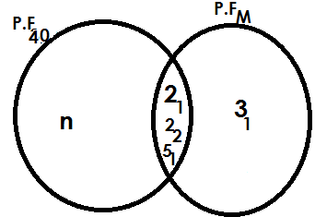

a) Find the value of;

(i) n (ii) m

(b) Find the GCF of 40 and m

(c) Find the LCM of 40 and m

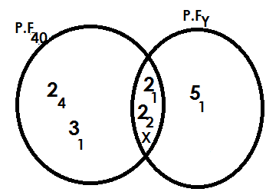2. Below is a Venn diagram. Use it to answer questions that follow.

(a) Find the value of

(i) X (ii) Y

(b) Find the GCF of 48 and y.

(c) Find the LCM of 48 and y.

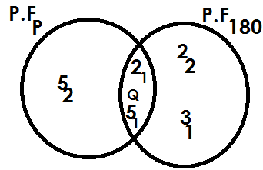3. Use the Venn diagram below to answer questions that follow.

(b) Find the value of

(i) Q

(ii) P

(c) Find the GCF of p and 180

(d) Find the LCM of p and 180.

**Finding lowest common multiple**

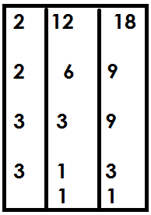1. Find the LCM of 12 and 18

LCM= (2x2) x (3x3)

=4x9

=36

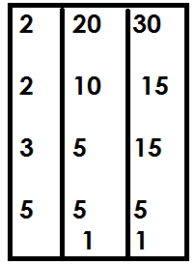2. Find the LCM of 20 and 30

LCM= (2x2) x (3x5)

=4x15

=60

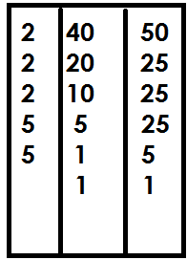3. Find the LCM of 40 and 50

LCM= (2x2x2) x (5x5)

=8x25

=200

**Activity**

1. Find the LCM of the following numbers

(a) 18 and 21 (b) 18 and 24

(c) 16 and 20 (d) 45 and 50

(e) 20, 30 and 40 (f) 18,20 and 30

(g) 9, 12 and 15 (h) 32, 24 and 24

**APPLICATION OF LCM**

1. Find the smallest number when divided by 30 or 24 there is no remainder.

**Solution**

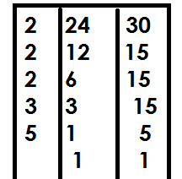 Smallest no. =LCM

= (2x2x2) x3(3x5)

=8x15

=120

2. Find the least number of books which when divided by either 20 or 36,3 books remain.

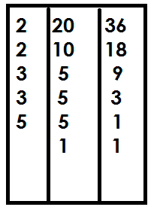 Least No.=LCM + remainder

= (2x2x3) x (3x5)

=12x15

=180

=180+3

=183 books

3. Two bells ring at interval of 20 minutes and 50 minutes for lower and upper section respectively.

(a) After how long will the bells ring together?

Common minutes=LCM

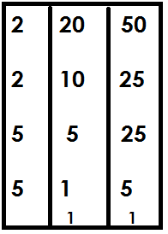

= (2x2) x(5x5) minutes

=4x 25 minutes

=100 minutes

The two bells will ring together after 100 minutes.

(b) If they last rung at 8:00am, when will they ring together again?

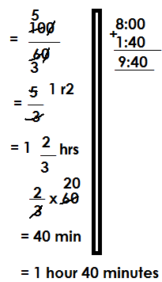 60 minutes=1hr

100minutes

They will ring together again at 9:40 am

4. Two soldiers were shooting at a target at an interval of 1 hour and 1 $\frac{1}{2}$ hours respectively.

(a) After how long will they shoot together?

Solution

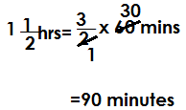 1 hour=60 minutes 1hr=60 mins

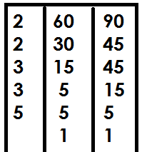 Common minutes = LCM

= (2x2) x (3x3) x5

= 4x9x5

= 180 minutes

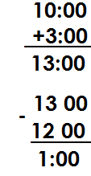(b) If they last shoot together at 10:00am, when did they shoot together again?

 60minutes=1hr

180 min=

=3 hours

They shoot together again at 1pm.

**Activity**

1. Find the smallest number that when divided by 12 or 9 there is no remainder.

2. What is the least number of sweet that when shared by either 8 or 20 pupils, no sweet remains?

3. Find the smallest number of books that when divided by either 18 or 24, 7 books remain.

4. What is the lowest number that when divided by either 11 or 13, 5 becomes the remainder?

5. At ABC P/S two bells ring at an interval of 30 and 40 minutes for nursery and primary respectively.

(a) After how long will the two bells will they ring together again

(b) If they first rung at 8:30 am, when will they ring together again?

6. Three bells for lower, middle and upper section at Kibuku P/S ring at an interval of 40 minutes, 50 minutes and 1 hour respectively.

(a) After how long will they be sounded together again?

(b) If they are first sounded at 8:00am, when are they sounded together again for the second time?

7. At a bus station three buses leave at an interval of 50 minutes, 1 hour and 1 $\frac{1}{2}$ hours respectively.

(a) After how long will the three buses leave at the same time?

(b) If they last left together at 10:00am, at what time will they leave together again?

**FINDING GCF/HCF**

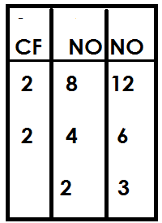1. Find the GCF of 8 and 12

= 2X2

= 4

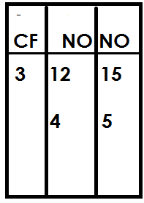2. Find the HCF of 12 and 15

HCF=3

3. Find the largest number that divides 6 and 8 without any remainder.

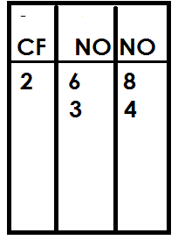 Largest no= HCF

HCF=2

4. Find the largest number that divides 18 and 24

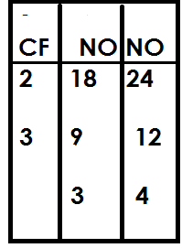 Largest no. =HCF

= 2x3

= 6

**Activity**

1. Find the GCF of the following numbers

(a) 15 and 20

(b) 24 and 36

(c) 18 and 21

(d) 9 and 21

(e) 11 and 22

2. Find the largest number that divides 9 and 24 without any remainder.

3. What is the highest number that divides 24 and 30 without a remainder?

4. Find the highest number of boys that you can give 21 and 24 pens equally?

**APPLICATION OF LCM AND GCF.**

1. The LCM of two numbers is 18. Find the second number.

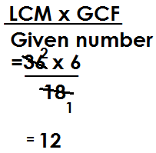 **Solution**

2nd no. =

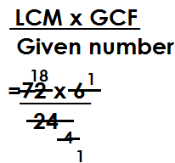2. The LCM of two numbers is 72 and their GCF is 6. If one of the numbers is 24, find the second number

2nd no. =

2nd no. = 18

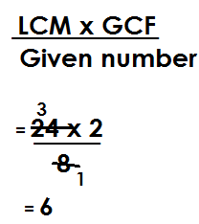3. The LCM of two numbers is 24 and their GCF is 2. If one of the numbers is 8. Find the second number

2nd no.=

**Activity**

1. The LCM of two numbers is 72 and their GCF is 6. If the first number is 18, find the second number.

2. The LCM of two numbers is 120 and their HCF is 10. If the first numbers is 40. Find the second numbers.

3. The LCM of two numbers is 225 and their GCF is 5. Find the second number if the first number is 25.

4. The LCM of two numbers is 300 and their GCF is 10. Given that the first number is 50, find the second number.

5. The LCM of two numbers is 144 and their GCF is 12. Find the second number if the first number is 36.

6. The product of two numbers is 216 and their cm is 36. Find their GCF.

7. The product of two numbers is 432 and their LCM id 72. Find their GCF.

**SQUARE AND SQUARE ROOT**

**Square numbers.**

A square number is a product of two same numbers.

A square is a number obtained by multiplying a given number by itself.

**Examples of square numbers**

12 = 1x1

= 1

22 = 2x2

= 4

32 = 3x3

= 9

42 = 4x4

= 16

52 = 5x5

= 25

{1, 4,9,16,25, 36, 49, 64, …}

**SEQUENCE OF SQUARE NUMBERS**

1. Find the next number in the sequence of

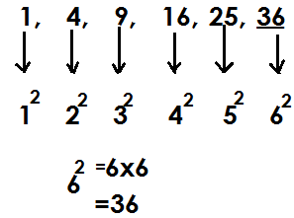 1,4,9,16,25,36

2. Find the next two numbers in the series of

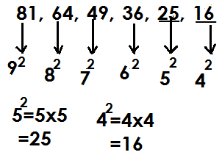 81, 64, 49, 36, 25, 16

**Activity**

Find the next numbers in the following series

(a) 1, 4, 9, 16, ________

(b) 36, 49, 64, 81, _____

(c) 100, 81, 64, 49, _____, _____

(d) 100, 121, 144, 169, ____, _____

(e) 81, 64, 49, 36, _____, ________

(f) 25, 16, 9, 4, _____

(g) 400, 361, 324, 289, ____, ____

1. Find the square of 9

92 = 9x9

= 81

2. What is the square of 13?

132 = 13x13

= 169

3. Find the square of 100

1002 = 100x100

= 10000

**Activity**

1. Find the square of the following whole numbers.

(a) 4 (b) 11

(c) 17 (d) 20

(e) 12 (f) 19

(g) 8 (h) 18

(i)144 (j) 132

(k) 225 (l) 500

**FINDING SQUARE OF FRACTIONS**

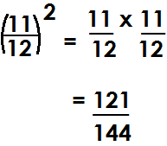a). Find the square of $\frac{11}{12}$

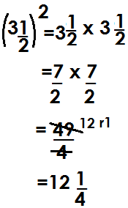(b) Find the square of 3 $\frac{1}{2}$

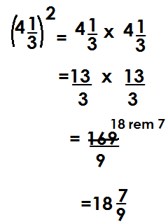(c) Find the square of 4 $\frac{1}{3}$

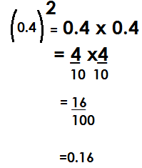(d) Find the square of 0.4

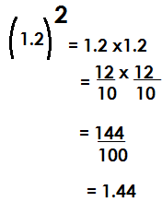(e) Find the square of 1.2

**Activity**

(a) $\frac{4}{5}$ (b) $\frac{7}{9}$ (c) $\frac{13}{14}$ (d) $\frac{8}{11}$ (e) $\frac{19}{21}$ (f) 1 $\frac{1}{4}$ (g) 2 $\frac{1}{5}$

(h) 5 $\frac{1}{3}$ (i) 3 $\frac{2}{3}$ (j) 0.8 (k) 0.06 (l)1.4 (m) 1.44 (n) 25.5

**SQUARE ROOTS**

A square root is a number that was multiplied by itself to obtain a square number.

The square root sign is

**Finding the square root of whole numbers**

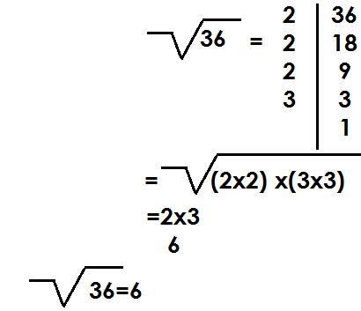1. Find the square root of 36.

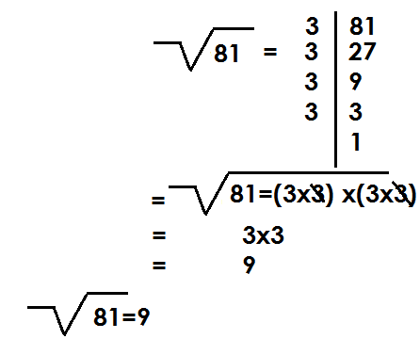2. Find the square root of 81

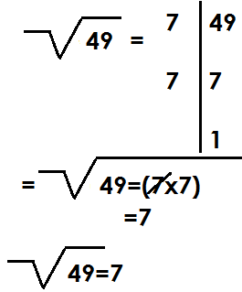3. What is the square root of 49?

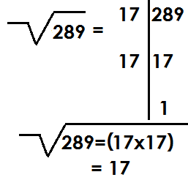4. Find the square root of 289

**Activity**

1. Find the square root of the following

(a)4 (b) 9 (c) 16 (d) 25 (e) 64

(f) 100 (g) 121 (h) 144 (i)169 (j) 196

(k) 225 (l) 256 (m) 324 (n) 400

**FINDING SQUARE ROOT OF FRACTIONS.**

**NOTE:**

While finding square root of fractions, the answers should take the nature of the question.

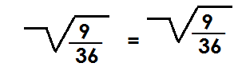1. Find the square root of

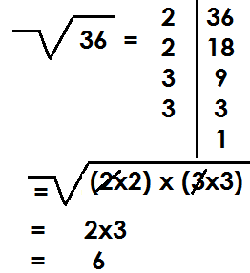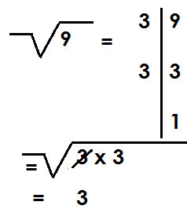

= =

=

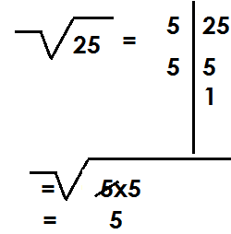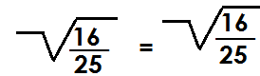2. Find the square root of

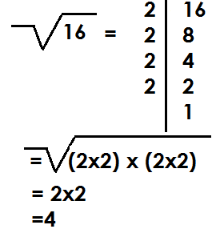 = =

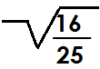

Therefore = $\frac{4}{5}$

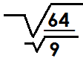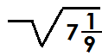3. Find the square root of 7

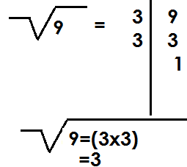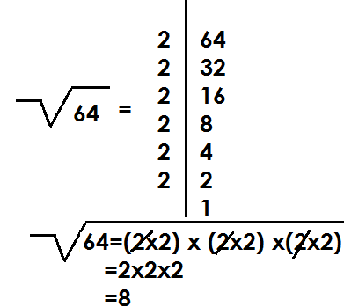 =

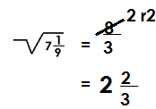

4. Find the square root of 1 $\frac{7}{9}$

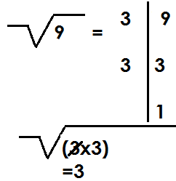 1 $\frac{7}{9}$ =

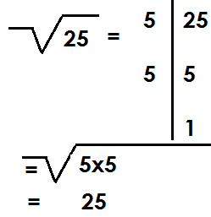

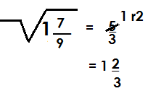

**Activity**

Find the square root of the following

(a) $\frac{1}{9}$ (b) $\frac{4}{49}$ (c) $\frac{36}{81}$ (d) $\frac{121}{169}$ (e) $\frac{225}{256}$ (g) 2 $\frac{1}{4}$

(h) 6 $\frac{1}{4}$ (i) 7 $\frac{1}{9}$ (j) 20 $\frac{1}{4}$ (k) 11 $\frac{1}{9}$ (l) 1 $\frac{9}{16}$

**FINDING SQUARE ROOT OF DECIMALS**

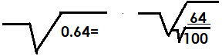1. Find the square root of 0.64

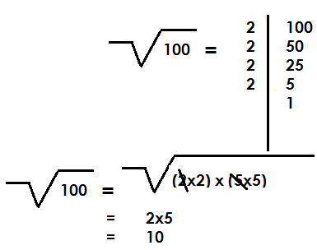

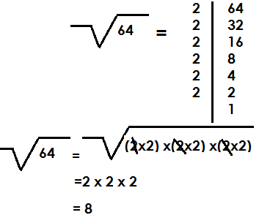

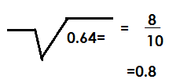

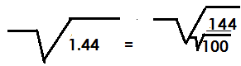2. Find the square root of 1.44

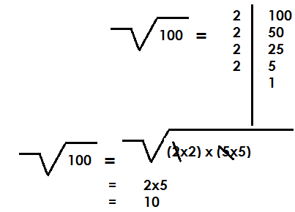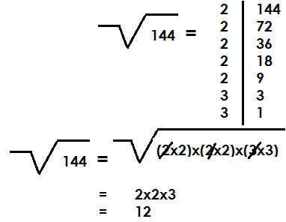

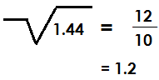

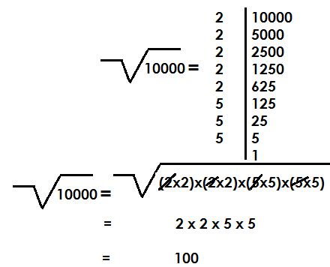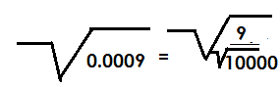3. Find the square root of 0.0009



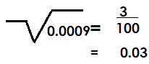

**ACTIVITY**

Find the square root of the following

(a) 0.09 (b) 0.81

(c) 2.56 (d) 4.41

(d) 0.36 (f) 1.96

(g) 0.0064

**APPLICATION OF SQUARE ROOTS**

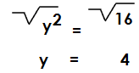1. Solve: y2=16

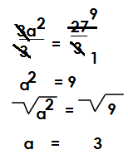2. Solve: 3a2=27

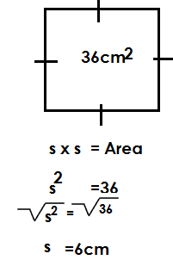3. The area of a square is 36cm2. Find the length of each side

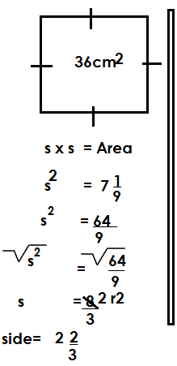4. The area of a square garden 7 $\frac{1}{9}$. Find the length of its side.

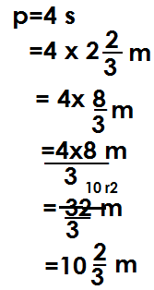 Find its perimeter

**Activity**

1. The area of a square is 49cm2. Find its side.

2. A square garden has area of 81cm2. Find the length of its side.

3. Find the length of one side of a square of area 1 m2

4. Find the perimeter of a square garden whose area is 64m.

5. Find the perimeter of a square garden when are is 1.96m2

6. Solve: x2=25

7. Solve for k= K2=144

8. Solve: p x p =18

9. Solve: 2y2=72

10. Solve for k: 5kxk=500.

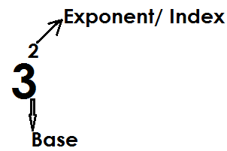**INDICES**

Given

To simplify in indices; leave the answer in power form.

To workout is to evaluate and give the value of the expression.

**ADDITION AND SUBTRACTION BY EXPANSION**

**Note:**

Expand the base by multiplying it as many times as the exponent.

Any number raised to exponent 0, gives one (1) and any number raised to exponent one (1) gives that same number.

1. Workout: 23+42

= (2x2x2) + 4x4

=8 +16

=24

2. Workout: 103+52

**Solution**

= (10x10x10) + (5x5)

=1000+25

=1025

3. Workout: 43-32

= (4x4x4)- (3x3)

= 64-9

= 55

4. Workout: 32-23

= (3x3)- (2x2x2)

= 9-8

= 1

5. Workout: 23+90+21

(2x2x2) + 1+2

8+3

11

6. Workout: 142-120

= (14x14) -1

= 196-1

= 195

**Activity**

Workout the following

(a) 43+23 (b) 23+32+50

(c) 42+32 (d) 34+42+21

(e) 34+40 (f) 42-32

(g) 62-23 (h) 43-51

(i) 100-33

**LAW OF INDICES IN MULTIPLICATION**

**Note:**

When multiplying powers of the same base, maintain one common base and add the exponents.

**Examples**

1. Simplify: 22 x 23

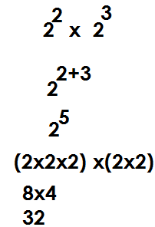 **Solution**

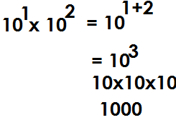2. Workout: 101x102

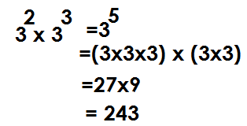3. Simplify: 32x33

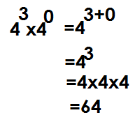4. Simplify: 43 x40

**Activity**

(a)24x22 (b) 53x51

(c) 31x33 (d) 23x2x21

(e) 104 x10 (f) 53x52

(g)32x31x30 (h) 92x90

**Laws of indices in division**

**Note:**

When dividing powers of the same base, maintain one common base and then subtract the exponents.

**Examples**

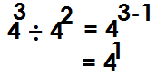1. Simplify: 43 42

2. Workout: 65 ÷ 64

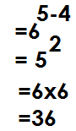 65 ÷ 64

3. Workout: 34 ÷ 3

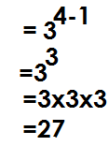34 ÷ 31=

4. Workout: 53 ÷ 50

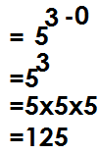53 ÷ 50 =

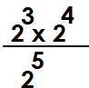

5. Workout:

 **Solution**

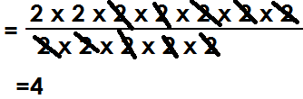

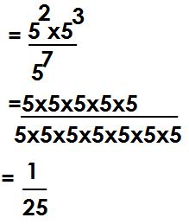6. Workout:

7. Workout:

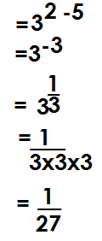

8. Work out the following

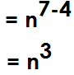(a) n7 ÷ n4

(b) p**3a** ÷ p**a**

P**3a**-p**a**

=p**2a**

**Activity**

1. Workout the following

(a)75 ÷ 74

(b) 103 ÷ 102

(c) 512 ÷ 59

(d) 37 ÷34

(e) 43 ÷ 41

(f)52 ÷ 50

2. Simplify the following.

(g) n10 ÷ n3

(h) 132k ÷ 13k

**TERM 2**

**FRACTIONS**

A fraction is part of a whole.

**Common fraction**

Is a fraction with a numerator and a denominator.

**Addition of common fractions**

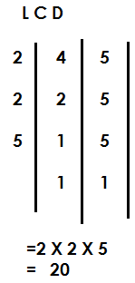1. Work out $\frac{1}{5}$ + $\frac{1}{4}$

**Solution**

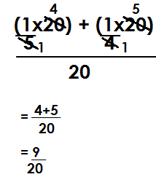

2. Workout: 2 $\frac{1}{3}$ + $\frac{3}{4}$

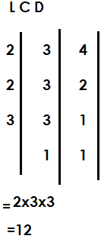 **Solution**

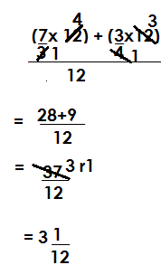 +

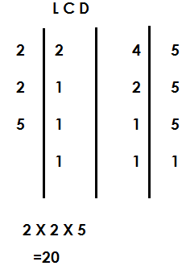13. Workout: $\frac{1}{2}$ + $\frac{1}{4}$ + 1 $\frac{1}{5}$

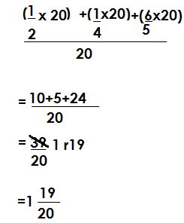

**Activity**

1. Workout the following

(a) $\frac{1}{6}$ **+ $\frac{1}{5}$ (b) $\frac{1}{3}$ + $\frac{3}{4}$ (c) 1 $\frac{1}{3}$ + $\frac{5}{6}$ (d) 2 $\frac{1}{3}$ + 1 $\frac{1}{2}$**

**(e) $\frac{1}{6}$ + $\frac{1}{8}$ + $\frac{1}{3}$ (f) $\frac{2}{3}$ +1 $\frac{1}{6}$ + $\frac{2}{9}$ (g) 2 $\frac{1}{4}$ + $\frac{3}{8}$ + $\frac{1}{8}$ (h) 5 $\frac{1}{3}$ + 1 $\frac{1}{2}$ + 3 $\frac{1}{3}$**

**SUBTRACTION OF FRACTIONS**

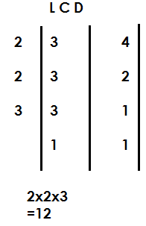1. Workout: 4 – 2

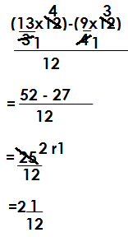 -

2. Simplify: 2 -

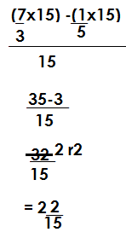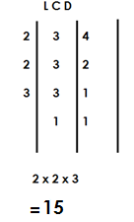 -

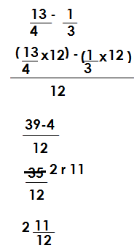  
3. Workout: 3 $\frac{1}{4}$- $\frac{1}{3}$

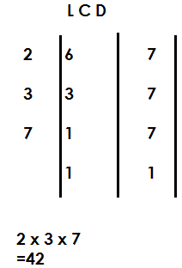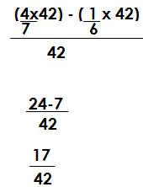4. Simplify: $\frac{4}{7}$- $\frac{1}{6}$

**Activity**

Workout the following

(a) $\frac{3}{8}$ **- $\frac{1}{8}$ (b) $\frac{1}{2}$- $\frac{1}{3}$ (c) $\frac{4}{5}$- $\frac{1}{4}$ (d) 3 $\frac{1}{7}$– 2 $\frac{1}{3}$**

**(e) $\frac{11}{12}$- $\frac{5}{8}$ (f) 5 $\frac{5}{6}$ 1+ $\frac{1}{2}$ (g) 4 $\frac{1}{2}$– 1 $\frac{5}{6}$**

**MULTIPLICATION OF COMMON FRACTIONS**

1. Workout: $\frac{3}{4 }$ x $\frac{2}{3}$

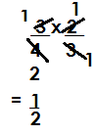 **Solution**

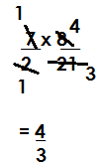2. Workout: 3 $\frac{1}{2}$ x $\frac{8}{21}$

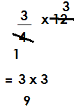3. What is $\frac{3}{4}$ of 12?

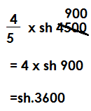4. What is $\frac{4}{5}$ of sh. 4500?

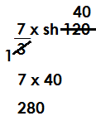5. What 2 $\frac{1}{3}$ of 120

**Activity**

1. Workout the following

(a) $\frac{1}{6}$ **x $\frac{2}{3}$ (b) $\frac{1}{2}$ x $\frac{1}{2}$ (c) $\frac{3}{8}$ x $\frac{4}{5}$ (d) 1 $\frac{1}{2}$ x $\frac{1}{3}$ (e) 2 $\frac{2}{3}$ x $\frac{3}{4}$**

**(f) 7 $\frac{1}{3}$ x 1 $\frac{2}{11}$ (g) 5 $\frac{1}{5}$ x 1 $\frac{1}{3}$ (h) 9 $\frac{1}{7}$ x 2 $\frac{5}{8}$ (i) 4 $\frac{1}{2}$ x $\frac{4}{9}$ (j) 6 $\frac{2}{3}$ x 1 $\frac{1}{8}$**

**FINDING RECIPROCAL**

**NOTE:**

A number multiplied by its reciprocal is equal to 1(one)

1. Find the reciprocal of

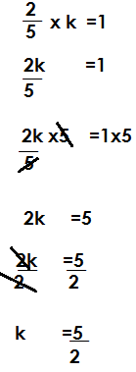Let the reciprocal be k

2. Find the reciprocal of $\frac{3}{4}$

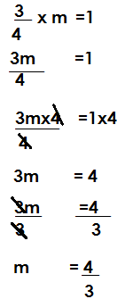Let the reciprocal be m

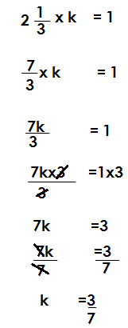3. Find the reciprocal of 2

4. Find the reciprocal of 4.2

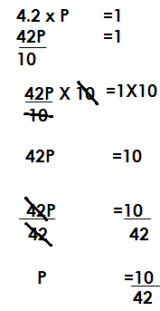 Let the reciprocal be P

**Activity**

Find the reciprocal of the following

(a) $\frac{5}{2}$ **(b) $\frac{2}{7}$ (c) $\frac{8}{11}$ (d) $\frac{13}{4}$ (e) 6 (f) 8 (h) 1 $\frac{1}{4}$**

**(i) 4 $\frac{3}{5}$ (j) 3 $\frac{1}{7}$ (k) 0.6 (l) 1.2 (m) 4.5**

**DIVISION OF FRACTIONS**

1. Work out: ÷ 9

÷

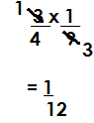

2. Workout: 3 ÷

÷

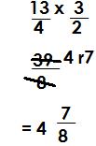

3. How many $\frac{1}{2}$ litre bottles can be got from 20 litres?

No. of bottles= $\frac{20}{1}$ ÷ $\frac{1}{2}$

= $\frac{20}{1}$ x $\frac{2}{1}$

=40 bottles

4. How many $\frac{1}{4}$ litre packets can be got from 5 litre packet of juice?

No. of packets= $\frac{5}{1}$ ÷ $\frac{1}{4}$

= $\frac{5}{1}$ x $\frac{4}{1}$

= 20 packets

5. How many 200g can be got from 2kg?

1kg = 1000g

2kg =2x1000g

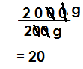 =2000g

=

6. Find the number of 40g packets that can be obtained from 2.4 kg packet?

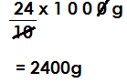 1kg =1000g

2.4kg =

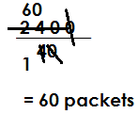

No. of packets=

7. How many 50cm pieces of cloth can be got from 250cm cloth?

1m =100cm

250m =250 x 100cm

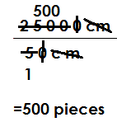 =25000cm

No. of pieces=

**Activity**

1. Workout the following.

(a) $\frac{2}{3}$ **÷ 2 (b) $\frac{4}{5}$ ÷ 20 (c) 4 $\frac{2}{7}$ ÷ 15 (d) 1 $\frac{1}{2}$ ÷ 12 (e) 3 $\frac{1}{2}$ ÷ 32 (f) $\frac{3}{4}÷1\frac{1}{2}$**

**(g) 2 $\frac{1}{2}÷$ 1 $\frac{1}{4}$ (h) 3 $\frac{3}{4}$ ÷ 1 $\frac{1}{2}$ (i) 4 ÷ 1 (j) 5 ÷ 2**

2. How many $\frac{1}{2}$ litre bottles can be got from 8 litres container?

3. 12 litres of milk were given to children. If each child got $\frac{1}{4}$ of a litre, how many children got milk?

4. How many $\frac{4}{5}$ litre packets of milk can be obtained from 64 litres container?

5. Find the number of $\frac{1}{4}$ litre bottles that can completely fill 30 litre tank.

6. How many 500g packets can be got from 20kg sack of beans?

7. Find the number of 200cm pieces of cloth that can be cut from 120m cloth.

**MIXED OPERATIONS**

**Given addition and subtraction**

1. **Example 1**

Simplify: - +

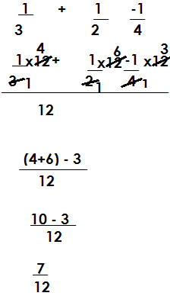 **Solution**

2. Simplify: – 1 + 2

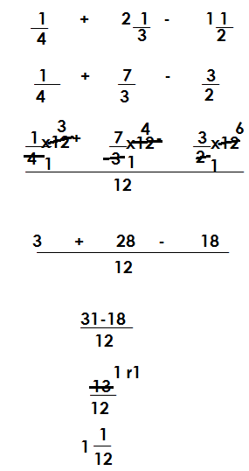 **Solution**

3. Workout: $\frac{1}{2}$- $\frac{3}{4}$ + 1 $\frac{1}{3}$

**Solution**

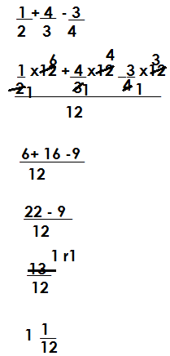

**Activity**

(a) $\frac{1}{3}$ **- $\frac{1}{2}$ + $\frac{3}{4}$**

(b***) $\frac{2}{3}$- $\frac{3}{4}$ + 1 $\frac{1}{2}$***

(c) $\frac{1}{4}$ **– 1 $\frac{1}{2}$ + 1 $\frac{4}{5}$**

(d) $\frac{1}{5}$ **- $\frac{3}{4}$ + $4\frac{1}{2}$**

(e) $\frac{3}{5}$ **- $\frac{3}{4}$ +1 $\frac{1}{5}$**

(f) $\frac{1}{12 }$ **- $\frac{1}{3}$ + $\frac{3}{4}$**

**GIVEN OTHER OPERATIONS**

1. **Example 1**

Simplify:

 $\frac{3}{4}$ X $\frac{1}{8}$ ÷ 1 $\frac{1}{2}$

$\frac{3}{4}$ ×( $\frac{1}{8}$ ÷ $\frac{3}{2}$)

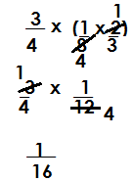

**Example 2**

Workout: $\frac{1}{4}$ of ( $\frac{2}{3} ÷ \frac{5}{12}$) + $\frac{1}{3}$

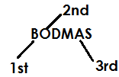 **Solution**

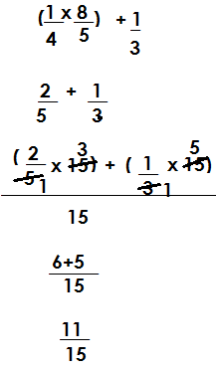 $\frac{1}{4}$ Of ( $\frac{2}{3 }$ × $\frac{12}{5}$) + $\frac{1}{3}$

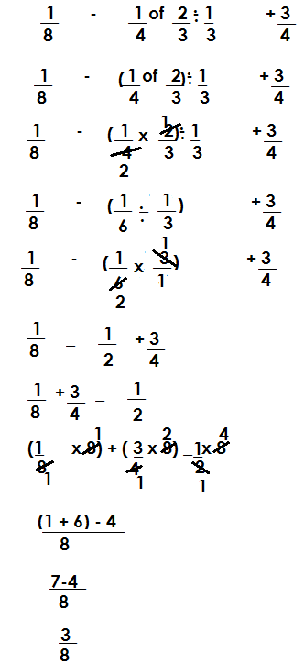3. Workout:

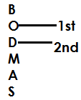

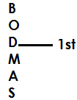4. Workout: $\frac{1}{9}$ ÷ $\frac{2}{3}$ x $\frac{1}{4}$ ÷ $\frac{5}{6}$

**Solution**

($\frac{1}{9 } ÷\frac{2}{3 }$) x ($\frac{1 }{4 } ÷\frac{5}{6}$)

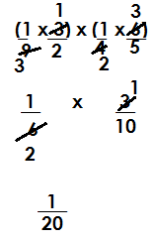

**Activity**

1. Workout:

(a) $\frac{1}{5}$ **Of ( $\frac{1}{2 } ÷\frac{2}{3}$) (b) $\frac{1}{3}$ × ( $\frac{1}{4 } ÷ \frac{3}{8}$) (c) 1 $\frac{1}{2}$ x $\frac{1}{3}$- $\frac{4}{9}$ (d) $\frac{1}{2}$- $\frac{1}{5}$ of $\frac{5}{6}$ + $\frac{1}{4}$**

**(e) $\frac{2}{3}$ Of $\frac{3}{4}$ ÷ $\frac{5}{6}$ + $\frac{1}{5}$ (f) $\frac{1}{16}$- $\frac{3}{4}$- $\frac{1}{12 }$ + $\frac{3}{4}$ (g) $\frac{1}{3}$- $\frac{1}{8}$ x $\frac{2}{3}$ + $\frac{2}{5}$**

**ADDITION OF DECIMAL**

**Example 1**

1. Workout: 24.6 +14.2+0.6

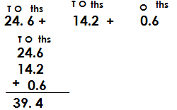 **Solution**



2. Workout:

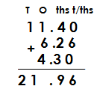**Solution**

3. Workout:

**Solution**

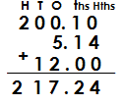



4. Add:

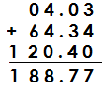 **Solution**

**Activity**

1. Workout the following

(a) 12.4 + 1.0 (b) 13. 46 +1 2 (c) 156.42 + 14 .2 4 + 10 .3

(d) 49. 36 + 14 .3 + 58. 489 (e) 114.4 +94.6 (f) 12+ 6.14 +2.1

**SUBTRACTION OF DECIMALS**

1. Workout:

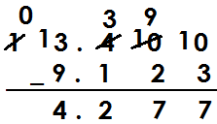 **Solution**

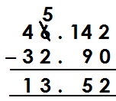2. Workout: 46.42-32.

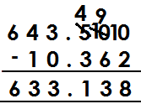3. Workout: 633.5- 10.362

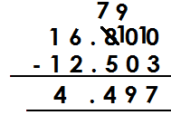4. Workout: 16.8- 12. 503

**Activity**

Workout the following

(a) 104. 2 – 86.124 (b) 14.7 – 13.62

(c) 32.4 -16.3 (d) 40-14.63

(e) 18.4 – 9. 376 (f) 32.46-16.814

(g) 162.2 – 98.236

**Multiplication of decimals**

1. 1 .2 x 0.81

Solution

X

=

= 0.972

2. Workout: 0.4x 0.2 x 0.12

= xx

=

= 0.0096

3. Workout: 0.6x 0.8

= $\frac{6}{10}$ X $\frac{8}{10}$

= $\frac{48}{100}$

= 0.48

**Activity**

Workout the following

(a) 1.2 x 4.3

(b) 6.2 x 0.4 x2

(c) 7.1 x 4.2

(d) 13.4 x 6.2

(e) 2.4 x 0.6 x 0.8

(f) 0.4x 0.6 x 2.3

(g) 0.8 x 12 0.6

**DIVISION OF DECIMALS**

1. Workout: 2.88 ÷ 1.2

**Solution**

= ÷

= ×

=

= 2.4

2. Workout: 0.72 ÷ 1.8

= $\frac{72}{100}$ ÷ $\frac{18}{10}$

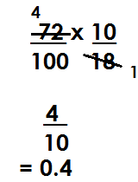

=

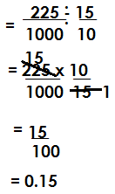3. Workout: 0.225 ÷ 1.5

4. Workout: 0.24 ÷ 0.6

= $\frac{24}{100}$ ÷ $\frac{6}{10}$

= $\frac{24}{100}$ x $\frac{10}{6}$

= $\frac{4}{10}$

= 0.4

**Activity**

(a) 0.12 ÷ 03 (b) 0.135 ÷ 4.5

(c) 0.48 ÷ 0.04 (d) 0.108 ÷ 0.012

(e) 96 ÷ 0.8 (f) 1.44 ÷ 1.2

(g) 0.123 ÷ 0.03 (h) 0.108 ÷ 0.36

**CHANGING COMMON FRACTIONS INTO DECIMALS**

1. Change into common a decimal

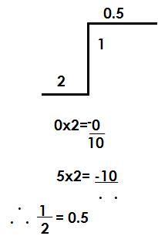 = 1 ÷ 2

2. Change into a decimal

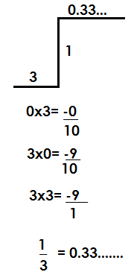 = 1 ÷ 3

3. Express as a decimal

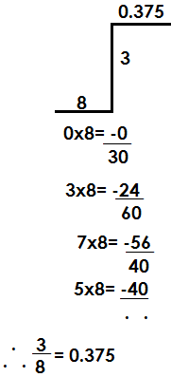 = 3 ÷ 8

4. Convert to a decimal

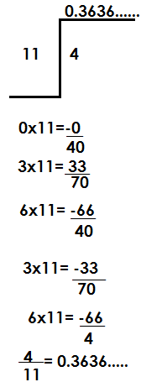 =4 ÷ 11

**Activity**

1. Change the following

(a) $\frac{1}{5}$ (b) $\frac{2}{3}$ (c) $\frac{3}{5}$ (d) $\frac{3}{4}$ (e) $\frac{4}{25}$ (f) $\frac{2}{9}$ (g) $\frac{1}{6}$

**CHANGING DECIMALS INTO COMMON FRACTIONS**

1. Change 0.135 into a common fraction

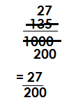

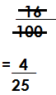2. Change 0.16 into a common fraction

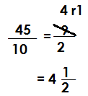3. Express 4.5 as a common fraction

4. What is 0.121 as a common fraction?

0.121 = $\frac{121}{1000}$

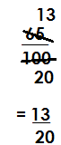5. Express 0.65 as a common fraction

0.65=

**Activity**

1. Change the following into common fractions

(a) 0.2 (b) 0.75

(c) 0.125 (d) 3.25

(e) 0.25 (f) 14.4

(g) 22. 5 (h) 6.25

**CHANGING RECURRING DECIMALS TO COMMON FRACTIONS**

1. Change 0.1212… to a common simplified fraction

Let the common fraction be k

K= 0.1212…

100xk= 0.1212…x100

100k=12.1212…

100k-k=12.1212…

0.1212…

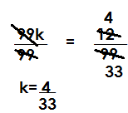 99k = 12

2. Change 0.333… into a common simplified common fraction

Let the common fraction be k

K= 0.333…

10k =0.3333…x10

10xk =0.333…x10

10k = 3.333…

10k-k =3.333…

0.333…

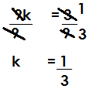 9k =3

3. Change 0.123123… to a simplified common fraction

Let the common fraction be k

K =0.123123…

10000 x k =0.123123…x1000

1000k =123.123123…

1000k-k =123.123123…

1. 123123…

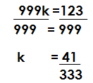99k =123

**Activity**

1. Change the following into simplified common fractions

(a) 0.4545… (b) 0.2424… (c) 0.6363…

(d) 0.8181… (e) 0.5454… (f) 0.66…

(g) 0.555… (h) 0.162162… (i) 0.145145…

(j) 0.121121121…

**MIXED OPERATIONS ON DECIMALS**

1. **Given addition and subtraction**

**NB:**

Given addition and subtraction, re arrange by adding first.

1. Workout: 2.6-3.1 + 4.6

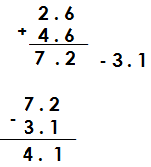 (2.6 +4.6) -3.1

1. Workout: 4.3-6+3.4

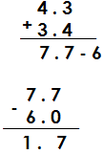(4.3 +3.4)-6

1. Workout: 1.12- 3.2 + 4.6

**Solution**

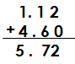(1.12 + 4.6)- 3.2

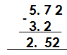

4. Workout: 0.43- 4.3 +6.4

**Solution**

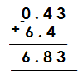 (0.43 + 6.4)- 4.3

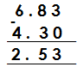

**Activity**

Workout the following:

(a) 0.7- 6.2 + 7.9 (b) 97.3- 12.5 + 0.63

(c) 30.4 + 3.4 -0.3 (d) 120.5 – 0.7 + 100.3

(e) 49.3 – 0.32 + 0.78 (f) 30.6 – 0.49 + 40.32

**GIVEN OTHER OPERATIONS**

**Note:**

Given other operations BODMAS should be applied.

1. Workout: 0.24 ÷ 0.8 x 0.7

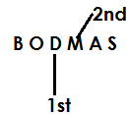 **Solution**

(0.24 ÷ 0.8) x 0.7

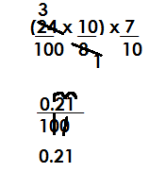 ( ) x

2. Workout: 0.4 x 1.2 ÷ 0.3 + 4.6

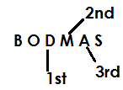 **Solution**

= 0.4 X (1.2 ÷0.3) + 4.6

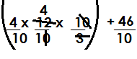 = **X ( ) +**

=

=  **+**

=

= **6.2**

3. Workout: 0.48 ÷ 0.2 of 0.6

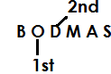 **Solution**

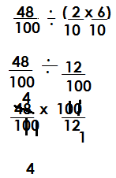0.48 $÷$ (0.2 of 0.6)

**Activity**

1. Workout the following

(a) 4.2 x 3.1 – 1.2 x 2.4 (b) 0.3 x 0.12 ÷ 0.4 + 0.5 (c) 0.15 ÷ 0.3 x 0.12

(d) 4.8 ÷ 1.2 x 0.8 + 0.3 (d) 4.8 ÷ 1.2 x 0.8 + 0.3 (e) 3.2 x 0.2 + 3.2 ÷ 0.8

 **DECIMALIZATION**

1. Workout:

= (0.24 x 0.7) ÷ 0.08

= **( ) ÷ ()**

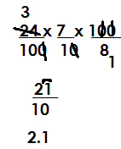



2. Workout:

= (0.16 x 0.12) ÷ (0.08 x 0.3)

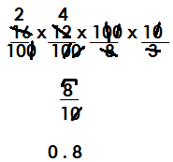 = **() ÷ ()**

3. Workout:

= (0.81 x 0.12) ÷ (0.9 x 0.06)

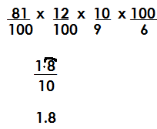 = **() ÷ ()**

4. Workout: $\frac{0.48-0.12}{0.4+0.2}$

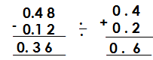= (0.48 – 0.12) ÷ (0.4 + 0.2)

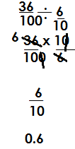= 0.36 ÷ 0.6

**Activity**

 Workout the following

(a) (b)



(c) (d)



(e) (f)



(g) (h)



(i)

**APPLICATION OF FRACTIONS**

1. In a class of 40 pupil, $\frac{2}{5}$ are boys and the rest are girls.

(a) Find the fraction of girls

**Solution**

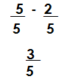 1- $\frac{2}{5}$

(b) How many girls are in the class?

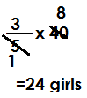 **Solution**

No of girls=

(c) If a half of the boys put on yellow shirts. How many boys put on yellow shirts?

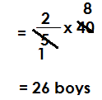 **Solution**

No of boys

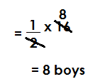

Half of the boys

2. In a village of 1800 people, $\frac{5}{9}$ are female and the rest are male.

(a) Find the fraction of male in the village

**Solution**

Fraction of male= 1 **- $\frac{5}{9}$**

= $\frac{9}{9}$**- $\frac{5}{9}$**

= $\frac{9-5}{9}$

= $\frac{4}{9}$

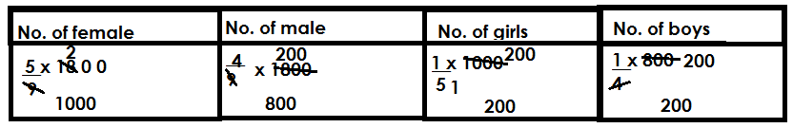(b) $\frac{1}{5}$ of the female are girls and $\frac{1}{4}$ of the male are boys. Find the number of children in the village

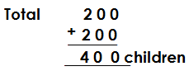

**Activity**

1. At a party attended by 120 people, $\frac{1}{4}$ were men and the rest were women.

(a) How many men attended the party?

(b) If $\frac{1}{10}$ of the men and $\frac{2}{3}$ of women took sodas. How many people took sodas at the party?

2. in a school of 2000 pupils. $\frac{2}{5}$ are boys and the rest are girls. Find the fraction of girls

(b) How many more girls than boys are in the school?

3. in a class of 200 pupils, $\frac{1}{4}$ of them are girls and the rest are boys.

(a) Find the fraction for boys.

(b) How any more boys than girls are in the class?

(c) if $\frac{1}{5}$ of the girls wear maroon t-shirts. How many girls wear maroon t-shirts?

4. In a school, $\frac{5}{8}$ are girls and the rest are boys. If there are 800 pupils in the class.

(a) Find the fraction for boys.

(b) If $\frac{1}{5}$ of the girls and $\frac{1}{3}$ of the boys play volley ball. How many pupils play volley ball.

**FINDING ORIGINAL QUANTITY GIVEN PARTS OF FRACTIONS**

**Example**

$\frac{1}{5}$ of a number is 20. Find the number.

**Solution**

Let the number be k

$\frac{1}{5}$ of k = 20

$\frac{1}{5}$ x k=20

 $\frac{k}{5}$ =20

K = 100

**Example 2**

of a number is 20. Find a $\frac{1}{5}$ of the number.

**Solution**

Let the number be n.

$\frac{4}{7}$ of n=20

$\frac{4}{7}$ x n =20

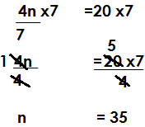 $\frac{4n}{7}$ =20

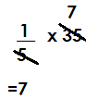Then $\frac{1}{5}$ of n

**Example 3**

After covering $\frac{4}{9}$ of the journey. Richards’s car got a puncture and he remained with 15km to complete the whole journey.

(a) How long was the whole journey?

Fraction of the remaining journey= 1- $\frac{4}{9}$

= $\frac{9}{9}$ **- $\frac{4}{9}$**

= $\frac{5}{9}$

Let the whole journey be m

$\frac{5}{9}$ of m= 15

$\frac{5}{9}$ x m = 15

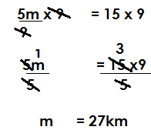 $\frac{5m}{9}$ =15

1. 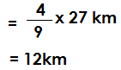What distance had he covered?

Distance =

**Example 4**

In a class of, $\frac{2}{5}$ are boys and the rest are girls, there are 12 girls. How many pupils are in the class?

**Solution.**

Fraction for girls =1 - $\frac{2}{5}$

= $\frac{5}{5}$ **- $\frac{2}{5}$**

= $\frac{3}{5}$

Let the number of pupils be n

$\frac{3}{5}$ of n =12

$\frac{3}{5}$ x n =12

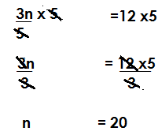 $\frac{3n}{5}$ =12

(b) How many boys and girls are in the class?

**Solution**

No. of boys= $\frac{2}{5}$ x 20

= 8 boys.

**Activity**

1. of a number is 40. Find the number.

2. In a class, $\frac{3}{4}$ are boys, and the rest are girls. If 25 pupils are girls. How many pupils are in the class?

3. In a class, $\frac{4}{5}$ are girls and the rest are boys. If there are 10 boys in the class,

(a) How many pupils are in the class?

(b) How many girls are in the class?

4. On a village, $\frac{5}{12}$ are children and the rest are adults, if there are 140 adults, what is the population in the village?

5. After covering $\frac{4}{9}$ of the journey, Peter’s car got a puncture and he remained with 120km to complete the journey. How long was the journey?

**FINDING REMAINING FRACTIONS GIVEN TWO OR MORE FRACTIONS**

1. Ruth spent $\frac{1}{4}$ of her income on food, $\frac{1}{5}$ on rent and she saved the rest. Find the fraction saved.

**Solution**

1. 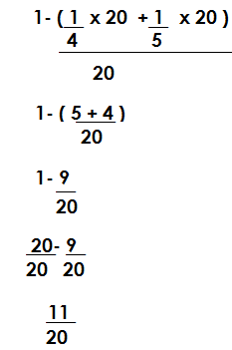( $\frac{1}{4} + \frac{1}{5}$)

(b) If she saved sh. 44,000. How much was her income?

**Solution**

Let the income be n

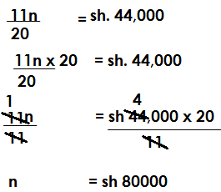 $\frac{11}{20 }$ x n = sh. 44,000

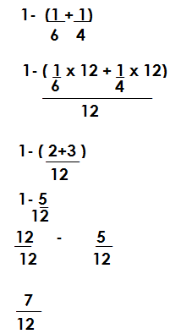In a village, $\frac{1}{6 }$ of the farmers grow beans, $\frac{1}{4}$ grow maize and the rest grow peas. Find the fraction of the farmers who grow peas.

(b) If 21 farmers grow peas, how many farmers are in the villages?

**Solution**

Let the farmers be n

$\frac{14}{24}$ x n =21

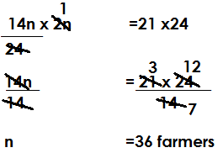 $\frac{14n }{24}$ =21

**Example 3**

Esther spent $\frac{2}{5}$ of his income on fees, $\frac{1}{3}$ on transport and the rest for rent.

(a) Find the fraction spent on rent.

**Solution**

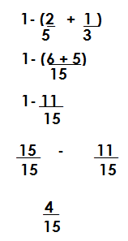

(b) If she spent sh. 112,000 on rent. Find his monthly income.

**Solution**

Let the income be n

$\frac{4}{15}$ x n = sh 12,000

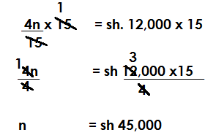 $\frac{4n}{15}$ = sh. 12,000

**Activity**

1. Mande spent $\frac{1}{9}$ of his income on food. $\frac{1}{3}$ on medical and the rest on fees. If he spent sh 60,000 on fees.

(a) Find the fraction for fees.

(b) How much was his income.

2. Rita spent $\frac{1}{4}$ of her salary on food. $\frac{1}{6}$ on fees and the rest on rent.

(a) Find the fraction spent on rent

(b) If she spent sh. 14000 on rent, find her monthly salary.

3. in class, $\frac{1}{3}$ of the children like English, $\frac{1}{3}$ like Maths and the rest like science. If 20 pupils like science, how many pupils are in the class?

4. Kadolo travelled $\frac{1}{4}$ of thejourney by bus, $\frac{1}{6}$ by taxi and he walked 28km. What distance did he cover by bus?

**INTEGERS**

Integers are positive or negative numbers including zero e.g. -3, -2, -1, 0, +1, +2…

**Note;**

Positives are written with a positive/plus sign or without e.g. + 2 or 2, +1 or 1, etc.

Negatives are written with a minus sign e.g. -1, -2, -8, etc.

Zero is neither a positive nor a negative and it is neutral.

**ARRANGING INTEGERS IN ASCENDING AND DESCENDING ORDER**

**Note**: Zero is greater than all negatives.

Any integer on the right is greater than any integer on its left.

**Examples**

1. Arrange -1, 0, -7, 3, -5 in ascending order.



2. Arrange 7, 5, -1, 4, -8, -4 in descending order.



3. Use>, < or = to complete the following statement.

-3 < +3

-7 < -4

-4 > -7

0 < +8

0 > -4

-7 < +4

**Activity**

1. State whether true or false, 0 is less than -2

2. Use >, < or = to complete the following

1. +2_________-2

-6__________0

-20_________+20

+50__________-100

-100__________-1000

+40____________+70

3. Arrange the following as instructed against each.

1. {-2, -4, -6, 0} in ascending order

(ii) {4, 2, 1, 3, 9, +1000} in descending order

(iii) {-6, 12, 8, -8, 7, 0} in a decreasing order

(iv) {-12, -30,0,10, -6} in an increasing order

(v) {-3, -4, +5, 4, -7} in ascending order

(vi) {-100, +10,15, +90} in descending order.

**ADDITIVE INVERSE/OPPOSITE OF INTEGERS**

**Examples**

1. What is the additive inverse of -3?

**Solution**

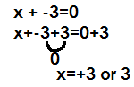Let the inverse be n

2. What is the additive inverse of 440?

**Solution**

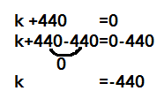Let the additive inverse be k

3. What is the additive inverse –(32x)

**Solution**

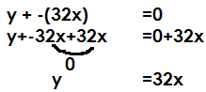Let the additive inverse be y

**Activity**

1. What is the additive inverse of the following?

1. -m 2. -600

3. +100 4. 3k

5. 167y 6. 0

7. -900

**ADDITION AND SUBTRACTION OF INTEGERS WITHOUT A NUMBER LINE**.

**Note:**

**- x - =+, + x += +, -x +=-, + x - = -**

When adding integers with the same sign maintain the sign.

**Examples**

Work out the following

a) +4 + +4

**Solution**

+4 + (+4)

4+4

+8

b) -8 + **-** 5

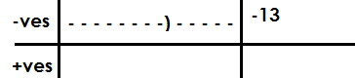 **Solution**

-8-(+5)

-8-5

-13

c) -k + -7k

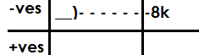**Solution**

-K + (-7k)

-k -7k

-8k

Workout the following

a) 4k + **+**5k

**Solution**

4k + (**+**5k)

4k +5k

9k

b) -4y+ (-5y + (-3y)

-4y-5y-3y

-12y

c) -4+ (-10)

-4 -10

-14

**Activity.**

Workout the following

1. +6 + +6

2. +10 + -4

3. -10 + -2

4. -14m + -16m + -5m

5. -10 +10

6. +7 +3

8. -10 +4

9. -2 +3

**SUBTRACTION OF INTEGERS**

**Examples**

Work out the following

(a) +7 - +8

+7 – (+8)

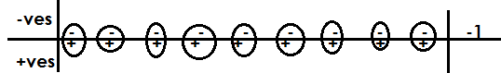 +7-8

-1

(b) -8 - -10

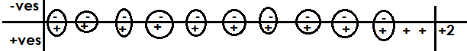 -8 – (-10)

-8 +10

+2

(c) -5y - +10y

-5y – (+10) y

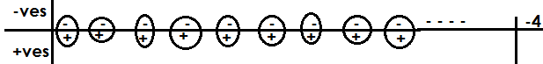 -5y – 10 y

-15y

(d) 9-13

9-13

-4

**Activity.**

Workout the following

1. 5 -2

2. 2-5

3. 4 - +10

4. 5- 10

5. -1 -2 -3

6. 11- -13

7. 14n - -16n

8. -7 - -13

9. -4 -11- +2

**ADDITION OF INTEGERS USING A NUMBER LINE.**

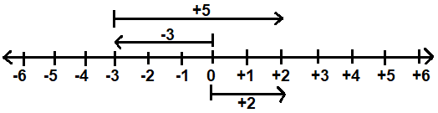1. Add: -3 + +5 using a number line.

**-**3 + **+**5 = **+**2

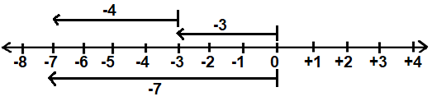2. Add: -3 + -4 using a number line.

**-**3 + **-**4 = **-**7

3. Workout +4 + -11 using number line

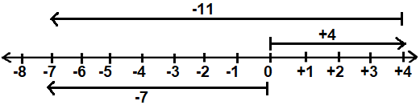

**+**4 + **-** 11 = **-**7

**Activity.**

Workout the following using a number line

1. -4 + +7

2. 7 + -4

3. -5 + -4

4. -9 +6

5. 6+ -10

6. 7 + -2

**SUBTRACTION OF INTEGER USING A NUMBER LINE.**

**Note:**

* When subtracting, the two arrows begin from a common point.
* An answer arrow is drawn from where the last integer arrow ended to where the first integer arrow ended.

**Examples**

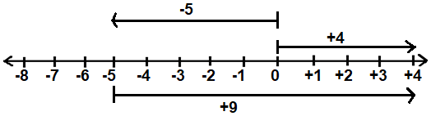1. Workout 4 - **-**5 using a number line.

4 - **-** 5 = **+**9

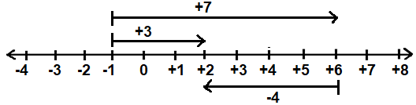2. Subtract +3 - +7 using a number line.

+3 - +7 = **-**4

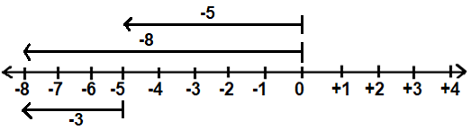3. Workout **-**8 - **-**5 using a number line.

**-**8 - **-**5 = **-**3

**Activity.**

Subtract the following using a number line

(a) -3 - -7

(b) 4 - -5

(c) -5 - +5

(d) -4 - -5

(e) -6 - -5

(f) 5 - -5

(g) -6 -5

(h) -4 - -6

**MATHEMATICAL STATEMENTS**

**Addition mathematical statements.**

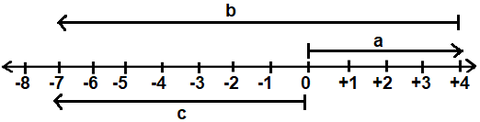1. Write down the mathematical statements shown on the number line below.

a + b = c

**+**4 + **-**11 = **-**7

2. Write the mathematical sentence represented on the number lie below.

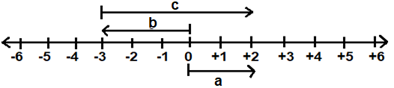

b + c = a

**-**3+ **+**5 = **+** 2

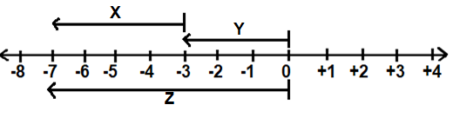3. Write the mathematical statement represented by the above number line.

Y + X = Z

**-**3 + **-** 4 = **-**7

**Activity.**

Write the mathematical statement represented on the number lines below.

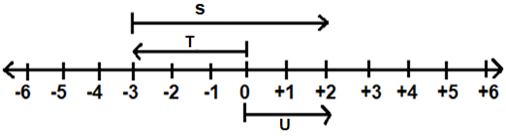

a)

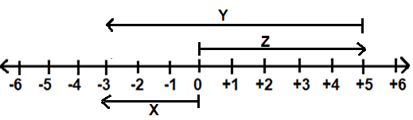b)

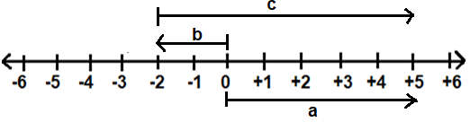c)

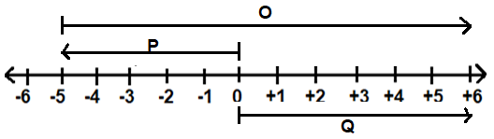d)

**Subtraction mathematical statements**

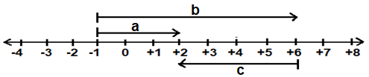1. Write down the mathematical statements shown on the number line below.

a – b = c

**-**3 - **+**7 = **-**4

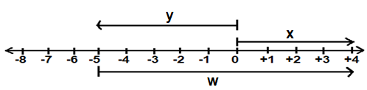2. Write down the mathematical statements shown on the number line below.

x – y = w

**+**4 - **-**5 = **+**9

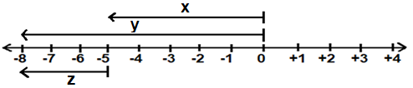 3. Write down the mathematical statements shown on the number line below.

y – x = z

**-**8 - **-** 5 = **-**3

**MULTIPLICATION OF INTEGERS ON A NUMBER LINE**

**Note:**

* 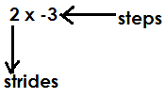Given2 x **-**3, 2 represents number of strides/ laps/groups and -3 represents number of steps. That is to say;

* 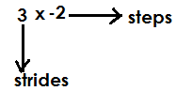Given **-**2 x3, first rewrite starting with a positive i.e. 3 x **-**2

0

**Examples**

Workout 2x-3 using a number line

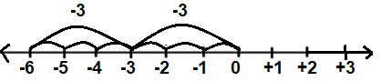

2x -3 = -6

Workout: -2 x4 using a number line.

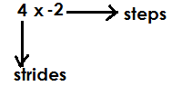-2 x4=

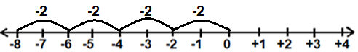

-2 x 4= -8

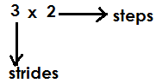Using a number line, workout 3x2

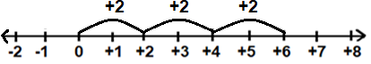

3x2=+6

**Activity**

1. Workout the following using a number line.

(a) 2 x 3 (b) 4 x 3 (c) 3 x **-**3 (d) 2 x **-**3 (e) 5 x **-**2

(f) **-**3 x 4 (g) **-**5 x 2 (h) **-**2 x 5 (i) **-**4 x 2

**DIVISION OF INTEGERS**

**Note:**

**1. + ÷ + = +**

**2. - ÷ - =+**

**3. - ÷ + = -**

**4.** **+ ÷ - = -**

The division of like signs gives **+**

The division of unlike signs gives **–**

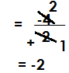1. Divide **-**4 ÷ **+**2

2. Workout: **-**10 ÷ **-**2

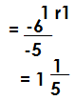3. Workout: -6 ÷ -5

**Activity**

Workout the following

(a) +10 ÷ +2 (b) +100 ÷ +10 (c) -16 ÷ -4 (d) -4 ÷ -16

(e) -39 ÷ -3 (f) -25 ÷ +5 (g)-18 ÷ -5 (h) + 23 ÷ -4

**APPLICATION OF INTEGERS**

1. Add: 4x to -5x

**-**5x + 4x

**-**1

2. Subtract: -2y from 20y

20y-(**-**2y)

20y + 2y

22y

3. A hot metallic rod at 400c was cooled in a refrigerator after 2 minutes, the temperature was 150c. How many degrees did the rod lose?

+400c -150c

250c

4. A fruit seller had 100 oranges, he sold off 60 oranges and later bought 150 more oranges. How many oranges does he have now?

100-60 +150

(100 +150)- 60

250 -60

190 oranges

5. The temperature of a place was 200F. If it dropped by 230c, what is the temperature of the place now?

**Solution**

**+**200F – (**+**230F)

**+**200F - 230F

**-**30F

6. A man was born in 30BC and he died in 20Ad. How old was he?

**Solution**

AD-BD

20 – (-30)

20 +30

50years

**Activity**

1. Add: 2k to -9k

2. Subtract: 7 from 11

3. Subtract -4 from 9

4. All’s weight dropped by8kg from 52kg. Find his weight.

5. Musa moved 3 steps backwards and other 7 steps forward. Find his position.

6. Apatient’s temperature dropped by 20c from 380c. Find the patients temperature now.

7. Moses was born in 45bc and died in 25 ad. How old wasMoses.

8. A man was born in 60 BC. If he died at 90 years, find his year of death.

9. Given that a man died at 48 years old. If he died in 15 AD, when was he born?

10. A teacher moved 4 steps forward,6 steps backwards and after 3 steps forward. At what integer was the teacher standing.

**RATIOS AND PROPORTION**

Proportion is a way of comparing two different things in terms of quantity.

Proportions is divided into three

(a) Direct proportion

(b) Indirect proportion/inverse proportion

(c) Constant proportion

Direct proportion

**Note:**

* Formation of scale is important.
* What we are looking for must be on the right and what we have been given on the left.
* In direct proportion, the equivalence of (1) is got by dividing what is on the right by what is on the left of the scale.

**I = $\frac{R}{L}$**

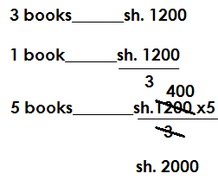1. Three books cost sh.1200. Find the cost of 5 such books.

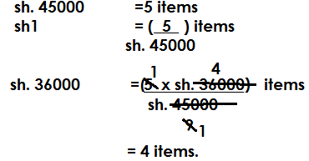2. At a shop, the cost of 5 items is sh. 45000. How many items will one get from sh. 36000?

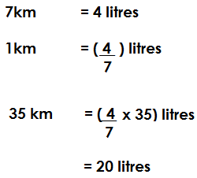3. Kato’s car consumes 4 litres of petrol every 7km. How many litres of petrol will it consume to cove 35km?

4. If 6 dresses cost sh.18, 000, how many dresses will Owino get from sh. 12,000.

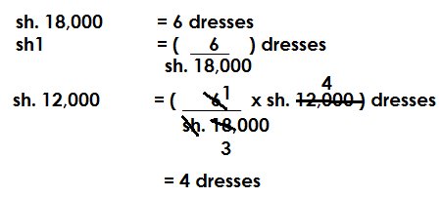

**Activity**

1. Four pens cost sh.2000. Find the cost of 9 such pens

2. Given that 7 items cost sh. 35000, what is the cost of 5 such items?

3. The bus fare for 3 people is sh. 21000. What is the fare for 5 people in such a bus?

4. The cost of 6 buckets is sh. 54000. Find the cost of 2 similar buckets.

5. The cost of 4 items in a shop is sh.48, 000. How many items can a person with sh. 3600 get?

6. In a market, 5tomatoes cost sh. 1500. How many tomatoes can a person buy with sh. 1800?

7. A dozen of sweets costs sh.3600. How much money is needed to pay for a quarter dozen?

8. A vehicle consumes 7 litres of petrol to cover a distance of 15km. how many litres of petrol will it consume to over a distance of 135km.

(b) If 3 litres cost sh. 12, 000, how much was spent on petro to cover that distance.

9. A taxi carries 14 passengers per trip. How many trips will it make to carry 392 passengers?

**EXCHANGE RATES**

Exchange rate is the value of a country’s currency in another country.

1. Given exchange rates at the forex bureau

1 dollar ($) ___________Ugsh. 3000

 1 pound ( ) _________Ugsh. 4000

Ksh. 1 _________________Ugsh. 25

(a) A trader had 120pounds. How much in Uganda shillings did he get at the bureau?

**Solution**

1 pound-------------ush4000

120 pounds------------ushs4000x120

------------ushs480,000

(b) Panda had ush. 4, 800, 000. How many dollars did he get at the forex bureau?

**Solution**

Ugsh. 3000------------1dollar

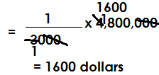 Ugsh. 1-------- ($\frac{1}{30000}$) dollar

Ugsh. 4,800,000=

(c) Ricardo had 120 pounds. How many dollars did he get at the forex bureau?

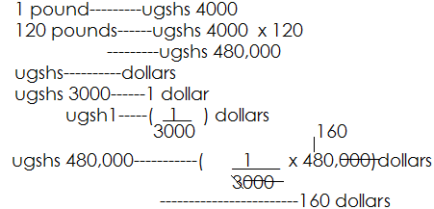

2. Below is a table showing exchange rate of different currencies at the forex bureau.

1ksh--------Ugsh. 30

1 pound----Ugsh. 4500

1 dollar ----- Ugsh. 2500

(a) A trader entered Uganda with 480 dollars. How much in Ksh. did he get?

**Solution**

1 dollar-------Ugsh. 2500

480 dollars-----Ugsh. 2500 x 480

-------Ugsh. 1,200,000

Ugsh. 30------1ksh

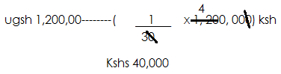 Ugsh 1-------- $\frac{1}{30}$ ksh

(b) A tourist had 46 pounds. How much in Ugandan shillings did he get at the forex bureau?

1 pound--------Ugsh. 4500

46 pounds------Ugsh. 4500 x46

----------Ugsh. 207 000

(b) Bazibu had Ugsh. 1,350,000. How many pounds did he get at the bureau?

**Solution**

Ugsh. 4500--------1 pound

Ugsh. 1--------- ($\frac{1 }{4500}$) pound

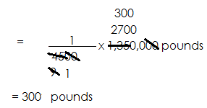Ugsh. 1,350,000-------

At Kamukamu forex bureau the exchange rates are as follows.

Kshs---------Ugsh. 25

1 dollar-------Ugsh. 3000

1 pound------Ugsh. 4000

(a) Musa entered Uganda with Ksh. 2500. How much money did he get at the forex bureau?

**Solution**

Kshs1-------Ugsh. 25

Kshs--------Ugsh. 25x 2500

--------Ugsh. 52500

(b) Mugoya had Ugsh. 1,200,000. How many dollars did he get at the forex bureau?

**Solution**

Ugsh. 3000------1 dollar

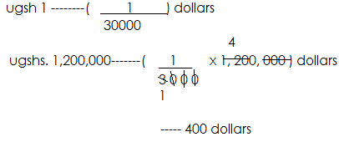

(c) Sharif entered Uganda with 360 pounds. How much in Kenya shillings did he get at the forex bureau?

 **Solution**

1 pound------- Ugsh. 4000

360 pounds-----Ugsh. 4000 x360

-------Ugsh. 1,440,000

Ugsh. 25--------Ksh 1

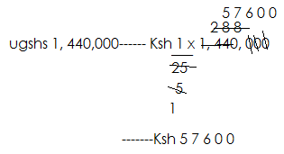 Ugsh. 1---------Ksh $\frac{1}{25}$

**Activity**

1. The exchange rates at the forex bureau are as follows

1 dollar---------Ugsh. 2200

Ksh 1 -----------Ugsh. 30

(a) How much in Uganda shillings can one exchange with 200 dollars.

(b) Kamba had Ugsh. 198,000. How much in dollars did he get at the forex bureau?

2. Given the exchange rate at the forex bureau

1 dollar-------Ugsh. 2500

1 Ksh-------24

(a) How much money in Uganda shillings will I get from the bureau if 1 have 120 dollars?

(b) Okello had 72,000 Ugsh, how much in Ksh did he have?

(c) If a trader had Ksh 12, 000, how many dollars did he get from the forex bureau?

3. Given the exchange rates below

1 dollar ( $) ------Ugsh. 2500

I Ksh --- 24

(a) How much money in Uganda shillings will I get from the bureau if I have 120 dollars?

(b) Okello had 72,000 Ugsh, how much in Ksh did he have?

(c) If a trader had Ksh 12,000, how many dollars did he get from the forex bureau?

3. Given the exchange rates below

1 dollar ( $ )--------Ugsh. 3000

Ksh 1 ------Ugsh. 25

(a) Modomodo entered Uganda with 600 dollars. How much in Kenya shillings did he have?

(b) Madat had Ugsh. 10, 800, 000. How many dollars did he get after the exchange?

**EXCHANGE RATE TABLE.**

The table below show the buying and selling rates of different currencies at Pikipiki forex bureau.

|  |  |  |
| --- | --- | --- |
| Currency | Buying | Selling |
| Ksh1 | Ugsh. 40 | Ugsh. 50 |
| 1 Pound | Ugsh. 4000 | Ugsh. 4500 |
| 1 dollar | Ugsh. 2500 | Ugsh. 3000 |

(a) Odama entered Ugandan with 360 dollars. How much in Uganda shillings did he get at the forex bureau?

1 dollar------Ugsh. 2500

360 dollars-------Ugsh. 2500x360

-----Ugsh. 900,000

(b) Mandela had Ugsh. 7,200,000. How much in Kenya shillings did he get at the forex bureau?

Ugsh 50-------Ksh1

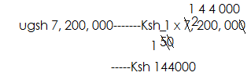 Ush1----------Ksh $\frac{1}{50}$

(c) James entered Uganda with 36,000 dollars. How many pounds did he get at the forex bureau?

 **Solution**

1. dollar--------Ugsh 2500

36,000 dollars-------Ugsh. 2500x 36,000

-------Ugsh. 90,000,000

Ugsh 45--------1 pound

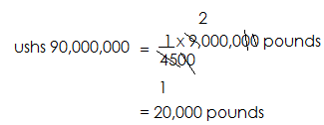Ugsh. -------( $\frac{1}{4500}$) pounds

Ugsh. 90,000,000--------

The table below shows the buying and selling rates at Quality forex bureau.

|  |  |  |
| --- | --- | --- |
| Currency | Buying | Selling |
| Ksh1 | Ugsh. 20 | Ugsh 30 |
| 1 pound | Ugsh. 3000 | Ugsh. 4000 |
| 1 dollar | Ugsh. 2000 | Ugsh. 2500 |

(a) A trader had Ugsh. 120,000. How much in Kenya shillings did he get at the Bureau?

Solution

Ugsh. 30------Ksh 1

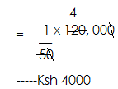 Ugsh. 1-------Ksh $\frac{1}{5}$

Ugsh. 120,000-------Ksh

(b) A trader had 600 pounds. How much in Uganda shillings did he get?

**Solution**

1 pound ------Ugsh. 3000

6000 pounds-------Ugsh. 3000x 600

---------Ugsh. 1,800,000

(c) Wambuzi had 180 dollars. How much in Kenya shillings did he get at the forex bureau?

 **Solution**

1 dollar-------Ugsh 2000

180 dollars------Ugsh. 2000x 180

----------3,600,000

Ugsh 30----------Ksh 1

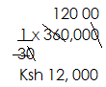 Ugsh 1-----------Ksh $\frac{1}{30}$

Ugsh. 360,000------Ksh.

**Activity**

1. The table below shows the buying and selling rates of different currencies at crane forex bureau.

|  |  |  |
| --- | --- | --- |
| currency | buying | selling |
| Ksh | Ush 30 | Ush 40 |
| 1 pound | Ush 3000 | Ushs 4000 |
| 1 dollar | Ushs 2000 | Ushs 2500 |

(a) Ouma had ush 4,800,000. How many dollars did he get at the forex bureau?

(b) A tourist had Ksh 12,000. How many pounds did he get at the forex bureau?

(c) Kwagala had ush 420,000. How much in Kenya shillings did he get at the forex bureau?

2. The table below shows the buying and selling rates of different currencies at Pakapaka forex bureau.

|  |  |  |
| --- | --- | --- |
| currency | buying | selling |
| Ksh | Ush20 | Ush30 |
| Us dollars( $ ) | Ush2000 | Ushs2500 |
| R. Franc | Ushs10 | Ushs15 |
| Pounds( ) | Ushs 4000 | Ushs 4200 |
| TZsh | Ushs 40 | Ushs 42 |

(a) Wandela had 120 dollars. How much in Uganda shillings did he have?

(b) A trader entered Uganda with 52 pounds. How much in Uganda shillings did he get?

(c) Mr.Otti had ushs 200,000. How much in dollars did he have?

(d) Sowedi had TZ sh 180,000. How much in Kenya shillings did he get?

**INDIRECT PROPORTIONS/ INVERSE PROPORTION**

In indirect proportion, the equivalence of one is got by multiplying what is on the right by what is on left.

1. 4 men take 6 minutes to clean the compound. How many men can clean the same compound in 8minutesS?

Solution

6mins--------4 men

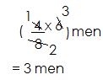 1 min----- (4x6) men

8min--------

2. 6 girls take 8 min to mop the class. How long will 12 girls take to do the same task?

**Solution**

6 girls--------8 min

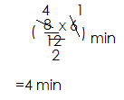 1girl------------ (8x6) min

12 girls--------

3. 12 boys take 6 hours to slash the compound. How many more boys are needed to slash the same compound in 2 hours.

Solution

6 hours-----12 boys

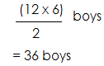 1 hour ------- (12x6) boys

2 hours-------

More boys------- (36-12) boys

--------- 24 more boys

4. A factory employs 10 workers to do a piece of work in 6 hours. One day 6 workers fell sick. How many hours did the remaining workers take to accomplish the task assigned?

**Solution**

10 – 6 = 4 workers

10 workers--------6 hours

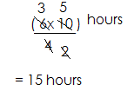 1 worker-------- (6x10) hours

4 workers-----

**Activity**

1. 3 men can do a piece of work in 6 days. How long will l 9 men take to do the same piece of work?

2. 4 boys take 9 minutes to offload a lorry. How many more boys are needed to do the same job in 6 minutes?

3. 5 children take 4 days to dig the garden. Hoe many days will ten children take?

4. 7 girls take 28 mins to wash a basket of clothes. How many more girls are needed to wash the same basket in 4 minutes?

5. 2 children can dig the school garden in 8 days. How many children can dig the same garden in 4 days.

6. 5 boys can mop a room in 10 hours five boys joined the group. How many less hours did they take?

**RATIOS**

A ratio is a number representing a comparison between two or more different things.

**EXPRESSING RATIOS AS FRACTIONS**

Express the following ratios as a common fraction

(a) 2:5

= $\frac{2}{5}$

(b) 6:5

= $\frac{6}{5}$

(c) 11:4

= $\frac{11}{4}$

Example II

The ratio of male to female in a group is 5:9. Express this as a fraction

**solution**

As a fraction = $\frac{5}{9}$

**Activity**

Express the following ratios as fractions

(a) 3:4 (b) 11:13 (c) 2:5 (d) 3:8 (e) 11:5

2. The ratio of sheep to goats to cows on Mukasa’s home is 3:4:5 respectively.

(i) What is the fraction of sheep to goats?

(ii) What is the fraction of goats to cows?

(iii) What is the fraction of sheep to cows?

(b) Express ratio 7:8 as a fraction.

**EXPRESSING FRACTIONS AS RATIOS**

**Note**:

Ratios must be in their lowest terms i.e. there should be no common factors between the given ratios. Express the following fraction as ratios.

(i) $\frac{2}{7}$

**Solution**

2:7

(ii) $\frac{6}{11}$

**Solution**

As a ratio= 6:11

(iii) $\frac{9}{12}$

 **Solution**

(iv) $\frac{8}{20}$ Fraction= $\frac{8}{20}$

As a ratio=4:5

**Activity**

1. Express the following fractions as ratios.

(a) (b) (c) (d)

2. In a village $\frac{6}{11}$ are female and the rest are male.

(a) What ratio of the whole village are female?

(b) What ratio of the whole village are males?

**EXPRESSING QUANTITIES AS RATIOS**

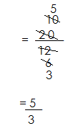1. In a class, there are 20 boys and 12 girls. Find the ratio of boys to girls in the class.

As a fraction=

As a ratio= 5:3

(b) Express the number of girls as a ratio of boys

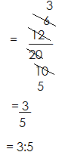 As a fraction =

(c) Express the number of boys as a ratio of the total number of pupils

Total number of pupils = 20 +12

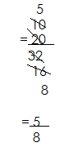 = 32

As a fraction

As a ratio =5:8

There are 18 boys and 24 girls in a class. What is the ratio of boys to girls?

**Solution**

As a fraction=

(b) What is the ratio of girls to boys?

 **Solution**

As a fraction=

As a ratio= 4:3

Express 40 min as a ratio of 2 hours

**Solution**

1hour= 6- min

2 hours= (60x2) min

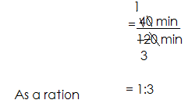 = 120min

As a ratio

Express 1 gross as a ratio of 3 dozens

Solution

1 gross=144 items

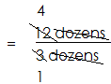 1 gross= 12 dozens

As a fraction=

As a ratio=4:1

**Activity**

(b) A woman had 36 tomatoes but 9 of them were rotten.

(a) What is the ratio of the good to the rotten tomatoes?

(b) What is the ratio of the spoilt tomatoes to the total number of tomatoes?

(2) In a village, 40 farmers grow beans, 30 grow maize and 60 grow cabbage.

(i) Find the ratio of the farmers who

(i) Grow cabbages to those who grow maize

(ii) Grow beans to those who grow cabbages

(iii) Grow beans to the total number of farmers.

3. Express 600 metres as a ration of 2km

4. Express 48 books as a ratio of 1 gross

5. Express 3 days as a ratio of 3 weeks.

6. Express 250g as a ratio of 1kg

7. Express 36years as a ration of a decade.

**INCREASING QUANTITIES USING RATIOS**

**NB:**

When increasing quantities using ratios, the biggest share part is made a numerator of the fraction formed.

**Example 1**

Increase sh. 2000 in the ratio of 5:4

**Solution**

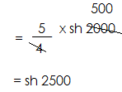 Fraction of given ratio= $\frac{5}{4}$

New amount=

**Example 2**

A school increased the price of uniforms from sh. 8000 in a ratio of 11:10. What is the new price of the uniforms?

**Solution**

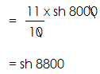Fraction= $\frac{11}{10}$

The new price is sh. 8.800.

**Example 3**

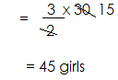A class has 30 girls. The number of girls increased in the ratio of 3:2.

New number=

**Example 4**

The amount of milk got from a cow was 150 litres a week but there is an increase in a ratio of 5:3. How much milk does the cow give?

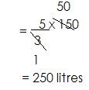**Solution**

**Activity**

1. Increase sh. 300 in the ratio of 2:1

2. Increase 240 in the ratio of 3:2

3. Increase sh. 4800 in the ratio of 5:4

4. The number of pupils in a school is 800. This year it has increased in the ratio of 6:5. How many pupils are in the school this year?

5. John’s farm had 900 cows. The cows increased in the ratio of 4:4. How many cows are on his farm now?

6. Mande’s monthly salary is sh. 9,000,000. If his salary was increased in the ratio of 4:4. What is his new salary?

**DECREASING QUANTITIES IN RATIOS**

**NB:**

When decreasing quantities using ratios, the smallest share part is made a numerator of the fraction formed.

**Example 1**

Decrease 400 in a ratio of 3:4

**Solution**

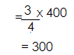 Decrease= $\frac{3}{4}$

New number=

**Example 2**

The price of a pair of shoes is sh. 20,000. If it decreased in the ration 3:4. Find the new price.

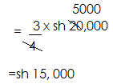 Fraction= $\frac{3}{4}$

New price=

**Example 3**

An article used to cost sh. 4000. The price decreased in the ratio of 2:5. What is the new cost of the article?

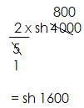 Fraction= $\frac{2}{5}$

New price =

**Example 4**

Decrease 600 litres in a ratio of 3:4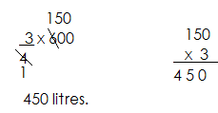

**Activity**

1. Decrease 600 in ratio of 2:3

2. Decrease 1400 books in the ratio 3:5.

3. Musa had sh. 100, which decreased in the ratio 3:4. How much money is john left with?

4. Tom’s goats decreased from 300 I the ratio of 3:5. What is the new number.

5. Decrease 8000 in the ratio of 8:10

6. Decrease sh. 49000 in the ratio of 2:7

**FINDING THE RATIO OF INCREASE OR DECREASE**

**Example 1**

The price of a pen was 500 it was increased to 800.

(a) In what ratio did it increase?

New old

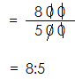 800 : 500

As a fraction=

**Example 2**

The number of books in a school reduced from 840 books to 1400. In what ratio did thy reduce?

New old

1400 : 840

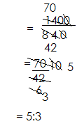

Fraction=

**Example 3**

The number of pupils in a school is 400 this year. The following year 80 pupils joined. In what ratio did it increase?

New= 400+80

=480

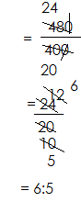 Old=400

Fraction=

**Example 4**

John had 100 eggs on his way to the market 20 eggs got broken. What was john’s ratio of decrease?

**Solution**

New= 100-20

= 80

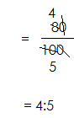Old=100

Fraction=

**Activity**

1. The price of a shirt was increased from sh. 4500 to sh. 5000. In what ratio was the increase?

2. In what ratio should Eva’s salary of sh. 82,000 be decrease to become

Sh. 60,000?

**SHARING QUANTITIES USING RATIOS**

**Examples**

The ratio of boys to girls in a class of 45 pupils is 2:3 respectively.

(a) Find the number of boys and girls in class.

Total ratio= 2+3

=5

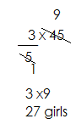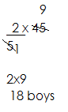 Boys girls

(b) How many more girls are in class than boys?

More=3-2

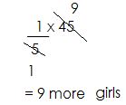 =1

2. A, B and C shared sh. 120,000 in the ratio of 2:5:3 respectively.

(a) How much did each get?

Total ration= 2+5+3 =10

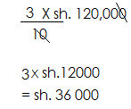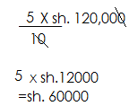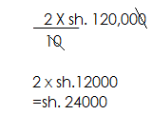A B C

(b) How much more money did B get than C?

More= 5-3

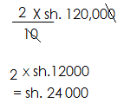 =2

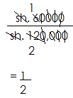(c) Express B’s share as a fraction of the total amount shared.

3. Ail, Alex and Allan contributed sh. 180,000 towards the start of a business in the ratio 3:2:5 respectively.

(a) How much money did each contributes?

Total ratio = 3+2+5

=10

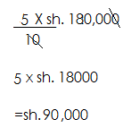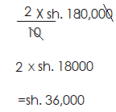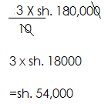 Ali Alex Allan

(b) How much more money did Allan contribute than Alex

More = 5-2

 = 3

=

4. Opio, Ouma and Okello shared 36 sweets in the ratio of 1:2:3 respectively.

(a) How many sweets did each get?

Total ratio =1+2+3

=6

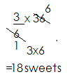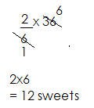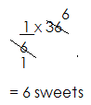 Opio Ouma Okello

(b) How many more sweets did Okello get than Opio?

More= 3-1

 =2

**Activity**

1. In a class of 48 pupils, the ratio of girls to boys is 3:5 respectively.

(a) Find the number of girls and boys in the class.

(b) How many more boys are in class than girls?

2. Musa and Ali shared 25 pens in the ratio of 2:3 respectively. How many pens did each get?

3. Mark, Marco and Mercy shared 240,000 in the ratio of 2:3:5 respectively.

(a) How much did each get?

(b) How much more money did mercy get than Mark?

4. The school enrolment comprising of boys, girls and teacher is in the ratio of 1: 4:5 respectively.

(a) If there are 1200 people, how many boys, girls and teachers are there?

(b) How many more boys are there than girls?

(c) Express the number of girls as a fraction of the total number of people in the school?

5. Allen, Alice and Alexis contributed half million shillings in the ratio of 5:2:3 respectively.

(a) How much money did each contribute?

(b) How much more money did Allen contribute than Alice?

(c) Write Alice’s contribution as a fraction of the total contribution.

**FINDING TOTAL QUANTITY SHARED IN A GIVEN RATIO**

1. In a class, the ratio of boys to girls is 2:3 respectively.

(a) If there are 27 girls, how many pupils are in class?

Total ratio= 2+3

=5

Let the number of pupils be k

$\frac{3}{5}$ of k= 27

$\frac{3}{5}$ x k =27

$\frac{3k}{5}$ =27

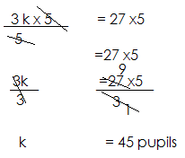

(b) How many more girls are in class than boys?

More = 3-2

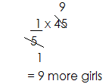

2. Aaron, Alvin and Alex shared some money in the ratio of 2:3: 5 respectively. If Alvin got sh. 18000,

(a) How much did they share altogether?

Total ratio= 2+3+5

=10

Let the total amount shred be k

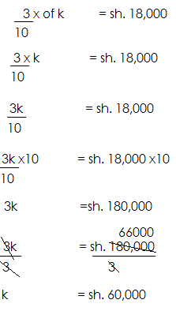

(b) How much more money did Alex get than Aaron?

More= 5-2

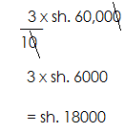 =3

3. A man gave some sweets to his three children. Abe and Abu in the ratio of 2: 3: 4 respectively. If Aba got 32 sweets.

(a) Total ration=2+3+4

=9

Let the total number of sweets be k

$\frac{2}{9}$ x k =32

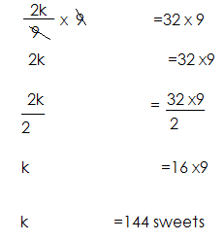 $\frac{2 k}{9}$ =32

1. How many more sweets did Abu get that Abe?

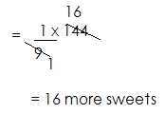More= 4-3

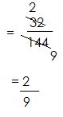(d) Express Aba’s number of sweets as a fraction of the total number of sweets

**Activity**

1. The ratio of boys to girls in a class is 4:5 respectively. If there are 36 boys, how many pupils are in class altogether?

2. The ratio of cows to goats on Mugisha’s farm is 6:7 respectively. If there are 490 goats;

(a) How many animals are on the farm?

(b) How many more goats are on the firm than cows?

3. Tom, Sarah and Annet shred some money in the ratio of 2:3: 5 respectively. If Sarah got sh. 24,000,

(a) How much did they share altogether?

(b) How much more did Annet get than Sarah?

4. Some money was contributed by a b and c in the ratio of 3:4:5 respectively. If B contributed sh. 360,000,

(a) How much money did they contributed altogether?

(b) How much more did c contribute than A?

(c) What fraction of the money did A contribute?

5. On a farm, the ratio of cows, goats and sheep is 3:2:4 respectively. If there are 720 cows,

(a) How many animals are on the farm?

(b) How many more sheep are on the farm than cows?

(c) What is the fraction of cows on the farm?

**MORE ABOUT FINDING QUANTITIES SHARED IN RATIOS**

1. The ratio of women to men in a meeting is 3:5. If there were more 24 men than women, how many people attended the meeting?

Total ratio= 3+5

8

More =5-3

= 2

Let the total number of people be k

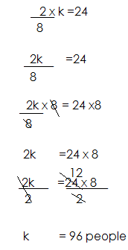

2. The ratio of Mukasa to Mukisa to Mubezi’s share is 2:3:5 respectively. If Mubezi got sh. 12000 more than Mukasa,

(a) How much did they share altogether?

Total ratio = 2+3+5

=10

More = 5-2

=3

Let their total share be k

$\frac{3}{10 }$ of k =sh. 12000

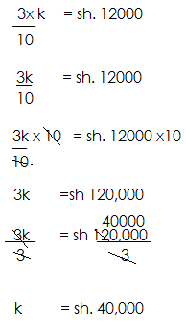

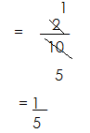(b) What fraction of the money did Mukasa get?

(c) How much more did Mukisa get than Mukasa

More = 3-2

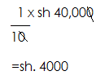 =1

3. At a party the ratio of children to men to women was 5:2:3 respectively. If there were 42 more children than women;

(a) How many people attended the party?

Total ratio = 5+2+3

10

More = 5-3

2

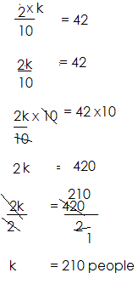 Let the total number of people be k

(b) How many less men attended the party than children?

Less=5-2

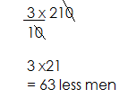 3

**Activity**

1. The ratio of male teachers to female teachers is 4:5, if there are 19 more female teachers than male, how many teachers are there altogether?

2. In a class the ratio of girls to boys is 25. If there are 12 more boys than girls, how many pupils are in class?

3. Opio, Okello and Oketch shared some money in the ratio of 2:3:5 respectively. If Oketch got sh. 27,000 more than Opio,

(a) How much did Oketch get than Okello?

4. P.5, P.6 and P.7 have the number of pupils in the ratio of 4:3:2 respectively. If there are 22 more pupils in p.5 than p.7

(a) Find the total number of pupils in the three classes.

(b) How many more pupils are in p.6 than p.7?

(c) Find the fraction of pupils in p.6

5. A fruit seller sold oranges, tomatoes and apples in the ration of 4:5:3 respectively. If he sold more 38 kg of tomatoes than apples.

(a) Find the total number of kg of fruits sold.

(b) How many more kgs of oranges did he sell than apples?

(c) Express the number of kgs of oranges sold as fraction of the total number of kgs sold altogether.

**PERCENTAGES**

A percentage is fraction with a denominator as 100

A percentage is a number out of hundred (100)

The symbol for percent is %

**EXPRESSING FRACTION AS PERCENTAGES**

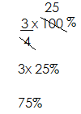1. Change $\frac{3}{4}$ into percentage

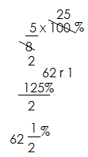2. Change $\frac{5}{8}$ into percentage

3. Change 1 $\frac{1}{2}$ into percentage

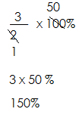 1 $\frac{1}{2}$ = $\frac{3}{2}$

**Activity**

Express the following as percentages

(a) $\frac{4}{5}$ (b) $\frac{3}{5}$ (c) $\frac{7}{10}$ (d) $\frac{1}{4}$

(e) $\frac{11}{20}$ (f) $\frac{3}{7}$ (g) $\frac{5}{6}$ (h) $\frac{9}{11}$

(i) 2 $\frac{1}{2}$ (j) $\frac{4}{3}$

**Expressing percentages as fractions**

1. Change 80% into a fraction

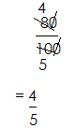 80% =

2. Express 25% as a fraction

25%=

3. Express 25 % as a fraction

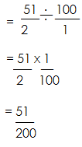 25 % = %

4. Change 12 $\frac{1}{3}$% into a fraction

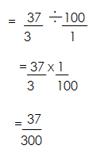 12 $\frac{1}{3}$% = $\frac{37}{3}$%

1. Convert 12 $\frac{1}{2}$% to a fraction

12 $\frac{1}{2}$% = $\frac{25}{2}$%

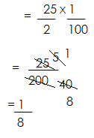= $\frac{25}{2}$ ÷ $\frac{100}{1}$

**Activity**

Express the following percentages as fractions

(a)40% (b) 75% (c) 50% (d) 85% (e) 15% (f) 60%

(g) 4 $\frac{2}{5}$% ( h) 62 $\frac{1}{2}$% (i)45 $\frac{1}{2}$% (j) 33 $\frac{1}{3}$%

**CHANGING DECIMALS INTO PERCENTAGES.**

1. Change 0.6 into percentage

0.6 =

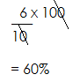

2. Express 0.03 as a percentage

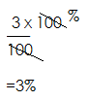 0.03=

3. Convert 1.2 to percentage

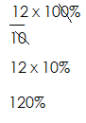 1.2 = $\frac{12}{10}$

**Activity**

Change the following decimals into portages

(a) 0.9 (b) 0.8 (c) 0.5 (d) 0.07 (e) 0.48

(f) 1.25 (g) 5.4 (h) 1.44

**EXPRESSING PERCENTAGE AS DECIMALS**

1. Write 60% as a decimal

60% =

2. What is 8% as a decimal?

8% =

= 0.08

3. Change 0.6% into decimal

0.6% = $\frac{6}{10}$ ÷ $\frac{100}{1}$

$\frac{6}{10}$ × $\frac{1}{100}$

$\frac{6}{1000}$

=0.006

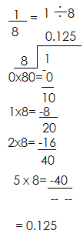4. Convert 12 $\frac{1}{2}$% to a decimal

12 $\frac{1}{2}$% = $\frac{25}{2}$ ÷ $\frac{100}{1}$

 $\frac{25}{2}$ × $\frac{1}{100}$

**Activity**

1. Express the following percentages as decimals.

(a)40% (b) 55% (c) 0.8% (d) 0.12%

(e) $\frac{1}{2}$% (f) $\frac{4}{5}$% (g) 62 $\frac{1}{2}$% (h) 33 $\frac{1}{2}$%

**EXPRESSING RATIOS AS PERCENTAGES**

1. Change 2:3 into percentage

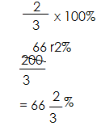 2:3 =

2. Express 3:4 as a percentage

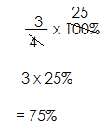 3:4 =

3. Convert 1:3 to percentage

1:3 =

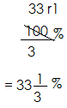 X 100%

4. Change 2:5 into percentage.

2:5 = $\frac{2}{5}$

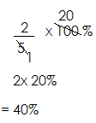 $\frac{2}{5}$ X 100%

**Activity**

1. Change the following ratio into percentages

(a) 1:2 (b) 9:10

(c) 11:20 (d) 4:5

(e) 3:7 (f) 5:6

(g) 7:9 (h) 1:8

**EXPRESSING PERCENTAGES AS RATIONS**

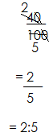1. Change 40% into ratio

40%=

2. Express 15 % into a ratio

15 % = ÷

= x

=

= 31:200

3. Write 33 % as a ratio

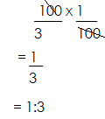 33 % = ÷

4. What is % as a ratio?

% = ÷

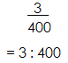 = ×

**Activity**

1. Change the following percentages into ratios

(a) 30% (b) 99%

(c) 55% (d) 75%

(e) $\frac{1}{3}$% (f) $\frac{4}{5}$%

(g) 12 $\frac{1}{2}$% (h)62 $\frac{1}{2}$%

**FINDING THE REMAINING PARTS OF THE PERCENTAGES**

1. In a class, 80% are boys and the rest are girls. Find the percentage for girls

**Solution**

Let the percentage for girls be n

n+80%=100%

n+80%-80%= 100%-80%

n =20%

2. A child read 25% of a book on Monday. 38% on Tuesday and 16% on Wednesday. What percentage is left to be read?

**Solution**

Let the percentage left be k

K+25% +38% +16%=100%

K+79% =100%

K+79% -79% =100% -79%

K =21%

3. 30% of the vehicles in town are white. 35% are red cars and the rest are black. Find the percentage of black vehicles

Let the percentage for black cars be m

M+30% +35%= 100%

M+65% =100%

M+65%-65% =100%-65%

M =35%

**Activity**

1. A child ate 45% of the cake. What percentage of the cake remained?

2. Mr. Opio sold 60% of his land. What percentage of the land was left?

3. If 10% of a mixture is water and 35% is milk, what percentage is the other content?

4. On a shamba, 20% of the crops are coffee trees, 25% are banana trees and 35% are cotton tress. What percentage is left for other trees?

5. In a music show, 40% of the audience were women and 30% were men. What percentage were children?

6. 30% of the people in Uganda listen to Capital Radio and 50% listen to CBS. What percentage of the people listen to other radio stations?

**MORE ABOUT FINDING REMAINING PARTS OF PERCENTAGES**

1. There are 205 more boys than girls in the class.

(a) What is the percentage for?

(i) Girls

Let the percentage for girls be n

|  |  |  |
| --- | --- | --- |
| girls | boys | total |
| n | n+20% | 100% |

n+n+20% =100%

2n+20% =100

2n+20+-20% =100%-20%

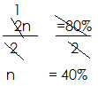

(ii) boys n+20%

=40% + 20%

=60%

**Example 2**

There are 10% more men than women in a meeting.

(a) What is the percentage of women in the meeting?

**Solution**

Let the percentage for women be n

|  |  |  |
| --- | --- | --- |
| women | men | total |
| n | n+10% | 100% |

n+n+10% =100%

2n+10% =100%

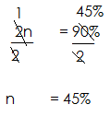 2n+ 10% -10% =100% -10%

(b) Find the percentage of men

Men =10+n

=10% + 45%

= 55%

3. A family spent 40% more on school fees than clothing.

(a) What percentage is spent on clothing?

Let the % of clothing be k

|  |  |  |
| --- | --- | --- |
| clothing | School fees | total |
| k | K+40% | 100% |

K+k+40% =100%

2k+40% =100%

2k+ 40%-40% =100%-40%

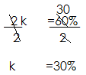 2k =60%

k = 30

(b) Find the percentage spent on school fees

School fees=k+40%

= 30% + 40%

=70%

4. The percentage of cows is thrice that of the goats on the farm.

(a) Find the percentage of goats on the farm

Let the % of goats be k

|  |  |  |
| --- | --- | --- |
| goats | cows | total |
| k | 3xk  3k | 100% |

K+3k =100%

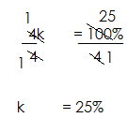 4k =100%

K = 25

(b) Find the percentage of cows on the farm

Cows =3k

3x k

3x25%

75%

1. find the percentage of more cows than goats

More=75%-25%

=50%

**Activity**

1. There are 30% more old students than new students in a school.

(a) Find the percentage of old students

(b) Find the percentage of new students

2. A family spend 50% more on sugar than soap.

(a) Find the percentage spent on soap.

(b) What percentage is spent on sugar?

3. A class has 10% more boys than girls/

(a) What percentage of the class are girls?

(b) Find the percentage of boys in class.

4. The percentage of women at a party is thrice that of men.

(a) Find the percentage of men at the party.

(b) Find the percentage of women.

5. The percentage of pupils in a school is 4 times that of the teachers.

(a) Find the percentage of teacher.

(b) Find the percentage of pupils in school.

**EXPRESSING QUANTITIES AS PERCENTAGES**

1. Henry had 40 goats and sold 15 of them.

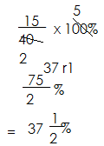(a) Find the percentage of the goats sold.

(b) Find the remaining percentage of goats

40-15

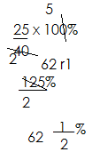 25

2. A boy got 8 correct answers out of 20.

(a) Find his core in percentage

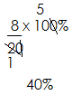

(b) What percentage did he fail?

20-8

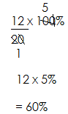 =12

3. In a class of 40 pupils, 30 are boys and the rest are girls.

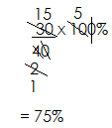(a) Find the percentage of boys in class?

(b) Find the percentage of girls in class

No of girls=40-30

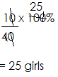 =10

% of girls =

4. In a class there are 35 girls and 15 boys. Find the percentage of boys in class

Total number of pupils=35+15

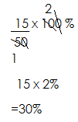 =50

% of boys=

**Activity**

1. If 30 of all pupils in class are girls.

(a) Find the percentage of girls in class

(b) Find the percentage of boys

2. A 20 litre jerry can has only 15 litres of water.

(a) What percentage of the jerry can is empty?

(b) What percentage of water is in the jerry can?

3. There are 20 players in a team. 4 play tennis, 11 play football and the rest play both games

(a) What percentage of the players play tennis?

(b) Find the percentage of players who play both games.

4. In a class, there are 7 desks, 8 pens and 10 books. Find the percentage of each item in class.

5. A man gave sh. 500 to his three children Ali, Musa and Mariam.

(a) If Ali got sh. 1500, find his percentage.

(b) Find Mariam’s percentage share if Musa got sh. 2000.

**EXPRESSING ONE QUANTITY AS A PERCENTAGE OF ANOTHER.**

1. Express 500g as a percentage of 1 kg

**Solution**

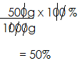 1 kg=1000g

2. Express 20 minutes as a percentage of 2 hours

Solution

1 hour=60min

2 hours=60x2

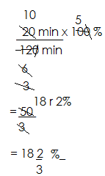 = 120 min

3. Express 72 objects as a percentage of 1 gross of objects.

**Solution**

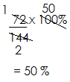 1 gross= 144 objects

**Activity**

1. Express 20 as a percentage of 60

2. What percentage of 80 is 60?

3. Express 200g as a percentage of 2 kg.

4. Express 20cm as a percentage of 2 metres.

5. What percentage of 1 hour is 15 minutes?

6. Write 40cm as a percentage of 2m

7. What percentage of 1 litre is 250cm3?

8. What percentage of 1km is 500cm?

**SHARING IN PERCENTAGE**

1. In a school of 400 pupils, 30% are boys and the rest are girls.

(a) Find the percentage of girls in school.

|  |  |  |
| --- | --- | --- |
| Girls% | Boys% | Total % |
| k | 30% | 1005 |

Let the number of girls be k.

K+ 30%=100%

K+30%-30%= 100-30%

K=70%

(b) How many boys are in school?

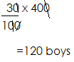 No. of boys are in school?

No. of boys=

(c) How many more girls are in school than boys?

More= 70%- 30%

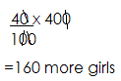 40%

2. There are 280 animals on Mugabi’s farm. 10% are rabbits, 30% are goats and the rest are sheep.

(a) Find the percentage of sheep on the farm.

|  |  |  |  |
| --- | --- | --- | --- |
| sheep | rabbits | goats | Total % |
| K | 10% | 30% | 100% |

Let the % of sheep be k

K+ 10% + 30% = 100%

K+ 40% =100%

K+40%- 40% = 100%- 40%

K =60%

(b) How many more sheep are on the farm than rabbits?

More% = 60% -10%

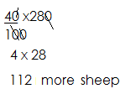 =40%

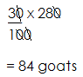(c) If $\frac{1}{4}$ of the goats were sold off, how many goats remained on the farm?

No. of goats=

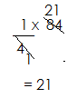

No. of goats sold=

No. of remaining goats= 84-21=63 goats

3. A fruiter sold 25% mangoes, 15% oranges, 50% apples and the rest were passion fruits.

(a) Find the percentage of passion fruits sold.

Let the % of passion fruits be k

|  |  |  |  |  |
| --- | --- | --- | --- | --- |
| Passion fruit | mangoes | oranges | apples | Total % |
| k | 25% | 15% | 50% | 100% |

K+25% + 15% +50%=100%

K+90% =100%

K+ 90%-90% =100%-90%

K =10%

(b) How many more mangoes were sold than oranges if 480 fruits were sold altogether?

More% =25%-15%

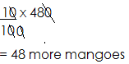 =10%

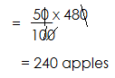(c) If each apple was sold at sh. 500, how much money did he get from selling apples?

1 apple--------sh 500

240 apples------sh. 500 x 240

=Sh. 120,000

**Activity**

1. In a class of 60 pupils, 10% are absent.

(a) Find the percentage of pupils present.

(b) How many more pupils were present than absent?

(c) If each pupil was given 3 sweets by the head teacher, how many sweets were given out altogether?

2. A school has 360 text books, 35% are for English, 25% are for science and the rest are for MTC.

(a) Find the percentage of MTC books.

(b) How many more English books are there than science books.

(c) If a pupil lost $\frac{1}{4}$ of the MTC books and was required to pay sh. 20,000 for each book, how much money did he pay?

3. In a village meeting attended by 120 people, 50% were men, 30% were women and the rest were children.

(a) Find the percentage of children in the meeting.

(b) How many more women attended the meeting than children?

(c) If $\frac{1}{3}$ of the children were girls, how many boys attended the meeting?

4. In a school of 1400 pupils 60% are girls and the rest are boys.

(a) Find the percentage of boys in school

(b) How many more girls are in school than boys?

(c) Given that $\frac{1}{4}$ of the girls and $\frac{1}{2}$ of the boys are in lower classes, how many pupils are in upper classes?

**MORE ABOUT SHARING IN PERCENTAGES**

1. There are 10% more boys than girls in a school of 1200 pupils.

(a) Find the percentage of girls in school.

|  |  |  |
| --- | --- | --- |
| Girls % | Boys% | Total % |
| k | K+10% | 100% |

K+ k+10% =100%

2k+10% =100%

2k + 10%-10% =100-10%

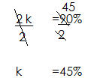 2k =90%

(b) How many more boys are in school than girls?

Boys% =k+10%

= 45% + 10%

=55%

More % = 55% -45%

=10%

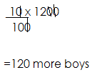 No. of more=

(c) If $\frac{1}{6}$ of the girls and $\frac{1}{3}$ of the boys are below 10 years, how many pupils are below 10 years.

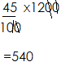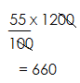 Girls boys

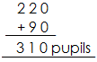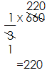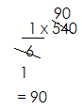Girls below 10yrs Boys below 10yrs Pupils’ below 10yrs

2. In a class of 80 pupils, there are 205 less boys than girls.

(a) Find the percentage of girls in class.

Let the % of girls be k

|  |  |  |
| --- | --- | --- |
| Girls % | Boys % | Total % |
| k | k-20 | 100% |

K+k-20 =100%

2k-20% =100%

2k-20%+20% =100%+20%

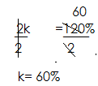 2k =120%

(b) How many more girls are in class than boys?

% of boys =k-20%

= 60%-20%

=40%

More% =60%-40%

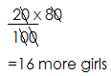 20%

(c) Given that $\frac{1}{6}$ of the girls have plaited hair, how many girls do not have plaited hair.

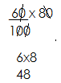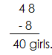 **No. of girls** **Girls with plaited hair** **Girls without plaited hair**

3. In a class of 200 pupils, the percentage of girls is thrice that of boys.

(a) Find the percentage of girls in class

Let the percentage of boys be k

|  |  |  |
| --- | --- | --- |
| boys | girls | Total % |
| k | 3xk  3k | 100% |

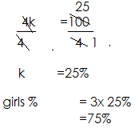 K+3k =100%

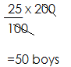(b) How many balls are needed if each boy in class is to be given 3 balls?

No. of boys =

1 boy-----3 balls

50 boys----- (3x50) balls

=150 balls

(c) How many more girls are in class than boys?

More% =75% -25%

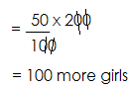 50%

**Activity**

1. There are 10% more cows than goats on a farm 3600 animals.

(a) Find the percentage of goats on the farm.

(b) How many cows are on the farm than goats?

(c) If each cow produces 10 litres of milk daily, how many litres of milk are produced on the farm daily?

2. There are 30% less women than men in a meeting of 100 people.

(a) Find the percentage of men in the meeting.

(b) How many more men attended the meeting than women?

(c) If each man contributed sh.500 and each woman contributed sh.200, how much money was contributed altogether?

3. Given that the percentage of MTC text books in the school library is 4 times more than that of English books.

(a) Find the percentage of MTC books in the library.

(b) If there are 240 text books altogether, how many more MTC text books are there than English text books?

(c) If each MTC text book was bought at sh. 25000and each English text book at sh20000, how much was spent on all the books.

4. The percentage of boys in a workshop is 9 times less than that of girls.

(a) Find the percentage of girls in the workshop.

(b) How many, more girls attended the workshop than boys if altogether there were 60 pupils.

(c) If each member paid sh. 500 on entry, how much was collected altogether?

**FORMING AND SOLVING EQUATIONS INVOLVING PERCENTAGES**

1. If 10% of a number is 40. What is the number?

Let the number be k

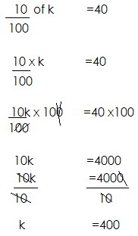

2. In a class, 20% are boys. If there 140 girls. How many pupils are in the class?

%age for girls = 100-205

=80%

Let the total no. of pupils be k

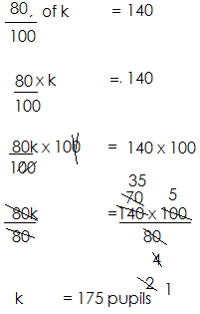

3. There are 10% more women than men in a village.

(a) Find the percentage for men

Let the % of men be x

Men women total

X x+10% 100%

X+x+10% =100%

2x+10%-10% =100%-10%

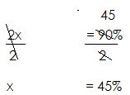 2x =90%

(b) If there are 275 women in the village. How many people are in the village?

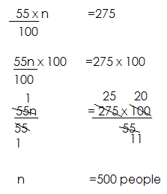 **Solution**

Let the total number be n

% for women = x+ 10%

=45%+ 10%

=55%

55% of n = 275

4. The percentage of cows is thrice the percentage of goats on a farm. If there are 150 cows on the farm, how many animals are on the farm?

**Solution**

Let the percentage for goats be r

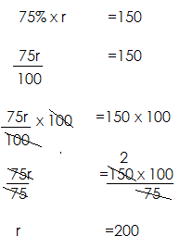Goats cows Total

X 3x 100%

X+3x =100%

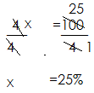

% for cows =3x

=3x25%

=75%

**Activity**

1. 20% of a number is 15. What is the number?

2. There are 24 boys in a class. This is 40% of the number of pupils in a class?

3. 30% of the animals in the farm are black, if there are 140 white animals.

(a) How many animals are on the farm?

(b) How many more white animals than black animals are on the farm?

4. There are 20% more girls than boys in a school. Fi there are 360 girls. How many pupils are in the school?

(b) How many more girls than boys are in the school?

5. The percentage of white papers is 4 times more than that of brown papers. If there are 200 white papers.

Find the total number of papers.

**INCREASING QUANTITIES IN A GIVEN PERCENTAGE**

1. Increase sh. 200 by 20%

100% +20% of sh. 200

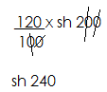 120% of sh. 200

2.Okidi’s pay was 12000 dollars. He was given a 30% increment. What is his new pay?

100%+ 30% of 12,000 dollars

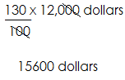 130% of 12,000dollars

3. The price of coffee was sh24, 000 a bag. It was increased by 10%

= 100% +10% of sh. 24, 000

= 110% of sh. 24,000

100

= Sh. 26400

4. A school had 500 books in the library last year. This year the number has increased by 20%. How many books are in the library this year?

**Solution**

100% +20% of 500 books

120% of 500 books

120 x 500 books

100

600 books.

**Activity**

1. Increase sh. 400 by 10%

2. Increase sh. 2000 by 20%

3. Increase 30 eggs by 10%

4. There are 500 pupils in a class. The number increase by 10%. What is the new number?

5. A dress used to cost sh. 10,000. This price increased by 5%. Calculate the new price of the dress.

6. There were 300 heads of cattle on a farm last year. This year there are 20% more. How many heads of cattle does the farm have this year?

**DECREASING QUANTITIES IN A GIVEN PERCENTAGE**

Example1

Decrease 300 by 10%

100%- 10% of 300

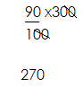 90% of 300

2. A company had 280 workers. 25% of them were retrenched. How many workers remained?

= 100%-25% of 280 workers

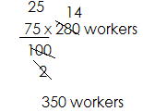= 75% of 280 workers

3. The cost price of maize flour was sh. 1000 per kg. It was reduced by 10%. What is the new price of flour per kg?

Solution

= 100%-10% of sh. 1000 per kg

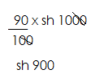 = $\frac{90}{100 }$ of sh. 1000

4. A man’s earn sh. 400,000. How much will his salary be if it is cut by 12 $\frac{1}{2}$%?

**Solution**

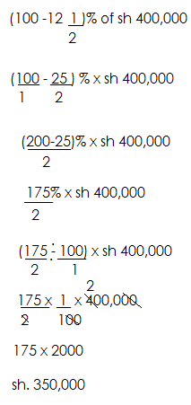

**Activity**

1. Decrease 400 by 10%

2. Decrease 1200 by 33%

3. Decrease 800 litres of petrol by 30%

4. A book was priced at sh. 600 before the sale. It was reduced by 20%. What is the new price?

**FINDING PERCENTAGE PROFIT AND PERCENTAGE PROFIT**

A profit is the amount gained after selling

Profit is realized when the selling price is higher than the buying price.

Profit=S.P- B.P

Loss is realized when the selling price is lower than the buying price

Loss = BP – S.P

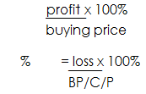Formula:

% age profit=

% age loss

Finding percentage profit and percentage loss

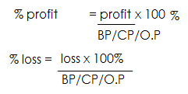

**Example one**

A trader bought a dress at sh. 1,600 and sold it at sh. 2000.

(a) Find her profit

**Solution**

Profit = selling price – cost price

Profit = sh. 2000- sh. 1600

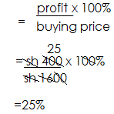 = 400

%age profit =

**Example 2**

Mulema bought a goat at sh35, 000 and sold it at sh. 32,000.

(a) Find the loss

Loss=cost price-selling price

=sh35,000 - sh32,000

= sh. 3000

(b) What percentage was the loss?

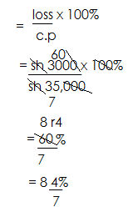 **Solution**

Percentage loss =

**Example 3**

A man bought a motor cycle at sh.600, 000. After one year he sold it at a loss of sh. 20,000. Find his percentage loss

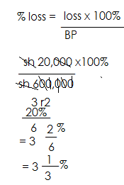**Solution**

**Example 4**

The cost of a book is sh. 2000. If a shopkeeper sold it at a profit of sh 500. What was his percentage gain?

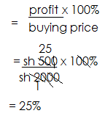

**Activity**

1. Musa bought a cow at sh. 10,000 and sold it at sh.8000.

(a) Find his loss.

(b) Find the percentage loss.

2. The cost of a pencil is sh. 200. Okoit sold it at a profit of sh. 50. What was his percentage profit?

3. Rita bought a book at sh. 20,000 and sold it at sh. 25,000.

(a) Find her profit

(b) Find her percentage profit.

4. Richard bought a television set at sh. 450,000 and sold it at sh. 470,000.

Find his percentage profit

5. Owen bought a shirt at sh. 250,000 and sold it at sh. 300,00. Find his percentage profit.

6. The price of a radio is sh. 43,000, a shopkeeper sold it at sh. 43,000. A shopkeeper sold it at sh. 41,280.

(a) Find his loss

(b) Calculate the percentage loss.

7. Obedi bought a car at sh.5, 000, 000 and sold it at sh. 6,000,000. Find his percentage profit.

**MORE ABOUT PROFIT AND LOSS**

1. A trader bought 10 eggs at sh. 500 each on his way to the market some eggs got spoilt and sold the remaining eggs at sh. 1000 each making a profit of sh. 2000.

(a) What was his buying price?

1 egg------sh. 500

10 eggs----sh. 500 x10

-----sh. 5000

(b) Find his selling price

Selling price =BP +P

= sh. 5000+ sh. 2000

=sh. 7000

3. A trader bought 8 pine apples each at sh. 500. Some pineapples got spoilt and he sold the remaining pineapples each at sh. 900 making a profit of

Sh. 500. How many pineapples got spoilt?

B.P=?

1 pineapple------sh. 500

8 pine apples------sh. 500 x 8

------sh. 4000

S.P = B.P + P

= sh. 4000 + sh. 500

= sh. 4500

No. of pineapples sold

Sh.900------1 pineapples

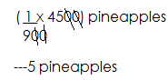 1 sh. ------($\frac{1}{900}$) pineapples

Sh. 4500------

Spoilt= 8-5

3 pineapples

**Activity**

1. Musota bought 40 oranges at sh. 500 each. On his way to the market some oranges got spoilt and sold each at sh. 600 making a loss of sh. 2000.

(a) Find his buying price.

(b) Find his selling price

(c) How many oranges were sold?

(d) How many oranges got spoilt?

2. A trader bought 20 pawpaw at sh. 50 each. On his way some paw paws got spoilt, he sold the remaining paw paws each at sh. 1000 making a profit of sh. 500. How many paw paws got spoilt?

3. A trader bought 20 eggs at sh. 500 each. On his way home, some eggs got broken. He sold the remaining eggs at sh900 and made a profit of sh. 800. How many eggs were spoilt?

**Finding the selling price and cost price when given percentage profit or loss.**

1. A trader bought a shirt at sh. 90,000 and later sold it at a profit of 30%. How much did he sell it?

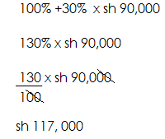

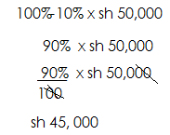2. A trader bought a shirt at sh. 50,000 after selling it he realized a loss of 10%. Find his selling price.

3. The buying price of a goat was sh150, 000, after selling it he realized a loss of 30%. What was his selling price?

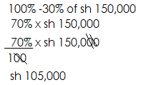

**Activity**

1. Amoti bought a bicycle at sh.300, 000 and later sold it at a loss of 20%. What was his selling price?

2. Martha bought a dress at sh. 200,00. She sold it to john at a profit of 10%. What was her selling price?

3. Wandera bought a plot of land at sh. 500,000. After 2 years he sold it to Opio at a profit of 10%. At how much did Opio pay for the plot of land?

4. Richard bought a vehicle at sh. 56,000,000 and sold it to Alex at a profit of 40%. How much did Alex pay for the vehicle?

5. Puki bought a bucket at sh. 10,000 and sold it to Racheal making a loss of 30%. How much did Racheal pay for the bucket?

**FINDING SIMPLE INTEREST**

**Note:**

The money banked, borrowed or lent is the principal (P)

**Rate: (R)**

This is the percentage used to calculate interest.

**Time(T)**

This is the period in years, months or weeks in which the money is kept, invested or used.

**Simple interest: (i)**

This is the extra additional amount of money offered or paid back.

**Amount (A)**

This is the sum of the principal and simple interest

Therefore amount = principal + simple interest

**CALCULATING SIMPLE INTEREST AND AMOUNT**

**Note:**

Simple interest = principal x rate x time

I = P X R XT

Amount = Principal +SI

**Note:**

When rate is given as per year and time is in months, change the months to years by dividing by 12.

When rate is given as per month and time is also in months, don’t divide the month by 12.

**Examples**

1. Kato deposited sh.20, 000 in a bank at a rate of 20% per year for 2 years. Find his interest

P=sh. 20,000

R= 20% p.a.

T=2yrs

S.I= PXRXT

=sh. 20,000x $\frac{20}{100}$ x2

=sh. 8000

2. Calculate the simple interest on sh. 24000 at a rate of 15% per year for 8 months.

**Solution**

P=sh. 24,000

R=15% p.a.

T= $\frac{8}{12}$

S.I= PXRXT

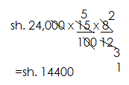

3. Ali borrowed sh.400,000 form a bank at a rate of 12% per month for 4 months.

(a) Find his simple interest

P= sh. 400,000

R= 12%p.m

T= 4 months

S.I= PXRXT

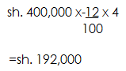

(b) Find the amount he paid back after that time

Amount= P+S.

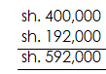

4. Alex deposited sh. 180,000 on his bank account aa rate of 10% per annum for 4 months.

(a) Find his interest

P=sh. 180,000

R=10% p.a

T= $\frac{4}{12}$

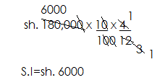 S.I= PXRXT

(b) Find his earning after that time.

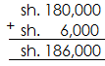 Amount= P+S.I

**Activity**

1. Find the simple interest on sh. 100,000 deposited in a bank for 5 years at a rate of 5% per annum.

2. A man borrowed sh. 30,000 at a rate of 20% per annum for 2 years.

(a) Find his interest after that time.

(b) How much will he pay back after that time?

3. Musa deposited sh. 60,000 in a bank at a simple interest rate of 5 $\frac{2}{3}\%$ per annum for 4 months. Calculate his amount of money paid in the bank.

4. Calculate the simple interest 0n sh. 40,000 at a rate of 10% per month for 1 years.

5. A village bank offered a business man sh. 360,000 at a rate of 4.5 % per annum for 5 years.

(a) Find his simple interest after 5 years.

(b) How much money will he pay back to the village bank after 5 years?

**DATA HANDLING**

**ARITHMETIC MEAN**

Mean of whole numbers

Mean/average

Median

Mode

Modal frequency

Frequency

Range

**MEDIAN**

Medina is the middle number got after arranging in either ascending or descending order.

Find the median of 5, 4, 5, 6, 7 and 2

**Solution**

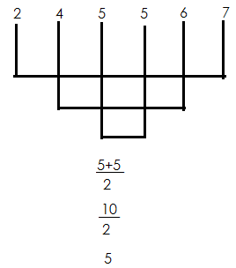

2. Find the median of 2, 3,6,3,8 and 4

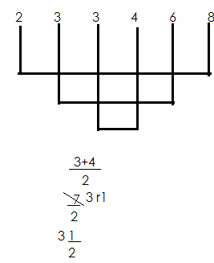

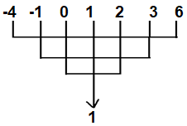3. Find the median of -4, 2, 0, 3, 6, -1 and 1

Median = 1

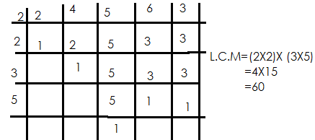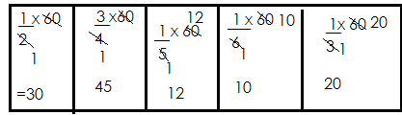4. Find the median of $\frac{1}{2},\frac{3}{4}$, $\frac{1}{5}$, $\frac{1}{6}$, $\frac{1}{3}$

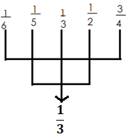 Ascending order

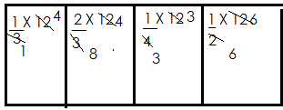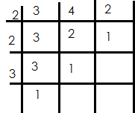5. Find the median of $\frac{1}{3}$**, $\frac{2}{3}$, $\frac{1}{4}$** and



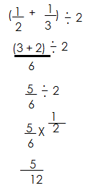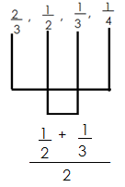

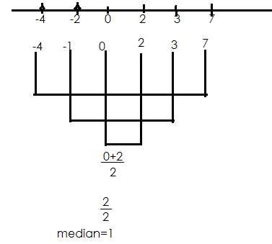6. Find the median of -4, 3, 0, -2, 7, 2

$\frac{0+2}{2}$

$\frac{2}{2}$

Median = 1

7. Find the median of 0.2, 0.6, 0.4, 0.5, and 0.8

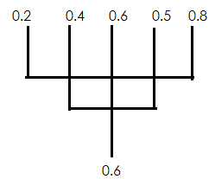 **Solution**

**Activity**

1. Find the median of the following

(a) 20, 30, 60, 40, 50

(b) -1, 0, 1, 2, 4, -3

(c) 3, 3, 7, 8, 4, 5, 7, 8

(d) $\frac{1}{2}$ **, $\frac{1}{3}$, $\frac{1}{4}$, $\frac{1}{5}$, $\frac{1}{6}$**

**(e) $\frac{2}{5}$, $\frac{1}{2}\frac{3}{4,}\frac{1}{6}$**

(f) -3, -4, 0,3,2,6

(g) $\frac{1}{3}$**, $\frac{3}{4}$, 1, $\frac{1}{2}$, $\frac{2}{6}$, $\frac{1}{2}$**

(h) 0.4, 0. 3, 0.7, 0.6, 0.2

**RANGE**

Range is the difference between the highest and lowest numbers given.

Range = Highest - Lowest

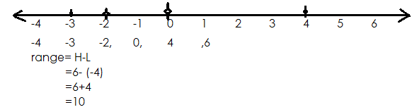Find the range of -2, -3, 4, 0, -4 and 6

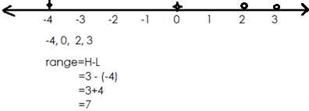2. Find the range 2, -4, 0, and 3

3. The median of 5 consecutive positive integers is +4

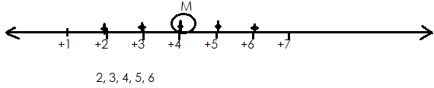(a) What are the numbers?

(b) Find their range

Range = H-L

= 6-2

=4

4. Find the range of

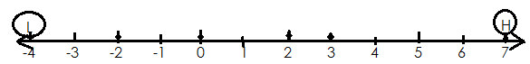 -4, 3, 0,-2, 7, and 2

-4,-2, 0, 2, 3, 7

Range=H-L

=7 – (-4)

=7+4

=11

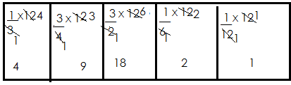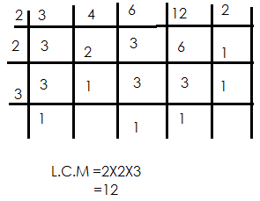5. Find the range of $\frac{1}{3}$**, $\frac{3}{4}$ 1 , ,**



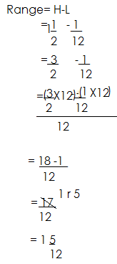

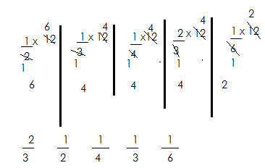6. Find the range $\frac{1}{2}$**, $\frac{1}{3}$, $\frac{1}{4}$, $\frac{2}{3}$, $\frac{1}{6}$**

Range= H-L

=

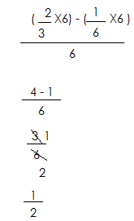

**Activity**

1. Find the range of the following

(a) 33, 38, 34, 36, 37, 35

(b) -5, 2, 3, 0, -2

(c) 5, 6, -2, -1, 3, 7

(d) $\frac{1}{2}$**, $\frac{1}{4}$, $\frac{1}{6}$, $\frac{1}{5}$, $\frac{3}{4}$**

(e) $\frac{1}{3}$**, $\frac{1}{2}$, $\frac{1}{4}$, $\frac{1}{10}$**

(f) -4, -2, 0, -1, 5

**MEAN/AVERAGE**

Mean is quotient of sum of all items and number of all items

Mean=sum of all items

No. of items

**Exmples**

Find the mean of 2, 4, 5, 6, 8, 7

Average=sum of all items

No. of items

=2+4+5+6+3+8+7

7

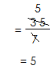

=

2. Find the average of 4, 0, -3, 8 and 6

Average=sum of all items

No. of items

= 4+0+8+6-3

3

= 18-3

 5

3. Calculate the average of -4, 1, 0, 9 and -6

Average=sum of all items

No. of items

= 9+1+0-4-6

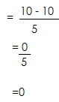 5

=

**Activity**

1. Find the average of the following

(a) 3, 6, 7, 4, 5

(b) 7, 8, 7, 8, 5, 2 and 5

(c) 40%, 20% 60% and 80%

(d) -2, 4, 6, 7 and 5

(e) -7, 0, 1, -5, 9 and 2

(f) 3, -4, -2, 7 and 6

(g) Find the average of 2y-2, 3y, 4 and 3y+6

(h) Find the average of k-3, k+5,2kand 2.

**AVERAGE/MEAN OF GROUPED DATA**

1. The table below shows marks scored by different pupils.

|  |  |  |  |  |
| --- | --- | --- | --- | --- |
| Marks | 40 | 60 | 30 | 80 |
| No of pupils | 3 | 2 | 4 | 1 |

a) How many pupils are in class.

**Soln.**

No of pupils = (3+2) + (4+1)

=5+ 5

**=10pupils**

b) Find their range in marks

**Soln**.

Range = H-L

= 80- 30

**= 50**

c) Find the median mark

30,30,30,30,40,40,40,60,60,80

= $\frac{40+40}{2}$

= $\frac{80}{2}$

= 40

d) Calculate the average mark.

**Soln.**

Average =

=

=

=

= 44

2. **Use table below to answer questions that follow.**

|  |  |  |  |  |  |
| --- | --- | --- | --- | --- | --- |
| No of pupils | 2 | 2 | 4 | 2 | 1 |
| marks of scored | 40 | 70 | 50 | 80 | 90 |

a) How many pupils did the test.

= 2+ 2+ 4+ 2+1

= 11 pupils

b) How many pupils scored above the average mark

Av = sum of items

No of items

= (2x40) + 70 x 2) + (50 x 4) + 80x 2) + (90x 1)

11

= 80+ 140+ 200+ 160+ 90

11

= 670

11

= 60 $\frac{1}{11}$

No of pupils = 2+2+1

= 5 pupils

3. The table shows marks scored by different pupils in a test.

|  |  |  |  |  |  |
| --- | --- | --- | --- | --- | --- |
| **marks** | 60 | 70 | 80 | 50 | 40 |
| **No of pupils** | 5 | 3 | 4 | 3 | 2 |

a) How many pupils did the test?

5+ 3+ 4+3+ 2

= 17 pupils

b) Find the range of marks scored

Range = H - L

=80- 40

= 40

c) Find the mean mark of pupils who scored below 70

Mean = Sum of items

No of items

= (60x 5) +( 50 x 3) + (40 x2)

5+ 3+ 2

= 300+ 150+ 80

10

= 530

10

= 53

**Activity**

1. The table below shows marks scored by some pupils in class.

|  |  |  |  |  |  |
| --- | --- | --- | --- | --- | --- |
| marks | 60 | 70 | 80 | 50 | 40 |
| no of pupils | 2 | 2 | 1 | 2 | 3 |

a) How many pupils are in class?

b) Find the median mark

c) Calculate the average mark

**2**. Use the table below to answer the given questions.

|  |  |  |  |  |
| --- | --- | --- | --- | --- |
| marks | 60 | 70 | 50 | 80 |
| no of pupils | 2 | 3 | 4 | 1 |

a) Find the number of pupils in class

b) Find the median mark

c) Find the range of marks scored

d) How many pupils scored above the average mark?

3. The table shows scores of different pupils in a class**.**

|  |  |  |  |  |
| --- | --- | --- | --- | --- |
| No of pupils | 60 | 80 | 30 | 70 |
| Marks scored | 2 | 1 | 4 | 2 |

a) Find the median score.

b) Find the range of the score.

c) Calculate the average mark of pupils who scored above the range.

4. Different weight of pupils were recorded in a certain class. Use it to answer questions that follow.

|  |  |  |  |  |  |
| --- | --- | --- | --- | --- | --- |
| weight in kg | 25 | 30 | 40 | 50 | 55 |
| No of pupils | 4 | 4 | 2 | 1 | 1 |

a) How many pupils are in class?

b) Find the median weight of pupils who are above 35kg

c) Calculate the average weight of pupils who are below 50kg

**MORE ABOUT GROUPED DATA.**

**Complete the table below**

|  |  |  |
| --- | --- | --- |
| Marks | No of pupils | Total |
| 40  **50**  30  90 | 3  2  4  **1** | 120  100  **120**  90 |

No of pupils= 120

40

= 3

Marks = 100

2

Total = 30 x 4

= 120

No of pupils= 90

90

= 1

b) Find the range

Range = H- L

= 90- 30

= 60

c) Find the median

30,30,30,30,40,40,40,50,50,50,90

= 40 + 40

2

= 80

2

= 40

d) Calculate the average mark.

Average= sum of all items

No of items

= 40 x 3) + 50 x 2) + (30 x 4) + 90 x 1)

10

= 430

10

= 43

e) Find the modal mark

**30**

f) Find the modal frequency.

**4.**

**Activity.**

**Complete the table below and answer the following questions.**

|  |  |  |
| --- | --- | --- |
| **Marks** | **No of pupils** | **Total** |
| 40  50  _____  80 | ________  2  3  _________ | 160  ________  180  80 |

a) Complete the table above

b) Find the modal mark

c) Find the modal frequency

d) Find the range

e) Find the mean mark

f) Find the median mark

**AVERAGE OF GROUPS.**

1. The average number of girls in 4 classes is 60. Find the total number of girls

**Solution**

Total = Average number

= 60 x 4

= 240 girls.

2. The average weight of 4 boys is 48kg.Find their total weight.

**Solution**

Total Weight = Average x number

= 48kg x 4

= 192kg

3. The average mass of 3 pickups is 4 tonnes. Find their total mass

**Solution**

Total = Average x 40

= 3 x 4

= 12 tonnes.

4. The average weight of 5 teachers is 60kg.Find their total weight.

Total weight = Average x number

= 60 x 5

= 300 kg

The average weight of 4 men is 50 kg. If 3 of them weighs 40kg,45kg and 45kg.Find the weight of the 4th man.

**Soln.**

Let weight of 4th be k

$\frac{sum of all items}{number of all items}$ = average

$\frac{k+40kg+45kg+45kg}{4}$ = 50kg

$\frac{k+130kg}{4}$ = 50kg.

$\frac{k+130kg}{4}$ × 4 = 50kg × 4.

k+130kg = 200kg

k + 130- 130 = 200 – 130

**k = 70kg**

The average weight of 6 boys is 60kg and the average weight of other 4 boys is 30 kg. Find the average of all boys

|  |  |  |
| --- | --- | --- |
| **No** | **Average** | **sum** |
| 6 | 60kg | (60 x 6) kg  360 kg |
| 4 | 30 | 30 x 4  120kg |

Average = sum of all items

No of items

= 360kg + 120 kg

6+ 4

= 480kg

10

= 48kg

2. The average weight of 6men is 45kg and average weight of other 4 men is 70 kg. Find the average weight of all men.

**Solution.**

|  |  |  |
| --- | --- | --- |
| NO | Average | sum |
| 6 | 45kg | (45 x 6) kg  270kg |
| 4 | 70kg | 70 x 4 kg  280 kg |

Average= sum of all items.

No of items

= 27 kg+ 280kg 0

6 + 4

=

= 55kg

3. The average age of 3 girls is 12 years. When Wasswa joins them, their average becomes 13 years. How old is Wasswa?

|  |  |  |
| --- | --- | --- |
| **No** | **Average** | **sum** |
| 3 | 12 | 3 x12) years  36 years |
| 3+ 1  4 | 13 | (4 x 13) years  52years. |

Wasswa’s weight= 52

- 36

16 years

Wasswa is 16 years.

4. The average age of 5 girls is 10 yrs. When Nakato and Babirye who are twins join them, their average becomes 12 yrs. How old is Babirye?

|  |  |  |
| --- | --- | --- |
| No | mean | sum |
| 5 | 10 | 5 x 10  50 years |
| 5 + 2  7 | 12 | (7 x 12) years  84years. |

Weight of twins= 84

* 50

34 years

Weight of Babirye =

=17kg

5. The average weight of 5 boys is 20 kg. When John leaves the group, the average weight becomes 22kg.How old is John.

|  |  |  |
| --- | --- | --- |
| No  5 | Average  20 | Total  5 x 20) kg |
| 5- 1  4 | 22 | 100kg  (4 x 22) kg  88kg |

John = 100 kg

* 88kg

12kg

**Activity.**

1. The average weight of 6 boys is 60 kg. Find their total weight.

2. The average age of 5 boys is 40 years. Find their total age.

3. The average of 6men is 45kg.Find their total weight

4. The average age of 5 girls is 12years and average age of 3 girls is 4 years. Find the average of all girls.

5. The average weight of 4 boys is 23kg and the average of 2 girls is 6kg.Find the average of 2 girls is 6kg.Find average age of all pupils.

6. The average weight of 3 woman is 60kg and the average weight of 3 women is 60kg.Find the average weight of all people.

7. The average weight of 4 boys is 42kg.When their teacher joins them, the average becomes 40kg.How heavy is the average.

8. The average age of 5 boys is 14 years. When their teacher joins them, the average becomes 40kg.How heavy is the teacher.

9. The average weight 5 boys is 50kg.When Nakato and Babirye joins the group their average become 40kg.Find the weight of Nakato.

10. The mean age of 3 boys is 14 years age of 2 of them is 13 years,15 years. Find the age of the 3rd boy.

11.The average weight of 5 pupils is 40kg.If 4 of them weigh 40kg,30kg,45kg and 35 kg. Find the weight of the 5th pupil.

**FINDING UNKNOWNS GIVEN AVERAGE**

**Note**

In this context, terms are separated using commas (,) and the word “and”

1. The average of n, 3,4 and 2 is 3. Find the value of x

**Solution**

sum of all items = Average

No of items

n+ 3+4+2 = 3

4

n + 9 x 4 = 3x 4

4

n+ 9 = 12

n+ 9-9 = 12

n+a+9 = 12-9

**n = 3**

2. The mean of 6,2k, 7 and 3 is 6. Find the value of k.

**solution**

sum of all items

no of items = mean

2k+6+7+3 = 6

4

2k+ 17 x 4 = 6 x4

4

2k + 16 = 24

2k+16-16 = 24-16

**=**

K = 4

3. The average of 3p,6 and 2p-1 is 10. Find the value of p

**Solution**

sum of all items = Average

No of items

3p+ 2p-1+6 = 10

3

3p+ 2p+6-1 = 10

3

5p+ 5 x 3 = 10 x 3

3

5p + 5 x 3 = 30-5

3

5p = 25

P 5

**P = 5**

b) Find their range

**soln.**

|  |  |  |
| --- | --- | --- |
| **3P**  3 X P  3 x 5  15 | **2P – 6**  (2 x P) – 6  (2 x 5) – 6  (2 x 5) – 6  10 – 6  **4** | **6** |

Range = H – L

= 15 – 4

= 9

**Activity:**

1. The average of 2,9,11, x,14 and 18 is 11. Find x

2. Find the value of k if the average of 7, x,3,9,8 and 10 is 8.

3. Given that the average of 5m, m+2,7-m and 3 is 8. Find the value of m.

4. If the average of m,6-2m,4m,3-2m and 4 is 4. Find the value of m.

5. The average of 5,3y,2-2y and 3 is 4. Find the value of y.

6. Find the value of p if the mean of 6,0,2p, p+4 and 2-p is 4.

7. The mean of n, 6, 7, 8 and 9 is 7. Find the value of n.

8. The mean of k, K + 4 and K + 2 is 6. Find K.

b) Find their range.

9. The average of 3, 4 and y is 5. Find the value of y.

10. The mean of 2 – X, 3X + 4, 0 and 6 is 5. Find the value of X.

11. The mean of K, K + 2 and 3 is 5. Find the value of K.

12. The average pf K – 6, 2K, K – 3, 6 and 15 – K is 10. Find the value of K.

**MORE ABOUT AVERAGE**

The table below shows marks scored by different pupils.

|  |  |  |  |  |
| --- | --- | --- | --- | --- |
| Marks | 40 | 50 | P | 20 |
| No. of pupils | 3 | 2 | 4 | 1 |

a) How many pupils did the test.

**=** 3 + 2 + 4 + 1

= 10 pupils

b) If the average mark was 36, find the value of P.

**soln.**

$\frac{Sum of all items}{No.of items }$ = Average

$\frac{\left(4 x P\right)+ \left(40 x 3\right)+ \left(50 x 2\right)+ (20 X 1)}{10}$ = 36

$\frac{4P+120+100+20}{10}$ = 36

$\frac{4P+240}{10}$ = 36 X 10

4P + 240 – 240 = 360 – 240

$\frac{4P}{4}$ = $\frac{120}{4}$

**P = 30**

**Find the median score**

**Soln.**

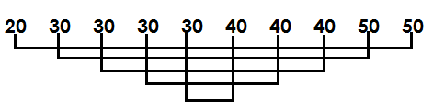

$\frac{30+40}{2}$

= $\frac{70}{2}$

Median =35

2. The table below shows marks scored by different pupils

|  |  |  |  |  |
| --- | --- | --- | --- | --- |
| Marks | 60 | Y | 50 | 40 |
| No. of pupils | 1 | 3 | 2 | 4 |

a) If the average score was 33. Find the value of y.

soln.

$\frac{Sum of all items}{No.of items}$ = Average

$\frac{\left(3 x y\right)+ \left(60 x 1\right)+ \left(50 x 2\right)+ (40 x 4)}{10}$ = 38

$\frac{3y+60+100+160}{10}$ = 38

$\frac{3y+320}{10}$ = 38

$\frac{3y+320 x 10}{10}$ = 38 x 10

3 y + 320 = 380

3y + 320 – 320 = 380 – 320

$\frac{3y}{3}$**= $\frac{60}{8}$**

**y = 20**

b) How many pupils scored above the median mark.

Median

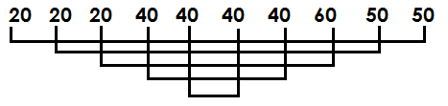

= $\frac{40+40}{2}$

= $\frac{80}{2}$

= 40

Above 40 = 3 pupils

3. The table below shows marks scored by different pupils in a test where average score was 30.

|  |  |  |  |  |
| --- | --- | --- | --- | --- |
| Marks | 40 | 20 | 30 | 50 |
| No. of pupils | 2 | M | 3 | 1 |

Find the value of m.

**Soln.**

$\frac{sum of all iems}{No.of all items}$ = Average

$\frac{\left(20 x m\right)+ \left(40 x 2\right)+ \left(30 x 3\right)+ (50 x 1)}{(m+6)}$ = 30

$\frac{20m+80+90+50}{m+6}$ = 30

$\frac{\left(20m+220\right) x (m+6)}{m+6}$ = 30 (m + 6)

20m + 220 = 30 x m + 6 x 30

20m + 220 = 30m + 180

20m – 30m + 220 = 30m – 30m + 180

-10m + 220 = 180

-10m + 220 – 220 = 180 – 220

$\frac{-10m}{-10}$**= $\frac{-40}{-10}$**

**M = 4**

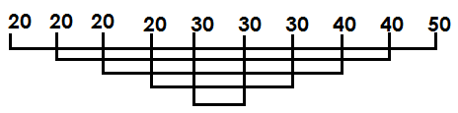b) Find the median mark.

=

=

**= 30**

4. The table below shows marks scored by different pupils

|  |  |  |  |  |
| --- | --- | --- | --- | --- |
| No. of pupils | 2 | n | 1 | 4 |
| No. of marks | 60 | 40 | 80 | 30 |

1. If the average mark was 44. Find the value of n.

**Soln.**

$\frac{Sum of all items}{No.of items}$ =Average

$\frac{\left(40 x n\right)+ \left(60 x 2\right)+ \left(80 x 1\right)+ \left(30 x 4\right)}{n+7}$ = 44

$\frac{40n+120+80+120 }{n+7}$ = 44

$\frac{40n+320}{n+7}$ = 44

$\frac{40n+320+\left(n+7\right)}{(n+7)}$ $=44 (n+7)$

40n + 320 = 44 x n + 7 x 44

40n + 320 = 44n + 308

40n + 320 – 320 = 44n + 308 – 320

40n = 44n – 12

40n – 44n = 44n – 44n – 12

$\frac{-4n}{4}$ = $\frac{-12}{-4}$

**n** = **3**

**Activity:**

1. The table below represents marks scored by a group of boys in end of term examination.

|  |  |  |  |  |
| --- | --- | --- | --- | --- |
| Marks | 30 | 25 | n | 35 |
| No. of pupils | 1 | 2 | 3 | 4 |

1. How many boys did the examination?
2. If the average mark of the boys was 34. Find the value of n.
3. Find the median mark

2. Study the table below.

|  |  |  |  |  |
| --- | --- | --- | --- | --- |
| Marks | 70 | 80 | m | 90 |
| No. of pupils | 2 | 3 | 4 | 1 |

If the average mark of the pupils was 71. Find the value of m.

1. Find the median mark.

3. The table below shows marks scored by different pupils in a test.

|  |  |  |  |  |
| --- | --- | --- | --- | --- |
| Marks | 50 | 60 | 40 | 80 |
| No. of pupils | K | 3 | 4 | 1 |

If the mean mark of the pupils was 52. Find the value of K

4. The table below shows marks scored by pupils in a mathematics test.

|  |  |  |  |  |
| --- | --- | --- | --- | --- |
| Marks | 80 | 70 | 90 | 60 |
| No. of pupils | 2 | 1 | n | 4 |

a) If their average score is 74. Find the value of n.

b) Find their median score.

**FINDING AVERAGE / MEAN OF COMPOUND TERMS**

1. Find the mean of 2y, 6, y + 4, and y + 6

**Soln.**

Mean =

**=**

**=**

**=**

**=** +

= y + 4

2. Find the mean of 3P + 4, P + 6, 3, 2 and P + 5

**Soln.**

Mean =

**=**

**=**

**=**

**=**

**=** +

= P + 5

3. Find the mean of k, 3k, 2 and K + 10

Mean =

**=**

**=**

4. Find the mean of 2m, 7, 0, 3 and 3m.

**Soln.**

Mean = $\frac{Sum of all items}{No.of items}$

**= $\frac{2m+3m+7+3+0}{5}$**

**= $\frac{5m+10}{5}$**

**= $\frac{5m}{5}$** + $\frac{10}{5}$

= m + 2

**Activity:**

1. Find the mean of the following: -

a) m, 6 and 2m.

b) 2w, 8, 3w, 4, 2 and w +4

c) 6, 4, and 3m + 8

d) 3k + 2, 5k + 4, 2k + 4 and 2k + 2

e) 2k + 4, 0, 3k + 6 and 2

f) k – 2, k + 6, 4 and 2k

**PIE CHARTS**

* Is a diagram in which quantities or proportions are illustrated as sectors of a circle
* It is also a circular graph representing data
* The sectors of a circle are mostly represented in degrees, fractions, percentages and quantities.
* Given degrees, all sectors must add up to 360o.
* Given percentages, all sectors must add up to 100%
* Given fractions, all sectors must add up to 1 (a whole).

**Interpretation of circle graph**

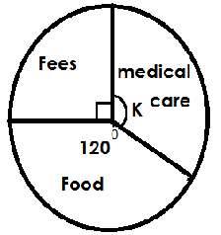The pie chart below shows how a man spent sh. 180,000. Use it to answer questions.

a) Find the values of K.

K + 90o + 120 o = 360 o

K + 210 o = 360 o

K + 210 o – 210 o = 360 o – 210 o

K = 150 o

b) How much did he spend on food?

**Soln.**

$\frac{120}{360}$ x sh. 180,000

**= sh. 60,000**

c) How much more money was spent on medical care than fees?

**Soln.**

More = 150 o – 90 o

**= 60 o**

More money = $\frac{60}{360}$ x sh. 180,000

= sh. 30,000

d) Express the amount spent on fees as a fraction

= $\frac{90}{360}$

= $\frac{1}{4}$

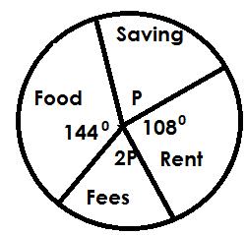2. The pie chart below shows how a man spent sh. 120,000.

a) Find the value of P.

P + 144o +2P + 108 o = 360 o

3P + 252 o = 360 o

3P + 252 o – 252 o = 360 o – 252 o

3P = 108 o

=

**P** = **36 o**

b) How much did he spend on rent?

Rent = $\frac{108}{36P}$ x sh. 120,000

= sh. 36,000

c) How much did she spend on food than fees?

|  |  |  |
| --- | --- | --- |
| Food | Fees | More in degrees |
| 144 o | 2 X P  2 x 36 o  72 o | 144 o – 72 o  72 o |

x sh. 120,000

**= sh. 24,000**

d) What percentage represents saving?

As a percentage = $\frac{P}{360}$ X 100%

$=\frac{36}{360}$ X 100%

= **10%**

e) Express his expenditure on Rent as a fraction.

As a fraction = $\frac{108}{360}$

= $\frac{3}{10}$

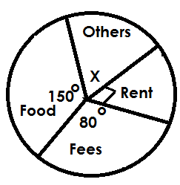3. Use the pie chart below showing how Mugisha’s spends his income to answer questions.

1. Find the value of X

X + 90o + 80 o + 150 o = 360 o

**X = 40 o**

1. How much does he spend on fees if he earns sh. 180,000?

$Fees=\frac{80}{360}$ x sh. 180,000

**= sh. 40,000**

1. How much more money did he spend on food than Others.

More = 150o – 40o

x sh. 180,000

**= sh. 55,000**

**Activity:**

1. The Pie chart below shows number of pupils who participated in games. There are 720 pupils altogether.

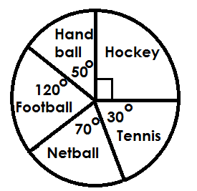

1. What is the most played game?
2. How many pupils play?
3. Football
4. Hand ball
5. If all girls play netball, how many girls are in the school?
6. How many more pupils play hockey than tennis?

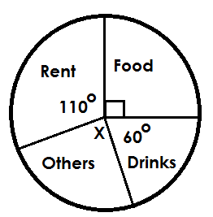3. The pie chart below shows a man’s expenditure of sh. 180,00 over the weekend.

a) Find the value X.

b) How much money is spent on food.

c) How much more money is spent on rent than drinks.

d) What fraction represents drinks.

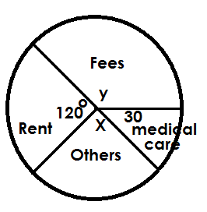3. Below is a pie chart showing how Modoolo spent his monthly salary of sh. 360,000. Use it to answer questions.

a) Find the value of;

i) X

ii) Y

b) How much money was spent on Rent?

c) How much more money was spent on Fees than others?

d) What percentage of the money was spent on medical care?

4. The pie chart below shows how a man spent his income of sh. 360,000.

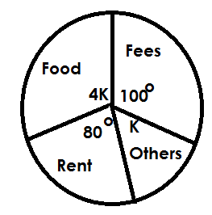

1. Find the value of K
2. How much does he spend on food?
3. How much more money did he spend on rent than others?
4. Express the amount spent on food as a percentage of his income.

**MORE ABOUT INTERPRETATION OF PIE-CHART**

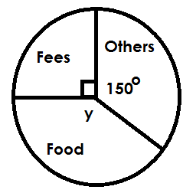1a ) The Pie chart below shows how a man spent his monthly salary

a) Find the value of Y

y + 90o + 150 o = 360 o

y + 240 o = 360 o

y + 240 o – 240 o = 360 o – 240 o

y = 120 o

b) If he spent sh. 45,000 on others, how much was his income?

**Soln**.

Let his income be K.

$\frac{150}{360 }$ x K = sh. 45,000

$\frac{150K}{360}$ = sh. 45,000

x 360o  = sh. 45,000 x 360

150K = sh. 45,000 x 360

$\frac{150K}{150}$ = $\frac{sh.45,000 x 360}{150}$

**K = sh. 108,000**

b) How much did he spend on fees?

Fees = $\frac{90}{360}$ x sh. 108,000

**= Sh. 27,000**

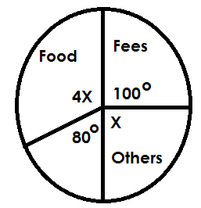2. The pie chart below shows how Musa spent his salary.

a) Find the value of X.

4X + X + 100o + 80 o = 360 o

5X + 180 o = 360 o

5X + 180 o – 180 o = 360 o – 180 o

5X = 180 o

=

X = 36 o

b) If he spent sh. 160,000 on rent. Find his salary.

Let his salary be K.

$\frac{80K}{360}$ x K = sh. 160,000

$\frac{80K}{360}$ = sh. 160,000

$\frac{80K}{360}$ x 360 = sh. 160,000 x 360

80K = sh. 160,000 x 360

$\frac{80K}{80}$ = $\frac{sh.160,000 x 360}{80}$

K = sh. 720,000

c) How much does he spend on food?

= 4 x K

= 4 x 36o

= 144o

x sh. 720,000

**= sh. 288,000**

d) How much more money was spent on Fees than Rent?

More = 100o – 80 o

**= 20 o**

x sh. 720,000

**= sh. 40,000**

**Activity:**

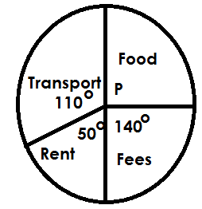1. The pie chart below shows how Alex spends his salary.

a) Find the value of P.

b) If he spends sh. 120,000 on food, how much does he earn?

c) How much money does he spend on fees?

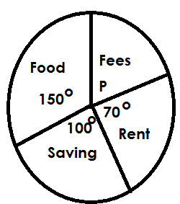2. The circle graph below shows how Okello spends his income.

1. Find the value of P
2. If he spends sh. 21,000 on rent, find his income.
3. How much money does he spend on Rent?
4. How much more money is saved than spent on fees?

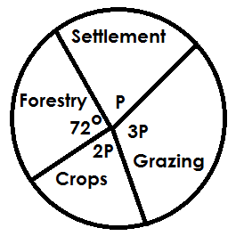3. Below is a pie chart showing how Kato divided his piece of land.

a) If he uses 4 acres for grazing, find the size of his land in acres?

b) How much more land is used for grazing than crops.

4. The pie chart below shows how Nandudu spent her income.

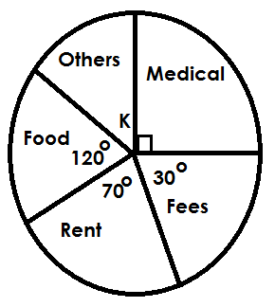

1. Find the value of K.

b) If she spent sh. 40,000 on others more than fees. Find his income.

1. How much did he spend on food?

**CONSTRUCTION OF PIE CHARTS**

**Note:**

While constructing pie charts, first change quantities, percentages, fractions into degrees.

**CONSTRUCTION OF PIE CHARTS GIVEN FRACTIONS**

* Given fractions, convert them to degrees by multiply the given fraction by 360o.

**Examples.**

A man spent $\frac{1}{4}$ of his salary on food.

$\frac{1}{3}$ on fees and $\frac{5}{12}$ on rent. Using a radius of 3cm. Show the man’s expenditure on a pie chart.

|  |  |  |
| --- | --- | --- |
| Food | Fees | Rent |
| $\frac{1}{4}$ x 300  90o | x 360o  120o | x 360o  150o |

2. Osama spent $\frac{1}{6}$ of his income on rent, $\frac{1}{4}$ on fees, $\frac{1}{3}$ on food and $\frac{1}{4}$ on medical. Using a radius of 3cm. Show Osoma’s expenditure on a pie chart.

|  |  |  |  |
| --- | --- | --- | --- |
| Rent | Fees | Food | Medical |
| $\frac{1}{6}$ x 360  60o | x 360  90o | x 360  120 o | x 360  90 o |

3. A man spent 0.2 of his salary on food, 0.4 on fees, 0.3 on rent and he saved 0.1. using a radius of 4cm. show the above information on a pie chart.

|  |  |  |  |
| --- | --- | --- | --- |
| Food | Fees | Rent | Saved |
| 0.2 x 360o $\frac{2}{10}$ x 360  72o | 0.4 x 360o  x 360o  144 o | 0.3 x 360o  x 360o  108 o | 0.1x 360  x 360  36 o |

**Activity:**

1. A man spent 2/5 of his income on food, 3/10 on Rent. 1/5 on fees and 1/10 on saving.

Using radius of 3.5cm, construct a pie chart showing how a man spent his income.

2. Mukasa spent $\frac{5}{12}$ of his salary on rent, $\frac{1}{3}$ on food and the rest on fees. Construct a pie chart and represent Mukasa’s expenditure. Use radius of 4cm.

3. The school’s expenditure per terms is as follows:

* $\frac{1}{3}$ on scholastic materials.
* $\frac{1}{12}$ on renovations
* $\frac{1}{6}$ on others

Using a radius of 3.5cm, construct a pie chart showing the above information.

4. A family spends 0.2 of its income on medical care, 0.1 on rent, 0.2 on saving and 0.5 on other things. Using radius of 4cm, construct a pie chart showing the above information.

5. Maleeka uses 0.3 of his land for agro forestry, 0.1 for settlement, 0.2 for crop growing and the rest of the land for grazing. Construct a pie chart of radius 3.5cm representing the above information

**CONSTRUCTION OF PIE CHARTS GIVEN PERCENTAGES.**

**Examples.**

A man divided his land as follows: -

20% for construction, 25% for crop growing, 10% for children and the remainder for grazing. Show the above information on a pie chart of radius 4cm.

|  |  |  |  |
| --- | --- | --- | --- |
| Construction | Crop growing | Children | Grazing |
| 20% x 360o  x 360 o  72 o | x 360 o  90 o | x 360 o  36 o | 100% - (25% + 20% + 10%)  100% - 55%  x 360 o  162 o |

2. In a village, 25% are men, 32% are children and 40% are women. Show the above information on a pie chart of radius 3.5cm.

|  |  |  |
| --- | --- | --- |
| Men | Children | Women |
| 25% x 360o  x 3600  90 o | 20% x 360 o  x 360 o  72 o | 40% x 360 o  x 360 o  1440 |

**Activity:**

1. 45% of the pupils in a school passed in grade I, 30% of the pupils passed in grade III and 10% pupils passed in grade IV. Represent this information on a pie chart/

2. In a basket, 30% of the fruits are manages, 25% are apples, 10% are oranges and 35% are pineapples. Using a radius of 3.5cm, show the above information on a pie chart.

3. Okello spends 30% of his salary on food, 15% on rent, 35% on fees and saves the rest. Use the information and draw a circle graph.

4. In a village meeting, 35% of the people are women, 40% are men and the rest are children. Represent this information on a pie chart.

**CONSTRUCTION OF PIE CHARTS GIVEN QUANTITIES**

* Given quantities, get total number of items.
* Express each item as a fraction of total and multiply by 360**o** to get number of degrees.

**Examples.**

In a bag, there are 2 pencils, 3 pens, 1 set and 3 books. Show the above information on a pie chart of radius 3cm.

Total = 2 + 3 + 1 + 3

= 9

|  |  |  |  |
| --- | --- | --- | --- |
| Pencils | Pens | Sets | Books |
| x 360o  80 o | x 360 o  120 o | x 360 o  40 o | x 360 o  120 o |

2. On a farm, three are 2 cows, 3 bulls, 5 goats and 8 rabbits. Using a radius of 3.5cm. show the above information on a pie chart.

Total = 2 + 3 + 5 + 8

= 18

|  |  |  |  |
| --- | --- | --- | --- |
| Pencils | Pens | Sets | Books |
| x 360o  40 o | x 360 o  60 o | x 360o  100 o | x 360 o  160 o |

**Activity:**

1. In a village, 4 farmers grow beans, 3 grow maize, 7 grow simsim and 6 farmers grow cassava. Using radius of 4cm. show the above information of a pie chart.

2. Abigail gave sh. 4,000 to her husband sh. 2,000 to her son. Sh. 3,000 to her daughter and sh. 1,000 to her driver. Represent this information on a pie chart of radius 4.5cm.

3. There are 5 bulls, 9 calves, 10 cows and 6 heifers on a farm. Represent the above data on a pie chart of radius 3.5cm.

4. A farmer earned sh. 4,000 from the sales of beans sh. 7,000 from peas sh. 3000 from tomatoes and sh. 6,000 from others. Use the information to draw a pie chart of radius 4.4cm

**CHANGING TIME FROM 12 HOURS CLOCK SYSTEM TO 24 HOUR CLOCK SYSTEM**

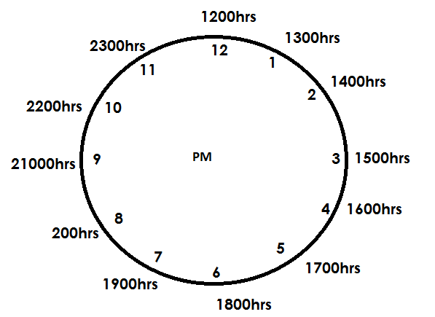**AM CLOCK FACE PM CLOCK FACE**

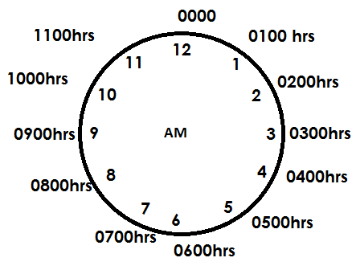

**Note:**

If the given time is in am, use the am part and when it is pm use pm clock face.

Examples.

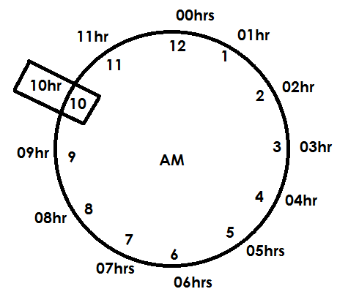1. Change 10:40am to 24 hours clock system

10:40am = 1040hrs

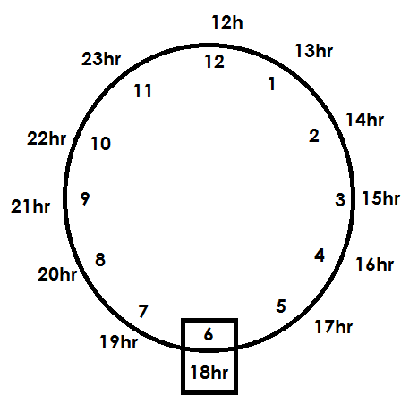**2. Change 6:20pm to 24 hour clock**

6:20pm = 1820hrs

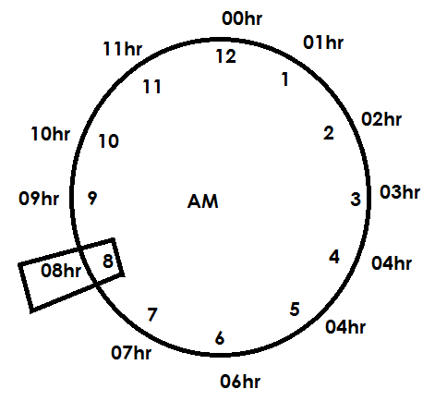**3.** Change 8:14am to 24 hours clock system

8: 14am = 0814hrs

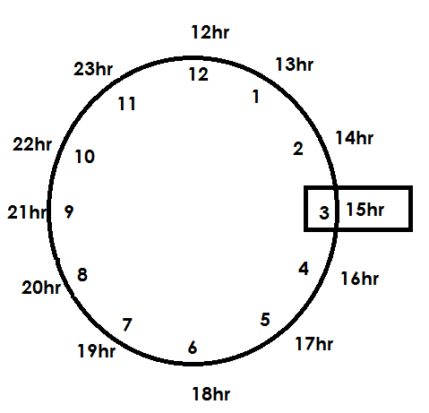4. Change 3:57 pm to 24 hours clock

3:57pm = 1557hrs

**Activity:**

**1. Change the following to 24-hour clock system**

a) 9:00am

b) 1240pm

c) 11:45pm

d) 7:30am

e) 9:42pm

f) 8:50pm

g) 10:59pm

h) 4:00pm

**CHANGING TIME FROM 24 HOUR CLOCK SYSTEM TO 12 HOUR CLOCK SYSTEM**

**Note:**

* If the given time in 24-hour clock system is below 12 hours, use am clock face.
* If the given time in 24 hour clock system is 12 hours and above, use the pm clock face.
* While writing time in 12-hour clock system, the part of the day **MUST** be indicated (am, pm)

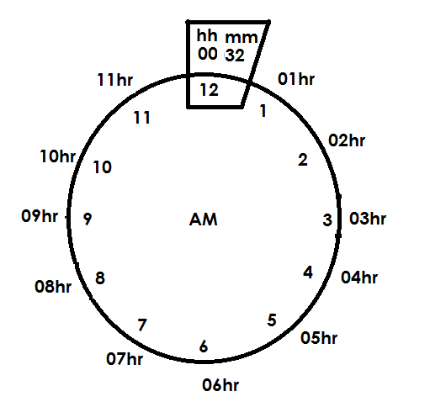1. Change 0032hrs to 12hr o’clock system

**00 32hrs = 12:32am**

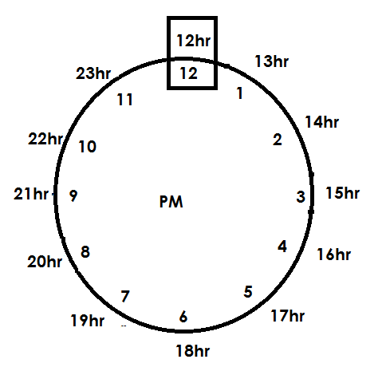2. Change 1240hrs to 12 hour clock system

**12 40hrs = 12:40pm**

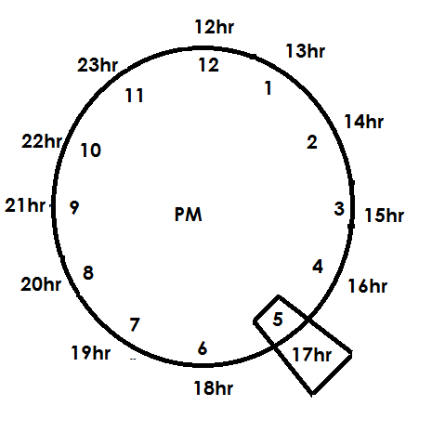3. Change 17 50 hours to 12 hour clock system

**17:50hrs = 5:50pm**

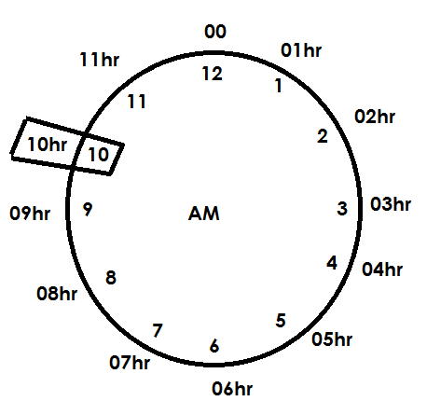4. Change 10:40hrs to 12hr clock system

**1040hrs = 10:40am**

**Activity:**

Change the following to 12-hour clock system.

a) 1026hrs

b) 0930hrs

c) 0845hrs

d) 1818hrs

e) 2340hrs

f) 1734hrs

g) 12:00hrs

**TIME, DISTANCE AND SPEED**

**TIME:**

**FINDING DURATION WITH IN THE SAME PART OF THE DAY.**

1. A lesson started at 8:00am and ended at 10:00am. For how long was the lesson.

**Soln.**

Duration = Ending time – starting time

= E.T - S. T

Hrs min

10 00

-8 00

2 00

**It was for 2 hours**

2. A meeting which stated at 9:20 am ended at 11:00am. For how long was the meeting?

**Soln.**

Duration = E.T – S.T

**HRS min**

10 60

11 00

-9 20

1 : 40

**It was for 1hr 40min**

3. A baby went to bed at 2:40pm and it woke up at 4:10pm. For how long was it in bed?

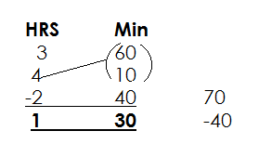Duration = E. T - S.T

**It was for 1 hr 30 min**

4. A math test started at 8:20am and ended at10:50 am. For how many hours was the test?

**Soln.**

Duration = E.T - S.T

HR min

10 50

- 8 20

**2 : 30**

**It was for 2hrs $\frac{30}{60}$**

It was for 2 ½ hrs.

**Activity**:

1. A math lesson started at 12:30pm and ended at 12:40pm. How long was the lesson?

2. An interview started at 7:20am and ended at 10:00am. For how long was the interview.

3. A Journey started at 3:40pm and ended at 7:20pm. For how long was the lesson.

4. A workshop which started at 7:20am and ended at 11:50am. For how long was the workshop?

5. A football match started at 8:20pm and ended at 11:10pm. For how long was the match.

**FINDING DURATION ACROSS DIFFERENT PARTS OF THE DAY.**

**Examples.**

Askari reported on duty at 8:00am and ended at 1:00pm.

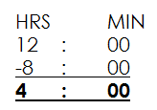**Soln.**

Hrs. : min

Duration = 4 : 00

+ 1 : 00

5 : 00

He was on duty for 5 hrs

**OR**

8:00am = 8 : 00

00 : 00hrs

08 00hrs

1:00pm = 1 : 00

+12 : 00hr

13 00hr

Duration = E.T - S. T

HR - Min

13 : 00

- 08 : 00

**5 : 00**

**He was on duty for 5 hours**

2. A meeting started at 10:40 a.m. and it ended at 2:30pm. For how long was the meeting.

From 10:40 Mid-day

HR Min

12 00

- 10 40

**1 20**

Duration = Hrs Min

1 : 20

+ 2 : 30

**3 : 50**

The meeting took 3 hours 50 minutes

3. How many hours are between 9:20am and 2:30pm?

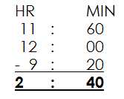**Soln.**

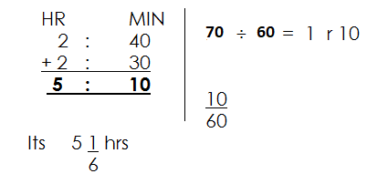

Duration =

**ACTIVITY**

1. A workshop which started at 11:40 am and ended at 3:20pm. For how long was the workshop.

2. A science lesson started at 8:20 am and 5:10pm, For how long was the lesson?

3. A tax collection started at 11:00am and ended at 4:20pm. For how long did the collection take?

4. A church serves started at 10:40am. Fr how long was the church service?

5. Athletics competition started at 9:30am and ended at 2:10pm. For how long was the competition?

**FINDING ENDING TIME GIVEN STARTING TIME AND DURATION**

1. A test which started at 8:15 am lasted for 2hrs. at what time did it end.

Ending time = starting time + Duration

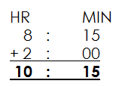E. T = S.T TD

It ended at 10:15 am

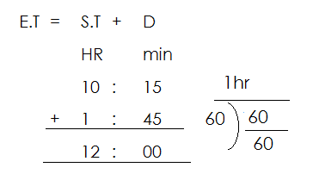2. A meeting which started at 10:15am lasted for 1 hr 45min. At what time did it end.

**It ended at 12:00 noon**

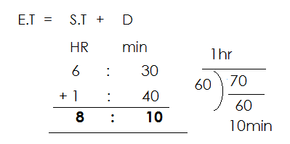3. Sarah leaves work for home at 6:30p.m. it takes her 1 hour 40 minutes to get home. What time does she get home?

She gets home at 8:10pm

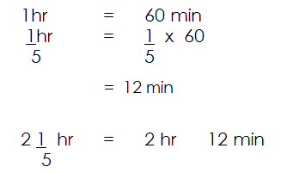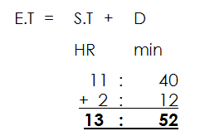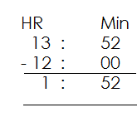4. A bus left Kampala at 11:40am travelling to Masaka for 2 $\frac{1}{5}$ hrs. At what time did it reach?

It ended at 1:52 pm

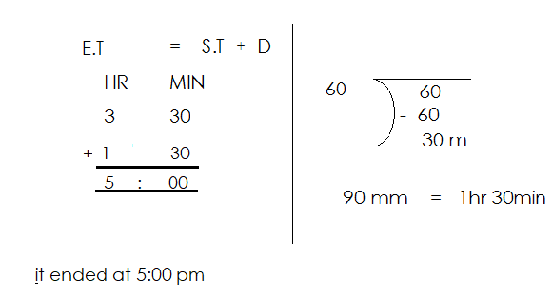5. Okello started performing at 3:30pm and took 90 minutes. At what time did it end?

**Activity:**

1. A football match started at 1:30pm and lasted for 1hr 30 minutes. At what time did it end?

2. A forty minutes lesson started at 11:00am. At what time did it end?

3. A Kamba bus started at 4:30pm and moved for 2 hr 30 minutes. At what time did he reach?

4. A science test that lasted for 2 ¼ hours, started at 9:40 am. At what time did it end?

5. A meeting started at 11:42 am and it lasted for 2 ½ hours. At what time did it end?

6. A parent’s meeting which lasted for 5 1/5 hours started at 10:40am. At what time did it end?

**FINDING STARTING TIME GIVEN ENDING TIME AND DURATON**

1. A fifty minutes lesson ended at 11:20a.m at what time did it start?

Soln.

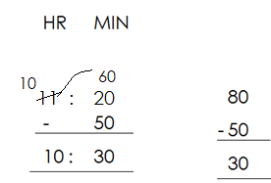S. T = E.T - D

**The lesson started at 10:30 a.m.**

A birthday party which lasted for 2 ½ hours ended at 11:20am. At what time did it end?

**Soln.**

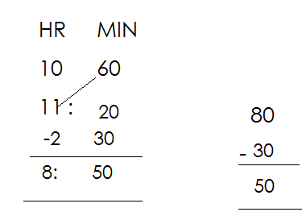S. T = E.T - D

**The lesson started at 8:50 a.m.**

3. A function which lasted for 4 $\frac{2 }{5}$ hrs ended at 3:05pm. At what time did it start?

Duration = 4hrs ( $\frac{2}{5}$ x 60) min

= 4 hrs 24 min

S. T = ET - D

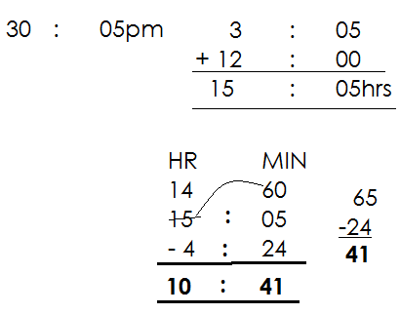 HR Min

It started at 10:41 a.m.

**Activity:**

1. A marathon which lasted for 2 hours ended at 10:00am. At what time did it start?

2. A lesson which lasted for 56 minutes ended at 11:20am. At what time did it start?

3. A drive which lasted for 2 $\frac{1}{4}$ hrs ended at 10:30pm. At what time did it start?

4. A function which lasted for 5 $\frac{2}{3}$ hours ended at 2:05pm. When did it start?

5. A man covered a certain journey from town A to town B in 4 $\frac{4}{5}$ hours. If she reached town B at 3:10pm, At what time did she leave town A?

6. A security guard who works for 7 $\frac{2}{3}$ hours left work at 2:00pm. At what time did he start working?

**FINDING DISTANCE GIVEN SPEED AND TIME**

Distance = speed x Time

1. A taxi covered a certain distance at a speed of 60km/hrs in 3 hours.

Distance = S x T

= $\frac{60km}{hr}$ x 3 hrs

**= 180km**

2. A car takes 2 ½ hours to cover a journey at a speed of 40km/hr. find the distance travelled.

Distance = S x T

= $\frac{40km}{hr }$ x $\frac{45}{60}$ hrs

= 90km

4. Calculate the distance travelled in 7 seconds at 8m/sec.

D = S x T

= $\frac{8m}{sec}$ x 7 sec

= 56m

**Activity:**

1. Find the distance travelled by a car in 4 hours at a speed of 30km/hr.

2. Asio’s journey took 3 hours at an average speed of 45km/hr. how long was the journey?

3. Find the distance covered by a car at a speed of 80km/hr in ¼ hours.

4. A taxi covered a certain distance in 1 ½ hours at a speed of 80km/hr. find the distance covered.

5. John takes 40 minutes to cover a journey at a speed of 60km/hr. How long was the journey?

6. Amooti takes 48 minutes travelling at 80kph. How far does he go?

7. A car moves at a speed of 80km/hr. what distance does it cover in 15 minutes?

8. The speed of a car is 30m /sec. calculate the distance it covers in 40 minutes.

9. A horse moves at a speed of 12 m/sec. calculate the distance it covers in 20 minutes.

**FINDING TIME, GIVEN DISTANCE AND SPEED**

**NOTE:**

Time = distance ÷ speed

**Example 1**

Find time taken to cover a distance of 120km at a speed of 40km/hr.

**Soln**.

**Time = distance ÷ speed**

=120km ÷ $\frac{40km}{hr}$

=120km x

= 3 hrs.

2. If a bus moves at 30km/hr. and covers a distance of 240km; How long does it takes to cover the journey.

Time = D ÷ S

= 240km ÷ $\frac{30km}{hr}$

= 240km x $\frac{hr}{30km}$

= 8 hours

3. A taxi covered 100km at a speed of 40km/hr. for how long did it move?

Time = D ÷ S

= 100km ÷ $\frac{40km}{hr}$

= 100km x $\frac{hr}{4okm}$

= 2 $\frac{1 }{2}$ hrs.

**Activity:**

1. How long will it take a cyclist to cover a distance of 80km at a speed of 20km/hr.

2. The speed of a cyclist is 70km/hr. how long will he take to cover a distance of 350km?

3. Find the time taken to cover a distance of 90km at a speed of 40km/hr.

4. A lex covered a distance of 90km at a speed of 20km/hr. find the time taken.

5. How long will a car take to cover a distance of 180km at a speed of 60km/hr?

6. Find the time taken by a taxi to cover a distance of 140km at a speed of 50km/hr.

**MORE ABOUT TIME TAKEN**

1. Car covered a distance of 120km at an average speed of 60km/hr. how much longer does it take if it moves a speed of 40km/hr.?

**Time at 60km/hr**

T = D ÷ S

=120km ÷ $\frac{60km}{hr}$

=120km x $\frac{hr}{60km}$

**= 2 hours**

More hours = 3hrs – 2hrs

= 1 hour

**Time at 40km/hr**

T = D ÷ S

=120km ÷ $\frac{40km}{hr}$

=120km x $\frac{hr}{40km}$

**= 3 hours**

2. At a speed of 30km/hr, a car covers a distance of 180km. how many less hours does it take to cover the same distance at a speed of 90km/hr?

**Time at 30km/hr**

T = D ÷ S

= 180km ÷ $\frac{30km}{hr}$

=180km x $\frac{hr}{30km}$

= 6 hours

**Time at 90kmkm/hr.**

T = D ÷ S

= 180km ÷ $\frac{90km}{hr}$

= 180km x $\frac{hr}{90km}$

= 2 hours

Less hours = 6hours – 2 hours

= 4 hours

3. Okello covered a distance of 240km at a speed of 80km/hr. How many more hours will he take to cover the same distance at a speed of 30km/hr?

Time at 80km/hr

T = D ÷ S

= 240km ÷ $\frac{80km}{hr}$

= 240km x $\frac{hr}{90km}$

= 3 hours

**Time at 30km/hr.**

T = D ÷ S

= 240km ÷ $\frac{30km}{hr}$

=240km x $\frac{hr}{30km}$

= 8 hours

More hours = 8 hours – 3 hours

=5 hours

**ACTIVITY:**

1. At a speed of 80km/hr, a car covers a distance of 240km. how many less hours does it take to cover the same distance at a speed of 120km/hr?

2. A cyclist covered a certain distance of 750km at a speed of 30km/hr. how many less hours can the same car take to cover the same distance at a speed of 50km/hr.?

3. How many more hours will a car travelling at a speed of 70km/hr. take to cover a journey of 350km if its speed is reduced to 50km/hr?

4. Find how many less hours will a taxi travelling at a speed of 50km/hr take to cover a journey of 300km. if its speed is increased?

**MORE ABOUT DISTANCE AND TIME**

1. A taxi and a bus left station A for station B a distance of 240km apart travelling at a speed of 40km/hr and 60km/hr respectively. How far from B will a taxi be when the bus arrives at station B?

|  |  |  |
| --- | --- | --- |
| Time of taxi | Time of bus | More time |
| T = D ÷ S  240km ÷ $\frac{40km}{h}$ 240km x $\frac{hr}{40km}$ 6 hours | T = D ÷ S  240km ÷ $\frac{60km}{h}$ 240km x $\frac{hr}{60km}$ 4 hours | 6 hours – 4 hours  = 2 hours |

**Distance of taxi in 2 hours.**

D = S X T

= $\frac{40km}{hr}$ x 2 hrs

= 80km

2. Town P and town Q are 480km apart. A taxi and a cyclist left town P travelling at 60km/hr. and 40km/hr. respectively. How far from town Q will a cyclist be when a taxi arrives there?

**Time of a taxi**

T = D ÷ S

= 480km ÷ $\frac{60km}{hr}$

= 480km x $\frac{hr}{60km}$

= 8 hours

**Time of cyclist**

T = D ÷ S

= 480km ÷ $\frac{40km}{hr}$

= 480km x $\frac{hr}{40km}$

**= 12 hours**

More hours = 12 hours – 8 hrs

= 4 hours

**Distance of cyclist in 4hrs**

T = D x S

= $\frac{40km}{hr}$ x 4hrs

**= 160km**

3. A cyclist and a motorist travelled from Peru to Meru a distance of 120km at a speed of 20km/hr and 60km/hr respectively. Find the distance that will have been covered by the cyclist when the motorist arrives at Meru.

**Time by motorist**

T = D ÷ S

= 120km ÷ $\frac{60km}{hr}$

= 120km x $\frac{hr}{60km}$

**= 2 hours**

**Distance by cyclist in 2hrs**

D = S x T

= $\frac{20km}{hr}$ x 2hrs

**= 40km**

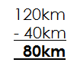b) How far from Meru will a cyclist be when a motorist arrives there?

**Activity:**

1. Towns K and P are 360km apart. A bus and a taxi left town K travelling at a speed of 120km/hr. and 40km/hr. respectively. How far from P will a taxi be when the bus arrives there?

2. A motorist and a cyclist left town X for Y a distance of 240km apart. While moving at a speed of 30km/hr. and 20km/hr. respectively. How far from town Y will a cyclist be when the motorist arrives town Y.

3. Bus station A and Bus station B are 180km apart. Gaga bus and Akamba left station A for B while moving at a speed of 90km/hr. and 30km/hr. respectively.

a) Find the distance that would have been covered by the Akamba bus when the Gaga bus arrives station B.

b) How far from station B will Akamba bus be when Gaga bus arrives there?

4. Othieno and his Friends home are 72km away from town Othieno and his Friend rode bicycles to town at a speed of 36km/hr. and 12km/hr. respectively.

How far from town will Othieno friend be when Othieno arrives town?

5. Mutasa and Mutaali were riding bicycles from home to the nearby town which 40km away at a speed of 8km/hr. and 5km/hr. respectively.

a) Find the distance that Mutaali would have covered when Mutasa arrived town.

b) How far from Town will Mutaali be when Mutasa arrives town?

**FINDING SPEED GIVEN TIME AND DISTANCE**

Speed is the rate at which a certain distance is covered at a given time.

Speed = $\frac{Distance }{Time }$

**OR**

Speed = Distance ÷ Time if given fraction.

1. Find the speed used to cover a distance of 120km. in 3 hrs.

S = $\frac{D}{T}$

= $\frac{120km}{3hrs}$

**= 40km/hr.**

2. A taxi left town K to town P a distance of 90km. What speed did it use to cover that distance in 2hrs?

Speed = $\frac{D}{T}$

= $\frac{90km}{2hrs}$

**= 45km/hr.**

3. Find the speed used to cover a distance of 100km in 2 $\frac{1}{2}$ hrs

Speed = D ÷ T

= 100km ÷ 2 **½** hrs.

= 100km ÷ $\frac{5}{2}$ hrs

= 100km x $\frac{2}{5hr}$

= 40km/hrs.

4. Wandela covered a distance of 120km in 45 mins. Find the speed used in km/hr.

S = D ÷ T

= 120km ÷ $\frac{45hrs}{60}$

= 120km x $\frac{60}{45hrs}$

= 160km/hr.

5. Find the speed used to cover a distance of 180km from 8:00am to 10:00am.

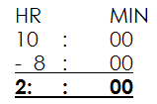Duration = E.T – S.T

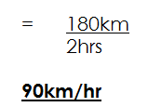Speed = D ÷ T

6. A taxi left Kampala at 8:00am t raveling to Iganga a distance of 120m. if it reached Iganga at 10:30am. Calculate its speed.

**Soln.**

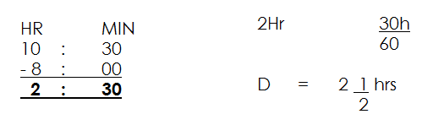 Duration = E.T - S.T

Speed = $\frac{D}{S}$ ÷ T

= 120km ÷ 2 $\frac{1}{2}$ hr

= 120km ÷ $\frac{5}{2}$ hr

= 120km x $\frac{2}{5hrs}$

**= 88km/hr.**

**Activity:**

1. Matama covered a distance of 120km in 2 hours. Calculate her speed in km/hr.

2. A car covered a distance of 180km in 4 ½ hrs. find the speed used.

3. Find the speed used to cover a distance of 100km in 1 ½ hrs.

4. Agaso bus covered a distance of 240km in 2 ½ hrs. calculate the average speed for the whole journey.

5. A taxi left Entebbe at 7:00a.m travelling to Kampala a distance of 120km. If it reached Kampala at 10:00am. Calculate its speed.

6. Musa covered a distance of 40km in 20 min. Find its speed in km/hr.

**CHANGING KM/HR TO M/SEC**

1. Change 26km/hr to m/sec.

$\frac{36km}{1hr}$ = $\frac{m}{sec}$

1km = 1000m

36km = (36 x 1000) m

= 36000m

1hr = 3600sec

Speed = $\frac{D}{T}$

= $\frac{36000m}{36000S}$

= 10m/sec

2. Convert 90km/hr. to m/s

$\frac{90km}{hr}$ = $\frac{m}{s}$

1km = 1000m

90km = (90 x 1000) m

= 90,000m

1hr = 3600sec

Speed =

=

= 25 m/s

3. Osako covered 360km in 2hours convert his speed in m/s

$\frac{360km}{2hr}$ = $\frac{m}{s}$

1km = 1000m

360km = (360 x 1000) m

1hr = 3600 sec

2hrs = (3600 x 2) sec

Speed = $\frac{D}{T}$

= **($\frac{360 x 1000}{3600 x 2 sec}$)**m

**= 50m/s**

4.A distance from Mbale to Iganga is 216km.A car takes 2 hours to cover the distance. At what speed in m/sec does it take?

1km = 1000m

130km = (216 x 1000) m

1hr = 360sec

2hrs = (3600 x 2) sec

Speed = $\frac{D}{T}$

= $\frac{(216 x 1000)m}{3600 x 2 sec}$

**= 30 m/s**

**Activity:**

1. Convert the following km/hr. to m/s

a) 72km/hr.

b) 54km/hr.

c) 144km/hr.

d) 108km/hr.

e) 162km/hr.

f) 126km/hr.

2. Musono covered 72km in 2hrs. What speed did he use in m/s?

3. The distance from Mbarara to Masaka is 360km. if it takes a taxi 4hours to cover the journey. Calculate its speed in m/s.

**CHANGING SPEED FROM M/S TO KM/HR**

1. Changing 10m/sec to km/hr.

$\frac{10m}{s}$ to $\frac{km}{hr}$

1000m = 1km

1m = ( $\frac{1}{1000}$)m

10m = ( $\frac{1 x 10 }{1000}$)km

= ( $\frac{10}{1000}$)km

36000 sec = 1hr

1 sec = ( $\frac{1}{3600}$) hr

Speed = D ÷ T

= $\frac{10}{1000}$ km ÷ $\frac{1}{3600}$ hr

= $\frac{10km}{1000}$ x $\frac{3600}{1hr}$

**= 36km/hr.**

2. Change 40m / sec to km/hr.

$\frac{40m}{sec}$ to $\frac{km}{hr}$

1000m = 1km

1m = ( $\frac{1}{1000}$)km

40m = ( $\frac{1}{1000}$ x 40) km

= $\frac{40}{1000}$ km

3600 sec = 1hr

1 sec = ( $\frac{1}{3600}$)hr

Speed = D ÷ T

= $\frac{40}{1000}$ km ÷ $\frac{1}{3600}$ hr

= $\frac{40}{1000}$ km x $\frac{3600}{1hr}$

**= 144km/hr.**

3. A plane covered 2000m in 80 seconds. Calculate its speed in km/hr

**Soln.**

1000m = 1km

1m = ( $\frac{1}{1000}$)m

2000m = ( $\frac{1}{1000}$ X 20000) km

= ( $\frac{2000}{1000}$)km

3600 sec = 1hr

1 sec = ( $\frac{1}{3600}$)hr.

80 sec = ($\frac{1}{3600}$)hr

= ( $\frac{80}{3600}$)hr

Speed = D ÷ T

= ( $\frac{2000}{1000}$)km ÷ $\frac{80}{3600}$ hr

= ( $\frac{2000}{1000}$)km ÷ $\frac{80}{3600}$ hr

= $\frac{2000}{1000}$ km x $\frac{3600}{30hr}$

**= 90km/hr.**

**Activity**

1. Change the following m/sec to km/hr.

a) 15m / sec

b) 20m / sec

c) 30m / sec

d) 50m /sec

e) 100m / sec

2. A distance of 40m was covered in 2 seconds. Calculate the speed used in km/hr.

3. Okot covered 120m in 2 seconds. Calculate his speed in km/hr.

**FINDING AVERAGE SPEED**

**PART A**

* **Involving a return journey.**

**Example 1**

A motorist travelled from Kampala to Entebbe a distance of 240km in 4hrs. He later returned in 6 hours. Calculate his average speed for the whole journey.

**Soln.**

|  |  |  |
| --- | --- | --- |
| Journey | Time | Distance |
| K – E | 4 hrs. | 240km |
| E – K | 6hrs | 240km |

Average speed = $\frac{Total distance covered}{total time taken }$

= $\frac{240km+240km}{4hrs+6hrs}$

= $\frac{480km}{10hrs}$

= **48km /hr.**

2. Taire covered a distance of 150km in 2hrs and then returned in 4hrs. calculate his average for the whole journey.

**Soln.**

|  |  |  |
| --- | --- | --- |
| Journey | Time | Distance |
| 1st | 2hrs | 150km |
| 2nd | 4hrs | 150km |

Average speed = $\frac{total distance covered}{total time taken}$

= $\frac{150km+150km}{2hrs+4hrs}$

= $\frac{300km}{6hrs}$

**= 50km/hr.**

3. Esther covered a certain distance from home to town at a speed of 120km in 1½hrs then returned in one hour.

Calculate his average speed for the whole journey.

|  |  |  |
| --- | --- | --- |
| Journey | Time | Distance |
| Home – town | 1 ½ hrs. | S x T  120km x 1 **½** hrs.  120km x $\frac{3}{2}$ **180km** |
| Town – home | 1hr | 180km |

Average speed = $\frac{total distance covered}{total time taken}$

= $\frac{180km+180km}{1\frac{1}{2}hr+1 hr}$

= (360km) ÷ 2 ½ hr.

= 360km ÷ $\frac{2}{5hr}$

= 360km x $\frac{2}{5hr}$

**= 144km/hr.**

**Activity:**

1. A taxi traveled from town A to town B a distance of 180km in two hours it later returned to town A in 3 hours. Calculate its average speed for the whole journey.

2. Amooti covered a distance of 200km from home to school in 2 hours. He later returned using the same route in 3 hours. Calculate his average speed for the whole journey.

3. A taxi travelled from town A to town B at a speed of 80km/hr. in 3 hours it later returned to town A in 2 hrs. calculate its average speed for the whole journey.

4. A bus travelled from Kampala to Bumba at a speed of 60km/hr. in 3 hours and then he returned in 2 hours. Calculate its average sped for the whole journey.

**MORE ABOUT AVERAGE ON RETURN JOURNEY.**

**Examples.**

1. A taxi covered a certain distance at a speed of 60km/hr. in 2hrs from town A to B then later returned at speed of 40km/hr. calculate its average speed for the whole journey.

|  |  |  |
| --- | --- | --- |
| Journey | Time | Distance |
| A – B | 2hrs | D = S x T $\frac{60km}{1hr}$ x 2hr  **120km** |
| B – A | D ÷ S $$\frac{120km}{40km/hr}$$ 3hrs | 120km |

Average speed = $\frac{total distance covered}{total time taken}$

= $\frac{120km+120km}{2hrs+3hrs}$

**= 48km/hr.**

2. Mandela left home travelling to town at a speed of 60km/hr. in 4hrs. he rested for an hour and later returned at a speed of 80km/hr. calculate his average speed for the whole journey.

|  |  |  |
| --- | --- | --- |
| Journey | Time | Distance |
| H – T | 4hrs | S x T $\frac{60km}{1hr}$ x 4hrs  240km |
| Rest | 1hr | ----- |
| T - H | D ÷ S  240km ÷ $\frac{hr}{80km}$ 3hrs |  |

Average speed = $\frac{Total distance covered}{Total time taken}$

= $\frac{240km+240km}{4hrs+3hrs+1hr}$

= $\frac{480km}{8hrs}$

**= 60km/hr.**

3. A motorist covered a certain distance at a speed of 80km/hr. in 2½ hrs. from town P to town Q. He rested for ½hour he later returned at a speed of 100km/hr. calculate his average speed for the whole journey.

|  |  |  |
| --- | --- | --- |
| Journey | Time | Distance |
| P – Q | 2 ½ hrs. | S x T $\frac{80km}{hr}$ x $\frac{5}{2}$ hrs  **200km** |
| Rested | $\frac{1}{2 }$ hrs. |  |
| Q – P | D ÷ S $$\frac{200km}{100km/hr}$$ 2hrs | 200km |

Average speed = $\frac{total distance}{total time}$

= $\frac{200km+200km}{2\frac{1}{2}hrs+\frac{1}{2}hrs+2hrs}$

= $\frac{400km}{5hrs }$

**= 80km/hr.**

**Activity:**

1. A bus travelled from Kampala to Mukono at a speed of 60km/hr. in 3 hrs. and then later he returned at a speed of 90km/hr. calculate its average speed for the whole journey.

2, A cyclist travelled at a speed of 90km/hr. in 2 hrs. from Kimonolike to Mbale, it later returned using the same route at a speed of 60km/hr. calculate its average speed.

3. A motorist travelled at a speed of 120km/hr. in 3hrs from Kibuku to Mbale it stopped for 2 hours and later returned at a speed of 90km/hr. calculate its average speed for the whole journey.

4. A motorist covered a certain distance at a speed of 60km/hr. in 2hrs he rested for ½ hr. and later returned. Using the same route at a speed of 80km/hr. calculate his average speed for the whole journey.

**FINDING AVERAGE SPEED OF CONTINUING JOURNEY**

1. A taxi travelled at speed of 60km/hr. from Kampala to Jinja in 2hrs. It then continued to Iganga a distance of 80km in 3 hrs. Calculate its average speed for the whole journey.

|  |  |  |
| --- | --- | --- |
| Journey | Time | Distance |
| K – J | 2hrs | S x T $\frac{60km}{1hr}$ X 2hrs  120km |
| Jinja – Iganga | 3hrs | 80km |

Average speed = $\frac{Total distance}{total time }$

= $\frac{120km+80km}{2hrs+3hrs}$

**= 40km/hr.**

2. A man travelled at a speed of 40km/hr. from P – Q in 3 hrs. he rested for 1hour later continued to town X at a speed of 120km/hr. in 2hrs. Calculate his average speed.

|  |  |  |
| --- | --- | --- |
| Journey | Time | Distance |
| P – Q | 3hrs | S x T $\frac{40km}{hrs}$ x 3 hours  120km |
| Rested | 1hr | ------ |
| Continued to town X | 2hrs | S x T $\frac{120km}{hr}$ x 2hrs  240km |

Average speed = $\frac{Total distance}{total time}$

= $\frac{120km+240km}{3hrs+1hr+2hrs}$

= $\frac{360km}{6hrs}$

**= 60km/hr.**

**ACTIVITY**

1. Crown bus travelled from town A to town B at a speed of 100km/hr. in 1 ½ hrs. he then continued to town C at a speed of 40km/hr. in 1 ½ hrs. workout its average speed for the whole journey.

2. Job covered a certain distance from Kampala to Iganga in 3 hours at a speed of 50km/hr. he rested for one hour and later continued to Mbale at a speed of 40km/hr. in 6hrs. calculate his average speed for the whole journey.

3. Kato left town A driving at 60km/hr. after 2hrs. his car got a puncture and delayed for 1 hour. He then continued at 80km/hr. for 3 hours to town B.

a) What distance had Kato covered before his car got a puncture.

b) How far is town B from A?

c) Calculate Kato’s average speed for the whole journey.

**TRAVEL GRAPH**

Is a time, distance graph used to describe the motion of objects.

The distance travelled is always represented on the vertical axis and time taken to travel that distance is always represented on the horizontal axis.

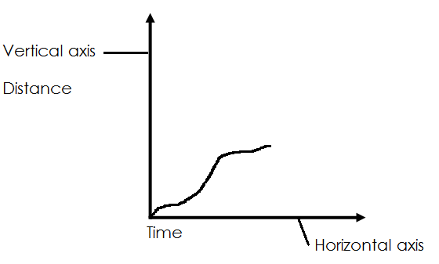**Illustration**

**INTERPRETING TRAVEL GRAPHS**

The graph below represents the distance and time taken by a bus and train. Study it and use to answer questions that below.

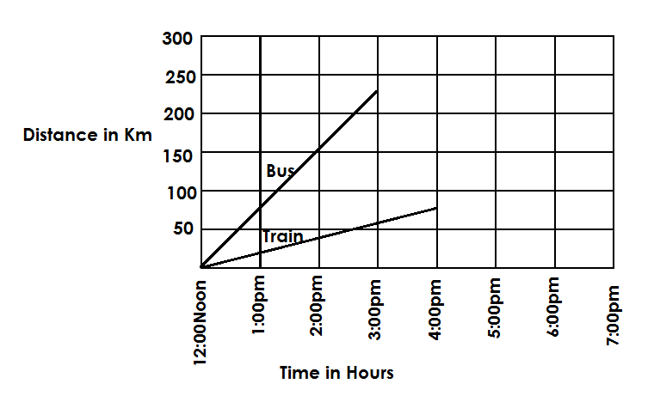

a) At what speed was the bus travelling.

S = $\frac{D}{T}$

Time = 3 hours

S = $\frac{225km}{3hrs}$

**= 75km/hr**

1. At what time had the bus covered 150km

**At 2:00pm**

c) What distance did the bus cover in 2 hours?

**150km**

d) What is the scale on the vertical axis?

2 boxes = 50km

1 box = $\frac{50km}{2}$

1 box = 25km

e) What distance did the train cover in 4 hours.

**75km**

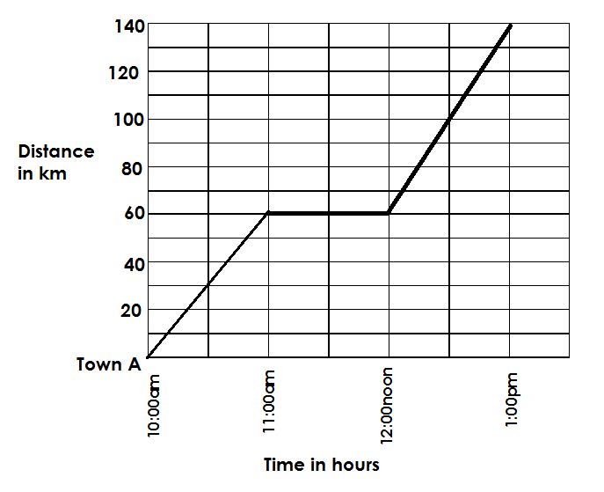The graph below represents a motorist journey from Town A to town B.

a) For how long did the motorist rest?

One hour

b) Calculate the speed of the motorist after resting.

D = 140km – 60km

= 80km

S = D

T

= $\frac{80km}{1hr}$

= 80km/hr.

c) How long did the whole journey take from Town A to town B.

duration = E.T - S.T

Hrs : Min

E.T = 1:00

+ 12:00

**13:00hrs**

**Hrs : min**

13 : 00

- 10 : 00

**3 : 00**

**It took 3 hours**

1. Calculate the motorist’s average speed for the whole journey.

S = $\frac{D}{T}$

D = 140km

T = 3 hours

Speed = $\frac{140km}{3hrs}$

= 46 $\frac{2}{3}$ km/hr

= 46 km

e) What distance had the motorist covered at 12:30pm

100km

**Activity:**

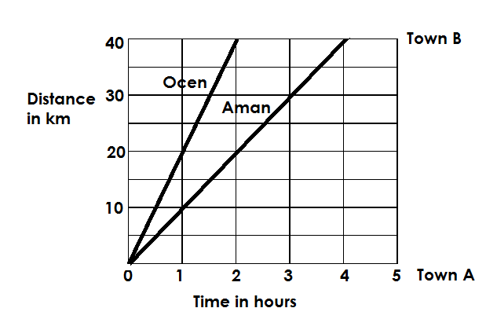1. The travel below represents Ocen and Amon’s journey from Town A to town B.

a) What is the scale on horizontal axis?

b) At what speed was Aman moving?

c) In how many hours had Aman covered 35km?

d) How many km had Ocen covered when Aman had covered 10km?

e) Calculate Ocen’s average speed for the whole journey.

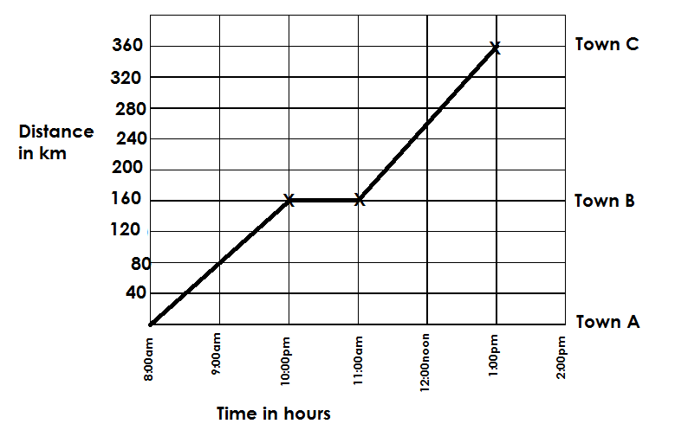2. The graph below shows how a motorist travelled from town A to town B and to town C. study it carefully and use it to answer questions that follow if the distance from town A to town C is 360km.

1. For how long did the motorist rest at town B?
2. At what time did the motorist arrive at Town C?
3. For how long did the motorist take to cover the whole journey?
4. Calculate the motorist’s average speed for the whole journey?
5. What distance had the motorist covered at noon?

3. The graph below shows Mudoola’s journey from his home to town and back home. Use it to answer questions that follow.

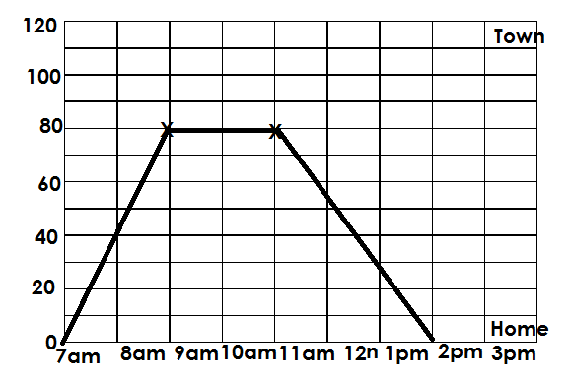

a) How far is town from Mudoola’s home?

b) For how long did he rest in town?

c) What speed did mudoola use while coming back from Town?

d) Calculate his average speed for the whole journey while

**DRAWING TRAVEL GRAPH**

**Note:**

When drawing travel graph, this should be noted and considered.

* The scale on the vertical and horizontal axes.
* The line drawn must represent distance travelled in relation to time taken.

**Example:**

1. Hoima is 200km from Kampala. A bus travelled from Kampala to Hoima at a speed of 40km/hr. for 3 hours. On the way, it rested at Kanu for 1 hour before continuing to Hoima at the same speed for 2 hours. Draw a travel graph and show the journey moved by the bus from Kampala to Hoima if the journey started at 7:00am.

|  |  |  |
| --- | --- | --- |
| Town | Time | Distance |
| Kampala to Kanu | 3 hours | D = S x T $$=\frac{40km x 3hrs}{hr}$$ = 120km |
| Resting | 1 hour |  |
| Kanu – Hoima | 2hours | D = S x T $$=\frac{40km x 2hrs}{hr}$$ = 80km |

Vertical scale:1 box reps 10km

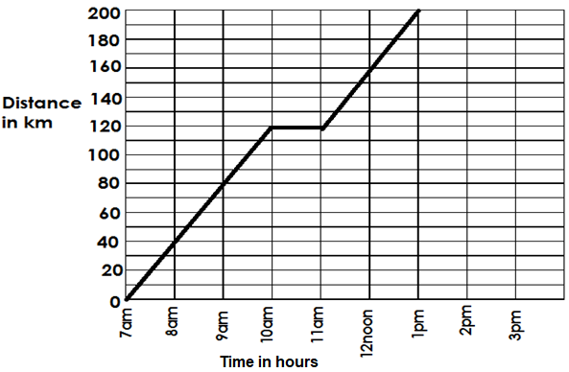Horizontal scale:1 box represents 30 minutes

2. Abbo leaves town K for town L at 8:00am. He travels for 1 ½hrs at 20km/hr. she rests for 30 minutes at town M and then continues to town L at 30km/hr. in 3 hours. After resting at L for 30 minutes, he returns to town K at a speed of 48 km/hr. draw a graph for Abbo’s journey (vertical scale 1square resp 10km.

|  |  |  |
| --- | --- | --- |
| Town | Time | Distance |
| K – M | 1 ½ hours | D = S x T $=\frac{20km}{hr}$ x $\frac{3}{2}$ hrs.  = 30km |
| Resting | 30 minutes ( $\frac{1}{2}$ hrs) |  |
| M – L | 3hours | D = S x T  = $\frac{30km}{hr}$ x 3hrs  =90km |
| Resting | 30 minutes (½ hrs.) |  |
| L – K | T = D ÷ S  =120 ÷ $\frac{48km}{hr}$ =120km x $\frac{hr}{48km}$ $=\frac{ 5}{2}$ hr  **= 2 ½ hr.** | 120km |

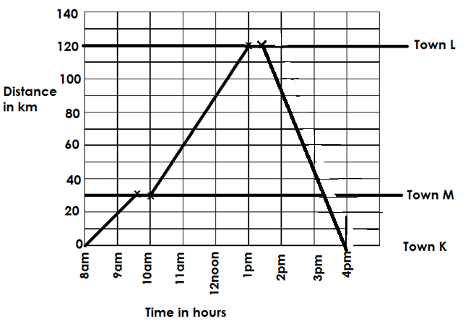

**Activity:**

1. Town A and Town C are 360km apart. A motorist travelled from Town A to Town B for 2 hours at a speed of 80km/hr. He rested at B for 1 hour and continued to Town C at a speed of 100km/hr. for 2 hours. If the motorist started his journey at 9am, draw a travel graph showing that journey.

2. Mukama left town A at 8:00am travelling at an average speed of 40km/hr. in 2 hours to Town B. He rested for ½hr. and later continued to town C at a speed of 60km/hr. in 1 ½ hrs. show Mumama’s journey on a t ravel graph.

3. A taxi left Kampala at 8:00am for Mbale while travelling at a speed of 60km/hr. for 2 hours. It stopped for 1 ½ hrs. at Jinja and later continued to Mbale at a speed of 40km/hr. in 3 hours. Show the taxi’s journey on a travel graph.

4. A motorist left town A at 8:00am travelling at a speed of 40km/hr. for 1 ½ hours to town B. He rested for ½ hours at Town B and inter travelled to Town C at an average speed of 45km/hr. for 2 hours. He rested at Town C before returning directly to Town A at a speed of 50km/hr. shoe the motorist’s journey on a travel graph.

**COORDINATE GRAPH**

* A coordinate graph is a graph of coordinates in ordered pairs.
* Coordinates are ordered pairs of numbers used to mark or plot a point on a graph of co-ordinates e.g. (-2, +5)
* The ordered pairs of numbers are in order of (X, Y)
* A coordinate graph comprises of two axes i.e., X – axis and Y - axis
* Each axis comprises of positive and negative integers with a zero as the mid-point or point of origin.

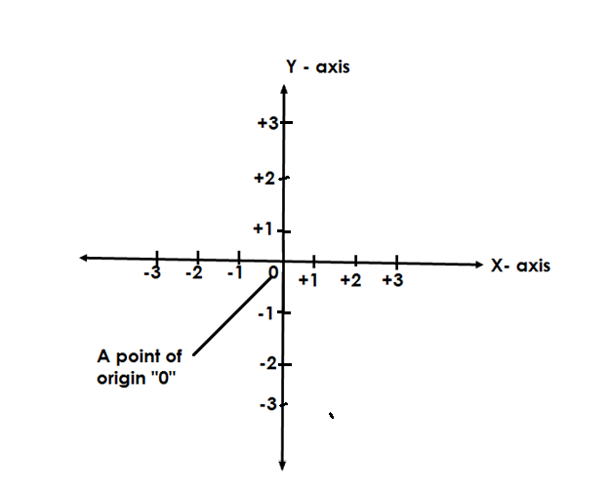**Illustration**

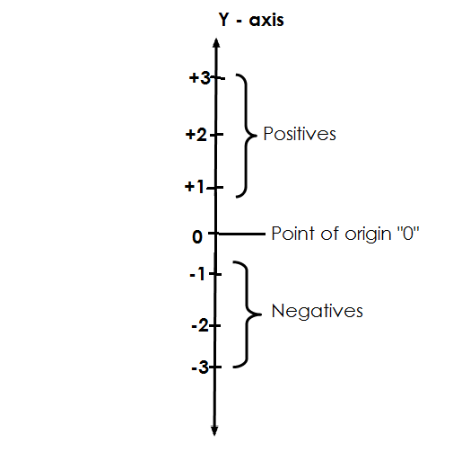

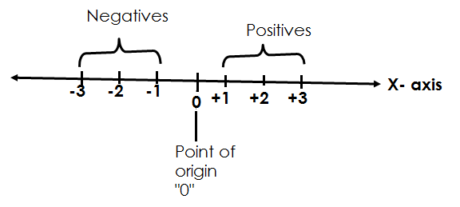

**NAMING COORDINATES OF THE PLOTTED POINTS**

1. 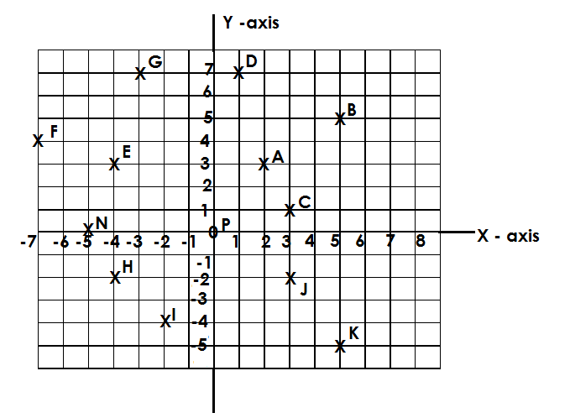Use the graph below to name the coordinates for the given points.

A (+2, +3)

B (+5, +5)

C (+3, +1)

D (+1, +7)

E (-4, +3)

F (-7, +4)

G (-3, +7)

H (-4, -2)

I (-4, -2)

J (+3, -2)

K (+5, -5)

L (+6, 0)

N (-5, 0)

O (0, +4)

P (0, 5)

**Activity;**

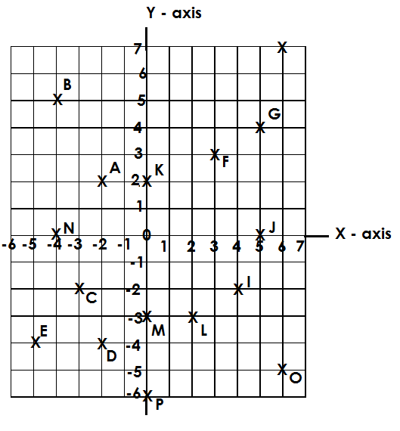Use the graph below to name the coordinates for the given points.

**PLOTTING COORDINATES ON A GRAPH**

1. Draw a coordinate graph and plot the following coordinates: -

A (1,1), B (-5,3), C (-4, -2), D (+5, +7), E (+6, +3)

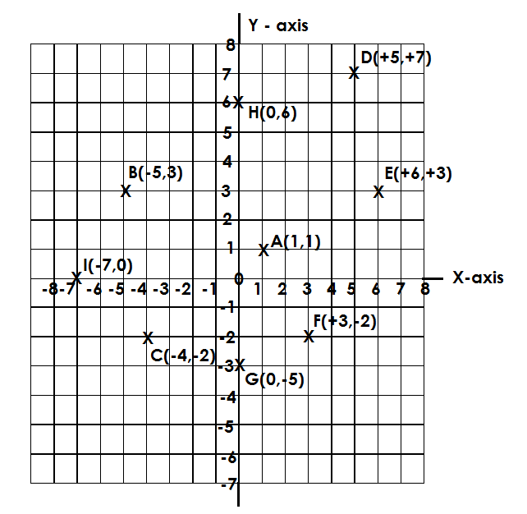F (+3, -2), G (0, -5), H (0,6) , I(-7,0)

**Activity.**

1. Draw a coordinate graph and plot the following coordinates: -

A (-3, 1), B (-4, -3), C (-2, 0), D (-5, 0), E (2, -6), F (-4,0).

2. Draw a 10 by 10 grid and plot the following points.

A (4, -2), B (1,1), C (-4, -5), D (-1,0), E (3, -2), F (3, -5)

3. Draw a 12 by 12 grid and plot the following points.

A (0,5), B (5,0), C (-3,0), D (0,0), E (0,0), F (0,2)

**FORMATION OF FIGURES BY PLOTTING**

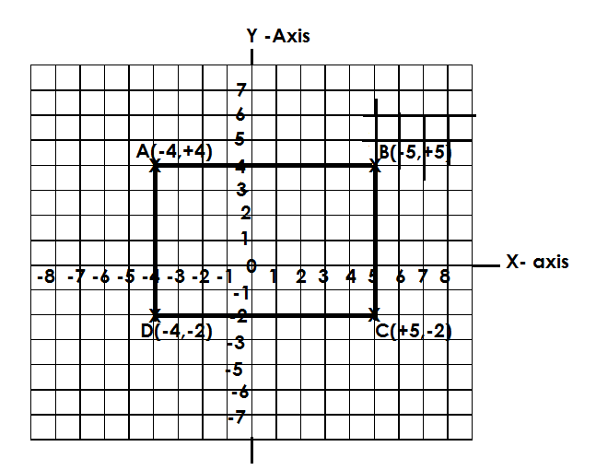1. Draw a coordinate graph and plot the following points.

b) Join points A to B to C to D and D TO A.

c) Name the figure formed.

Rectangle

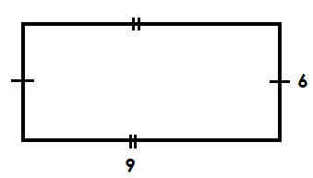d) Calculate the area of the figure formed.

Area = L x W

= 9 x 6

**= 54 square units**

2. Draw a 10 by 10 grid and plot the following coordinates.

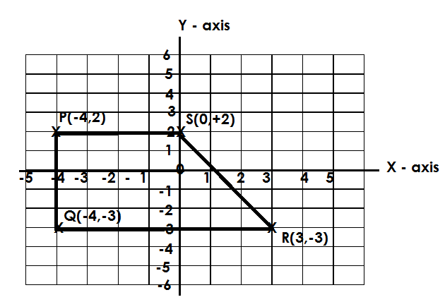 P (-4, +2), Q (-4, -3), R (3, -3) and S (0 + 2)

b) Join P to Q, Q to R to S and S to P.

c) Name the figure formed joining.

Trapezium

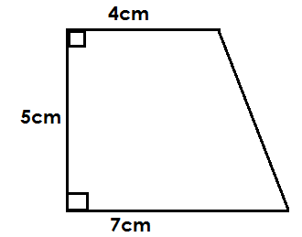d) Calculate the area of the figure formed if 1 box represents 1cm.

Area = ½ x h (a + b)

= ½ x 5cm (7cm + 4cm)

= 5cm (11cm)

2

= 5cm x 11cm

2

= cm2

**= 27 ½ cm2**

**Activity:**

1. Draw a coordinate graph and plot the following points.

A ( -4, +2), B (+4, +2), C (+4, -6) and D (-4, -6)

1. Join A to B, B to C, C to D and D to A.
2. Calculate the area of the figure formed.

2. Draw a coordinate graph and plot the following points.

R (-5, +1), P (-2, +4) and Q (+1, +1)

b) Join R to P, P to Q and Q to R.

c) Name the polygon formed after joining.

d) Calculate the area of the figure formed if 1 box represents 1cm.

**GEOMETRY (ANGLES)**

An angle is the amount of turning between two straight lines at a fixed point.

**Types of angles**

* Acute angles
* Obtuse angles
* Right angles
* Reflex angles
* Straight line angles
* Centre angles

**ACUTE ANGLES**

Acute angles are angles less than 90 o e.g., 60o, 80 o,18**0**, 30**0**, 88**0,** 35**0**, 45 o, 1 o, 50 o, 22 o, 75 o, etc.

**Illustration**

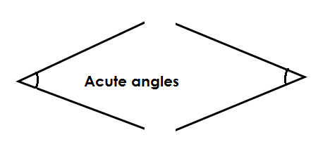

**Obtuse angles**

These are angles that are greater than 90o but less than 180o i.e., 91 o ,179o, 91 o, 105o, 98 o, 150 o etc.

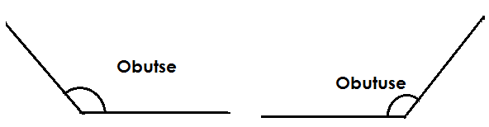**Illustration**

**REFLEX ANGLES**

* These are angles greater than 180o but less than 360o e.g., 181o – 359o e.g., 190o, 200o, 240o, 354o, etc.

**Illustration**

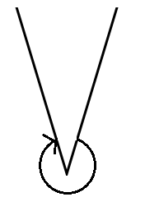

**STRAIGHT LINE ANGLES**

A straight-line angle is an angle that measures 180o.

**Illustration**



**RIGHT ANGLES**

A right angle is an angle that add up to 90o.

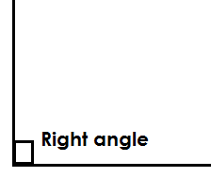**Illustration**

**COMPLEMENTARY ANGLES**

These are two or more angles that add up to 90o.

**Examples.**

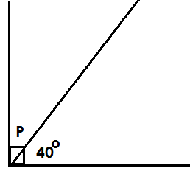1. Find the value of P in the figure below.

P + 40o = 90 o

P + 40 o – 40 o = 90 o – 40 o

P = 50 o

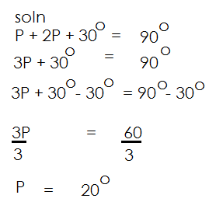2. Find the value of P in the figure below.

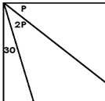

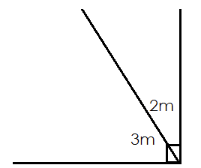3. Find the value of M

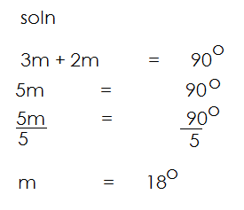

**SUPPLEMENTARY ANGLES**

These are two or more angles on a straight line that adds up to 180**o**.

**Examples.**

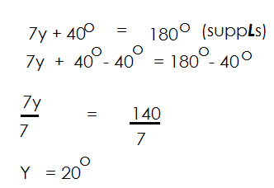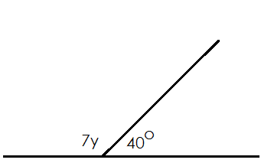Find the value of the unknown in the following.

a)

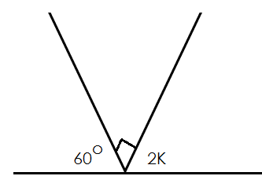b)

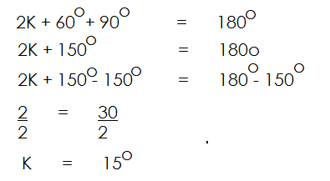

**ANGLES AT A POINT**

Are angles which add up to 360**0**.

**Examples.**

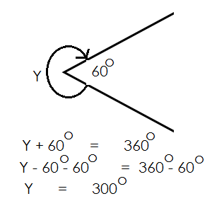Find the Size of angle y

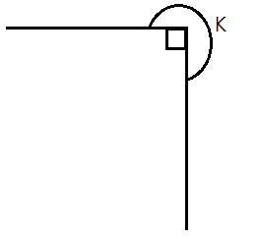2. Find the value of K

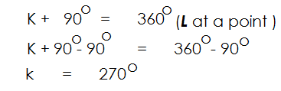

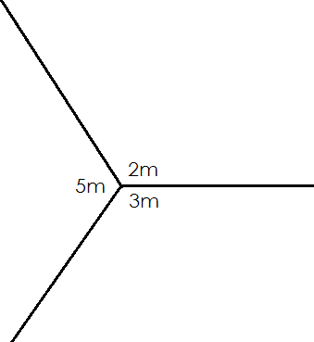3. Find the value of m.

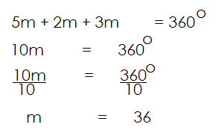

**Activity:**

1. Calculate the value of the unknown angle.

1. 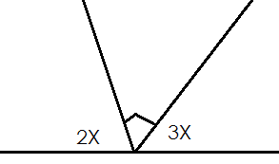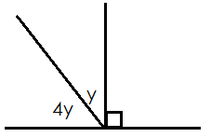 b)

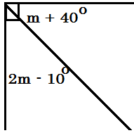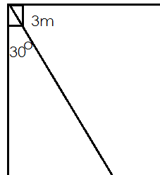c) d)

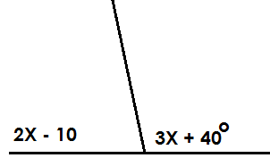

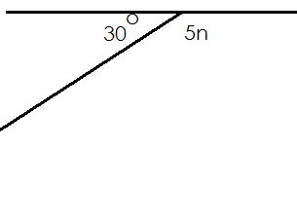e) f)

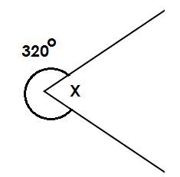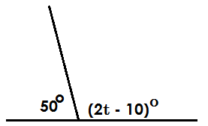g) h)

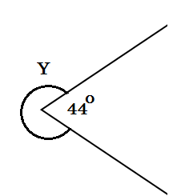i)

**FINDING COMPLEMENT OF COMPOUND ANGLES.**

1. Find the complement of Y

Comp. = 90**0** - Y

2. Find the complement of 2X

Comp. = **90 – 2x**

1. Find the complement of 2Y – 300

Comp. = 90o – 2y – 30 o

= 90 o – 2y + 30 o

= 90 o + 30 o – 2y

= **120 o – 2y**

4. Find the complement of 2P + 60o.

90 o – (2P + 60 o)

90 o – 2p – 60 o

90 o – 60 o – 2p

30 o – 2p

5. Find the complement of 2K + 40o

**Soln.**

90 o – (2K +40 o)

90 o – 2K – 40 o)

90 o – 40 o – 2K

50 o – 2k

Find the complement of the following: -

a) 2m

b) y + 40o

c) K – 30 o

d) 3m – 42 o

e) 2y + 36 o

**FINDING SUPPLEMENT OF COMPOUND NUMBERS**

1. Find the supplement of K.

**Soln**.

180o – K

1. Find the supplement of 2m

**Soln**.

180 o – 2m

1. Find the supplement of 2K +40 o

**Soln**.

180 o – (2k + 40) o

180 o – 2k – 40 o

180 o – 40 o – 2k

140 o – 2k

1. Find the supplement of m + 70o

**Soln.**

180 o – (m + 70) o

180 o – m – 70 o

180 o – 70 o – m

110 o – m

**Activity:**

Finding the supplement of the following angles:

a) m

b) 3K

c) 2y – 120 o

d) y – 60 o

e) 2y + 36 o

f) 30 o – 2p

**DRAWING AND MEASURING ANGLES**

* Angles are measured using a protractor.
* The learners should choose the scale to use i.e., either inner scale or outer scale.

**Examples.**

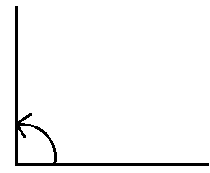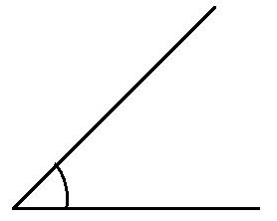Measure the following angles.

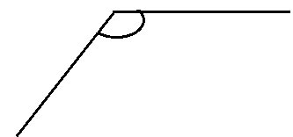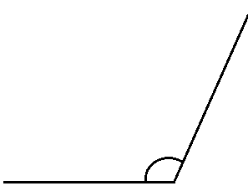

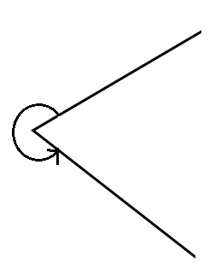

**CONSTRUCTING ANGLES USING A PAIR OF COMPASSES.**

a) 90o

b) 60 o

c) 75 o

d) 120 o

**Angles got by bisecting**

a) 30o (bisect 60o)

b) 150 o = (construct 30o and name 150 o)

c) 45 o = (bisect 90 o)

d) 135 o

**Activity:**

Construct the following angles: -

a) 90o, 45o, 60o, 120o, 145o, 30o, 105o

**Bisecting lines and angles.**

**Bisecting a line**

* Draw a given line and label it (MN).
* Place the compass needle at the two points (M and N) and mark arcs above and below.
* It forms two intersecting arcs up and down and draw a line to join the two intersecting arcs.

1. Bisect line MN

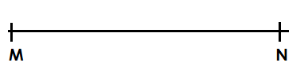

**Activity:**

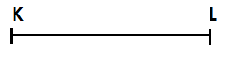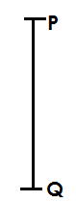Bisect the following lines

a) b)



c)



D)

**BISECTING ANGLES.**

Bisecting an angle is to divide the given angle into two equal parts.

**Example I**

Using a pair of compasses, a ruler and a pencil only. Bisect the given angles below.

**Procedure:**

* Place the needle of the pair of compasses at the fixed point.
* Make two arcs on the two lines that are meeting at the fixed point.
* Transfer the needle to any arcs made and make the upper arc.
* Transfer the needle of the compass to the second arc and intersect the arc made to form the point of intersection or point of bisection.
* Join the point of intersection to the point of origin (fixed point) using a ruler and a pencil only.

**Exercise.**

Using a pair of compasses, a ruler and a pencil only, bisect the obtuse angle in the diagram below.

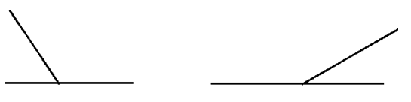

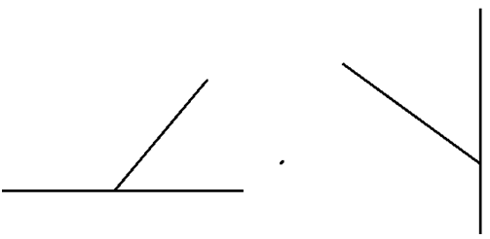

**Activity:**

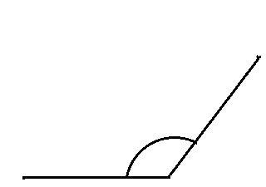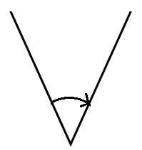Using a pair of compasses, a ruler and a pencil only, bisect the given angle.

a) b)

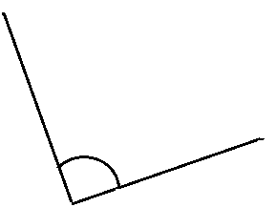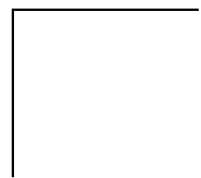

c) d)

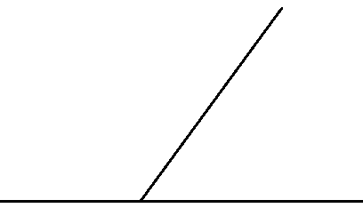Using a ruler, a pencil and a pair of compasses only. Bisect the acute angle.

Using a ruler, a pencil and a pair of compasses only. Bisect the obtuse angle.

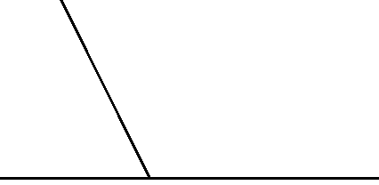

**DROPPING A PERPENDICULAR FROM A GIVEN FIXED POINT**

**Example I**

Using a pair of compasses, a ruler and a pencil, drop a perpendicular from point P through line AB at point K.

**Procedure:**

* Place the needle at point P.
* Adjust the compass such that you make two acres on the given line.
* Transfer the needle to any of the arcs made and construct lower arc.
* Transfer the needle of the pair of compasses to the second arc and intersect the first arc to form a point of intersection.
* Join the point of intersection to point P using a pencil and a ruler.

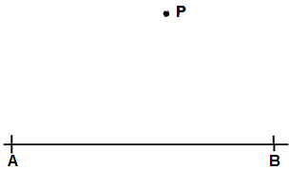

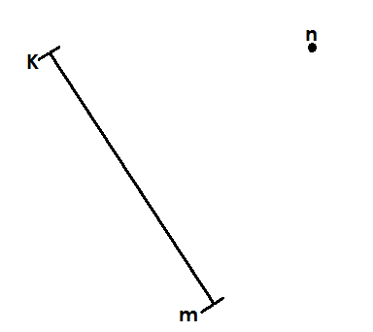1. Using a pair of compasses, a ruler and a pencil only. Drop a perpendicular from n to meet line KM at point S.

**Exercise.**

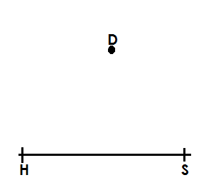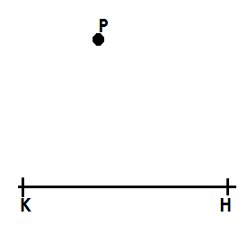Using a pair of compasses, a ruler and a pencil. Drop a perpendicular from a given point to meet a given line.

a) b)

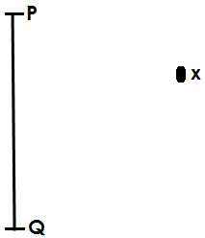c)

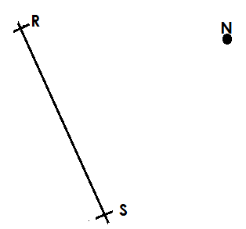

d)

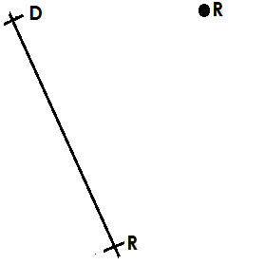e)

**ANGLES FORMED BETWEEN PARALLEL LINES.**

**PARALLEL LINES.**

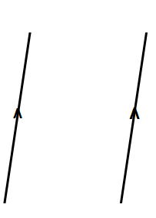These are lines that cannot meet because they have the same distance apart and running in the same direction.

**symbol**

If two or more lines are crossed by a line (Transversal line), different angle properties will be formed.

**These include:**

* Co-interior angles
* Co-exterior angles
* Alternating angles
* Corresponding angles
* Vertically opposite angles
* Supplementary angles
* Complementary angles

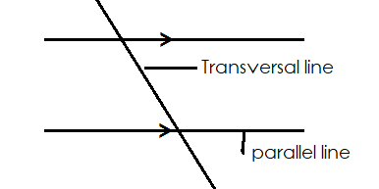**Illustration of parallel lines with a transversal line.**

**Co-interior angles**

* They add up to 180o.
* They are found inside parallel lines.
* They are formed on the same side of the traversal line.
* One angle is acute and another angle is obtuse.

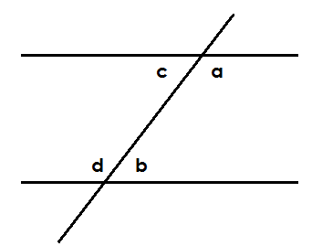**Illustration**

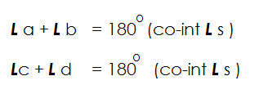

**Examples.**

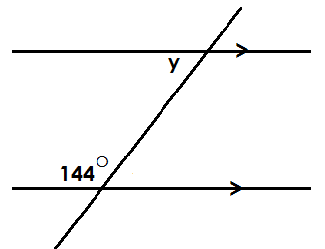1. Find the value of Y.

y + 44o = 180 o (Co-int ***L*** s)

y + 144 o – 144 o = 180 o – 144 o

**y = 36 o**

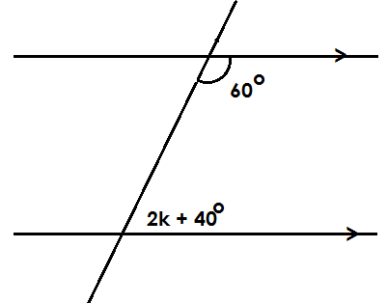2. Find the value of k.

2K + 40o + 60o = 180o (co-int L s)

2K + 100o = 180o

2K + 100o – 100o = 180o – 100o

=

**K = 40o**

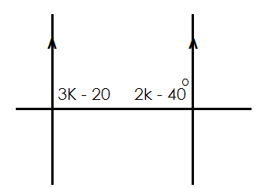3. Find the value of K.

3K – 20o + 2K – 40 o = 180 o (Co-int L s)

3K + 2K – 20 o – 40 o = 180 o

5K – 60 o = 180 o

5K – 60 o + 60 o = 180 o + 60 o

=

K = 48 o

4. Find the value of m in the figure below.

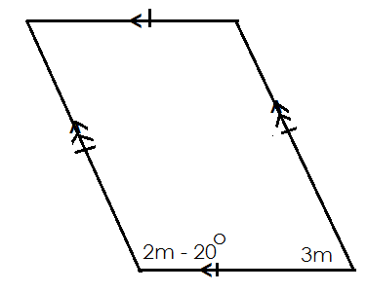

2m + 3m – 20o = 180 o (Co- int Ls)

5m – 20 o = 180 o

5m – 20 o + 20 o = 180 o + 20 o

=

**M = 40 o**

**Activity:**

1. Find the value of P. 5. Find the value of p.

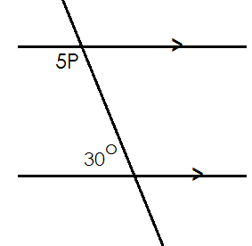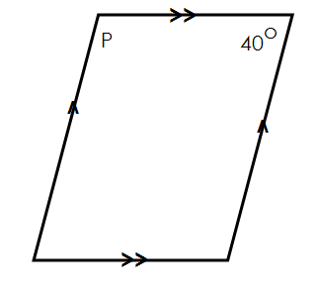

2. Find the value of K 4. Find the value of m.

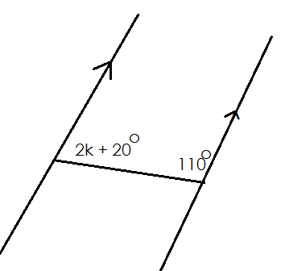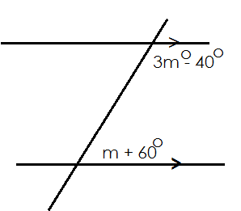

3. Find the value of m.

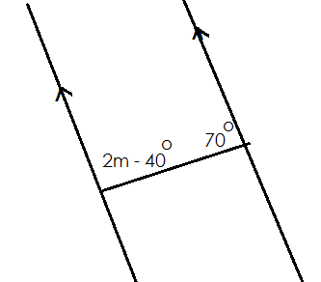

**CO- EXTERIOR ANGLES**

* They add up to 180o.
* They are found outside the parallel lines.
* They are found on one side of the transversal line.
* One is obtuse and another is acute.

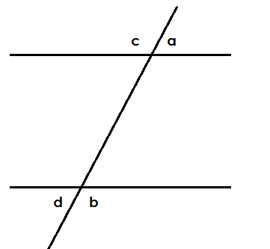**Illustration**

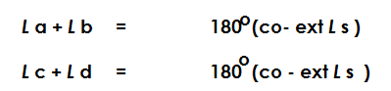

**Examples:**

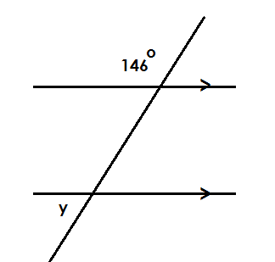Find the value of y.

Y + 146o = 180 o (Co – ext. L s)

Y + 146 o – 146 o = 180 o – 146 o

**Y = 34 o**

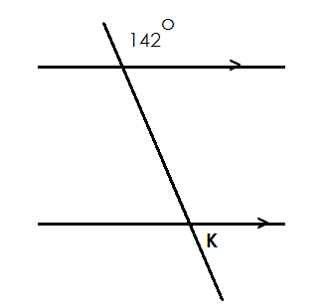2. Find the value of K.

K + 142o = 180 o (co – ext. L s)

K + 142 o – 142 o = 180 o – 142 o

**K = 38o**

1. 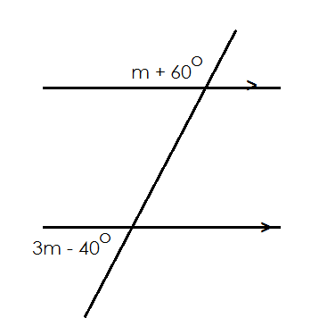Find the value of m.

3m – 40 o + m + 60 o = 180 o (co-ext. L s)

3m + m + 60 o – 40 o = 180 o

4m + 20 o = 180 o

4m + 20 o = 180 o

4m + 20 o – 20 o = 180 o – 20 o

=

**M = 40o**

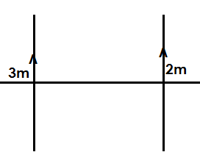**Activity:**

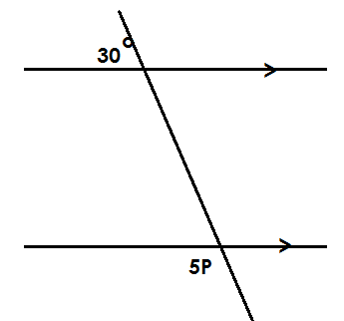Find the value of unknown in the following:

1. 2.

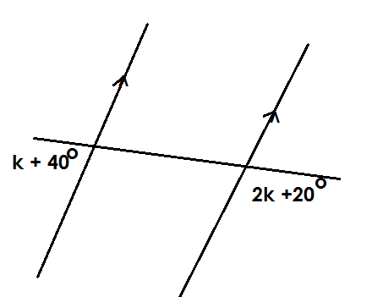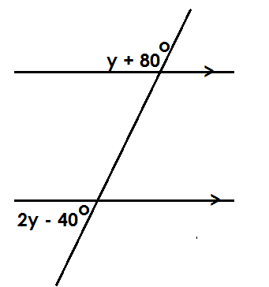

3. 4.

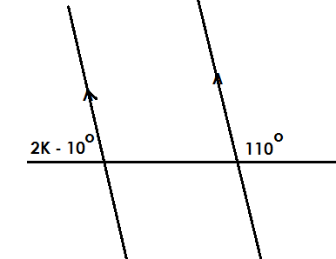

5.

**CORRESPONDING ANGLES**

* Corresponding angles are equal.
* Corresponding angles are formed on the same side of the transversal line.
* One is found inside and another one outside parallel lines.
* One angle is found on the lower parallel line and another angle on the upper parallel line.

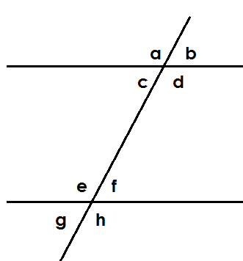**Illustration**

***L*** a = ***L*** e

***L*** c = ***L*** g corresponding angles

***L*** b = ***L*** f

***L*** d = ***L*** n

**Examples**

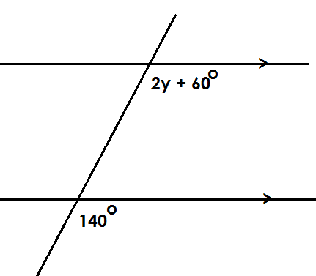Find the value of y

**Soln.**

2y + 60o = 140o (Corrs L s)

2y + 60o – 60o = 140o – 60o

=

y = 40o

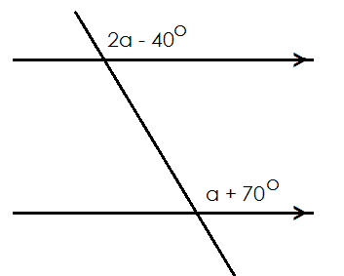2. Find the value of a

**Soln.**

2a – 40o = a + 70 o (Corrs. Ls)

2a – 40 o + 40 o = a + 70 o + 40 o

2a = a + 110 o

2a – a = a – a + 110 o

a = 110 o

1. 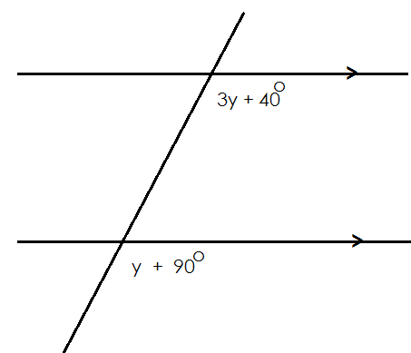Find the value of y.

**Soln.**

3y + 40o = y + 90 o

3y + 40 o – 40 o = y + 90 o – 40 o

3y = y + 50 o

=

**y = 25o**

**Activity:**

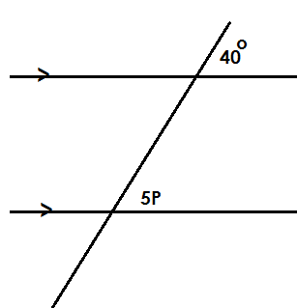1. Find the value of the unknown letter.

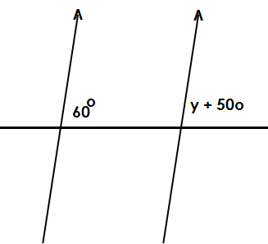

2.

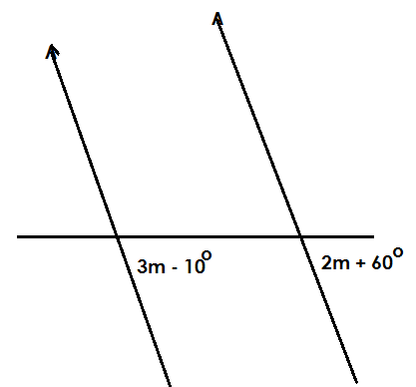3.

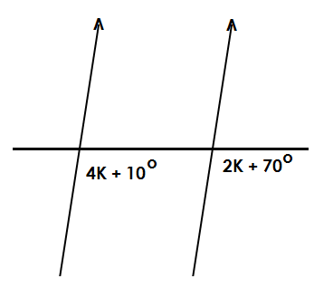

4.

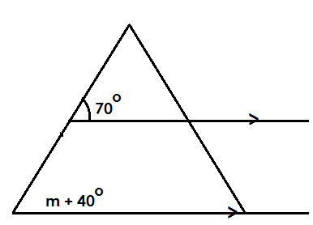

5.

**ALTERNATING ANGLES**

* Alternating angles are equal.
* Alternating angles are formed on both sides of the transversal line.
* If they are inside, they are called alternate interior. If they are outside, they are called alternate exterior.

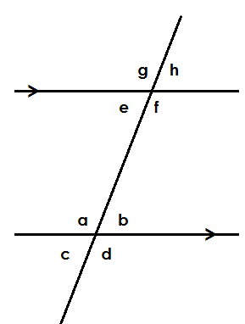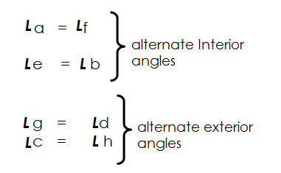**Illustration**

**Examples**

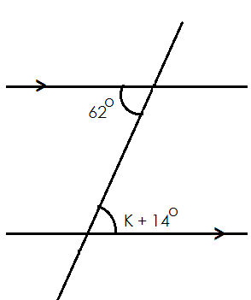1. Find the value of K in the diagram below.

K +14o = 62 (Alt int ***L*** s)

K +14 o – 14 o = 62 o – 14 o

K = 48 o

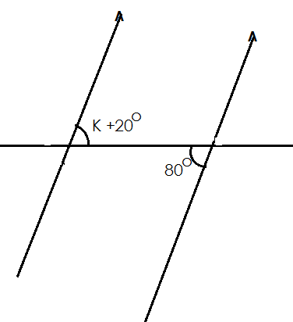2. Find the value of n.

K + 20o = 80o (Alternate int ***L*** s)

K + 20o – 20o = 80o – 20o

**K = 60o**

3. Find the value of K.

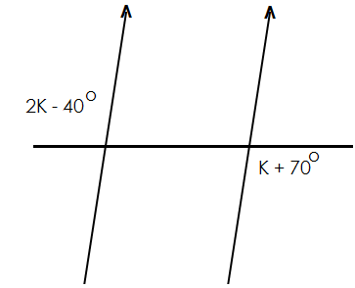

**Soln.**

2K – 40o = K + 70 o

2K – 40o +40 o = K + 70 o + 40 o

2K = K + 110 o

2K – K = K – K + 110 o

**K = 110 o**

**Activity:**

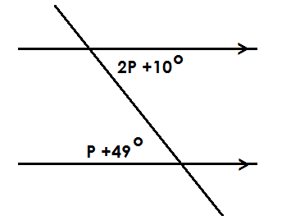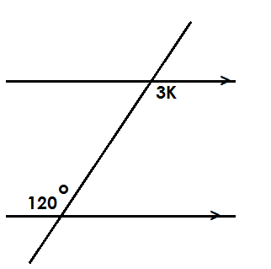Find the value of the unknowns in the following: -

1. 2.

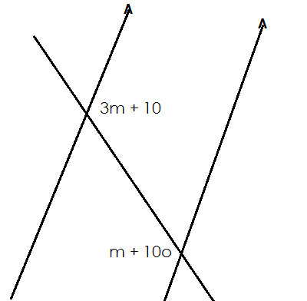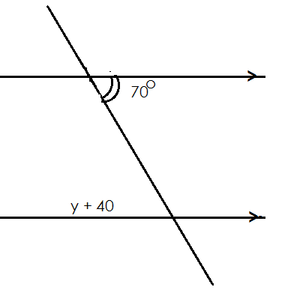

3. 4.

**VERTICALLY OPPOSITE ANGLES.**

These are angles formed when two line cross each other to form letter X (**X angles)**

Vertically opposite angles are equal.

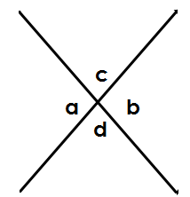**Illustration**

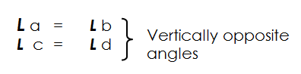

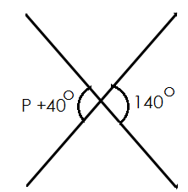1. Find the value of K.

Soln.

P + 40o = 140 (Vert. opp. Ls)

P + 40 o – 40 o = 140 o - 40 o

P = 100o

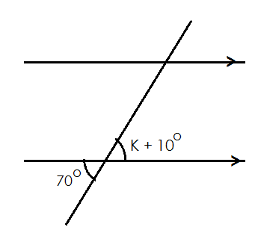2. Find the value of k.

K + 10o = 70o (Vert. Opp. Ls)

K + 10o – 10o = 70o – 10o

K = 60o

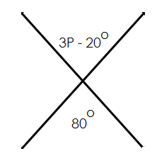3. Find the value of P.

3P – 20o = 80o (Vert. Opp. Ls)

3P - 20o +20o = 80o + 20o

=

**P = 33 o**

**Activity:**

Find the value of the unknown in the following

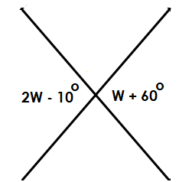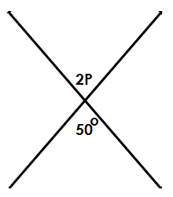a) b)

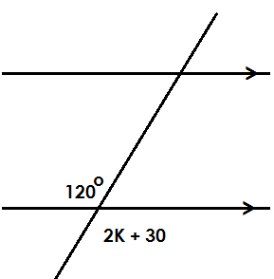

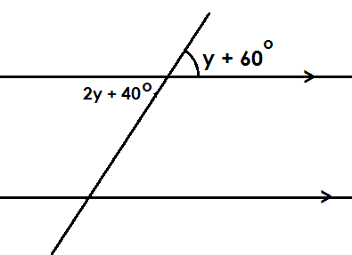

c) d)

**APPLICATION OF PARALLEL LINES**

1. In the diagram below find the value of Y.

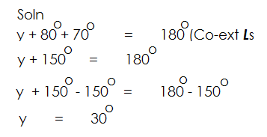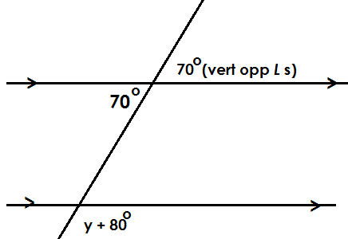

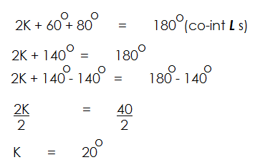2. Find the value of K.

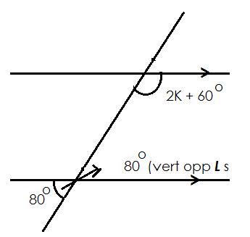

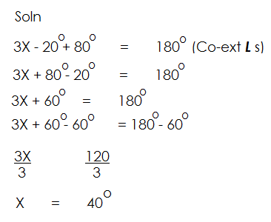3. Find the value of X.

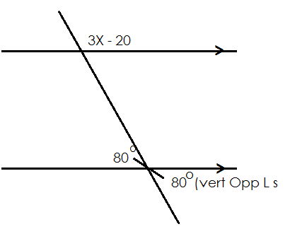

**Activity:**

Find the value of the unknown.

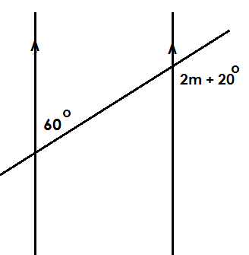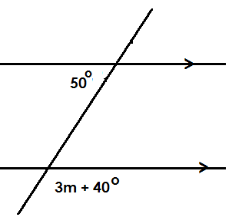a) b)

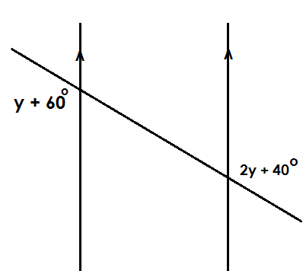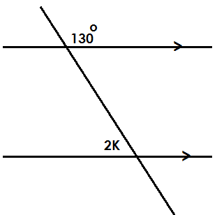

c) d)

**MORE APPLICATION OF PARALLEL LINES (part 1).**

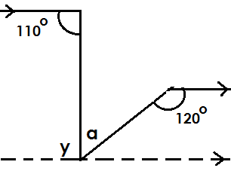Find the value of a

Y + 110o = 180 o (co-int L s)

Y + 110 o – 110 o = 180 o – 110 o

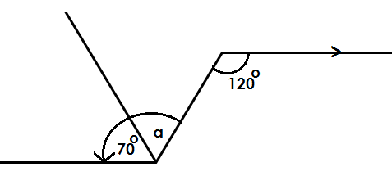 **Y = 70 o**

y + a = 120o

70o + a = 120 o

70 o – 70 o + a = 120 o – 70 o

**a = 50 o**

Find the value of k.

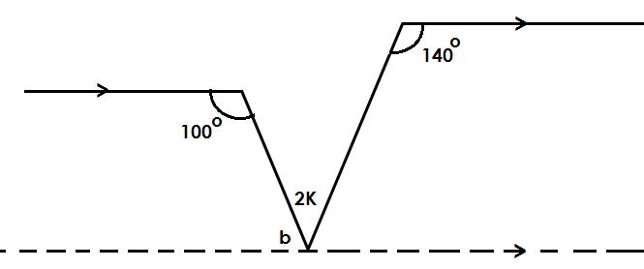

b + 100o =180 o (Co-int Ls)

b + 100 o – 100 o =180 o – 100 o

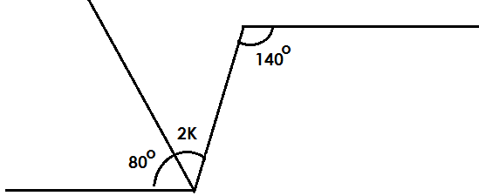b = 80 o

2K + 80o = 140 o (Alt int ***L*** s)

2K + 80 o – 80 o = 140 o – 80 o

=

K = 30 o

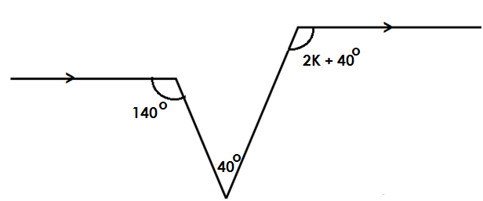3. Find the value of K

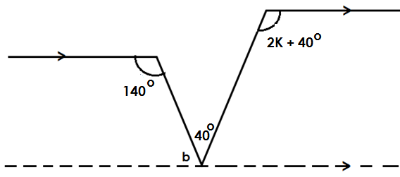**Soln.**

b + 140o = 180o (Co-int ***L*** s)

b+ 140o = 180o – 140o

b = 40o

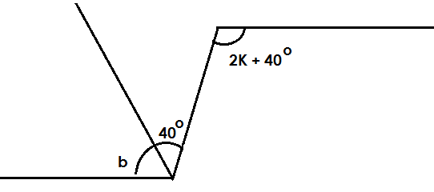

2K + 40o = b + 40o (Alt int ***L***s)

2K + 40 o = 40 o + 40 o

2K + 40 o – 40 o = 80 o – 40 o

=

K = 20 o

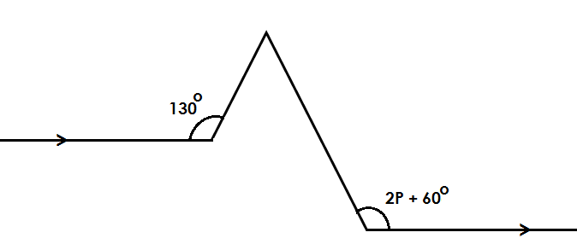4. Find the value of P

**Soln.**

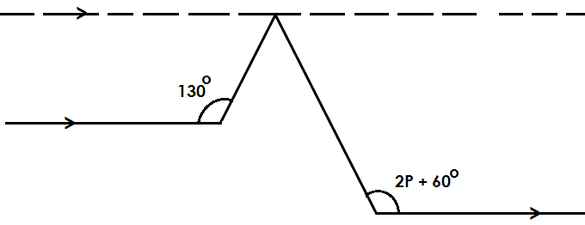

b + 130o = 180o

b + 130 o – 130 o = 180 o – 130 o

b = 50 o

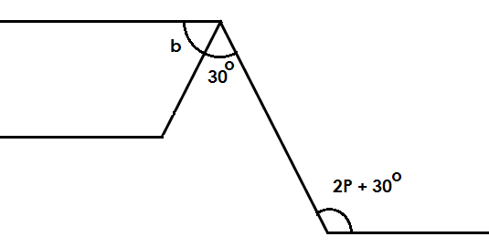

2P + 30o = 30 o + 50 o (Alt int ***L***s)

2P + 30 o = 80 o

2P + 30 o – 30 o = 80 o – 30 o

=

P = 25

**Activity:**

Find the value of the unknown

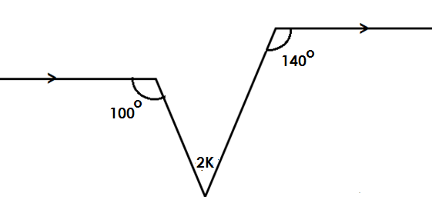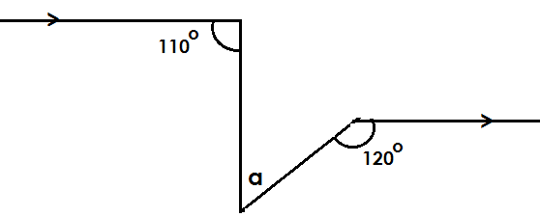

1. 2.

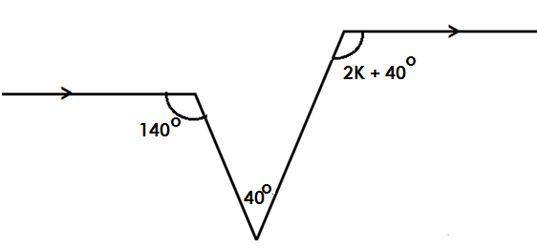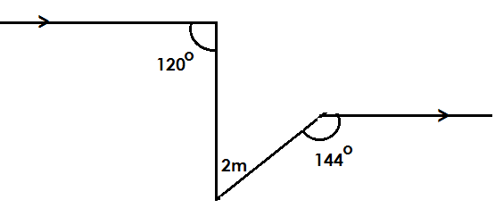

3. 4.

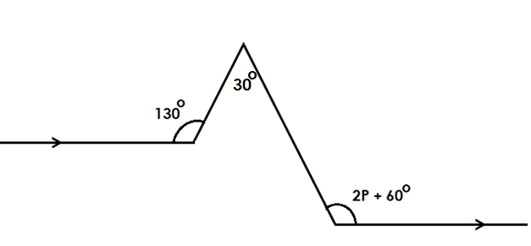

5.

**MORE ON APPLICATION OF PARALLEL LINES (Part 2)**

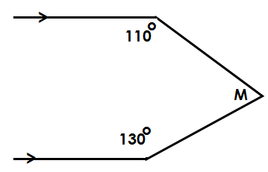Find the value of P

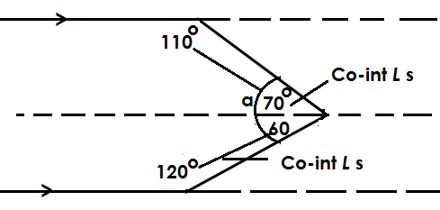soln.

**Soln.**

a + 110 o = 180o (Co-int. angles)

a + 110 o = 180 o – 110 o

a = 60 o

b + 120 o = 180 o

b + 120 o – 120 = 180 o

Therefore;

m = a + b

= 70o + 60o

= 130o

2. Find the value of P.

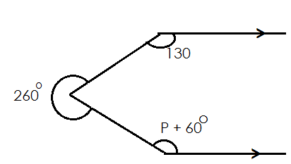

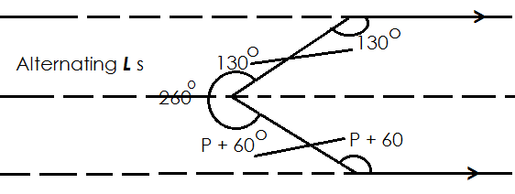**Soln.**

P + 60o + 130 o = 260 o

P + 190 o = 260 o

P + 190 o – 190 o = 260 o – 190 o

P = 70 o

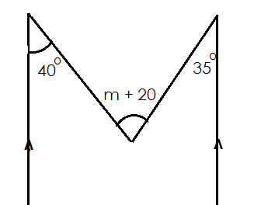3. Find the value of m.

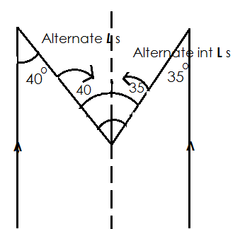**Soln.**

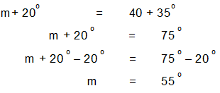

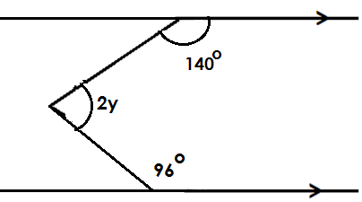4. Find the value of Y.

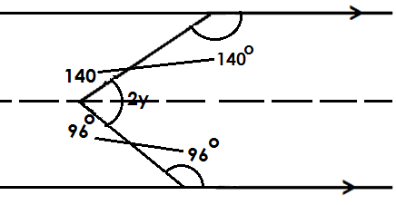**Soln.**

2y + 140o +96o = 360o (Ls at a point)

2y + 236o  = 360o

2y + 236 o – 236 o = 360 o – 236 o

=

y = 62 o

**ACTIVITY:**

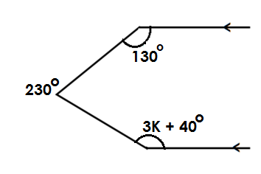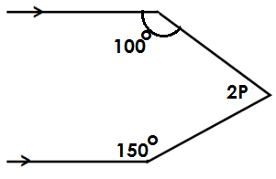Find the unknown in each of the figures below.

a) b)

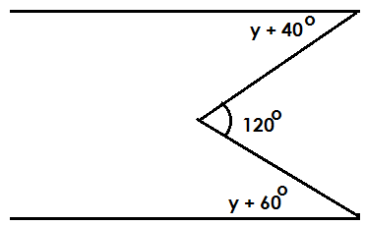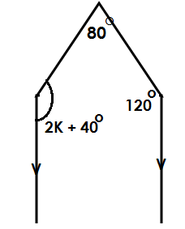

c) d)

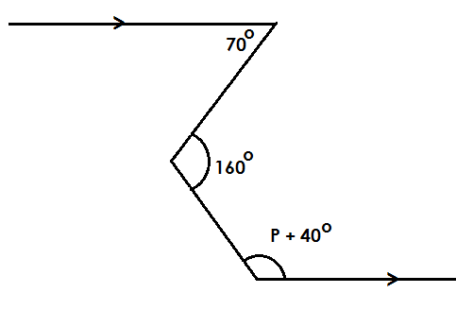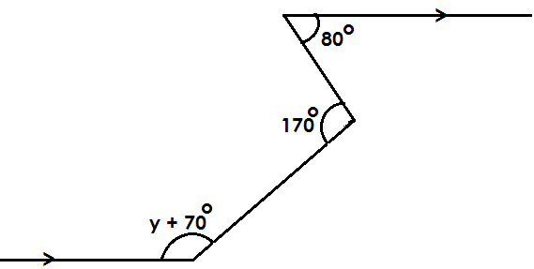e) f)

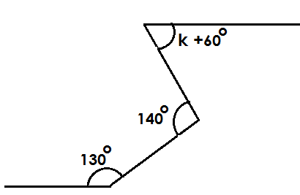g)

**PARALLEL LINES AND TRIANGLES**

**Example**

1. Find the value of P

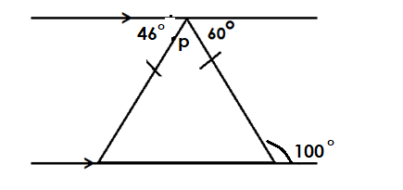.

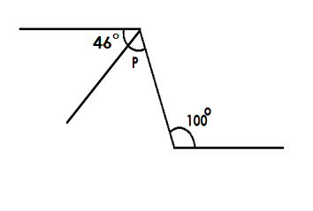**Soln.**

P + 46o  = **100 o** (Alt. int L sum)

P + 46 o – 46 o = 100 o - 46 o

P = 54 o

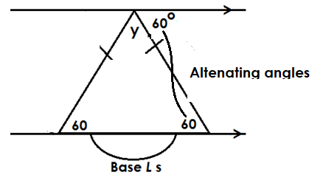2. Find the value of Y

y + 60o + 60o = 180o (int. L sum of )

y + 120 o = 180 o

y + 120 o = 180 o – 120 o

y = 60 o

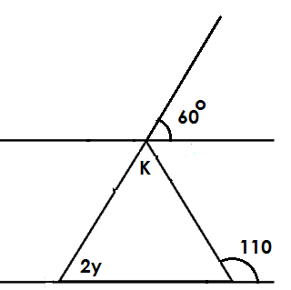3). Use the diagram below to answer questions

Find the value of y.

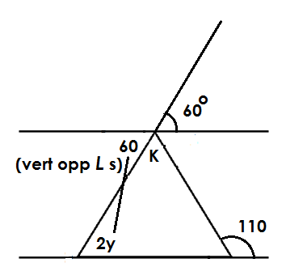**Soln**.

2y = 60o (Alt int ***L*** s)

=

y = 30o

Find the value of K.

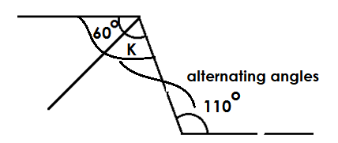**Soln.**

K + 60o = 110 (Alt int ***L***s)

K + 60 o – 60 o = 110 o – 60 o

K = 50 o

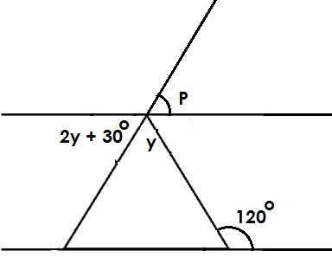Find the value of y in the figure below

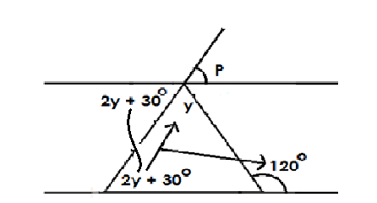**Soln.**

y + 2y + 30o = 120 o (sum of 2 int<s = 1 Opp. ext.***<***)

3y + 30 o = 120 o

3y + 30 o – 30 o = 120 o – 30 o

=

y = 30o

Find the value of P

**Soln.**

P = 2y + 30 o (vert. Opp. ***<***s)

P = (2x 30 o) +30 o

P = 60 o +30 o

P = 90 o

**Activity:**

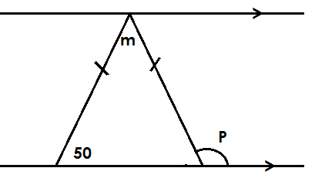1. Find the value of the unknowns in the figure bellow.

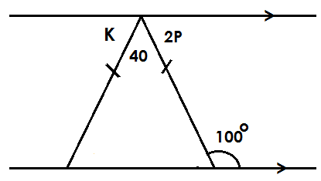2. Find the value of K and P.

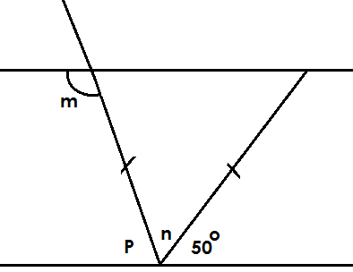3. Use the figure below to answer questions below.

Find the value of;

a) n

b) P

c) m

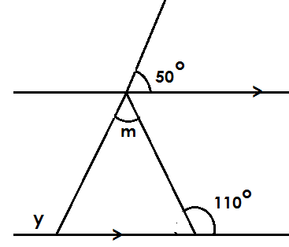4. Find the value of y and m.

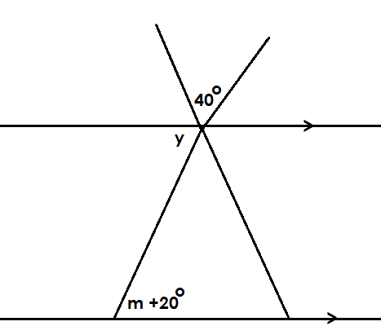5. Use the figure below to answer the given questions.

Find the value of;

1. y
2. m

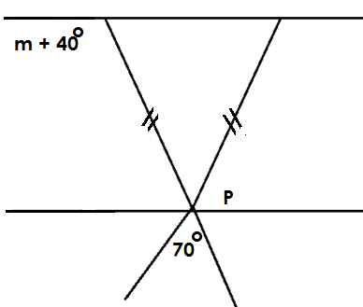6. Use the figure below to answer the given questions.

Find the value of

i) P

ii) m

**ISOSCELES TRIANGLES**

* These are triangles with two sides equal.
* Their base angles are equal.
* An isosceles triangle has one line of folding symmetry.

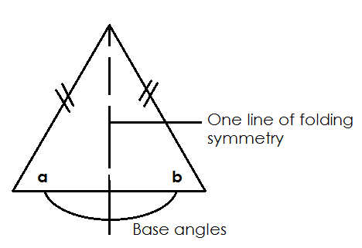**Illustration**

***<***a = ***<*** b (base angles of an isosceles triangle)

**Examples.**

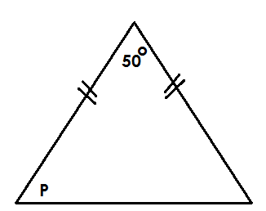1. Use the diagram below to answer questions.

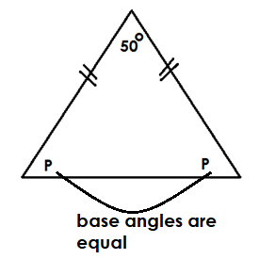Find the value of P.

P + P + 50o  = 180 o (int L sum of )

2P + 50 o = 180 o

2P + 50 o – 50 o = 180 o – 50 o

=

P = 65 o

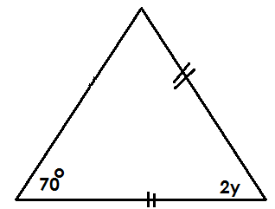2). Find the value of y in the figure below.

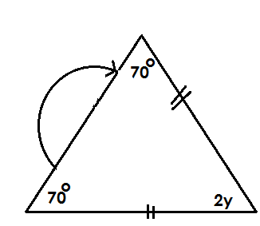**Soln.**

2y + 70o + 70 o = 180 o (int L sum of )

2y + 140 o = 180 o

2y + 140 o – 140 o = 180 o – 140 o

=

Y = 20 o

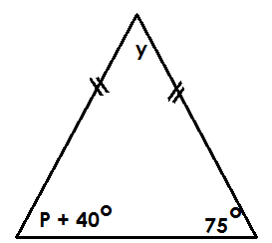3. Find the value P.

**Soln**.

P + 40o = 75 (Base Ls of )

P +40o – 40o = 75o – 40o

P = 35o

ii) Find the value of Y.

y + P + 40o +75 o = 180 o (int L sum of )

y + 35 o + 40 o + 75 o = 180 o

y + 150 o = 180 o

y + 150 o – 150 o = 180 o – 150 o

**y = 30 o**

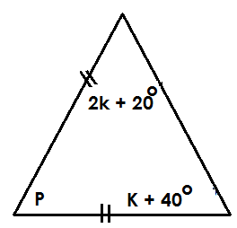4. Below is a triangle. Use it to answer questions.

a) Find the value of K.

**Soln.**

2K +20o = K + 40 o (Base <s)

2k + 20 o – 20 o = K + 40 o – 20 o

2K = K + 20 o

2K – K = K – K + 20 o

K = 20 o

Find the value of P

P + 2K + 20 o + 2K + 40 o = 180 o (int L sum of )

P + (2 x 20 o) + 20 o + 20 o + 40 o = 180 o

P + 40 o + 20 o + 20 o + 40 o = 180 o

P + 120 o = 180 o

P + 120 o – 120 o  = 180 o – 120 o

P = 60 o

**Activity:**

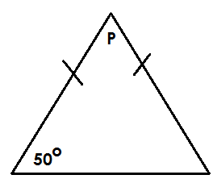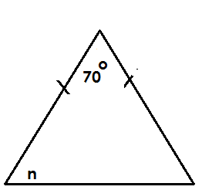1. Find the value of unknowns in the following.

a) b)

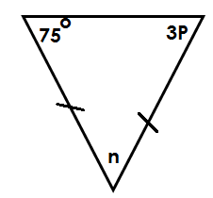c)

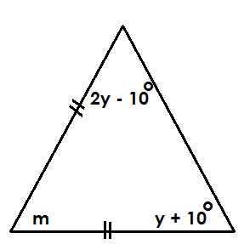4. Use the figure below to answer the given questions below.

Find the value of;

i) y

ii) m

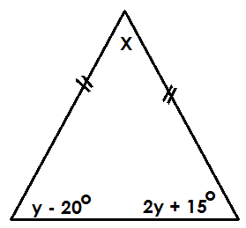5. Use the figure below to answer the given questions below.

Find the value of

i) Y

ii) X

**THE SUM OF TWO INTERIOR ANGLE BEING EQUAL TO ONE OPPOSITE EXTERIOR ANGLE**

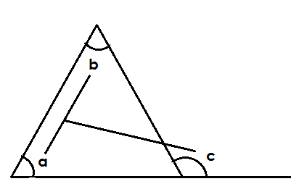

***L*** a + ***L*** b = ***L***c (sum of 2 int ***L*** s = 1 Opp. ext.<)

**Examples**

1. Find the value of y in the triangle.

**Soln.**

y + 40o = 100 o (sum of 2 int Ls = 1 Opp. ext.<)

y + 40 o – 40 o = 100 o – 40 o

y = 60 o

2. Find the value of K

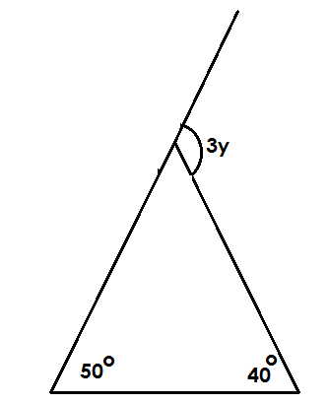

50o + 40 o = 3y (sum of 2 in ***L*** s = 1 Opp. Ext ***L***)

=

**y = 30o**

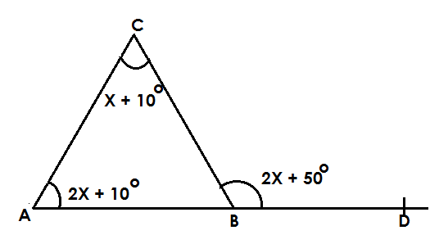3. Study the diagram below and answer questions.

a) Find the value X.

**Soln**.

2X + 10o + X + 10 o = 2X + 50 o (sum of 2 int L s = 1 Opp. ext. L)

2X + X + 10 o + 10 o = 2X + o 3X + 20 o – 20 o = 2X + 50 o – 20 o

3X o = 2X + 30 o

3X – 2X = 2X – 2X +300 o

X = 30 o

b) Find the size of angle ABC.

**Soln.**

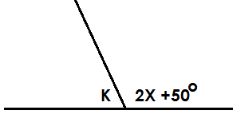

K + 2X =50o = 180o (supp L s)

K + (2 x 30o) + 50o = 180o

K + 60 o + 50 o = 180 o

K +110 o = 180 o

K + 110 o – 110 o = 180 o – 110 o

K = 70 o

**Activity:**

1. Find the value of unknowns in the following.

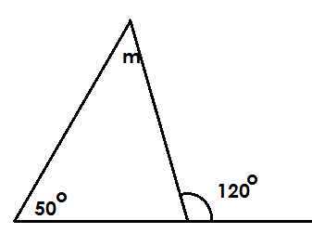a)

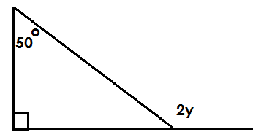

b)

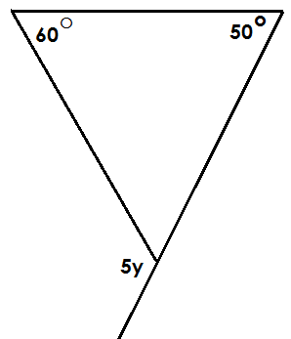c)

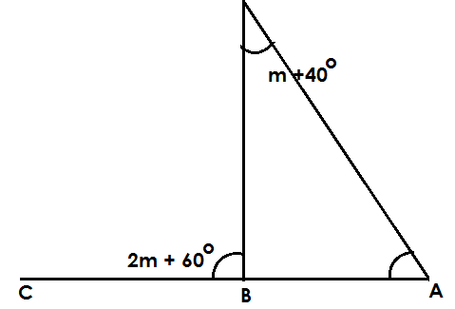

d)

a) Find the value of m.

b) Find the size of angle CBD

c) Find the size of the angle DBA.

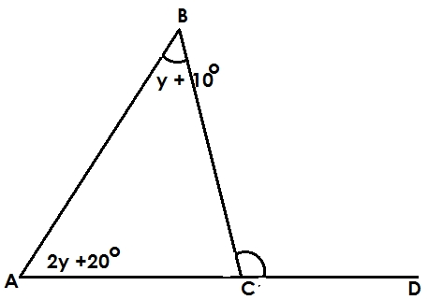5. Use the figure below to answer the given questions below.

a) Find the value of y.

b) Find the size of angle ACB

6. Find the value of y.

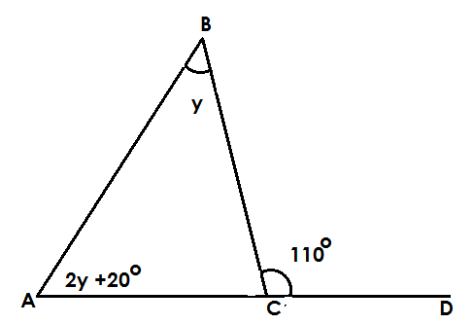

a) Find the value of y.

b) Find the size of angle ACD

**MORE ABOUT SUM OF TWO INTERIOR ANGLES EQUALS TO ONE OPPOSITE EXTERIOR ANGLES**

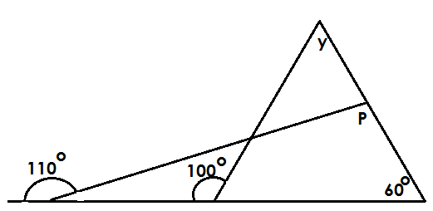Study the diagram

Find the value of y.

**Soln.**

y + 60o = 100 o (sum of 2 int Ls = 1 Opp. ext. L)

y + 60 o – 60 o = 100 o – 60 o

y = 40 o

Find the value of P.

P + 60 o = 110 o

P + 60 o – 60 o = 110 o – 60 o

P = 50 o

**Activity:**

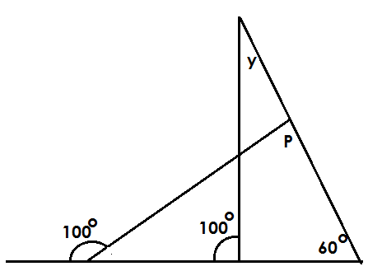1. Find the value of the unknowns.

Find the value of y

**Soln.**

y+60o = 100 o (sum of 2 int ***L*** s = Opp. ext. ***L***)

y + 60 o – 60 o= 100 o – 60 o

y = 40 o

Find the value of P.

P + 60 o = 110 o

P + 60 o – 60 o = 110 o – 60 o

P = 50 o

**Activity:**

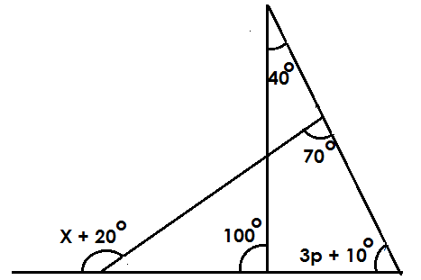1. Find the value of the unknowns in the figure below.

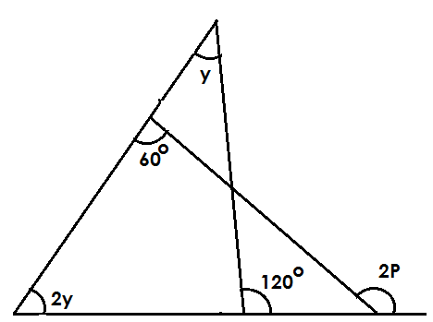2. Use the figure below to answer the given questions below.

a) Find the value of y.

b) Find the value of P.

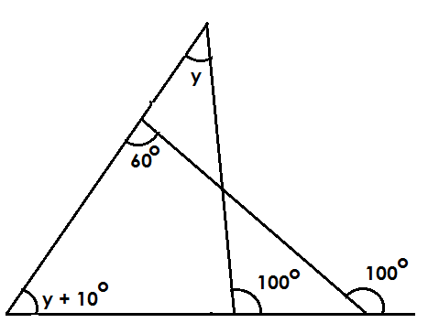3. Use the figure below to answer the given questions below.

Find the value of;

i) y

ii) P

**CONSTRUCTION OF POLYGONS**

**Square**

* It has four equal sides.
* It has four right angles.

**Procedure**

* Draw a sketch
* Draw a base line
* Mark two points and label them.
* Construct an angle of 90o at each point.

**Example**

Using a pencil, a ruler and a pair of compasses only construct a square ABCD of side 5cm.

**Sketch**

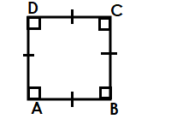

**Accurate square.**

Measure diagonal DB = 9cm.

**CONSTRUCTING A SQUARE IN A CIRCLE**

1. Construct a square in a circle of radius 4cm.

**Step I**

* Draw a circle of radius 4cm and on it draw diameter AB.
* Draw a perpendicular bisector of AB and name the points of intersection with the circle CD.
* Join the adjustment to form a square.

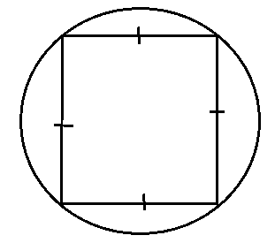**Sketch**

**Accurate square.**

**Activity:**

Using a ruler, pencil and a pair of compasses only construct in a square in a circle of radius.

1. 3cm
2. 4.5cm
3. 5cm

**CONSTRUCT A RECTANGLE**

* Draw a sketch
* Draw the base line AB.
* Construct 90o at the two points.

**Example**

Using a ruler, a pencil and a pair of compasses only, construct a rectangle ABCD where AB = 6cm and BC = 4cm.

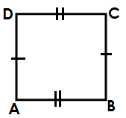**Sketch**

**Accurate rectangle**.

**Activity:**

1. Using a ruler, a pencil and a pair of compasses only. Construct a rectangle MNOP where MN = 8cm and NO = 6cm.

a) Measure diagonal MO

b) Measure angle PMN

2. Using a ruler, a pencil and a pair of compasses only, construct a rectangle KLMN where KL = 7.5cm, LM = 5.5cm.

a) Measure diagonal NL

b) Measure the size of angle LKM

**CONSTRUCTING A TRIANGLE**

**Note:**

* In constructing of triangles, a sketch must be drawn.
* The given information in the question must be represented.

**Sketch**

Using a pair of compasses, a ruler and a pencil only, construct a triangle of OPQ where OP = PQ = QO = 7cm.

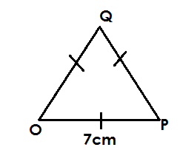Sketch

**Accurate triangle.**

Measure angle OPQ = 60o

2. Using a pair of compasses, a ruler and a pencil. Construct a triangle ABC where AB = BC = CA = 6cm. drop a perpendicular sketch from C to meet AB at point X.

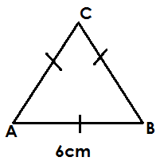**Sketch**

**Accurate triangle**.

Measure line CX =

**Activity:**

1. Using a pencil, a ruler and a pair of compasses. Construct a triangle MNO where MN =NO =OM = 7.5cm.

2. Using a pair of compasses, a ruler and a pencil. Construct a triangle XYZ where XY = YX = ZX = 5.5cm.

b) Measure angle XZY

3. Using a ruler, a pencil and a pair of compasses only. Construct a triangle MNO where MN = NO = OM =7.5cm.

b) Drop a perpendicular from O to meet MN at K.

**CONSTRUCTING A SCALENE TRIANGLE**

Using a pair of compasses, a ruler and a pencil only. Construct a triangle ABC where AB = 5cm, BC = 6cm and CA = 7cm.

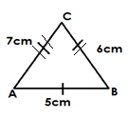**sketch**

2. Using a pair of compasses, a ruler and a pencil only. Construct a triangle OPQ where OP = 5cm OQ = 8cm and QO = 6.5cm.

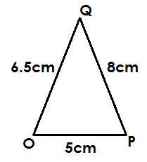**sketch**

Measure angle OPQ

**Activity:**

1. Using a pair of compasses, a ruler and a pencil. Construct a triangle KLN where KL = 6.5cm. LM = 7cm and MK = 5cm.

b) Measure angle MKL

2. Using a ruler, a pencil and a pair of compasses only. Construct a triangle LMN where LM = 7cm MN = 5.5cm and NL =6cm.

b) Measure LMN

**CONSTRUCTION OF TRIANGLES GIVEN SIDE ANGLE SIDE (S.A.S)**

Using a pair of compasses, a ruler and a pencil only ABC where AB = 7cm, ***L*** ABC = 600 and line BC = 6cm.

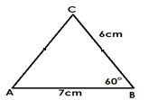**Sketch**

Measure AC

2. Using a pair of compasses, a ruler and a pencil only. Construct a triangle ABC where AB = 8cm, BC = 6cm and ABC = 90o.

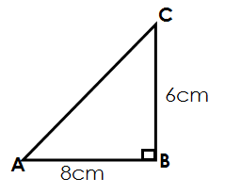 **Sketch**

3. Construct a triangle KLM where KL = 7cm and angle MKL = 45o and MK = 5cm.

Measure L KLM

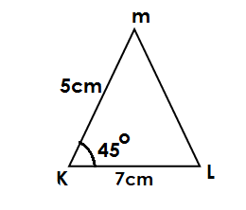 **Sketch**

Measure angle KLM

**Activity:**

1. Using a pair of compasses, a ruler and a pencil only. Construct a triangle MNO where MN = 6cm MO =7cm and OMN = 60o.

b) Measure line NO.

2. Using a ruler, a pencil and a pair of compasses only construct a triangle BCD where BC = 8cm CD = 8cm and angle BCD = 45o.

3. Using a ruler, a pencil and a pair of compasses only. Construct a triangle XYZ where XY= 7.5cm, ZX = 5.5cm and angle ZXY = 90o.

**OBTUSE ANGLES**

1. Using a pair of compasses, a ruler and a pencil only, construct a triangle ABC where AB = 6cm and angle ABC = 120o and BC = 5cm.

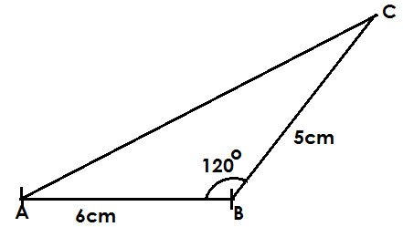 **Sketch**

1. Measure L ACB
2. Measure line AC

2. Using a ruler, a pencil and pair of compasses only. Construct a triangle MNO where MN = 6cm, NO = 7cm and angle MNO = 135o.

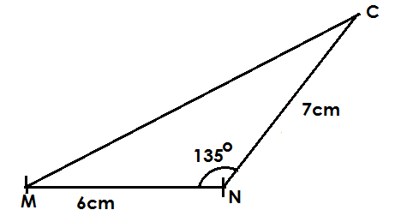**Sketch**

b) Measure line MO.

c) Measure angle MON.

3. Using a ruler, a pencil and a pair of compasses only. Construct a triangle ABC where AB = 7cm, ***L*** ABC = **105o** and BC = 6cm.

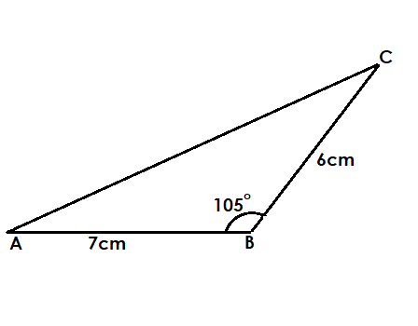 **Sketch**

Measure angle ACB =

**Activity:**

1. Using a ruler, a pencil and a pair of compasses only. Construct a triangle OPQ where OP = 7cm, ***L***QOP = 120o and OQ = 4cm

b) Measure QP

c) Angle A

2. Using a pair of compasses, a ruler and a pencil only, construct a triangle MKL where MK = 5.5cm. ***L*** LMK = 13 and line LM = 6cm.

b) Measure ***L*** K

3. Using a pair of compasses, a ruler and a pencil only. Construct a triangle POT where TPO = 105o and PT = 5cm.

b) Measure TO

**CONSTRUCTION OF TRIANGLES GIVEN SIDE ANGLES (SAA)**

1. Using a pair of compasses, a ruler and a pencil only. Construct a triangle MAG where MA = 7cm, ***L*** MAG = 90o and GMA = 45o.

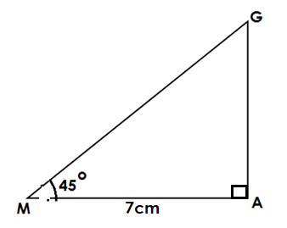**Sketch**

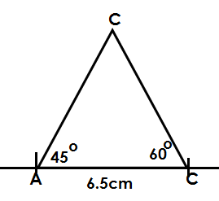2. Using a ruler, a pencil and a pair of compasses only. Construct a triangle ABC where AB = 6.5cm ***L*** ABC = 60o and ***L*** CAB=45o Drop a perpendicular from C to meet AB at K.

**Sketch**

**Activity:**

1. Using a ruler, a pencil and a pair of compasses only. Construct a triangle MNO where MN = 7cm, ***L*** MNO = 45o, and L NMP = 90o.

a) Measure the length NO

2. Using a ruler, a pencil and a pair of compasses only. Construct a triangle KLM where KL = 8cm. KLM = 45o and KL = 60o

b) Measure angle KMN

3. Using a ruler, a pencil and a pair of compasses only. Construct a triangle ABC where AB = 7.cm, ABC = 60o and BAC = 45o. drop a perpendicular line from C to meet AB at X.

b) Measure line CX

**PYTHAGORAS THEOREM**

* 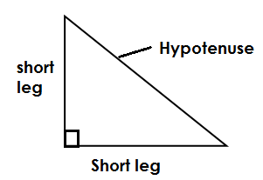It states that the sum of squares on the short legs will equal to the number of squares on its hypotenuse

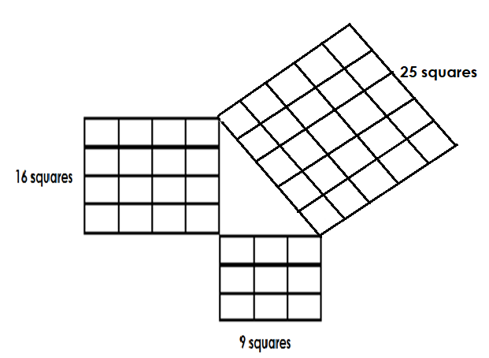

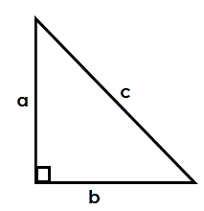

a2 + b2 =c2

**Examples.**

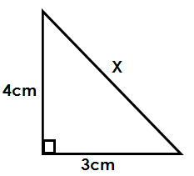1. In the figure below, find the value of X.

**Soln.**

a2 + b2 = c2

42+ 32 = x2

4 x 4 + 3 x 3 = x2

16 + 9 = x2

=

5 = X

X = 5cm

Find its perimeter

P = S + S + S

= 4cm + 3cm + 5cm

= 12cm

c) Find its area

**soln.**

A = $\frac{1}{2}$ X b x h

= $\frac{1}{2}$ x 3cm x 4cm

= 6cm

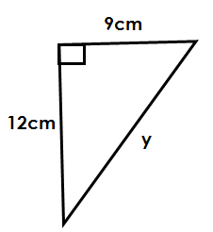2. Given the figure below. Find its height.

a2 + b2 = c2

122 + 92 = y2

12 x 12 + 9 x 9 = y2

144 + 81 = y2

=

15 = y

**y = 15**

b) Find its area.

Area = $\frac{1}{2}$ x b x h

= $\frac{1}{2}$ X 9cm x12cm

**= 54cm2**

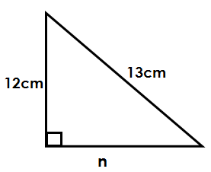3. Use the figure below to answer questions that follow

a) Find the value of n.

n2 + b2 = c2

n2 + 122 = 132

n2 + 12 x 12 = 13 x 13

n2 + 144 = 169

n2 + 144 – 144 = 169 – 144

$\sqrt{n2}$ = $\sqrt{25}$

**n = 5cm**

b) Find the perimeter

P = S + S + S

= 12cm + 5cm + 13cm

**= 30cm**

**Activity:**

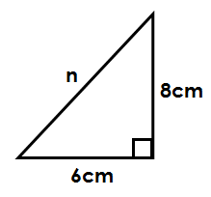1. In the figure below,

a) Find the value of n.

b) Find its area and perimeter.

2) Find the value of the;

i) Unknown

ii) Area

iii) Perimeter

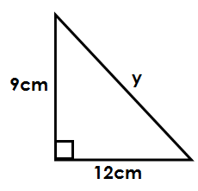of the following: -

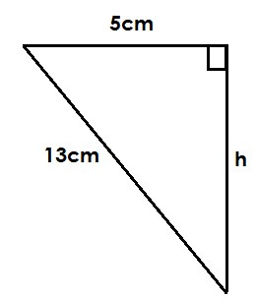a) b)

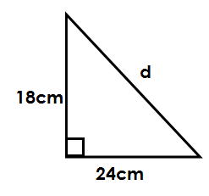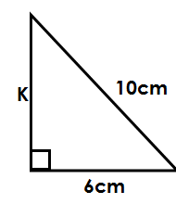

c) d)

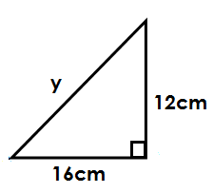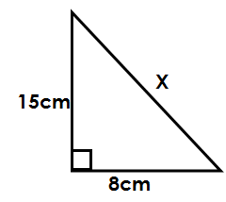

e) f)

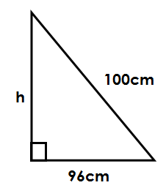

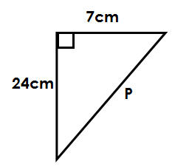

g) h)

**ISOSCELES TRIANGLE AND PYTHAGORAS THEOREM**

Below is a triangle. Use it to answer questions.

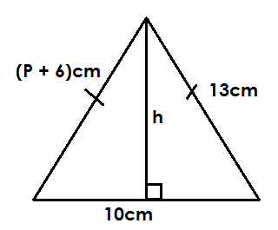a) Find P.

side = side

P + 6 = 13

P + P – 6 = 13 – 6

P = 7cm

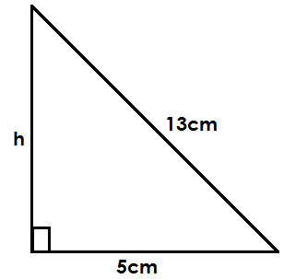b) Find the value of h.

a2 + b2 = c2

h2 + 52 = 12

h2 + 5 x 5 = 13 x 13

h2 +25 = 169

h2 +25 – 25 = 169 – 25

$\sqrt{h2}$ = $\sqrt{144}$

**h = 12cm**

c) Calculate its area.

A = $\frac{1}{2}$ x b x h

= $\frac{1}{2}$ x 10cm x 12cm

**= 60cm2**

1. Below is a triangle. Use it to answer questions.

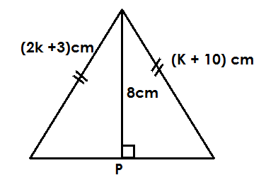

Find the value of K

Side = side

2k + 3 = k + 10

2k + 3 – 3 = k +10 – 3

2k = k + 7

2k – k = K – k + 7

K = 7

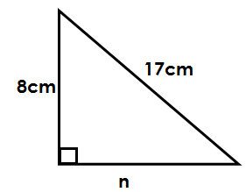**Find the value of P.**

a2 + b2 = c2

n2 + 82 = 17

n2 + 64 – 64 = 289 – 64

$\sqrt{n2 }$ = $\sqrt{225}$

**n = 15cm**

p = n + n

= 15cm + 15cm

**= 30cm**

Find its area.

Area = $\frac{1}{2}$ x b x h

= $\frac{1}{2}$ x 30cm x 8cm

**= 120cm2**

3. Study the figure below and answer questions.

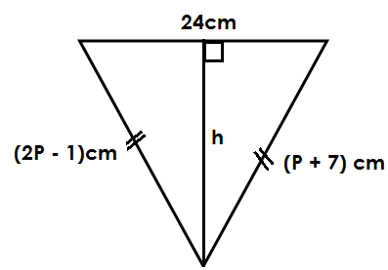

a) Find the value of P.

**soln.**

side = side

2P – 1 = P + 7

2P – 1 + 1 = P + 7 + 1

2P = P + 8

2P – P = P – P + 8

**P = 8**

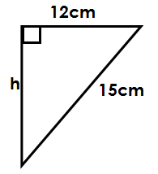Find the value of h

a2 +b2 = c2

h2 + 122 = 152

h2 + 12 x 12 = 15 x 15

h2 + 144 = 225

h2 + 144 – 144 = 225 – 144

$\sqrt{h2 }$ = $\sqrt{81}$

**n = 9cm**

find its area

Area = $\frac{1}{2}$ X b x h

= $\frac{1}{2}$ x 24cm x 9cm

**= 108cm2**

**Activity:**

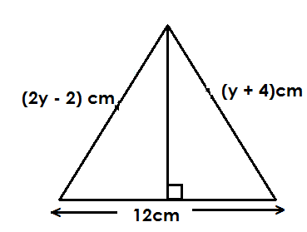1. Study the figure below and answer questions.

a) Find the value of Y.

b) Find the value of h

c) Find its i) Area

ii) Perimeter

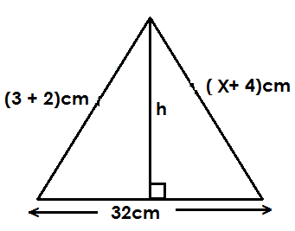2. Study the figure below and answer questions

a) Find the value of i) X

ii) h

1. Find its area.

3. Study the figure below and answer questions

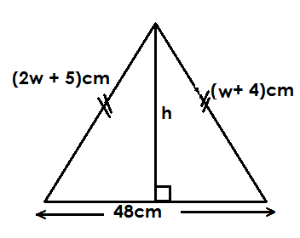

Find the value of;

i) W

ii) h

**FINDING BASE OR HEIGHT OF TRIANGLE GIVNE AREA**

Here, apply the formula for finding area of a triangle which is;

Area = x b x h

1. The area of a triangle is 48cm2. If its base is 16cm, find the height.

$\frac{1}{2}$ x b x h = Area

$\frac{1}{2}$ x 16cm x h = 48cm2

8cmh = 48cm2



8cmh = 48cm x cm

8cmh 8cm

h = 6cm

Base = 8cm

3. Find the height of a triangular garden whose area is 60cm2 and has of 10m.

$\frac{1}{2}$ x b x h = Area

$\frac{1}{2}$ x 10cm x h = 60m2

5mh = 60cm2

12

5mh = 60m x m

5m 5m

h = 12m

height = 12m

**Activity**

1. Find the height of a triangle whose is 33cm2 and has height of 11cm.

2. What is the base of a triangle of area 65cm2 and has height of 13dm?

3. Find the base of a triangle whose area is 84m2 and has height of 14m.

4. The area of a triangle is 104cm2. Find its base of its height is 16cm2.

5. The area of a triangular flower garden is 300m2. Find the length of its base if it has height of 20m.

**APARALLELOGRAM**

- A parallelogram is slanted rectangle.

- Its two opposite sides are equal and parallel to each other.

- It has two diagonal bisecting each other at an angle of 90**0** hence perpendicular to each other.

- It has no line of folding symmetry.

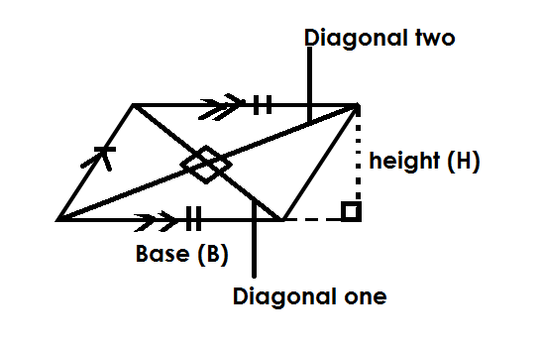 **Illustration**

**FINDING AREA OF A PARALLELOGRAM**

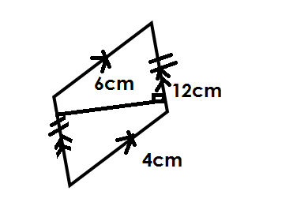 **Area = B x H**

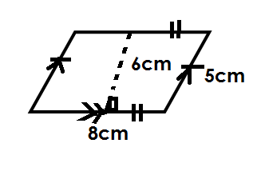1. Find the area of the figures below.

(a) (b)

Area = B x H Area = B x H

= 8cm x 6cm = 12m x 6m

= 48cm**2** = 72m2

**Activity**

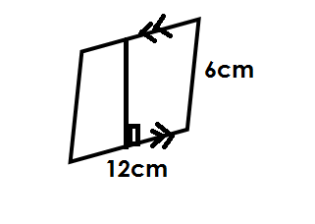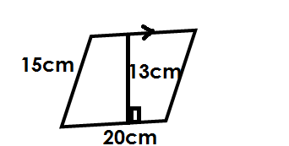 Find the area of the following

(a) (b)

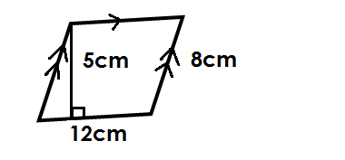

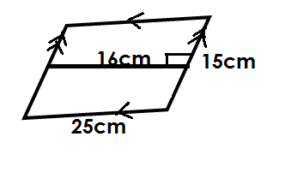(c) (d)

**FINDING HEIGHT OR BASE OF PARALLELOGRAM GIVEN AREA**

**Note**:

Use the formula; Area = B x H to find base or weight of a parallelogram.

1. Find the base of a parallelogram whose area is 32cm2 and its height is 4cm.

B x H = Area

B x 4cm = 32cm2

4cm B = 32cm2

8

4cm = 32cm x cm

4cm

B = 8cm

2. Find the height of a parallelogram whose area is 45cm2 and has base of 9m.

B x H = Area

9m x h = 45cm2

5

9mh = 45m x m

9m 9m

h = 5m

height = 5m

3. The area of a parallelogram is 54dm2. Find its base if it has heigh of 9dm.

B x H = Area

B x 9dm = 54dm2

9dmb = 54dm2

6

9dmb = 54dm x dm

9dm 9dm

B = 6dm



Base = 6dm

**Activity**

1. Find the base of a parallelogram whose area is 36cm2 and has height of 12cm.

2. The area of a parallelogram is 84cm2. Find its height if its base 14m.

3. Find the height of a parallelogram of area of 48dm2 and base of 8 dm.

4. Given that a parallelogram has area of 64cm2 and height of 16cm. Find its base.

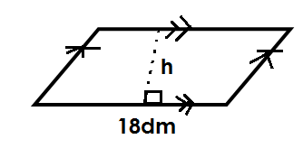5. The figure below has area of 81dm2. Find the value of h.

**A RHOMBUS**

* A rhombus is a slanted square.
* All its sides are equal.
* It has two opposite sides parallel.
* It has two diagonals bisecting each other at an angle of 900 and also acting as its line of folding symmetry.
* A rhombus is made up of 4 congruent triangles.

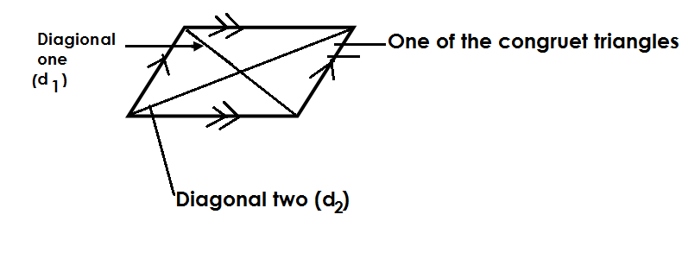**Illustration**

**FINDING AREA OF ARHOMBUS AND PERIMETER**

Area = x d1 x d2

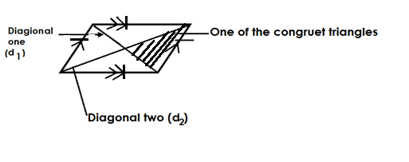 Area = x b x h (Where 4 represents 4 congruent triangles)

1. Find the area of the rhombus below.

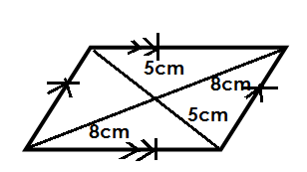 Area = x d1 x d2

8

= x 10cm x 18cm

d1 = 5cm + 5cm = 10cm x 8cm

10cm = 80cm2

d2 = 8cm + 8cm

16cm

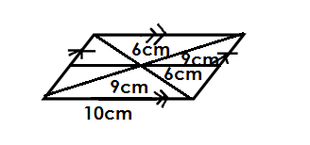2. Find the area and perimeter of the figure below.

Perimeter

P= 4 x S

d**1** = 6cm+6cm = 4 x 10cm

= 12cm = 40cm

d**2** = 9cm+9cm

= 18cm

Area = x d**1** x d**2**

= x 12cm x 18cm

= 6cm x 18cm

= 108cm**2**

3. Find the area and perimeter of the figure below.

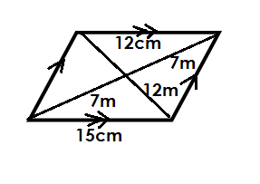 d1 = 7m + 7m

= 14m

d2 = 12m + 12m

d2 = 24

Area = x d1 x d2

7

x 14m x 24m

= 168m2

**Perimeter**

P = S + S + S + S

= (15m + 15m) + 15m + 15m

= 30m + 30m

= 60m

**Activity and perimeter**

1. Find the area of the following figures.

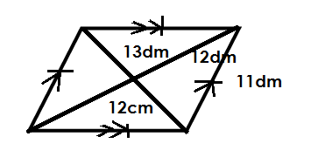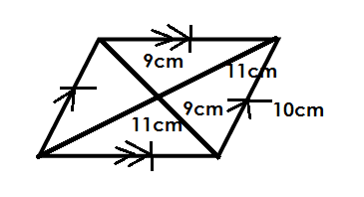(a) (b)

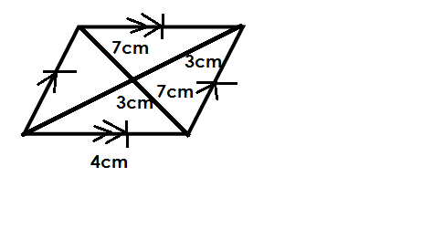

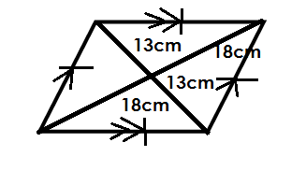(c) (d)

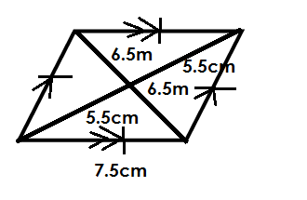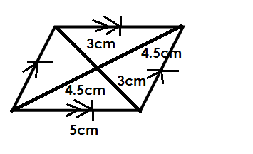(e) (f)

**FINDING THE MISSING DIAGONAL OF ARHOMBUS GIVEN AREA**

1. The area of a rhombus is 80cm2. If one diagonal is 16cm. Find the other diagonal.

Area = x d1 x d2

x 16cm x d2 = 80cm2

8cmd2 = 80cm2

10

8cmd2 = 80cm2 x cm

8cm = 8cm

d2 = 10cm

2. Find the second diagonal of a rhombus whose area is 120dm2 and its other diagonal is 10dm.

Area = x d1 x d2

Area = x d1 x d2

5dm d2 = 120dm2

24

5dm d2  = 120dm2  x dm

5dm 5dm

d2 = 24dm



Diagonal = 24dm

3. A rhombus whose area is 40cm2 has one diagonal of 16cm. Find the length of the second diagonal.

Area = x d1 x d2

x 16cm x d2 = 40cm2

8d 8cm d2 = 402

5

8cm d2 = 40cm x cm

d2  = 8cm

Diagonal = 5cm

**Activity**

1. The area of a rhombus is 36cm2. If the first diagonal is 6cm, find the second diagonal.

2. Given that the area of a rhombus is 48cm2 and is its first diagonal is 12m, find the second diagonal.

3. Find the length of the second diagonal of a rhombus whose area is 96cm2 and the shorted diagonal is 9dm.

4. Find the second diagonal of a rhombus of area 24cm2 and the length of its second diagonal is 8m.

5. If a rhombus has area of 54cm2 and the longer diagonal of length 12cm, find the length of the shorter diagonal.

**TRAPEZIUM**

- A trapezium is a quadrilateral made up a triangle or triangles and another quadrilateral (square or rectangle).

- It has two parallel sides.

- A scalene trapezium has no line of folding symmetry.

- An Isosceles trapezium has one line of folding symmetry.

Illustration

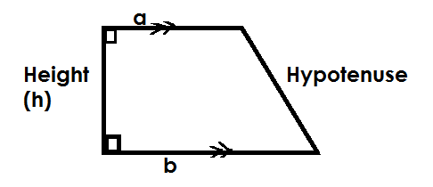(a) **Scalene trapezium**

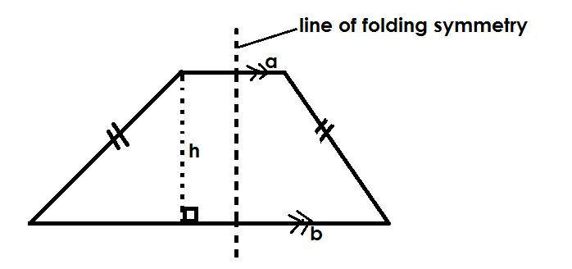(b) **Isosceles trapezium**

**a** is the shorter parallel side.

**b** is the longer parallel side.

**h** is the height of the parallelogram.

**FINDING AREA AND PERIMETER OF A TRAPEZIUM**

Area = x d1 x d2

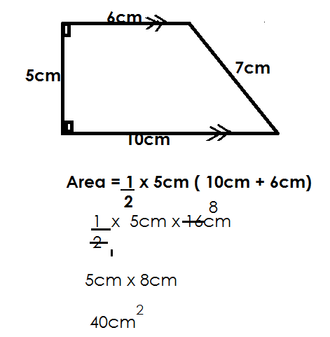1. Find the area of the figure below.

(b) Find its perimeter

P = S + S + S + S

= (10cm + 7cm) + (6cm + 5cm)

= 17cm + 11cm

= 28cm

2. Find the area and perimeter of the figure below.

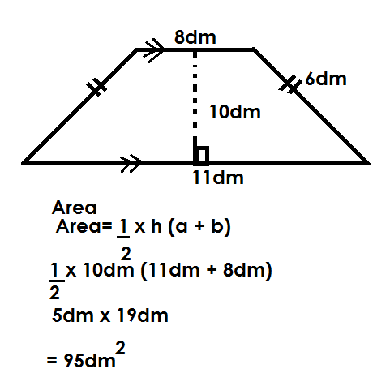

Perimeter

P = S + S + S + S

= (11dm + 6dm) + (8dm + 6dm)

= 17dm + 14dm

= 21dm

3. Below is a figure, use it to answer questions that follow.

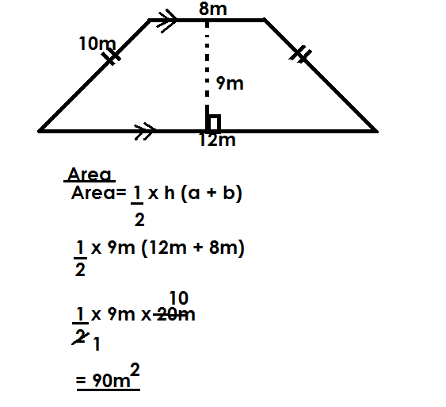 Perimeter

P = S + S + S + S

= (12m + 8m) + (10m + 10m)

= 20m + 20m

= 40m

**Activity**

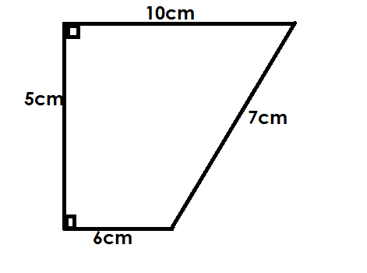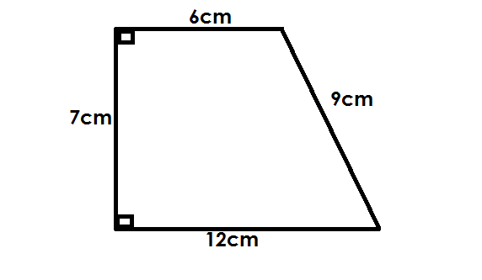 Find the area and perimeter of the following figures.

(a) (b)

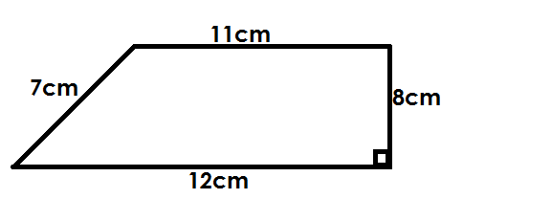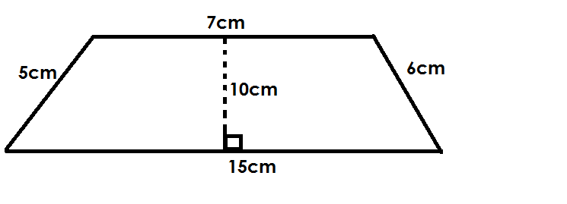

(c) (d)

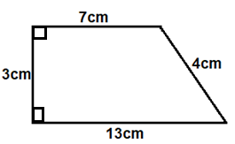

(e)

**FINDING UNKNOWN SIDES OF A TRAPEZIUM GIVEN AREA.**

1. Below is a trapezium whose area is 42cm2.

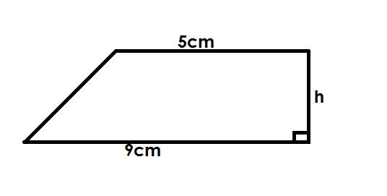

Find the value of h.

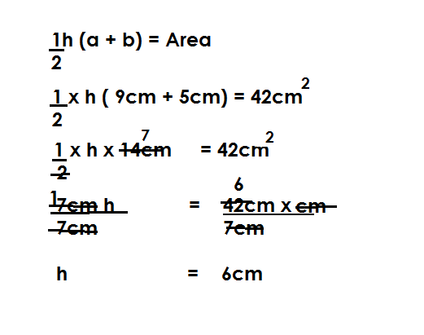 **Soln.**

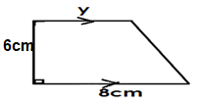2. Below is a trapezium whose area is 42cm2.

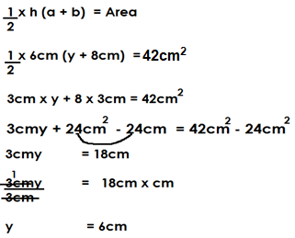

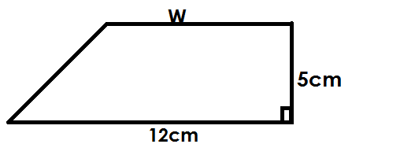3. The figure below is a trapezium whose area is 50cm**2**.

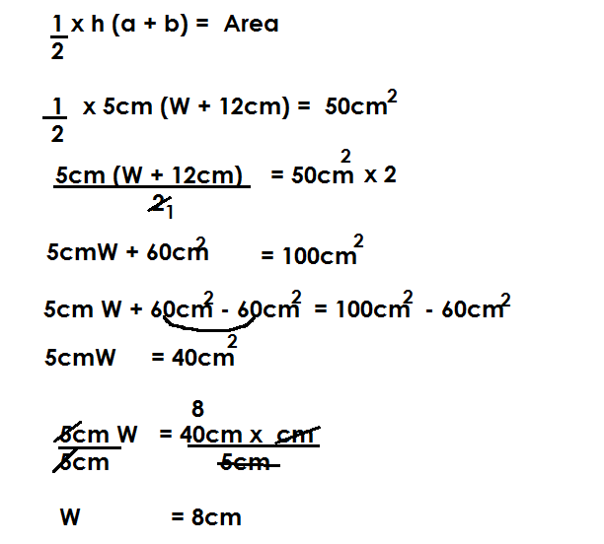

**Activity**

1. Given the figure below find the unknown.

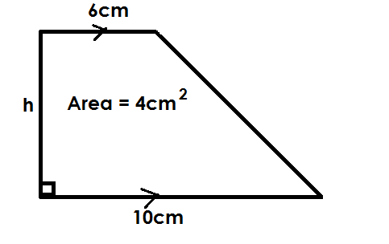(a) (b) Find its perimeter.

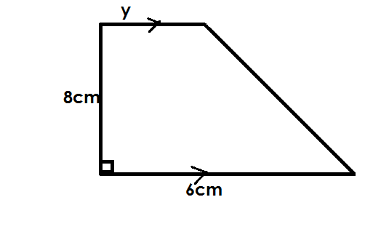2. The figure below is a trapezium whose area is 44cm2.

a) Find the value of y

b) find the perimeter of the figure.

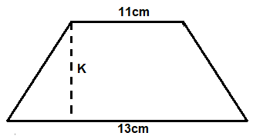3. The figure below is trapezium whose area is 144cm**2**. Find the value of K.

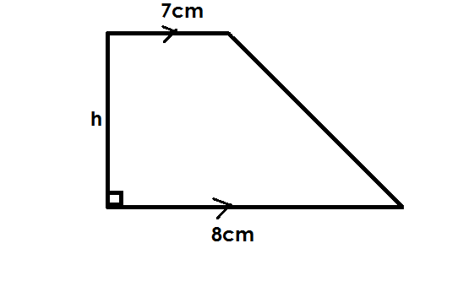4. The area of the figure below is 90cm**2**. Find the value of h.

**A TRAPEZIUM AND PYTHAGORAS THEOREM**

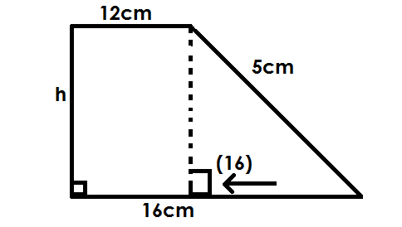1. Below is a trapezium. Use it to find the value of h.

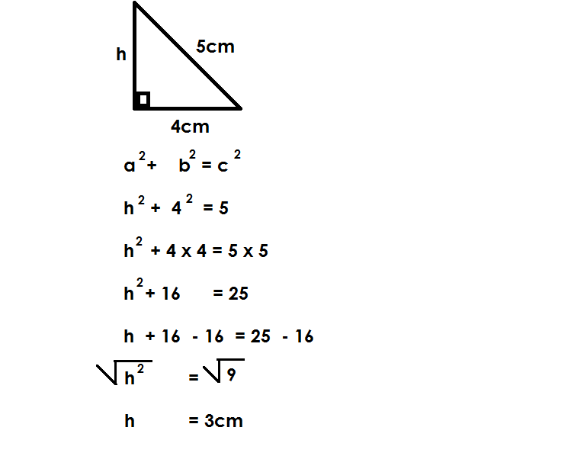  **Soln.**

(b) Find its perimeter

P = S + S + S + S

= 16cm + 5cm + 12cm + 3cm

= 36cm

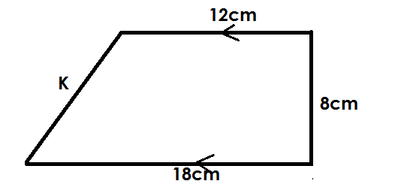2. Use the figure below to answer questions that follow.

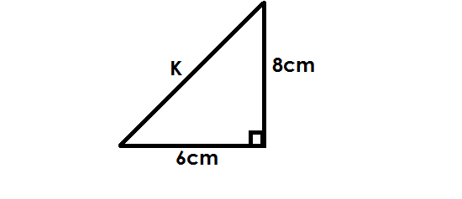(a) Find the value of K.

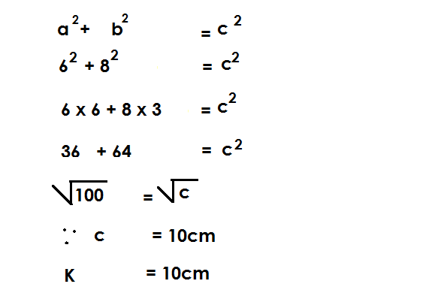

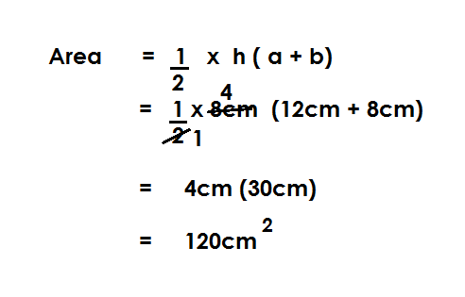(b) Find the area of the figure.

(c) Find its perimeter

P = S + S + S + S

= 18cm + 8cm + 12cm + 10cm

= 48cm

**Activity**

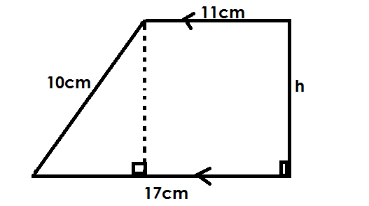1. Below is a trapezium. Use it to answer question.

(a) Find the value of h.

(b) Find its area.

(c) Find the perimeter of the figure.

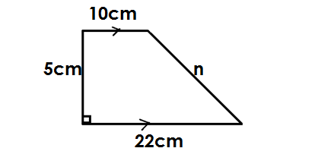2. Below is a trapezium

(a) Find the value of n.

(b) Find its perimeter.

(c) Find its area.

3. In the diagrams below.

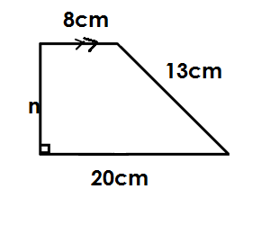

(a) Find the value of h.

(b) Find its area.

(c) Find its perimeter.

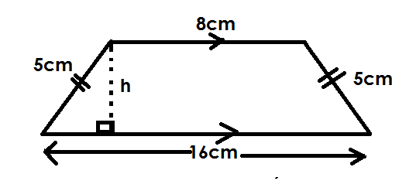4. Use the figure below to answer questions that follow.

(a) Find its height.

(b) Find its area.

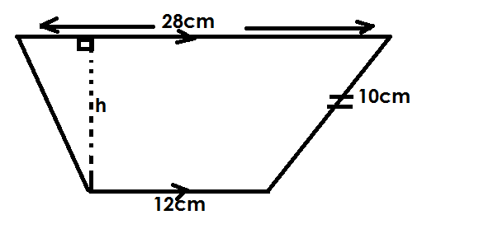5. Below is a trapezium, use it to answer questions that follow.

(a) Find the value of h.

(b) Find its area.

**FINDING ONE SIDE OF A RECTANGLE GIVEN AREA AND PERIMETER**

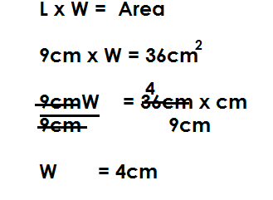1. Below is a rectangle whose area is 36cm2. Find its width.

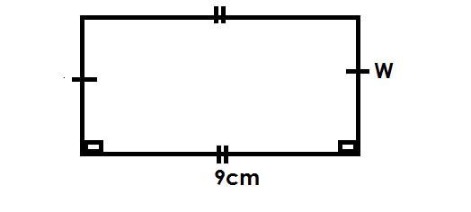

(b) Calculate its perimeter

P = L + W + L + W

P = 9cm + 4cm + 9cm + 4cm

= 26cm

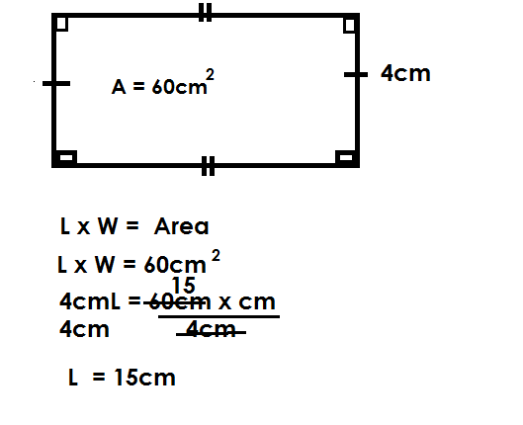2. Find the perimeter of a rectangle whose area is 60cm**2** and has width of 4cm.

**Perimeter.**

P = L x W x L x W

P = 15cm + 4cm + 15cm + 4cm

= 38cm

**Activity**

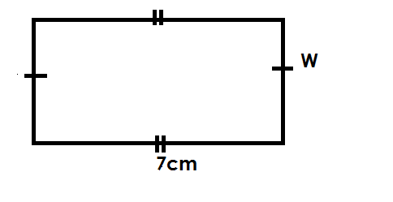1. Find the perimeter of a rectangle below whose area is 28cm2 and length is 7cm.

3. Find the perimeter of a rectangle whose area is 40cm2 and width is 5cm.

(a) Find the L

3. Given area of a rectangle is 126cm2 its width is 9cm. Find its length.

(b) Find its perimeter.

4. The area of a rectangle is 50cm2 and its width is 5cm. Find its perimeter.

Finding one side and area given perimeter.

**FINDING ONE SIDE AND AREA GIVEN PERIMETER.**

1. The perimeter of a rectangle below id 24cm. Find its area.

L + W + L + W = P

7cm + W + 7cm + W = 24cm

7cm + 7cm + W + W = 24cm

14cm + 2w = 24cm

14cm – 14cm + 2w = 24cm - 14cm

5

2w = 10cm

2 2

W = 5cm

**Area = L x W**

= 7cm x 5cm

= 35cm2

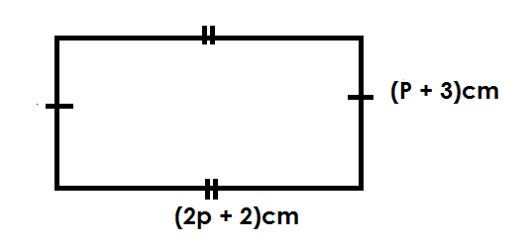2. The perimeter of the figure below is 46cm.

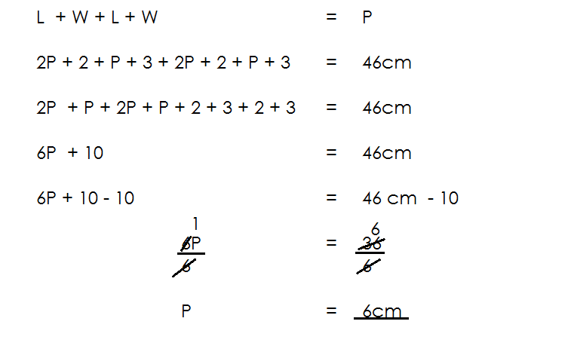 Find the value of P.

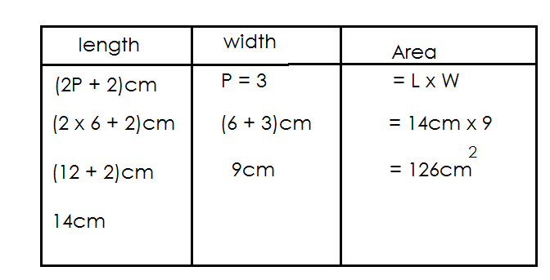(b) Find its area

**Activity**

1. The perimeter of a rectangle is 38cm.

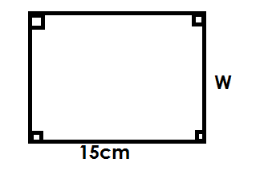

(a) Find the value of W.

(b) Find the area of the rectangle.

2. The perimeter of the figure below is 34cm. find the value of x.

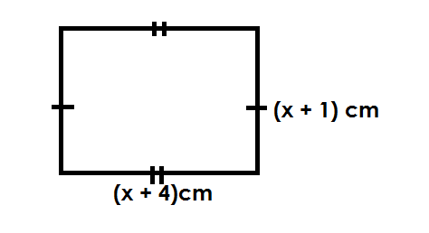

(b) Find its area.

3. The perimeter of a rectangle below is 30cm.

a) Find the value of P.

(b) Find its area.

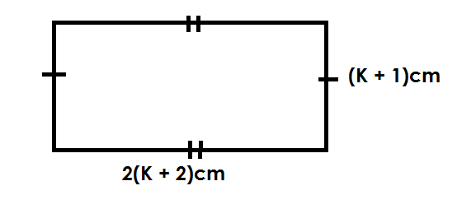4. The perimeter of a rectangle is 28cm.

Find its area.

**Finding one side of a square given area.**

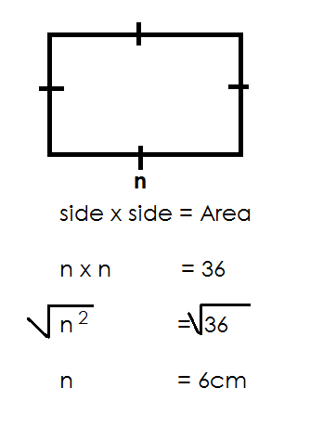1. The area of a square garden is 36cm**2**. Find one side of a square.

2. The area of a square garden is 225dm2. Find one side of a square.

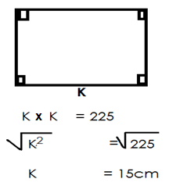 **Let one side be K.**

3. The area of a square garden is 6.25dm2. Find the length of AB.

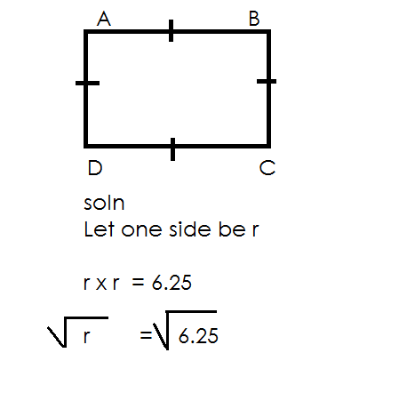

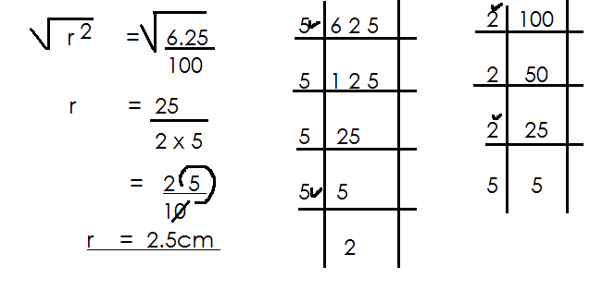

**Activity**

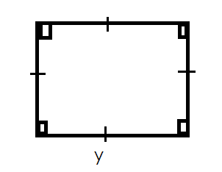1. If the area of the figure below is 49cm**2**. Find the length of one side.

2. If the area of a square below is 144cm**2**. Find one side of a square.

3. The area of a square is 400cm**2**. Find one side of a square.

4. The area of square garden is 0.009dm**2**. Find one side of the garden.

5. The area of a square swimming pool is 1.69cm**2**. Find one side of the swimming pool.

**FINDING AREA OF SHADED PARTS OF THE A RECTANGLE.**

**Note.**

Area of the shaded part = Area of the outer figure **–** Area of the inner figure.

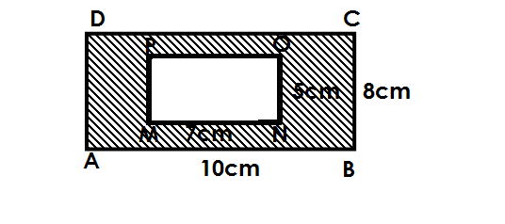1. Find the area of the shaded part in the figure below.

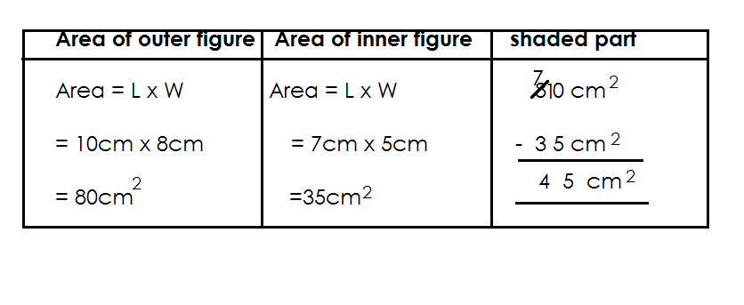

2. Find area of shaded part in the figure below.

6cm



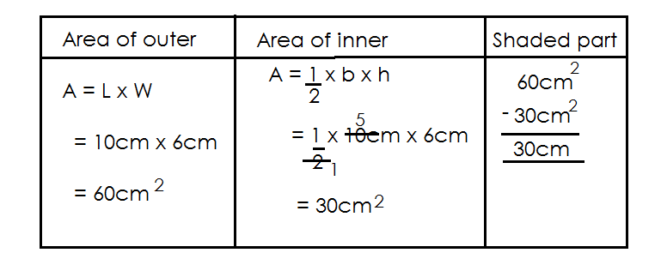 10cm

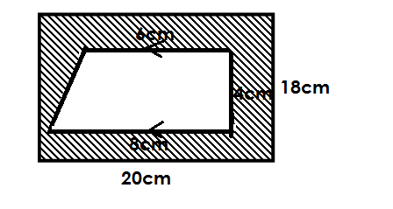3. Find the area of the shaded part in the figure below.

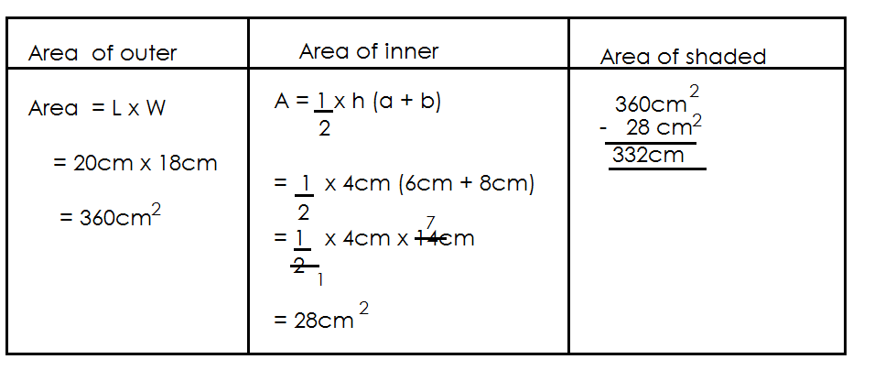

**Activity**

1.Study the figure below and answer question.

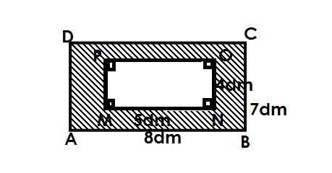

(a) Find the area of the outer figure.

(b) Find the area of the inner figure.

(c) Find the area of the shaded part.

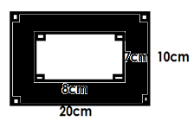2. Find the area of the shaded part.

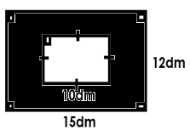3. Find the area of the shaded part.

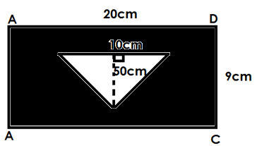4. Study the diagram below and answer questions.

(a) Find the area of the inner figure.

(b) Calculate the area of the shaded part.

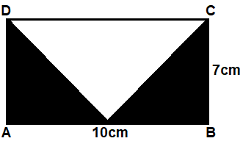5. Study the figure below and answer questions.

(a) Calculate the area of the outer figure.

(b) Find the area of the unshaded part.

(c) Calculate the area of the shaded.

**MORE ABOUT CALCULATING AREA OF THE SHADED PART**

**Examples.**

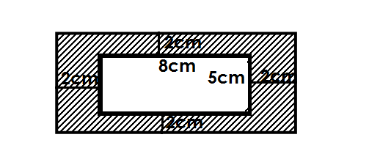1. Study the figure below and answer questions.

(a) Find the length and width of the outer figure.

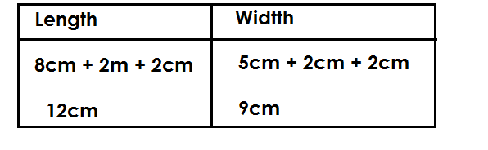

(b) Find the area of the outer figure.

Area = L x W

= 12cm x 9cm

= 108cm2

(c) Find the area of the inner figure

A = L x W

= 8cm x 5cm

= 40cm2

(d) Calculate the area of the shaded part.

108cm2

- 40cm2

68cm2

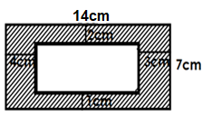2. Find the area of the shaded part.

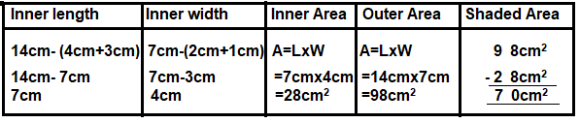

**Activity.**

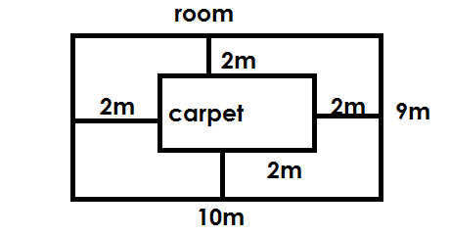1. A rectangle room 10m by 9m is covered by a carpet in the centre, such that 2m width is left uncovered all round find the area of the uncovered part.

2. A rectangular from is 30m by 20m a photo is placed centrally leaving 3m long the length and 2.

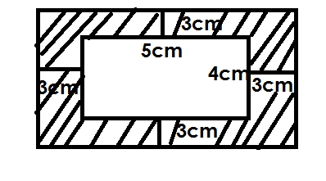3. Study the figure below and answer questions.

(a) Find the length and width of the outer rectangle.

(b) Find the area of the outer figure.

(c) Find the area of the inner figure.

(d) Calculate the area of the shaded part.

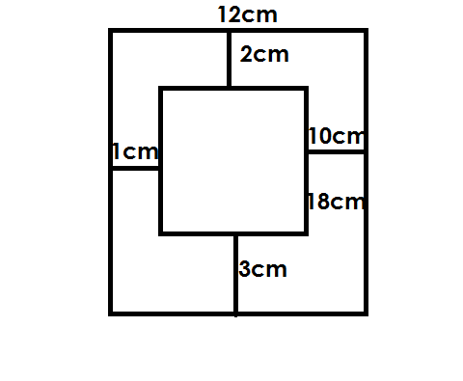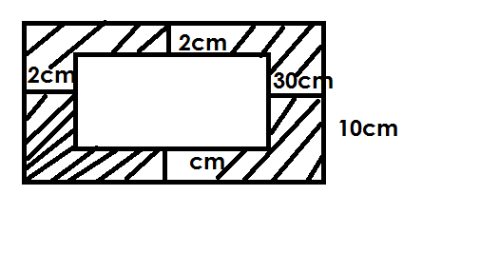2. Find the area of the shaded parts.

(a) (b)

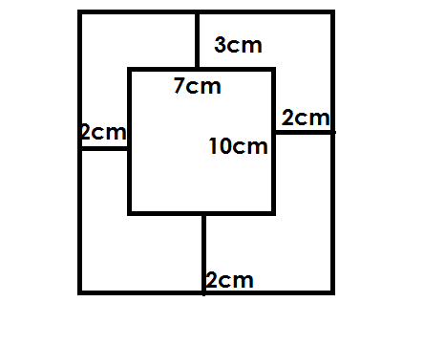

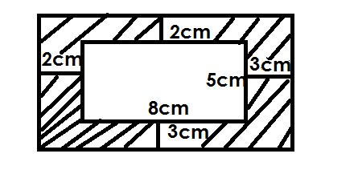(c) (d)

**FINDING BASE OR HEIGHT OF TRIANGLE AND A PARALLELOGRAM BY** **COMPARAING AREAS**

**Examples.**

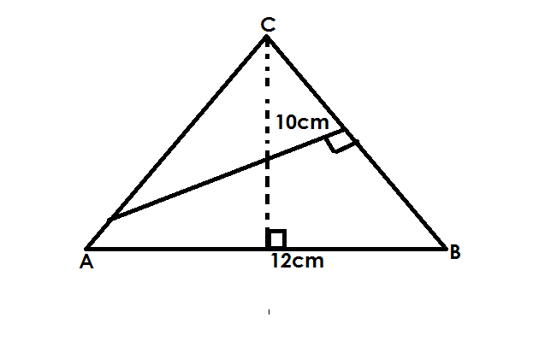1. Find the length of BC in the figure below.

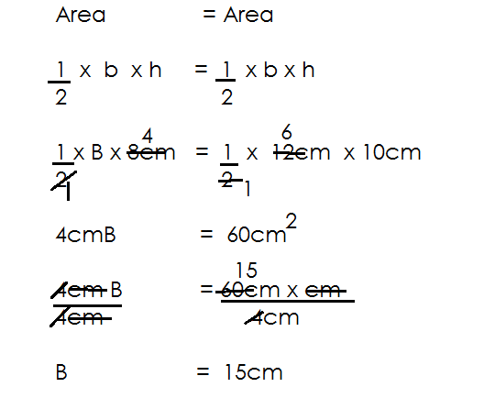 **Soln**.

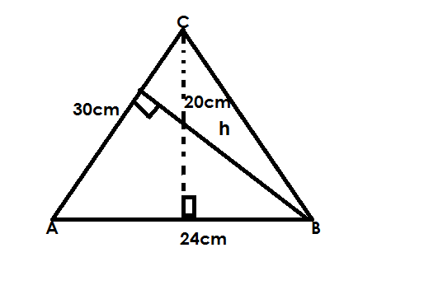2. Find the value of n in the figure below.

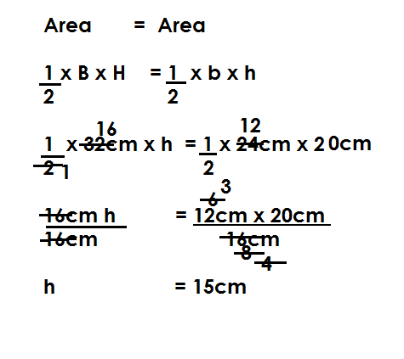

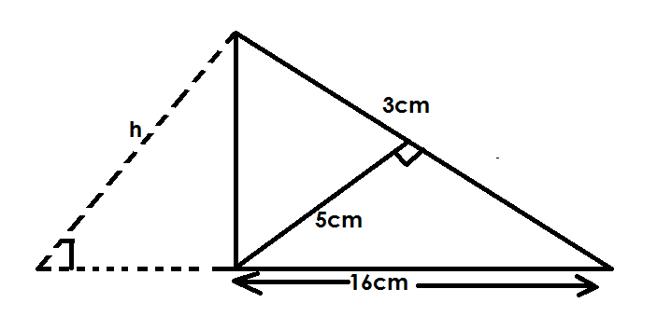3. Use the figure below to find the value of h.

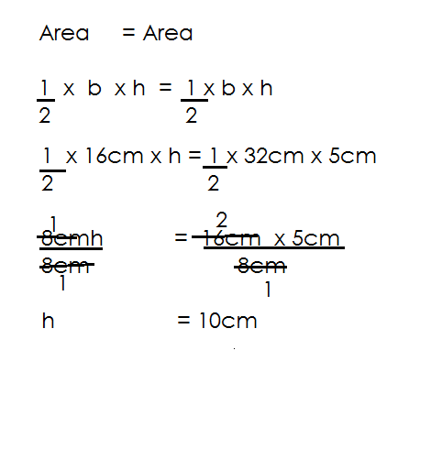 **Soln.**

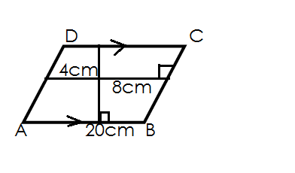4. below is a parallelogram, use it to find length BC

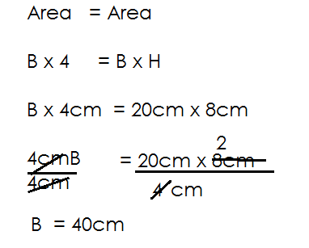**Soln.**

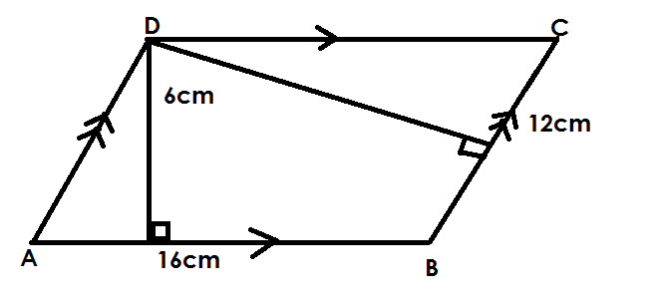5. Find the value of h in the figure below.

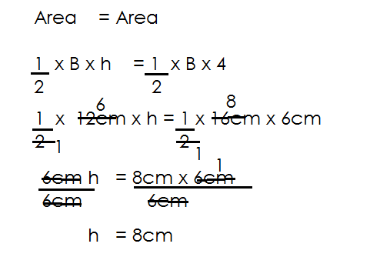

**Activity**

Use the figures below to answer questions that follow.

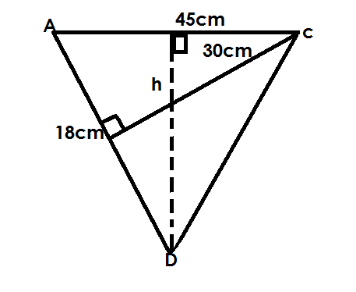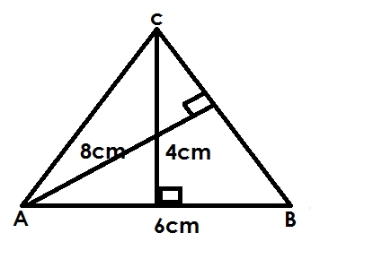a. b.

Find length BC Find h.

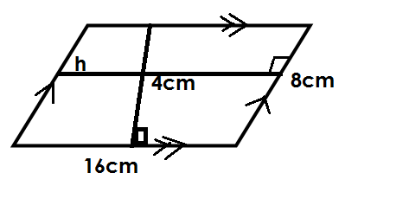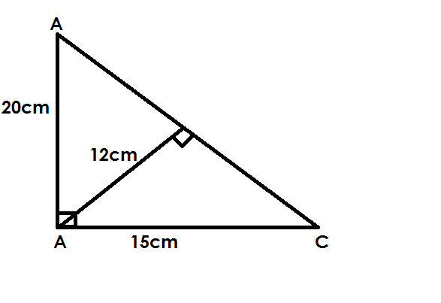c. d.

Find AC Find h.

**CHANGING KM2 to M2**

**Note**:

**1km = 1000m**

1. Change 4km2 to m2

**Soln.**

1km = 1000m

1km**2**= 1000m x 1000m

4km**2** = 4 x 1000m x 1000m

= 4000000m**2**

2. Chang 0.2km2 to m2

1 km = 1000m

1km2  = 100m x 100m

0.2km2 = 0.2 x 1000m x 100m

= 2 x 1000m x 1000m

10

= 200,000m2

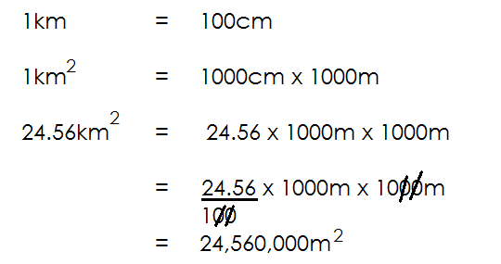3. Convert 24.56km2 to m2

**Activity**

Convert the following km2 to m2

(a) 10km2

(b) 0.3km2

(c) 0.3km2

(d) 40km2

(e) 120.3km2

**Converting M2 to Km2**

**Note:**

1. Convert 3,040,000m2 to km2

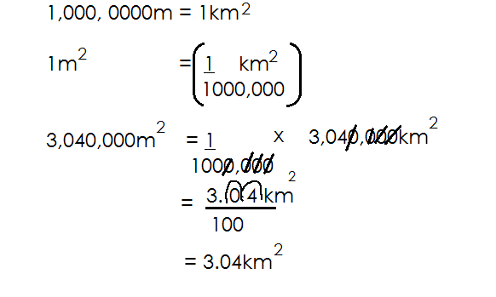**Soln.**

2. Convert 90700m2 to km2

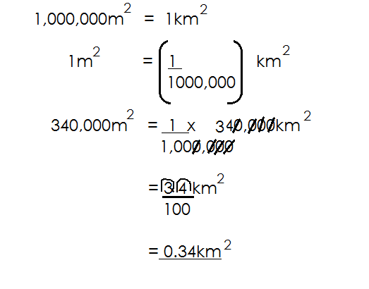**Soln.**

3. Convert 340,000m2 to km2

**Activity**

1. Convert the following m2 to km2

(a) 2,000,000m2

(b) 340000m2

(c) 350,000m2

(d) 4,000,000m2

(e) 990, 000m2

(f) 403m2

**CIRCLES**

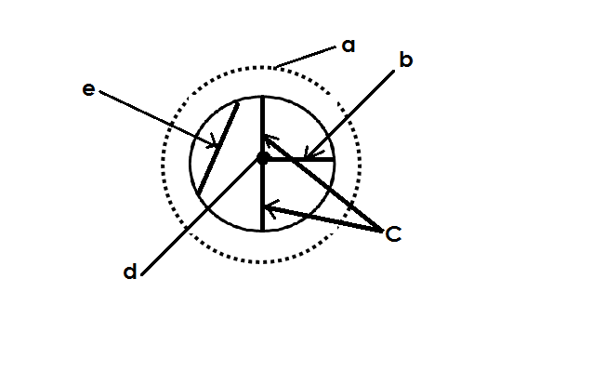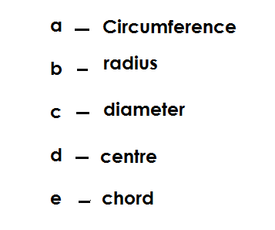**PARTS OF A CIRCLE**

**CIRCUMFERENCE**

Circumference is the total distance round a circular object / circle.

**DIAMETER**

Diameter is straight line running from the circumference through the centre to the circumference of the circle.

Diameter is the twice radius (D =2r)

It is the longest chord of the circle.

**RADIUS**

Radius is the line of a running from the center of the circle to the circumference.

Radius is a half of diameter.

**CHORD**

Chord is the line running from circumference to circumference of a circle.

Is the line joining one arc to another arc of the circle.

**PI (π)**

PI is the quotient of the circumference and diameter of a circle.

The value of PI is taken as $\frac{22}{7}$, 3 $\frac{1}{7}$ or 3.14

Use PI as $\frac{22}{7}$ or 3 $\frac{1}{7}$ if diameter or radius or height is a multiple of 7.

Use PI as 3.14 if diameter or radius is not a multiple of 7.

**FINDING RADIUS OR DIAMETER OF ACIRCLE.**

Diameter = r + r

= 2r

Radius = $\frac{D}{2}$ or D ÷ 2

**Examples.**

Find the diameter of a circle whose radius is 14cm.

**Soln.**

D = r + r

= 14cm + 14cm

= 28cm

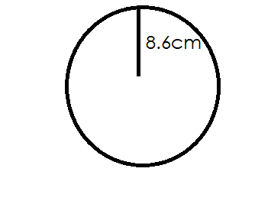2. Find the diameter of a circle below.

D = r + r

= 8.6cm + 8.6cm

= 17.2cm

3. Find the diameter of a circle whose radius is 7 $\frac{1}{2}$ cm

**Soln**.

D = r + r

= 7 $\frac{1}{2}$ cm + 7 $\frac{1}{2}$ cm

= 15 cm + 15 cm

2 2

= 15cm + 15cm

2

= $\frac{30}{2}$ cm

= 15cm

4. Find the radius of a circle whose diameter is 20cm.

**Soln.**

r = D

2

10

= 20cm

2

=10cm

5. Below is a circle. Find its radius.

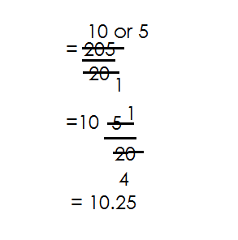 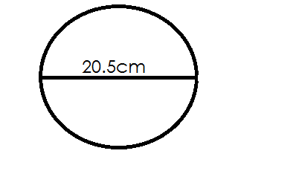

Soln.

R = D ÷ 2

= 20.5 ÷ 2

= 205 ÷ 2

10

= 205 x 1

10 2

6. Find the radius of a circle whose diameter is 30 $\frac{1}{2}$ cm

**Soln**.

r = d ÷ 2

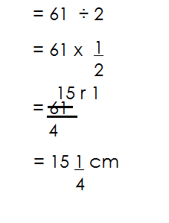 = 30 $\frac{1}{2}$ ÷ 2

**Activity**

1. Find the radius of a circle whose diameter is

a. 6cm

b. 20.4cm

c. 10cm

d. 40.4cm

e. 20cm

f. 20 $\frac{1}{2}$ cm

g. 45cm

h. 6.5cm

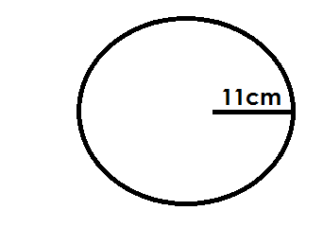2. Find the diameter of the circle below

3. Find the diameter of a circle whose radius is

(a) 4cm

(b) 3 $\frac{1}{2}$ cm

(c) 17 $\frac{1}{2}$ cm

(d) 20cm

(e) 15cm

(f) 10 $\frac{1}{2}$

(g) 22 $\frac{1}{2}$ cm

**FINDING CIRCUMFERENCE AND AREA OF A CIRCLE**

Circumference = πD

Area = πr2

Where π = Pi ( $\frac{22}{7}$**or** 3.14)

D = Diameter

R = Radius

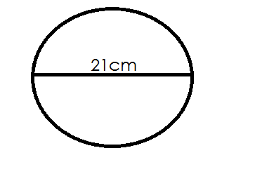1. Find the circumference of the circle below.

C = πD

3

= $\frac{22}{7}$ x 21

= 66cm

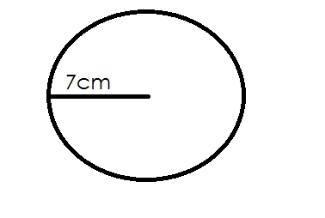2. Use the circle below to answer question

a. Find its circumference

C = πD but D = r + r

2

= $\frac{22}{7}$ x 14cm = 7cm + 7cm

= 44cm = 14cm

(b) Find its area

Soln.

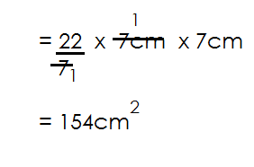 Area = πr2

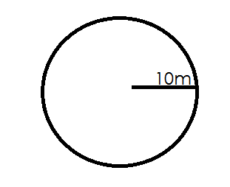3. Use the figure below to answer questions.

(a) Calculate its area

**Soln.**

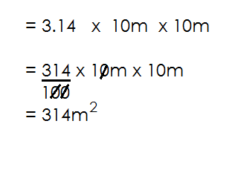 Area = πr2

(b) Work out its perimeter

**Soln.**

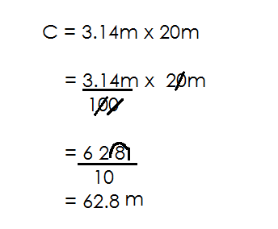 C = πD

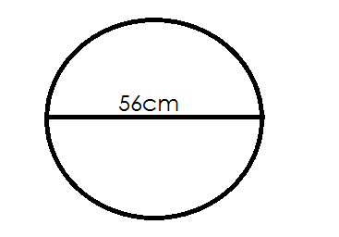4. Use the figure below to answer question

a. Calculate its area

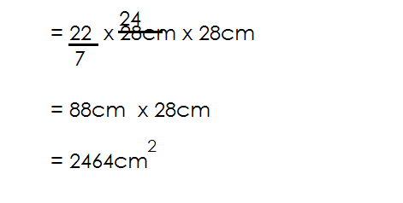 Area = πr2

b. Find its circumference

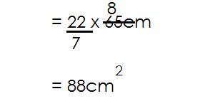 C = π D

**Activity**

Find the area of and circumference of the following

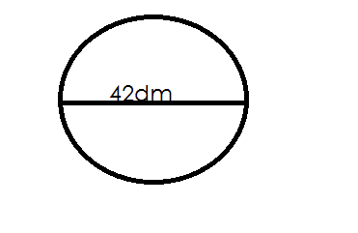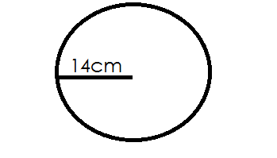

(1) 2.

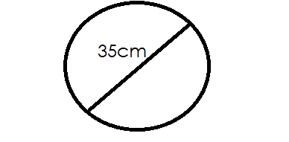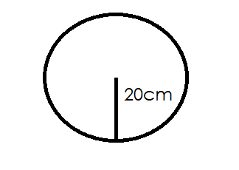3. 4.

5. A circular plate has a diameter of 14cm. Calculate its circumference.

6. The radius of a car tyre is 20m. Calculate its area.

7. A circular bottom of a mug has a radius of 7cm. Find its area.

**FINDING RADIUS OR DIAMETER OF A CIRCLE GIVEN CIRCUMFERENCE**

1. The circumference of a circle is 22cm. Find its diameter.

**Soln.**

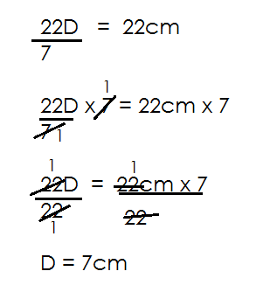 π D = C

(b) Calculate its area

**Soln.**

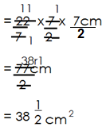 Area = πr2

2. Find area of a circle whose circumference is 440cm.

**Soln.**

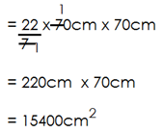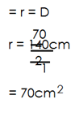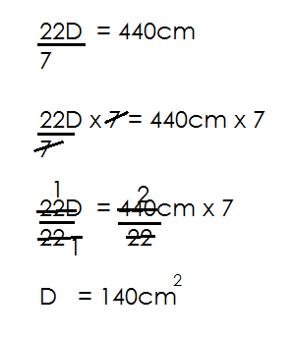 π D = C Area = πr2

**Activity**

1a. The circumference of a circle is 88cm. Find its radius.

(b) Find its area.

2. The circumference of a circle is 220cm.

(a) Find its radius

(b) Find its area

3. The circumference of a circle is 44cm. Find its area.

4. Find the diameter of a circle whose circumference is 264cm.

**VOLUME, CAPACITY AND TOTAL SURFACE AREA OF PRISMS**

- A prism is a closed sided figure with two common ends.

**Examples of prism.**

* Cube (square based prism)
* Cuboid (rectangular based prism)
* Cylinder (circular based prism)
* Trapezoidal prism (Trapezium based prism)

**VOLUME, CAPACITY AND TOTAL SURFACE OF A CUBE.**

* Volume is the amount of space occupied by an object.
* Volume is measured in cubic units.

**CAPACITY**

* Capacity is the amount of content that a given container can accommodate.
* - capacity = volume L

1000cm3

**Cube**

- A cube is a prism made up of 6 square faces.

**Illustration**

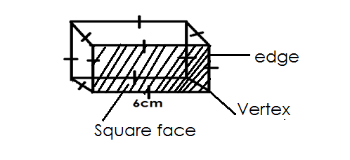

**It is made up of: -**

* 6 faces
* 8 vertices
* 12 edges

Therefore, volume of a cube is;

**Volume = S x S x S**

**The net of a cube.**

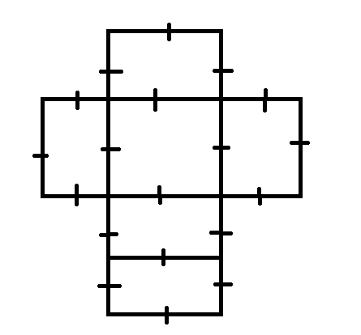

**Therefore, T.S. A = 6S2**

**Examples.**

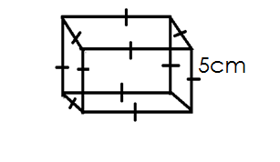Below is a cube. Use it to answer questions that follow.

(a) Find its volume

V = S x S x S

= 5cm x 5cm x 5cm

= 125cm3

(b) Calculate its T.S.A

T.S.A = 6S2

= 6 x 5cm x 5cm

= 150cm2

(c) How many litres of water does it hold when completely full?

capacity = Volume L

1000cm3

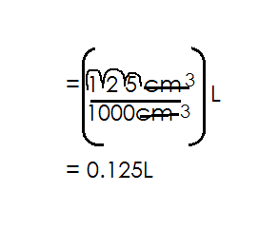

2. Find T.S.A of a cube of side 7m.

**Soln.**

T.S.A = 6S2

= 6 x 7m x 7m

= 294m2

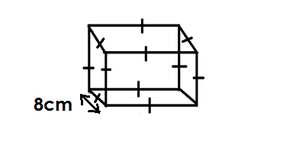3. Find volume, capacity and T.S.A of the figure below.

(a) Volume = S x S x S

= 8cm x 8cm x 8cm

= 512cm3

(b) T.S.A = 6S2

= 6 x S x S

= 6 x 8cm x 8cm

= 384cm2

(c) Capacity

**Soln.**

Volume L

1000cm3

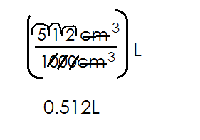

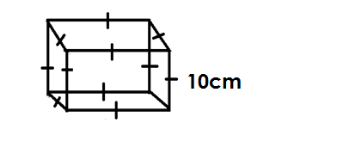2. Use the figure below to answer questions that follow.

a. Find its volume.

Volume = S x S x S x S

= 10cm x 10cm x 10cm

= 1000cm3

b. Find its total surface area

T.S.A = 6S2

= 6 x S x S

= 6 x10cm x 10cm

= 600cm2

c.Find its capacity

Capacity = Volume L

1000cm3

= 1000cm3 L

1000cm3

= 1L

3. Find the volume of a cube whose side is 20cm.

**Soln.**

Volume = S x S x S

= 20cm x 20cm x 20cm

= 8000cm3

4. Find the T.S.A of a cube whose side is 15cm.

T.S.A = 6S2

= 6 x 15cm x 15cm

= 90cm x 15cm

= 1350cm2

**Activity**

1. Use the figures below to find;

(i) Volume

(ii) T.S.A

(iii) Capacity of the following.

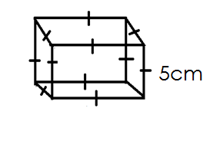(a)

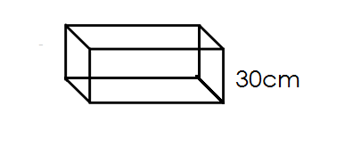

(b)

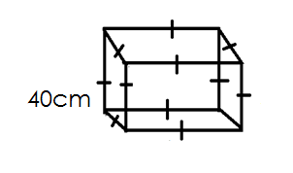

3.

4. Find the T.S.A of a cube whose side is 5cm.

5. Find the capacity of a cube whose side is 120cm.

**FINDING LENGTH OF EACH SIDE OF A CUBE GIVEN BASE AREA OR T.S.A.**

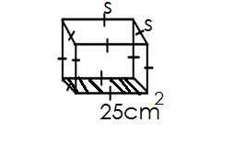1. The base area of a cube is 25cm**2**. Find its volume.

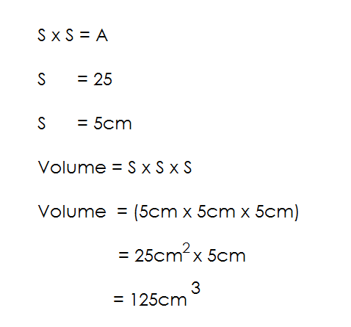

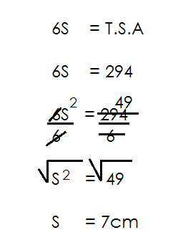2. The T.S.A of a cube is 29cm**2**. Find the length of each side.

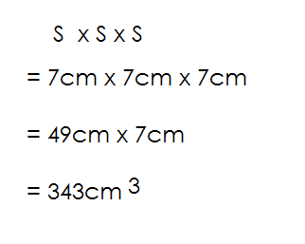(b) Calculate its volume.

3. The base area of a cube is 400cm2. Find the length of each side.

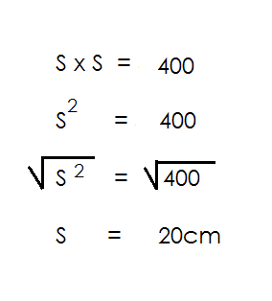 **Soln.**

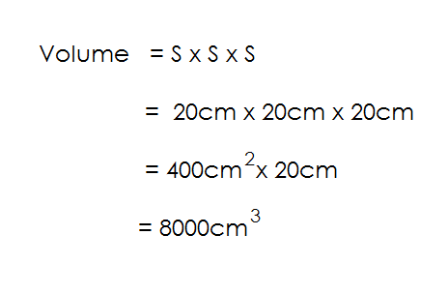(b) Find its volume

4. The T.S.A of a cube is 2400cm2. Find one side of the cube.

**Soln**.

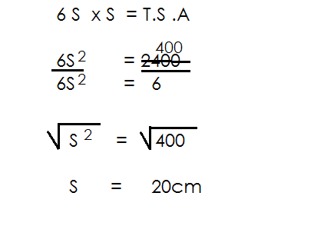

**Activity.**

1. The base area of a cube is 100cm2.

(a) Find the length of one side.

(b) Find its volume.

2. The base area of a cube is 81cm2. Find its volume.

3. The base area of a cube is 36cm2. Find its T.S.A.

4. The T.S.A of a cube is 96cm2.

(a) Find one side of a cube.

(b) Find its volume.

5. The T.S.A of a cube is 150cm2.

Find its volume.

6. The T.S.A of a cube is 216cm2. Find its volume.

7. The T.S.A of a cube is 1014cm2. Find its capacity.

**VOLUME, CAPACITY AND T.S.A OF ACUBOID**

A cuboid is a rectangular based prism.

It made of up of:

* 6 faces
* 8 vertices
* 12 edges

**Illustration**

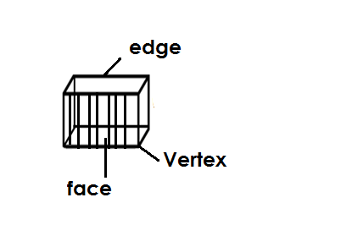

**Note:**

Volume = L x W x H

T.S. A= 2(L x W) + 2(L x H) + 2(W x H)

Capacity= $\frac{Volume}{1000}$ litres

**Examples.**

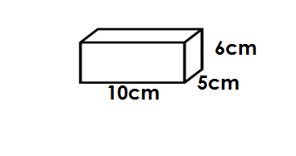1. Use the figure below to answer questions that follow.

a) Find its volume.

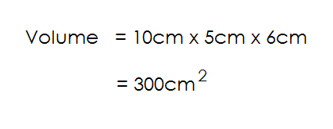 **Soln.**

b) Find the capacity of the figure

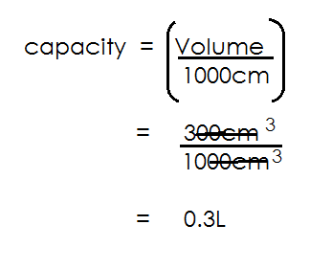 **Soln.**

c) Find its T.S.A

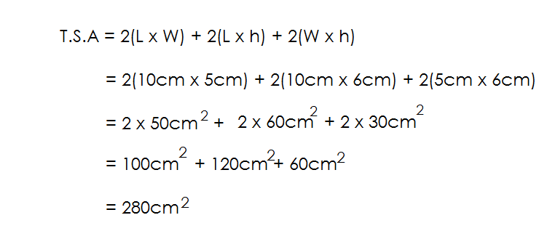 **Soln.**

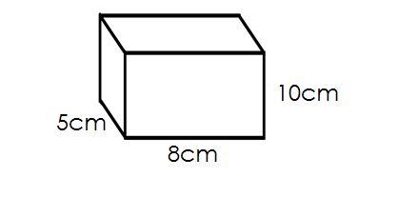2. Below is a cuboidal tin, use it to answer questions that follow.

(a) Find the volume of the figure

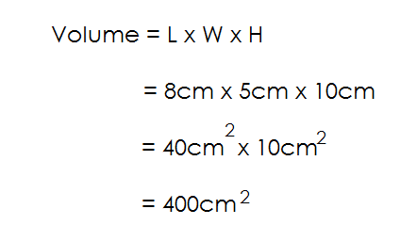 **Soln.**

(b) How many litres does it hold when completely full?

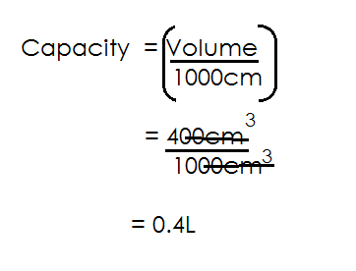 **Soln.**

(c) Find the T.S.A of the figure

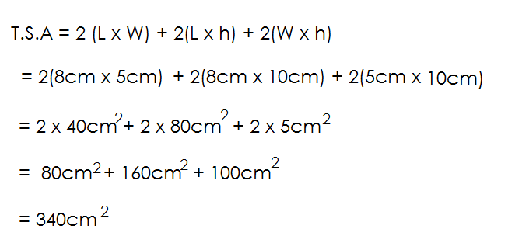 **Soln.**

**Activity**

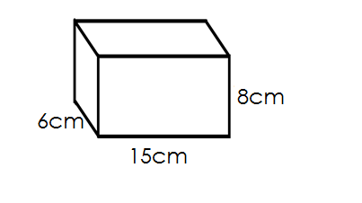 Find the volume capacity and T.S.A of the following.

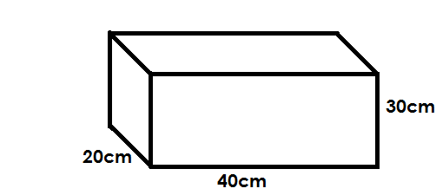1. 2.

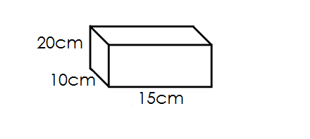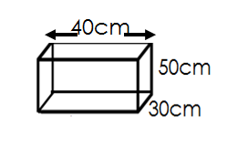

3. 4.

**MORE ABOUT VOLUME AND CAPACTY**

**Examples.**

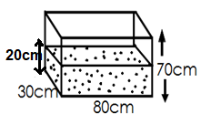1. The tank below is holding some water. Use it to answer questions.

(a) How many litres of water are in the tank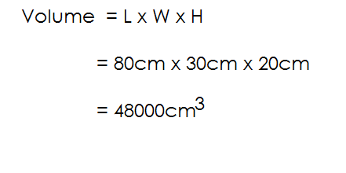?

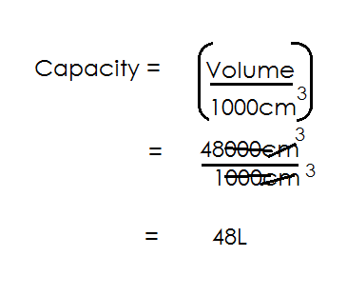

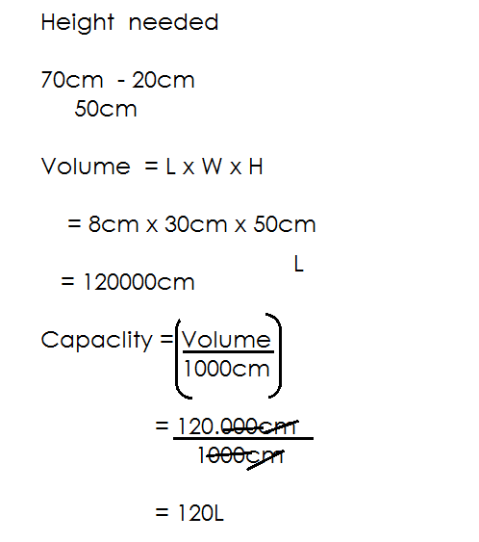(b) How many litres are needed to fill the tank?

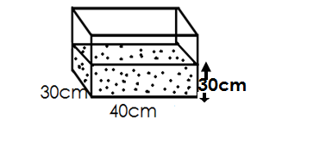2. The tank below is holding some water.

(a) How many litres of water are in the tank?

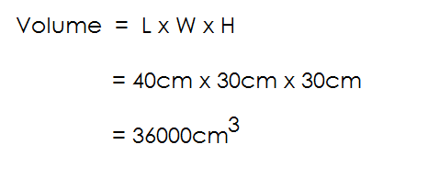 **Soln.**

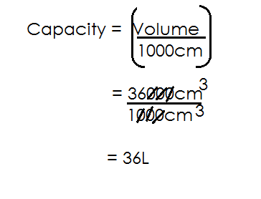(b) Find its capacity

(c) If the tank is $\frac{2}{3}$ full of water. How many litres of water can it hold when completely full.

**Soln.**

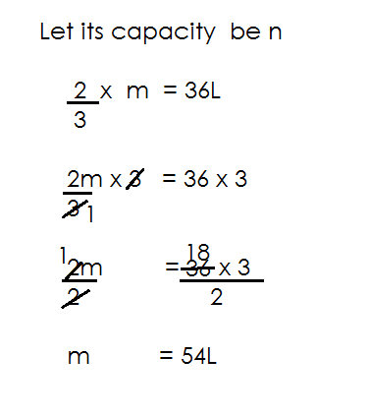 Let its capacity be n.

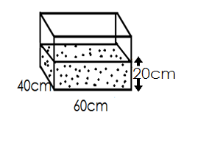2. The tank below is $\frac{3}{4}$ full of water.

How many litres of water can the tank hold when completely full.

**Soln.**

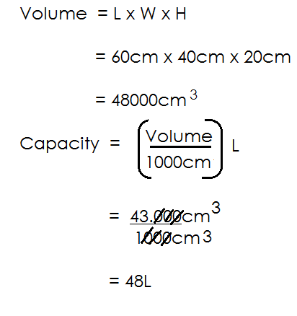

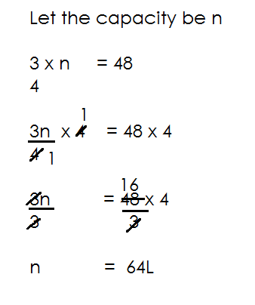

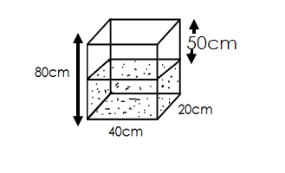3. The tank below is holding some water

a) How many litres of water are in the tank.

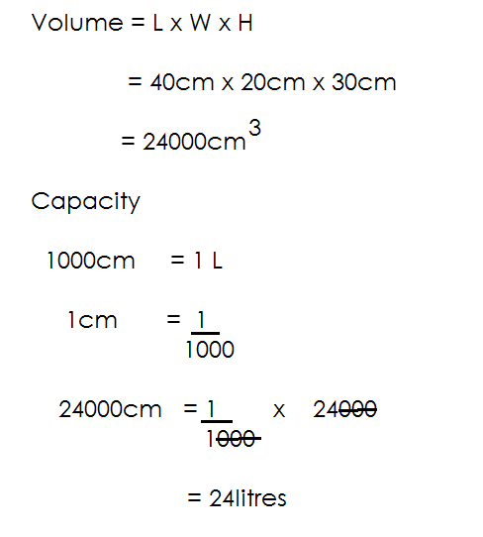 **Soln**.

(b) How many litres are needed to fill the tank.

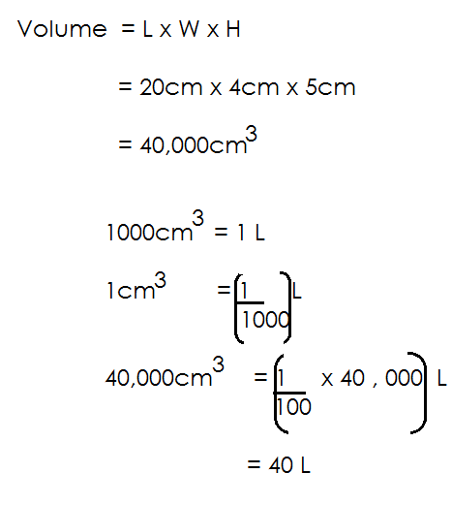 **Soln.**

**Activity**

1. The tank below is holding some water.

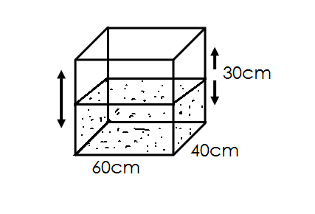

(a) How many litres are in the tank

(b) How many litres are needed to fill the tank.

2. Below is a water tank.

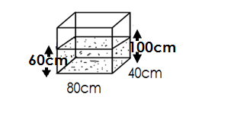

(a) How many litres of water are in the tank?

(b) How many litres are needed to fill the tank?

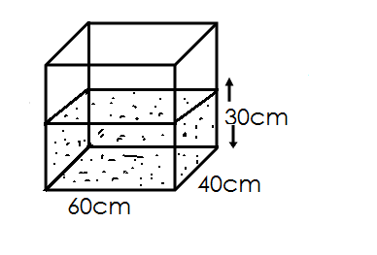3. The tank below is holding some water.

(a) How many litres of water are in the tank?

(b) If the tank is $\frac{1}{3}$ full of water. How many litres of water can the tank hold when completely full.

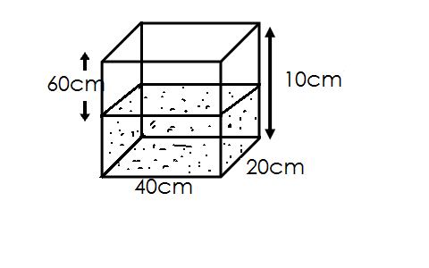4. The tank below is holding some water.

(a) How many litres are in the tank?

(b) How many litres are needed to fill the tank?

**FINDING UNKNOWN SIDE OF A CUBOID GIVEN CAPACITY OR T.S.A**

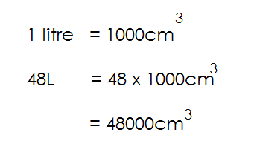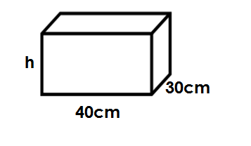1. Below is a tank holding 48litres

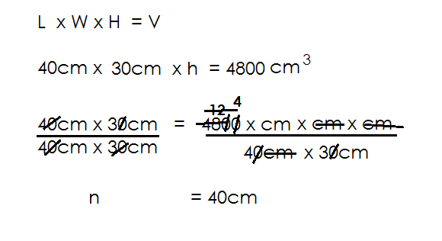a) Find the value of h.

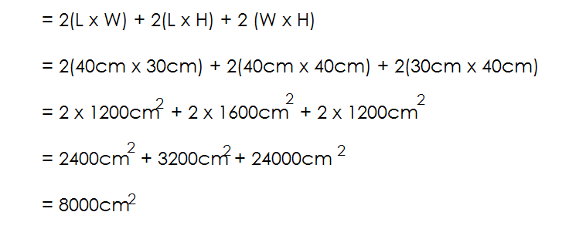b) Find the total surface area of the figure.

T.S. A

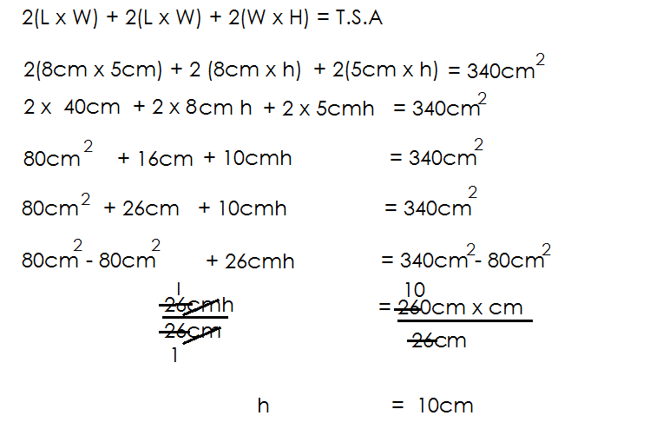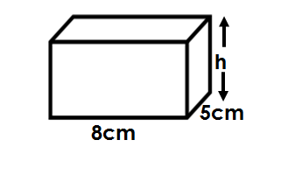2. T.S. A of the figure below is 340cm2.

a) Find its height.

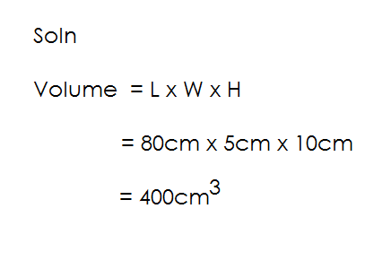b) Find the volume

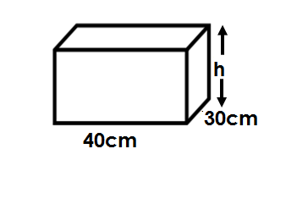3. The tank below is holding 36litre of water. Use it to answer questions.

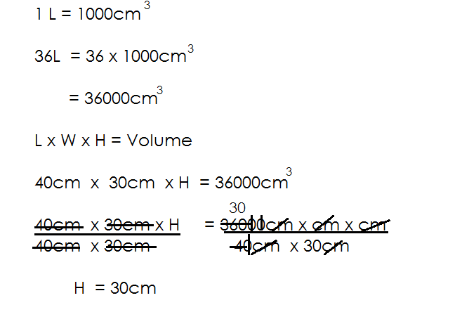a) Find its height

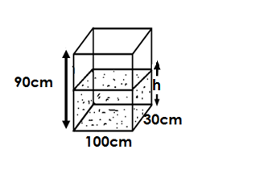3. The tank below is holding 120litres.

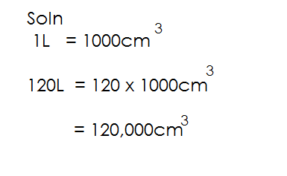

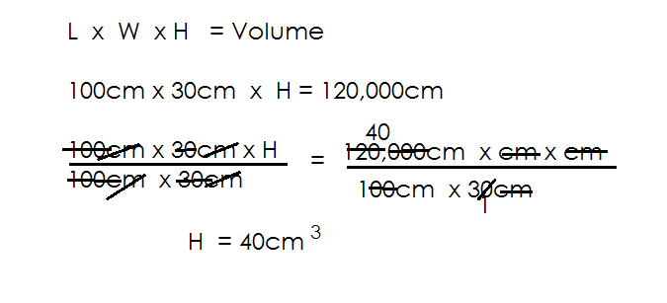a) Find the value of h.

(b) How many litres of water are needed to fill the tank above?

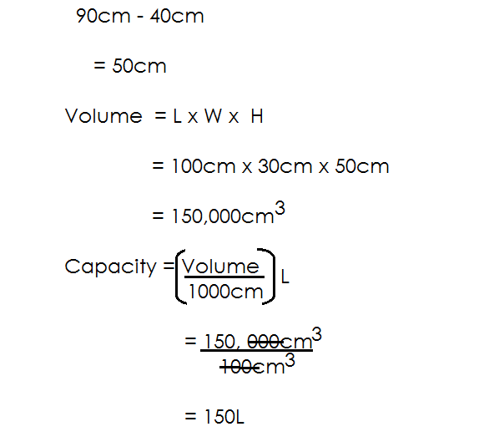 **Soln**.

**Activity**

1. The tank below is holding 72litres of water.

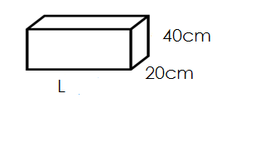

Find the value of L

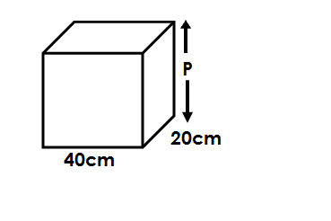2.

If the tank is holding 48litres. Find the value of P.

3. The tank below is holding 120litres.



(a) Find the value of h.

(b) How many litres of water are needed to fill the above tank?

4. The tank below is holding 40 litres.

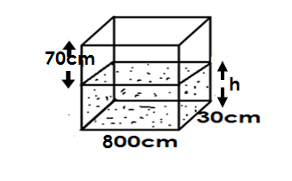

(a) Find the level of water in the tank.

(b) How many litres of water are needed to fill the tank?

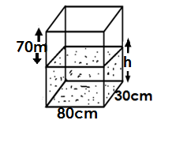5. The tank below is holding 36litres of milk.

(a) Find h.

(b) How many litres are needed to fill the tank?

**VOLUME AND CAPACITY OF CYLINDER (CIRCULAR BASED PRISM)**

**Note.**

A Cylinder is made of up of 2 faces i.e.

* The 2 circular ends
* Curved surface (rectangle surface)

**Volume = πr2 x h**

**Where, r = radius**

**h = height**

**illustration.**

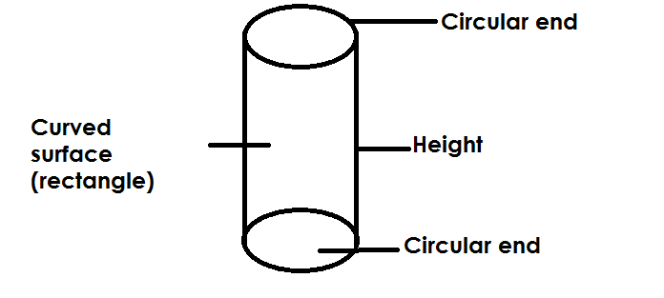

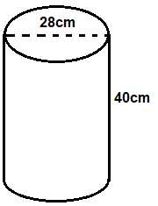1. Below is a cylinder use it to answer questions.

(a) Calculate its volume

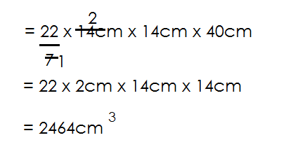 Volume = πr2x h

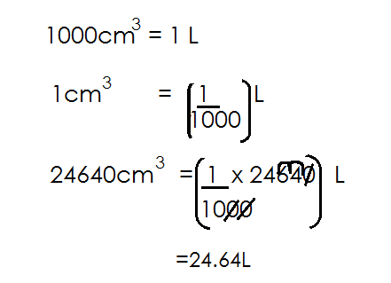(b) How many litres of water can it hold when completely full?

2. Below is a cylinder. Use it to answer questions.

(a) Find its volume.

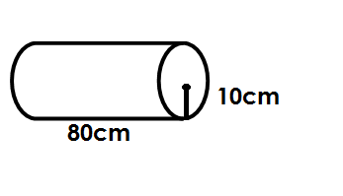

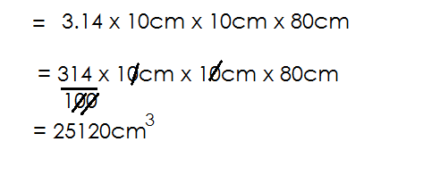 Volume = πr2 h

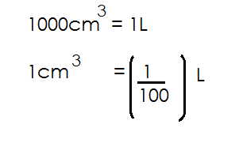(b) Find its capacity.

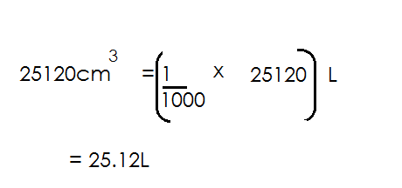

**Activity**

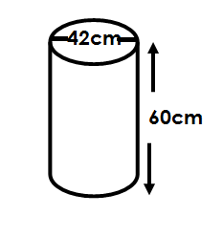1. Find the volume and capacity of the following.

(a)

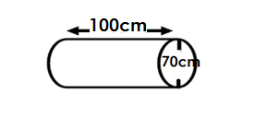(b)

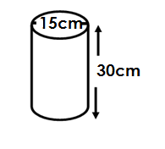

(c)

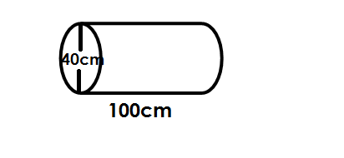

(d)

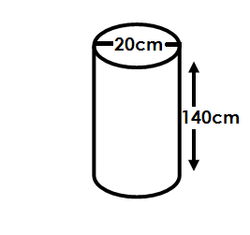(e)

**ALGEBRA**

Algebra is the branch of mathematics dealing with symbols or unknowns to represent quantity of something.

**COLLECTING LIKE TERMS**

1. Simplify: m + m + m

= 4m

2. Simplify: 3k + 4k + k

= 8k

3. Simplify: 6m + 10 + m + 4

= 6m + m + 10 + 4

= 7m + 14

4. Simplify: 4y – 8 + y + 3

= 4y + y + 3 – 8

= 5y – 5

5. Simplify: 2a x + 3mn + 5ax - 2mn

= 2ax + 5ax + 3mn - 2mn

= 7ax + mn

6. Simplify: m + 5k – 4m + 2k

= m – 4m + 5k + 2k

= -3m + 7k

**Activity**

1. Simplify: K + 2K + 3K

2. Simplify: 3m – m + 2m

3. Simplify: 3k – 2m + 2k + 5m

4. Simplify the following

(a) 3Km – 2Km + 3W - 5W

(b) 3P – 6 – 2P + 8

(c) 4xy – 2m – ab +2k

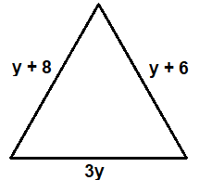3. Below is a triangle. Find its perimeter.

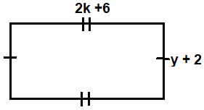4. Below is a rectangle. Find its perimeter.

**SUBSTITUTION**

To substitute is to replace.

1. Given that a = 6, b = 4 and c=2

Find the value of;

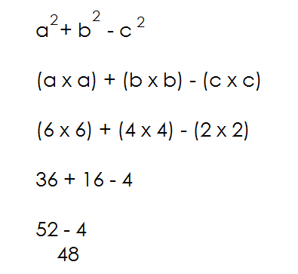(i) a + b + c (iv) a**2** + b**2** + c**2**

6 + 4 + 2

12

(ii) a b c

**Soln.**

a x b x c

6 x 4 x 2

24 x 2

48

(2) Given 2a = 6, b = 3 and c= 4

(iii) $\frac{abc}{4a}$

**Soln.** (a) Find the value of

$\frac{abc}{4b}$ b + 3

$\frac{a x b x c}{4 x b}$ = 3 + 3

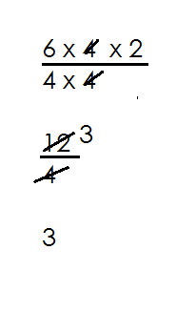 = 6

(b) 2ab

= 2a x b

= 6 x 3

= 18

**Activity**

Given m = 3, n =3 and k = 2

Find the value of

(i) 2m + 3m

(ii) mk - nk

(iii) mkn

(iv) k (m + n)

(v) k2 + 2k

4

2. Given a = 4, 12y = 6 and m = 4

Find:

(i) a + ya

(ii) 3a - my

(iii) ay

M

(iv) y (am + y)

**MORE ABOUT SUBSTITUTION**

1. Given that a = -4 b= -3, c= 2

Find (i) a + b

= **-** 4 + -3

= **-**7

(ii) a – b = **-**4 - **-**3

= **-**4 – (**-**3)

=**-**4 + 3

= **-**1

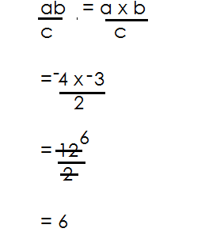(iii)

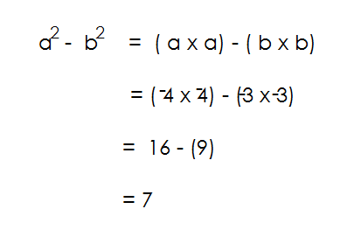(iv) a**2** – b**2**

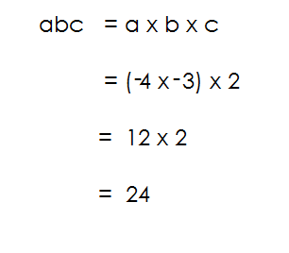(v) abc

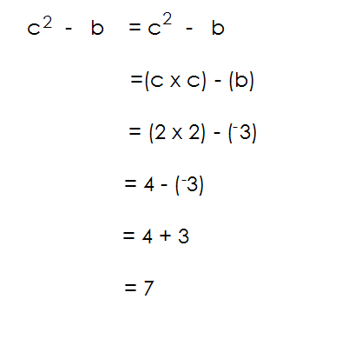(vi) c**2** - b

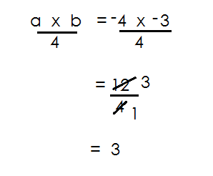(viii)

**Activity**

If a = b = 4 and c = -2

(a) Find

(i) a + b

(ii) abc

(iii) a2 + c2

(iv) a2 - c

(v) a x b

-2

(vi) 2bc

(vii) 2(b – c)

2. Given that P = -8, Q = **-**2 and y = 4 find

(i) PQ + 4

(ii) P – Q

(iii) Q2 – y

3. Given that a = b = 4 and c= -6

Find (i) a + b – c

(ii) b - c

(iii) 2ac

(iv) c**2** + b

**OPENING BRACKETS**

**Note**:

* While opening bracket, multiply the figure immediately before brackets by all terms inside brackets.
* A negative sign outside brackets changes all signs outside brackets while a positive sign does not change signs inside brackets.
* On the third step there is a check point about integers.

1. Simplify: 4 (m + 2)

**Soln.**

4 x m + 4 x 2

4m + 8

2. Simplify: 2(2p – 3k)

**Soln.**

2 x 2p – 2 x 3k

4p - 6k

3. Simplify: -6 (m - 2)

**Soln.**

-6 x m + 2 x 6

- 6m + 12

4 Simplify the following

a. 4(m + 6)

**Soln.**

4 x m + 6 x 4

4m + 24

b. -3(-7a - 2b)

-3 x -7 + 2b x 3

21a + 6b

**Activity**

Simplify the following.

1. 3(k - 2)

2. 5(x + 4)

3. -2 (y + 4)

4. -4 (m – 6)

5. -4(2p – 4)

6. -3 (k + 5)

7. -2(-2 + k)

**MORE ABOUT REMOVING BRACKETS**

**Examples**

1. (x + 1) + (2 x + 3)

x + 1 + 2 x +3

x + 2 x 1 + 3

3x + 4

2. 2(y + 2) + 3(y – 2)

2 x y + 2 x 2 + 3 x y – 2 x 3

2y + 4 + 3y – 6

2y + 3y + 4 – 6

5y – 2

3. 5(q + 3) + 3(q – 1)

5 x q + 3 x 5 + 3 x q – 1 x 3

5q + 15 + 3q – 3

5q + 3q + 15 – 3

8q + 12

4. (9x – 4) + (x +1)

9x - 4 + x + 1

9x – x + 1 – 4

8x – 3

**Activity**

1. 5(p + 2) +2(p – 4)

2. 3(k – 4) + 2(k +3)

3. 4(y – 6) + 2 (y – 4)

4. 3(y – 4) + 2(y -2)

5. 3(k – 4) + 2(k + 3)

6. 5(k – 4) + 2(k + 1) + 3(k + 2)

**OPENING BRACKETS INVOLVING A NEGATIVE SIGN OUTSIDE BRACKET**

1. Simplify: 5(n – 4) – 3(n – 4)

**Soln.**

5 x n – 4 x 5 – 3 x n + 4 x 3

5n – 20 – 3n +12

5n – 3n + 12 – 20

2n – 8

2. Simplify: 7(p + 4) – 5 (p + 2)

7 x p + 4 x 7 – 5 x p – 5 x 2

7p + 28 – 5p – 10

7p – 5p + 28 – 10

2p + 18

3. Simplify: 7(y – 4) – 3 (y – 6)

7 x y – 4 x 7 – 3 x y + 6 x 3

7y - 28 – 3y + 18

7y - 28 - 3y + 18

7y - 3y + 18 – 28

4y - 10

4. Simplify: 3(m – 4) – 2 (m +2)

3 x m – 4 x 3 – 2m – 2 x 2

3m – 12 – 2m - 4

3m – 2m – 12 – 4

m – 16

**Activity**

1. Simplify: (9x – 4) – (x – 1)

**Simplify the following**

(a) 3(3x + 2) – 2 (x + 1)

(b) (7m – 1) + (m – 6)

(c) 8(m + 2) – 5 (m – 3)

(d) 4(n – 2) – 2 (n + 4)

(e) 5(p + 2) – 3 (p + 4)

(f) (5k – 6) – (3k – 4)

**SUBTRACTION OF COMPOUND TERMS**

**Note:**

* While dealing with compound terms first introduce brackets.
* Follow instructions governing opening of brackets

**Examples.**

1. Subtract: (3k + 4) from (5k – 6)

(5k – 6) – (3k + 4)

5k – 6 – 3k – 4

5k – 3k – 6 – 4

2k -10

2. Subtract: p + 4 from 4p – 3

(4p – 3) – (p + 4)

4p – 3 – p – 4

4p – p – 3 – 4

3p – 7

3. Subtract 2m + 2 from (5m – 6)

(5m – 6) – (2m + 2)

5m – 6 – 2m – 2

5m – 2m – 6 – 2

3m - 8

4. Subtract 2(4n – 6) from (n – 4)

(n – 4) – 2 (4n – 6)

n – 4 – 2 x 4n + 6 x 2

n – 4 – 8n + 12

n – 8n + 12 – 4

-7n + 8

**Activity**

Subtract the following

1. (t – 3) from (4t + 4)

2. (4n – 3) from (7n + 2)

3. 6k + 3 from 10k + 7

4. 5(x – 5) from 4(x – 4)

5. x – 1 from -2 (9 x -4)

6. (K – 2) from 3(K + 2)

**OPENING BRACKETS INVOLVING FRACTIONS**

**Examples.**

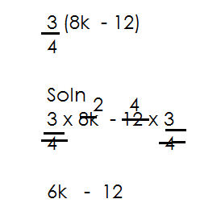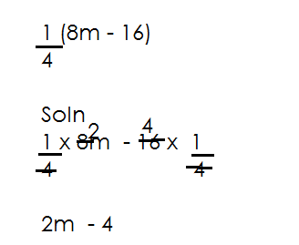1. Simplify: $\frac{3}{4}$ (8k- 12) 2. Simplify: (8m – 16)

3. Simplify: $\frac{2}{3}$ (2m – 6n)

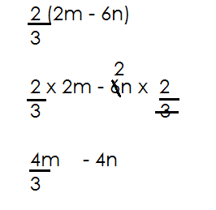

**Activity**

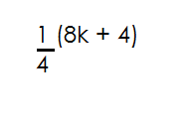1. Simplify the following

(a)

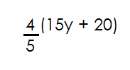

(b)

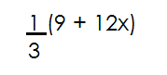

(c)

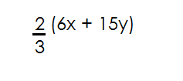

(d)

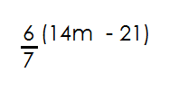

(e)

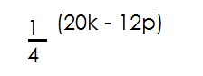

(f)

**SOLVING SIMPLE EQUATIONS**

1. Solve the following equation

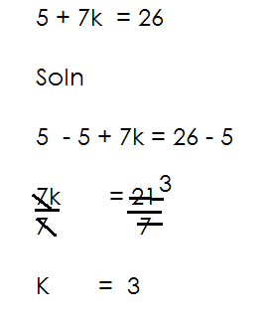(a) K + 4 = 8 (d) Solve: 5 + 7k = 26

**Soln.**

K + 4 – 4 = 8 – 4

K = 4

(b) 2m – 6 = 12

**Soln.**

2n - 6 + 6 = 12 + 6

2m = 18

2m = 18 9

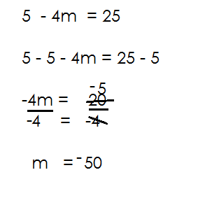 2 (e) Solve: 5 – 4m = 25

m = 9

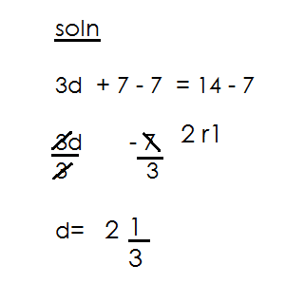(c) Solve: 3d + 7 = 14

**Activity**

Simplify the following equation.

(a) m + 3 = 11

(b) P – 5 = 9

(c) 7y + 4 = 18

(d) 3p – 2 = 7

(e) 4 + 3y = 16

(f) 3 + 4p = 27

(g) 12 - 2n = 4

(f) 1 – 5k = 11

**SOLVING EQUATION INVOLVING BRACKETS**

1. Solve the following equations

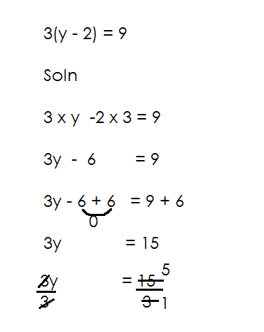(a) Solve: 2(k + 4) = 20 (b) Solve: 3(y – 2) = 9

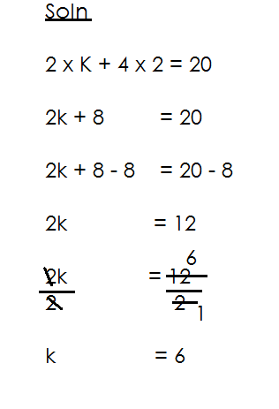

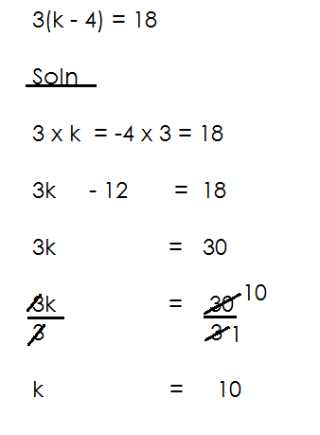(c) Solve: 3(k – 4) = 18

**Activity**

Solve the following equation

(a) 3(m + 2) = 21

(b) 5(k + 2) = 20

(c) 4(k + 2) = 30

(d) 2(y – 3) = 8

(e) 2(x – 2) = 6

(f) 7(m – 1) = 0

**SOLVING EQUATION INVOLVING UNKNOWNS ON BOTH SIDES**

Solve the following equations

1. 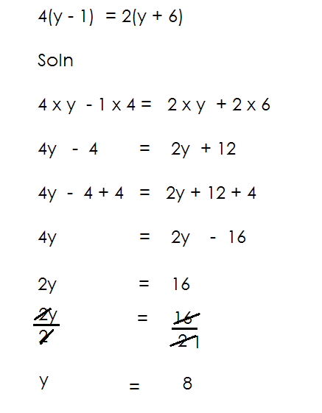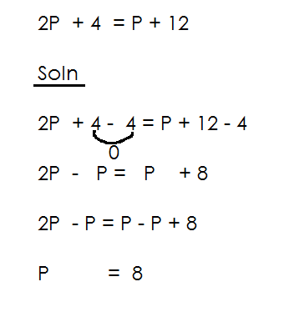Solve: 2p + 4 = p + 12 (b) Solve: 4(y – 1) = 2(y + 6)

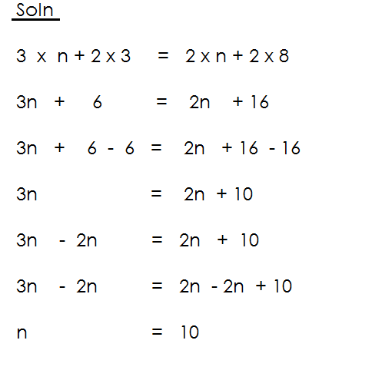(c) Solve: 3(n + 2) = 2(n + 8)

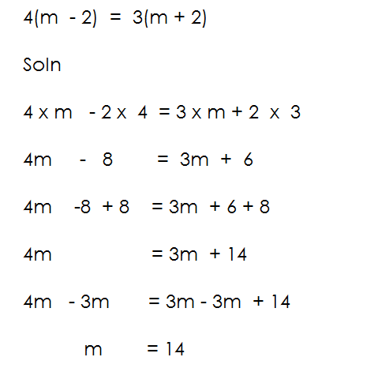 (d) Solve: 4(m – 2) = 3(m + 2)

**Activity**

Solve the following equations

(a) 3p + 6 = p + 14

(b) 4y – 2 = y + 10

(c) 5n – 6 = 2n + 6

(d) 3(w + 2) = 2(w + 5)

(e) 5(y + 1) = 2(y + 6)

(f) 3(m – 2) = 2(m + 4)

(g) 2(k – 2) = k + 4

**COMPARING SIDES OF A RECTANGLE.**

**NOTE**:

Opposite sides of a rectangle are equal. That is to say.

(i) Length = Length

(ii) Width = Width

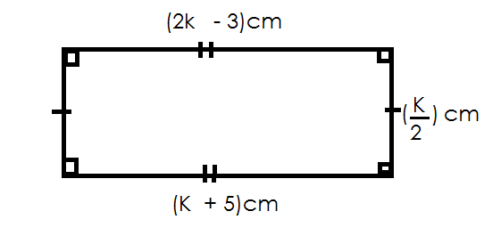1. Below is a rectangle, use it to answer questions that follow.

(a) Find the value of K.

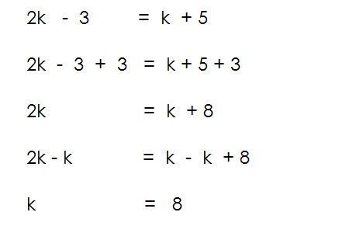

(a) Find its area

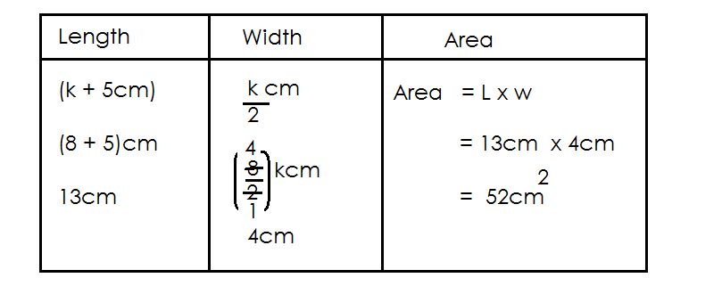

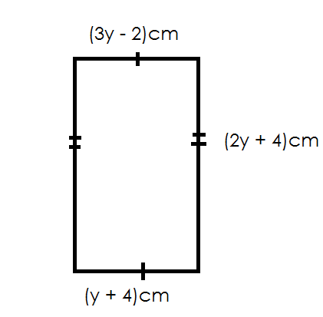2. Use the figure below to answer questions that follow.

(a) Find the value of y.

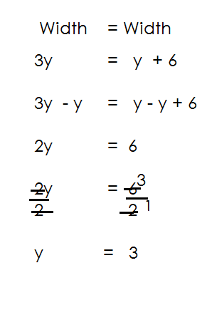

(b) Calculate its area.

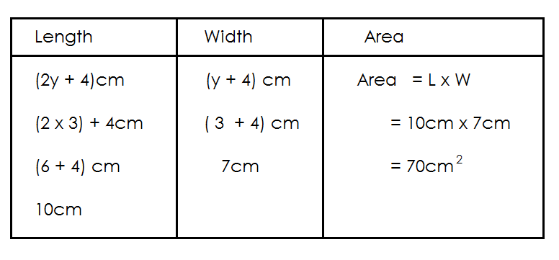

**Activity**

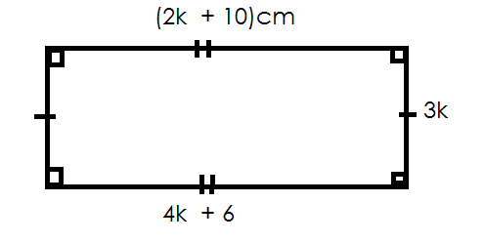1. Below is a rectangle. Use it to answer question.

(a) Find the value of K.

(b) Find its area.

(c) Find its perimeter

2. Study the figure below and answer questions.

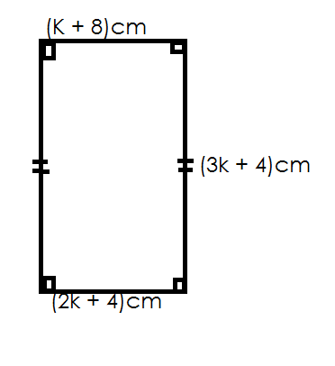

(a) Find the value of k.

(b) Find its area.

3. Find the area of the figure below.

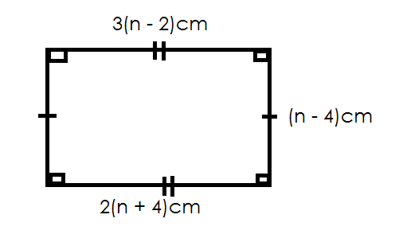

4. Study the figure below and answer questions.

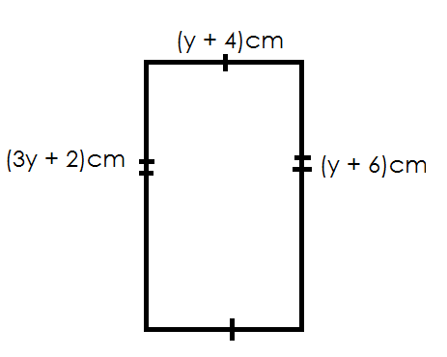

(a) Find the value of y.

(b) Find its perimeter.

5. Study the figure below and answer question.

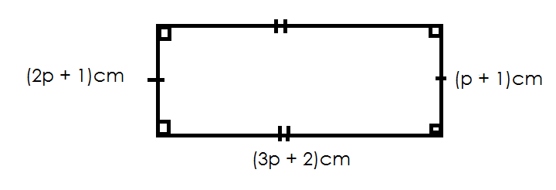

(a) Find the value of P.

(b) Find its area.

**COMPARING SIDES OF ISOSCELES TRIANGLE.**

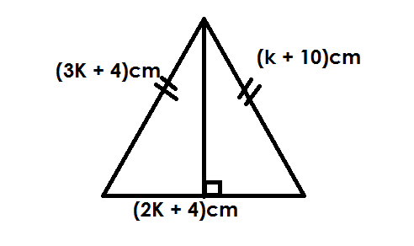Below is a triangle use it to answer questions.

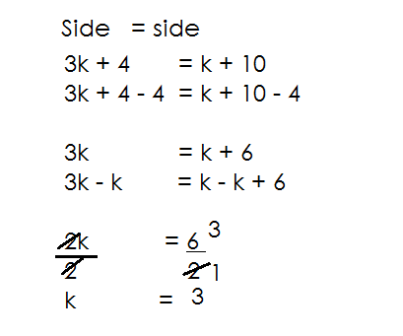(a) Find the value of k.

(b) Find its area

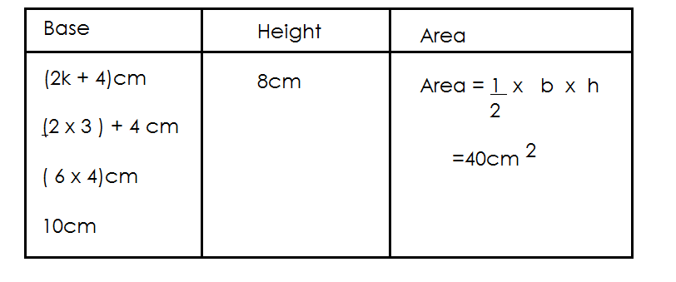

2. Use the figure below to answer questions that follow.

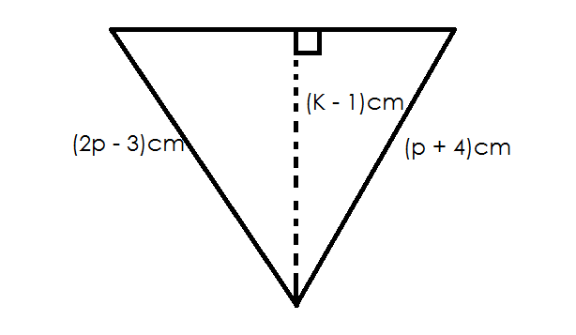

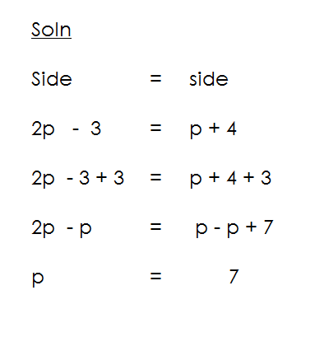(a) Find the value of P.

(b) Find the area of the triangle

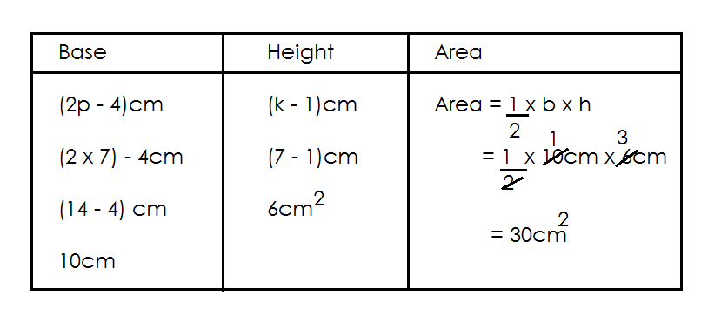

**Activity**

1. Use the figure below to answer questions that follow.

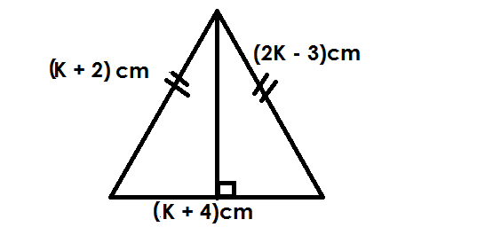

(a) Find the value of k.

(b) Find the area of the triangle.

2. Below is a triangle, use it to answer questions that follow.

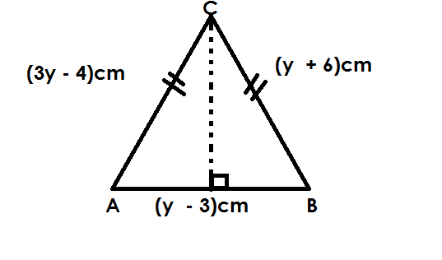

(a) Find the value of y.

(b) Calculate the area of the figure.

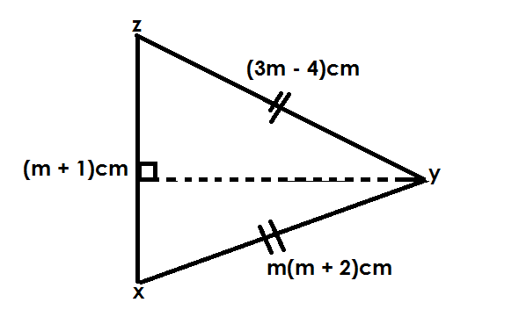3. Use the triangle below to answer questions that follow.

(a) Find the value of m

(b) Find the area of the figure XYZ

(c) Find the perimeter of the figure.

4. Below is a figure, use it to answer questions that follow.

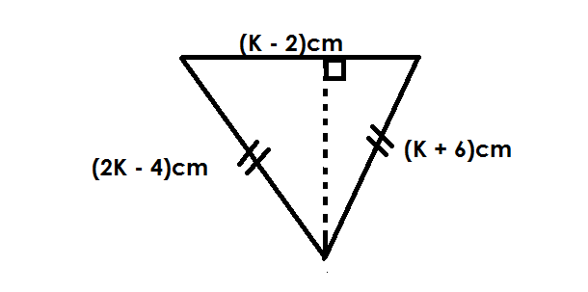

(a) Find the value of k.

(b) Find the area of the figure.

5. Use the figure below to answer questions that follow.

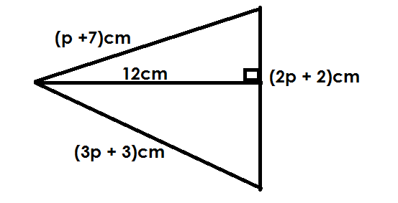

(a) Find the value of p.

(b) Find the area of the figure.

(c) Find the total distance around the figure.

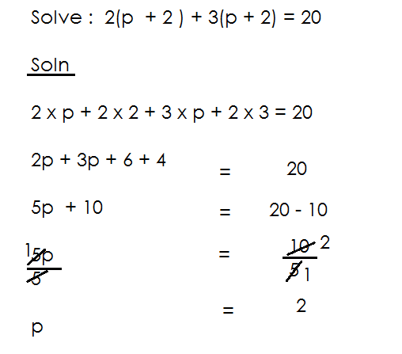**SOLVING EQUATIONS INVOLVING TWO BRACKETS**

1.

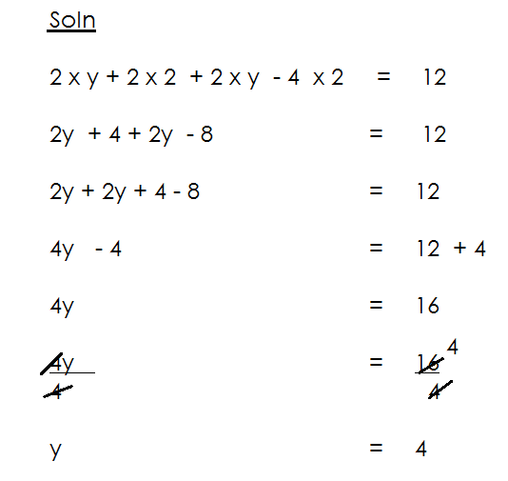2. Solve: 2(y + 2) + 2(y – 4) = 12

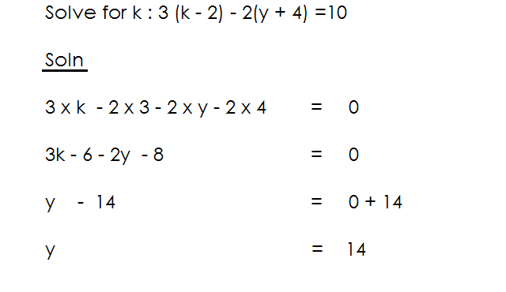

3.

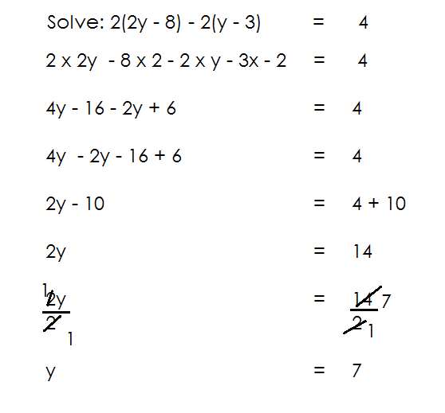4.

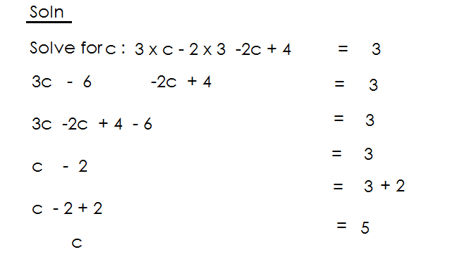5. Solve: 3(c – 2) – 2(c – 2) = 3

**Activity**

1. **Solve the following**

(a) 3(k + 1) + 2(k + 2) = 17

(b) 2(m + 2) + 2(m + 2) = 20

(c) 2(n + 4) + 3(k – 6) = 5

(d) 7(m + 2) + 3(m – 4) = 18

(e) 3(y – 4) – 2(y – 4) = 7

(f) 7(k – 4) – 3(y – 6) = 10

(g) 4(m- 2) – 2(m + 3) = 4

(h) 2(p – 3) – (p – 5) = 0

**SOLVING EQUATIONS INVOLVING FRACTIONS**

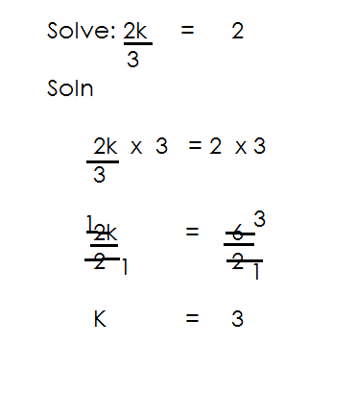1.

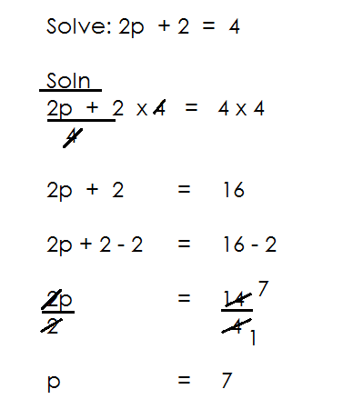2.

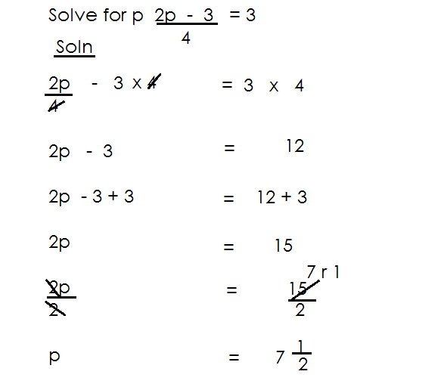3.

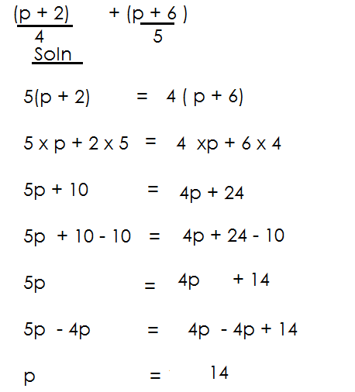4. Solve:

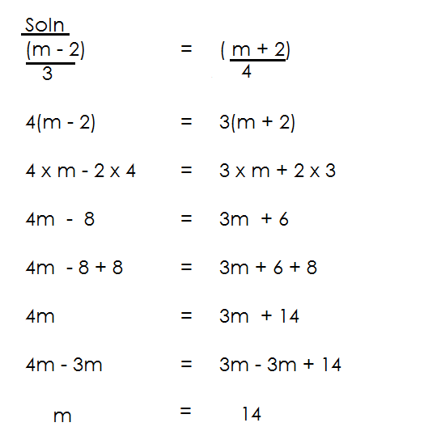5.

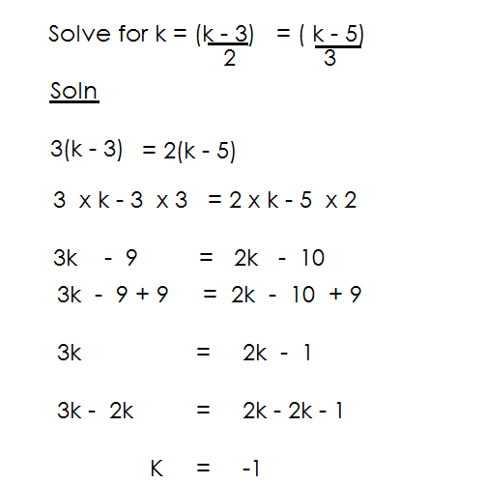6.

**ACTIVITY**

1. 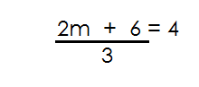 Solve the following

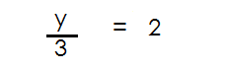(a) (c)

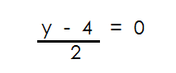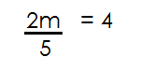

(b) (d)

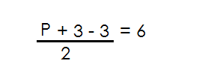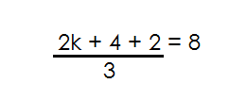(e) (f)

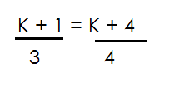

(g)

**APPLICATION OF ALGEBRA**

1. I think of a number, add 6 to it and the result is 20. What is the number?

Let the number be K.

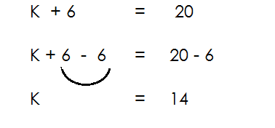

2. James and Peter shaded 30 mangoes. If Peter got 18 mangoes. How many mangoes did James get?

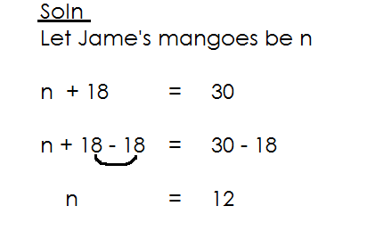

3. Richard is 6 years older than Manda, if their total age is 25years. How old is each of them.

|  |  |  |
| --- | --- | --- |
| Mande | Richard | Total |
| r | r + 6 | 28 |

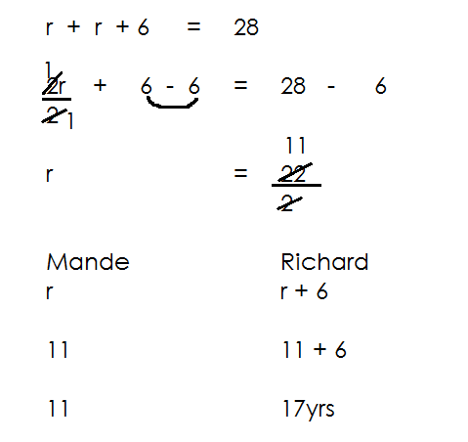

Esther is 12 years older than Anisha. If their old age is 40 year. How old is each of them.

|  |  |  |
| --- | --- | --- |
| Anisha | Esther | Total |
| K | K t 12 | 40 |

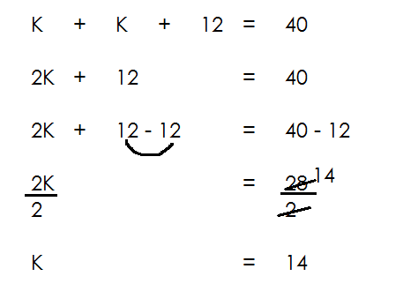

|  |  |
| --- | --- |
| **Anisha** | **Esther** |
| K  14  14 | K t 12  14 + 12  = 26 |

Ronald and Musa shared 24mangoes if Ronald got 4 more mangoes than Musa. How man mangoes did Musa get?

|  |  |  |
| --- | --- | --- |
| **Anisha** | **Esther** | **Total** |
| r | r + 4 | 24 |

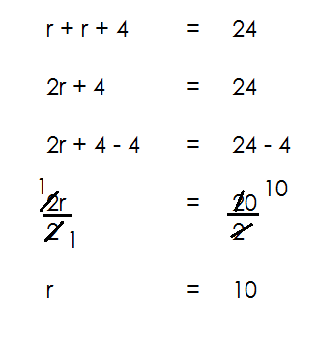

Osako picked mangoes for three days consecutively. He was picking 2 more mangoes than the previous day. If he picked a total of 36 mangoes. How many mangoes did he on the first day?

**Soln.**

Let the first day be r.

|  |  |  |  |
| --- | --- | --- | --- |
| **1St day** | **2nd day** | **3rd day** | **Total** |
| r | r + 2 | r + 2 + 2 | = 36 |
| r | r + 2 | r + 4 | = 36 |

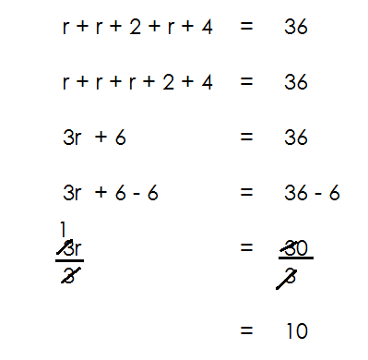

**Activity**

1. Amoti is 5 years older than Mr. Bin if their total age is 35 years. How old is each of them?

2. Drake is 10 years older that Lillian, if their total age is 40 years. How old is Drake?

3. Oundo and Tonny shared 36 sweets. If Tonny got 2 more sweets than Oundo. How many sweets did each get?

4. In a market, a cow costs sh. 200,000 more than a goat. If Mercy bought two animals at sh. 800,00. How much is a goat?

**More about application of Algebra**

Omara is 6 years younger than Derrick. If their total age is 18. How old is Omara?

Let Derrick’s age be n.

|  |  |  |
| --- | --- | --- |
| **Derrick** | **Omara** | **Total** |
| n | n – 6 | 18 |

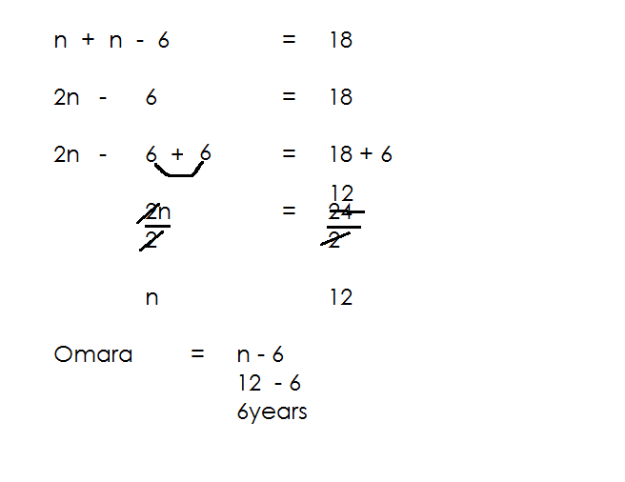

Omara = n – 6

= 12 – 6

= 6 years.

2. Mandela is 8 years younger than Nabata. If their total age is 34 years. How old is each of them?

**Soln.**

|  |  |  |
| --- | --- | --- |
| **Mandela** | **Nabata** | **Total** |
| **K – 8** | **K** | **34** |

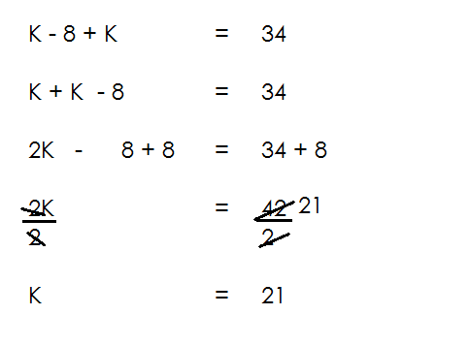

|  |  |
| --- | --- |
| **Mandela** | **Nabata** |
| K – 8  21 – 8  13yrs | K  21years |

3. At the supermarket. A shirt costs sh. 2000 less than a dress. A trader bought both at sh. 6000. How much is a dress?

|  |  |  |
| --- | --- | --- |
| **Dress** | **shirt** | **Total** |
| b | b - 2000 | Sh. 6000 |

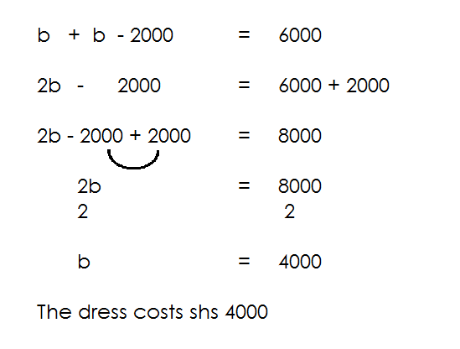

**Activity**

1. Martha is 9 years younger than her mother. If their total age is 41. How old is Martha?

2. Kafulu is 12yrs younger than Kakare. If their total age is 40 years. How old is each of them?

3. Sarah is 20 years younger than Oluka. If their total age is 52years. How old is each of them?

4. Solo bought 4 less sweets that Nelson if they both bought a total of 30 sweets. How many sweets did Nelson buy?

5. A hen costs sh. 5000 less than a turkey if they cost of both is sh. 65,000. Find the cost of a hen.

**MORE APPLICATION OF ALGEBRE INVOLVING AGE.**

**Examples.**

1. Mbaluma is twice as old as Musa. If their total age is 36 years.

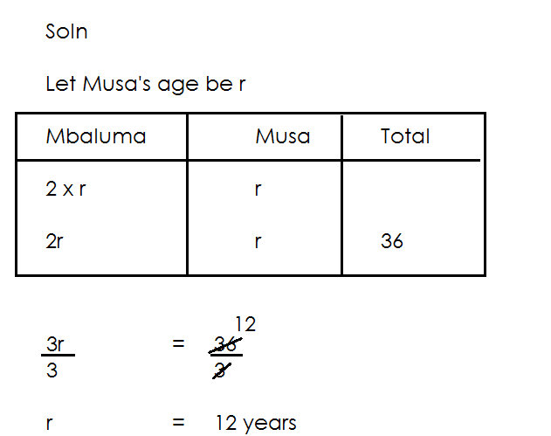How old is each of them now?

|  |  |
| --- | --- |
| **Mbaluma** | **Musa** |
| 2r  2 x 12  24yeara | r  12  12years |

2. Wasswa is 4 times as old as Kato. If their total age is 60 years. How old is Wasswa?

**Soln.**

Let Kato’s age be n

|  |  |  |
| --- | --- | --- |
| **Kato** | **Wasswa** | **Total** |
| n  n | 4 x n  4n | 60  60 |

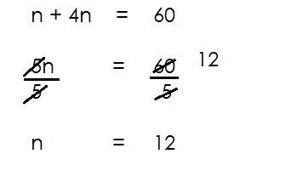

Wasswa = 4n

= 4 x 12

= 43 years.

3. Mane is 3 times as old as Bob, the difference in their age is 40 years. How old is each?

|  |  |  |
| --- | --- | --- |
| **Mane** | **Bob** | **difference** |
| 3K | K | 40 |

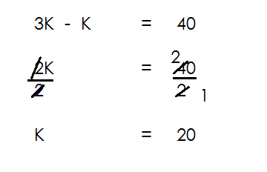

|  |  |
| --- | --- |
| Mane | Bob |
| = 3 x k  = 3 x 20  = 60 years | = k  = 20 years |

4. Osako is 4 times as old as Odur, the difference in their age is 36 years. How is Osako?

|  |  |  |
| --- | --- | --- |
| **Osako** | **Odur** | **Difference** |
| 4n | n | 36 |

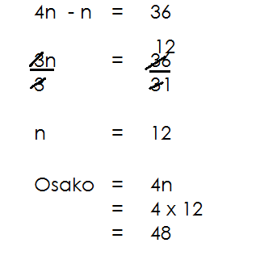

5. James is twice as old as John. In ten years’ time, heir total age will be 80 years. How old is each of them?

**Soln.**

Let John’s age be h

|  |  |  |  |
| --- | --- | --- | --- |
| **Time** | **James** | **John** | **Total** |
| Now | 2 x h | h |  |
| Future | 2h + 10 | h + 10 | 80 |

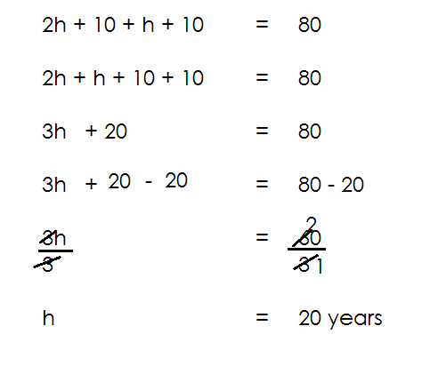

|  |  |
| --- | --- |
| **James** | **John** |
| 2h  2 x 20  40 | h  20 years |

**Activity**

1. Sandra is three times as old as Annet. If their total age is 48 years. How old is Annet?

2. A mother is 4 times as old as her daughter. Their total age is 30 years. Find the daughter’s age.

3. Anna is 2 years than Eva. Their total age is 15 years. Find Eva’s age.

**INEQUALITIES AND SOLUTION SETS**

Inequality is a relationship between two expression that are not equal. It is often written in the form of an equation but with the symbols > or <.

**Symbols used**



**is greater than**



**is greater than or equal to**

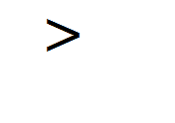

**is less than**



**is less than or equal to**

**Solution set**

Is a set of all possible values and integers that satisfy a given inequality.

**Forming solution sets**

1. Given that K < 5. Find the solution set for y.

**Soln.**

K < 5

K = {4, 3, 2, 1, 0, -1, …)

2. Given the solution set that satisfies m > 4.

**Soln.**

M > 4

 M = {5, 6, 7, 8, 9, …)

3. Find the saluting set for P 6

 **Soln.**

P 6

P = {6, 5, 4, 3, 2, 1, …}



4. Write the solution set for y 10

 **Soln.**

y 110

Y = {10, 11, 12, 13, 14, …}

5. Find the solution set for x if is a prime number in x 1

Soln.

 X 1

{1, 2, 3, 4, 5, 6, 7, 8, …}

X = {2, 3, 5, 7, …}

**Activity**

1. Write the solution set for the following inequalities.

(a) x 8 (f) x 3

(b) m 11 (g) Q 7 7

(c) 4 K (i) r -7

(d) P 9 (j) z - -1

(e) 10 W (k) h - -3

2. If m 8, give a solution set for m if m is positive number.

3. If y 11, give a solution set for y if y is an even number.

**SOLVING INEQUATION AND FINDING SOLUTION SET**

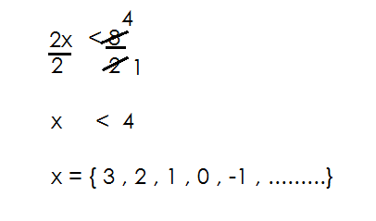1. Solve and give a solution set for the inequality 2x < 8

}

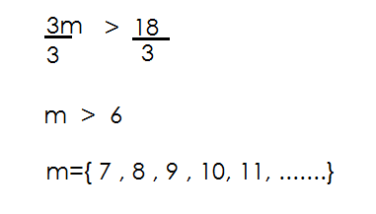2. Solve and find a solution set for 3m > 18.



3. Solve and find a solution set for 2K 16 where K is a multiple a positive multiple of 2.

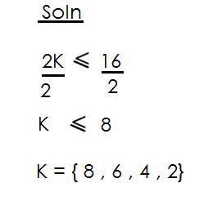



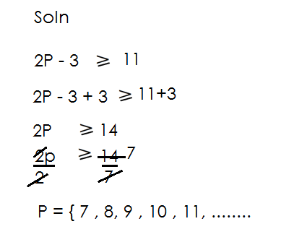4. Solve and form a solution for 2p – 3 11

}

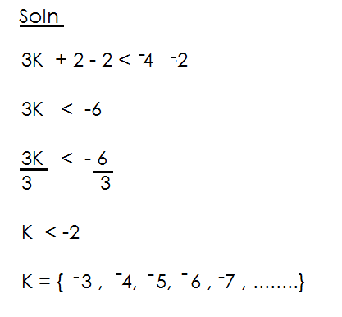5. Solve and form a solution set for 3K + 2 -4

6. Solve and form a solution set for 13 2P - 3 where P is an even number.

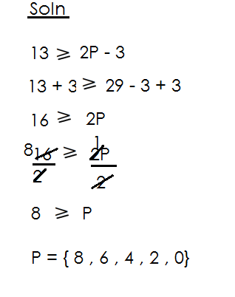

**Activity**

**Activity.**

1. Solve the following inequalities and form a solution set for each.

(a) 4K 16

(b) 21 3m

(c) 2P -12

(d) -18 3K

2. Solve and form a solution set for each inequality below.

(a) 2m – 5 7 (f) P + 5 7

(b) 3 + P 11 (q) 2y + 3 15

(c) 4P + 3 19 (i) 3x - 3 12

(d) 35 3y + 5

(e) 2x - 4 0

3. If 3x - 2 10, form a solution set for the inequality where x is a prime number.

4. Form a solution set for 2y + 4 26. Where y is an odd number.

**SOLVING INEQUALITIES AND FORMING A SOLUTION SET INVOLVING A NEGATIVE COEFFICIENT**

**NOTE**:

When a negative coefficient is divided on both sides of the inequality, the sign changes to its opposite.

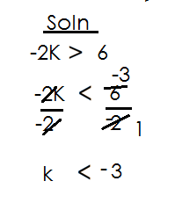1. Solve form a solution for -2K 6

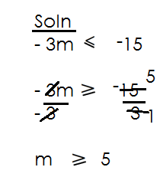 2. Form a solution set for m if **-**3m **-**15 where m is an even number.

3. Write down all the possible positive values of m for **-**2m – 3 **-**3

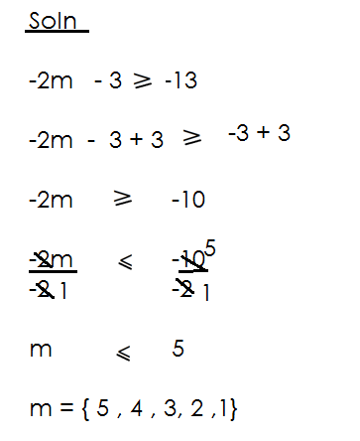



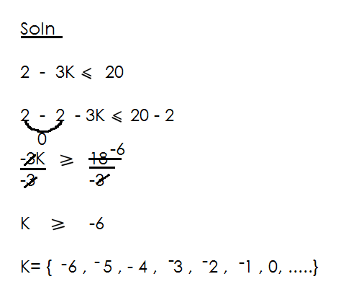4. Solve and write a solution set for 2 – 3K 20.

**Activity**

1. Solve and form a solution set for the following inequality.

(a) -4K -8

(b) -14 -2y

(c) -3x 12

(d) -21 -3P

(e) -2m + 1 9

(f) 5 – 3K 20

(g) 2 - 2P -18

2. Form a solution for 4 – 5K 24 where K is a positive integer.

3. If – 17 -2m + 3 and m is a multiple of 20 less than 100, Write all the possible values of m.

***CORRECTIONS AND FINDINGS.***

|  |  |
| --- | --- |
| ***CONTENT*** | ***PAGE.*** |
|  |  |
|  |  |
|  |  |
|  |  |
|  |  |
|  |  |
|  |  |
|  |  |
|  |  |
|  |  |
|  |  |
|  |  |
|  |  |
|  |  |
|  |  |
|  |  |
|  |  |
|  |  |
|  |  |
|  |  |
|  |  |
|  |  |
|  |  |
|  |  |
|  |  |
|  |  |
|  |  |
|  |  |